JSS Science and Technology University



“Time Table Management”

Software Engineering
by

Name Roll No. USN No.

Akshay S H 7 01JST17CS014
Bharath C 12 01JST17CS033
Jithendra S R 29 01JST17CS068

Under the guidance of

Prof. Ashritha Murthy
DEPARTMENT OF COMPUTER SCIENCE ENGINEERING,2019
Table of Contents
Table of Contents ii
Revision History ii
1. Introduction 1
1.1 Purpose 1
1.2 Document Conventions 1
1.3 Intended Audience 1
1.4 Product Scope 1
1.5 References 1
2. Overall Description 2
2.1 Product Perspective 2
2.2 Product Functions 2
2.3 User Classes and Characteristics 2
2.4 Operating Environment 2
2.5 Design and Implementation Constraints 2
2.6 User Documentation 2
2.7 Assumptions and Dependencies 3
3. External Interface Requirements 3
3.1 User Interfaces 3
3.2 Hardware Interfaces 3
3.3 Software Interfaces 3
4. System Features 4
4.1 System Feature 1 4
4.2 System Feature 2 4
5. Other Nonfunctional Requirements 4
5.1 Performance Requirements 4
5.2 Safety Requirements 5
5.3 Security Requirements 5
5.4 Software Quality Attributes 5
5.5 Business Rules 5
6. Other Requirements 5
Appendix A: Glossary 5

Revision History

Name | Date | Reason For Changes | Version
Bharath | 10-09-2019 | Initial Version | 0.1
Akshay | 23-10-2019 | Intermediate Vision | 1.0
Jithendra | 25-11-2019 | Expected Final Version | 2.0

Introduction

Purpose
The purpose of this document is threefold:
- To explain the process by which the preliminary requirements from Time Table Management Project were analyzed and refined
- To state the requirements for the Time Table Management Project in a way that allows tracing from the original (ambiguous, unrefined) form to the analyzed and refined form.
- To show the analysis of the requirements (dependencies, issues resolved, how the requirements have been understood, etc.)
Therefore, this document is more than a requirements specification – it is also a statement of how the requirements were derived from the input, and how the requirements relate to each other.

Document Conventions
Font type: Times New Roman
Font size
- Titles: Bold with 18 size.
- Headings: Bold with 14 size with Verdana Font Type.
- Body: Normal text with 12 size.
Links to ppt are used within the document.
Pictures are shown and flow diagrams are defined within the document.
product is a software application which is accessed from a web browser and used to schedule meetings.

Intended Audience
- The document is meant mainly for stakeholders to understand the inner working of the application and developers to keep track of the changes made or maintain a formal approach for the development of the project and record each and every details of the project
- The document is designed meeting the IEEE 830-1998 standard.
- The section of Interface Requirement and System features and a reference to the developers and Overall Description is the reference for the Stakeholders.

Product Scope
Timetable Generation System generates timetable for each class and teacher, in keeping with the availability calendar of teachers, availability and capacity of physical resources (such as classrooms, laboratories and computer room) and rules applicable at different classes, semesters, teachers and subjects level. Best of all, this Timetable Generation System tremendously improves resource utilization and optimization.

The Scope of this project can also be extended to different departments and can also be implemented to the entire college keeping in mind all the constraints specified.

1.5 References
- This document is laid out in a modified IEEE830-1998 style.
- For drawing UML Diagram: https://www.draw.io/
- Algorithm Used: https://www.geeksforgeeks.org/genetic-algorithms/
- Already Existing Software: https://www.academia.edu/33126367/TIMETABLE_MANAGEMENT_USING_GENETIC_ALGORITHMS

General Description

Product Perspective
- Timetabling concerns all activities with regard to producing a schedule that must be subjective to different constraints.
- Timetable can be defined as the optimization of given activities, actions or events to a set of objects in space-time matrix to satisfy a set of desirable constraints.
- A college timetable is a temporal arrangement of a set of lectures and classrooms in which all given constraints are satisfied.
- Creating such timetables manually is complex and time-consuming process.
- By automating this process with computer assisted timetable generator can save a lot of precious time of administrators who are involved in creating and managing course timetables.
- Since every college has its own timetabling problem, the commercially available software packages may not suit the need of every college.

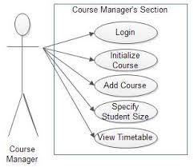

Product Functions
- Generates required timetable for the entire Computer Science Department considering all the soft and hard constraints.
- Provides interface for both students as well as Faculty for accessing the General Time Table or their specific Timetable.
- Provides Fully Automated approach for design and implementation of Time Table.
- Provides Manual editing Options and Swap between the faculties according to their interests and seniority.
- Generates Multiple Time Tables to facilitate faculties as well as final year students according to their Schedules, in case any.
- Provides Multiple Views for different user.
- Provides Full Authentication for Administrator and required authentication for faculties and students.
- Provides Database facility to store and retrieve information.

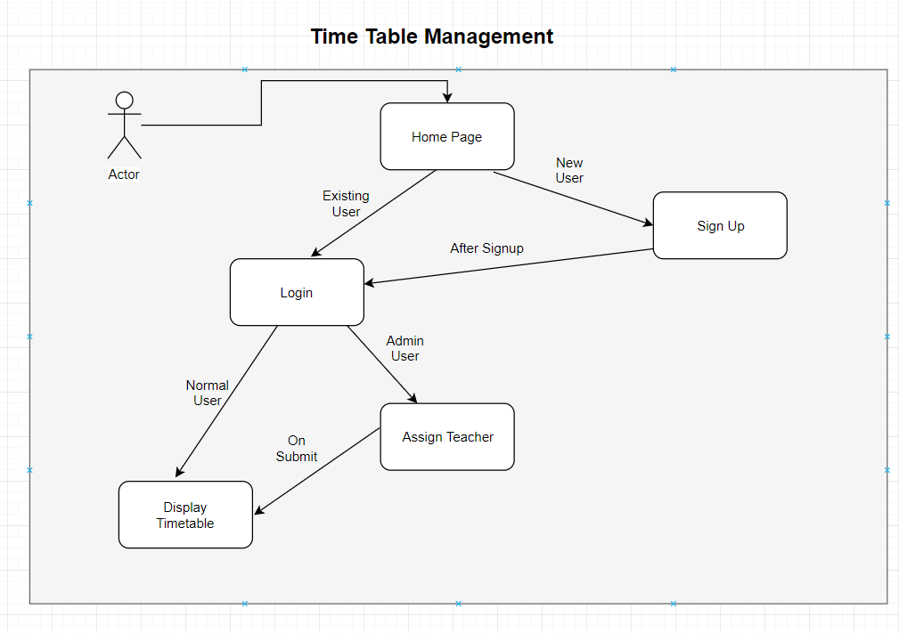

User Classes and Characteristics
There are three types of users in this system. The first two are non-authorized users and authorized users. The only distinction between them is that authorized users are allowed to see the preference and exclusion sets of other users. It is the third type of user, the administrator, who is able to initially setup the system, add new users, and set their authorization level.

Student
- Students must be studying in JSS STU (formerly SJCE).
- Student must have the knowledge of how to operate the webpage.
- Student must be able to read and understand the English language since the software will be in English language.

Faculty
- Faculty must be academic staff in JSS STU (formerly SJCE).
- Faculty must have the knowledge of how to operate the webpage.
- Faculty must be able to read and understand the English language since the software will be in English language.

Admin
- Admin must be some authority or HOD in JSS STU (formerly SJCE).
- Admin must have the knowledge of how to design and implement webpage.
- Admin must know how to use a database.
- Admin must know all the faculty details and student details.
- Admin must know about UI interaction with software.

Operating Environment

Software Environment:
- This project will run on Django Server and webpage which will be connected to each other.
- Webpage will be implemented using HTML, CSS, JavaScript.
- Python programming language will be used to design and implement a user interface and also implementation of our core algorithm.
- On the database side, SQLite will be used to design and implement the necessary entities, tables and relations.
- Apart from that we also have mobile view excluding the webpage.

2.4.2 Hardware Environment:

Minimum specifications to run our web application:
- Processor (Windows) – Intel core i5.
- Recommended RAM - greater than 2 GB.
- Recommended Storage Space – greater than 500 GB.
- Internet connection necessary (not meant for offline use).

Design and Implementation Constraints

Hard Constraints
- Class can only be assigned if room is spare.
- No teacher or student have more than one class at a time.
- A classroom must have enough seats to accommodate all students.

Hard Constraints
- Time of class preferred by teacher.
- Specific Room preferred by any teacher.
- Break time between different lectures preferred by teacher.
- Less walk to attend lectures by student.

User Documentation

Overview
- User: The User is one who intends to view the Time Table i.e. it can be Student, Teachers, Course/Subject Co-Ordinator and even the Head of Department. Multiple users can connect through the software for viewing the time table. User need not to know that how information is stored in database.

- Admin: She/he is the one that uses the Software to generate Time-Table according to the needs and specific requirements of the Class for which the time table needs to be formed. She/he should know how to add new teacher’s information to database and manipulate the database depending on the requirements.

User Interface and How to Use
- First of all, the Website prompts for Login Information of the user to facilitate Authentication to the user and to provide security for the user it is used to distinguish between Student and Faculty Login and the following image will show the snap shop.

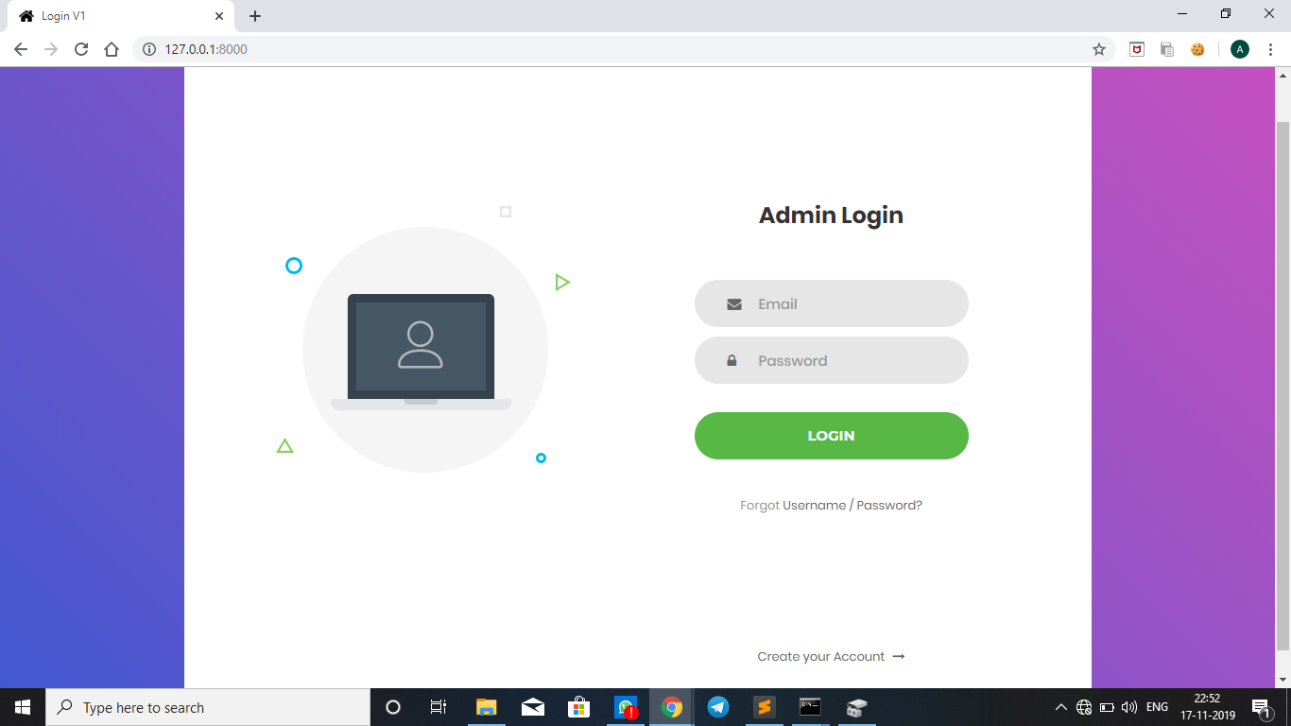

- If the user is not Registered to the website, he/she should go for the signup page and fill all the relevant details required for the website.

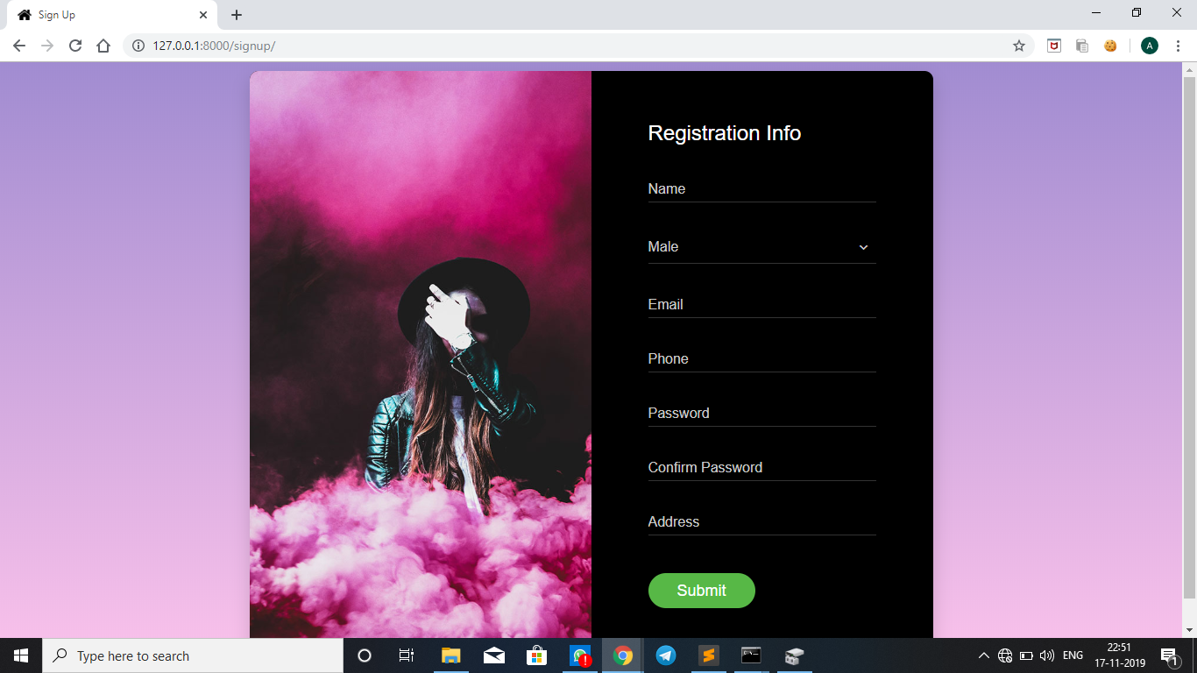

- The Login for admin is different from that of the users as after the Login the user is provided with the list of teachers whom he has to assign to their respective classes and corresponding subjects.

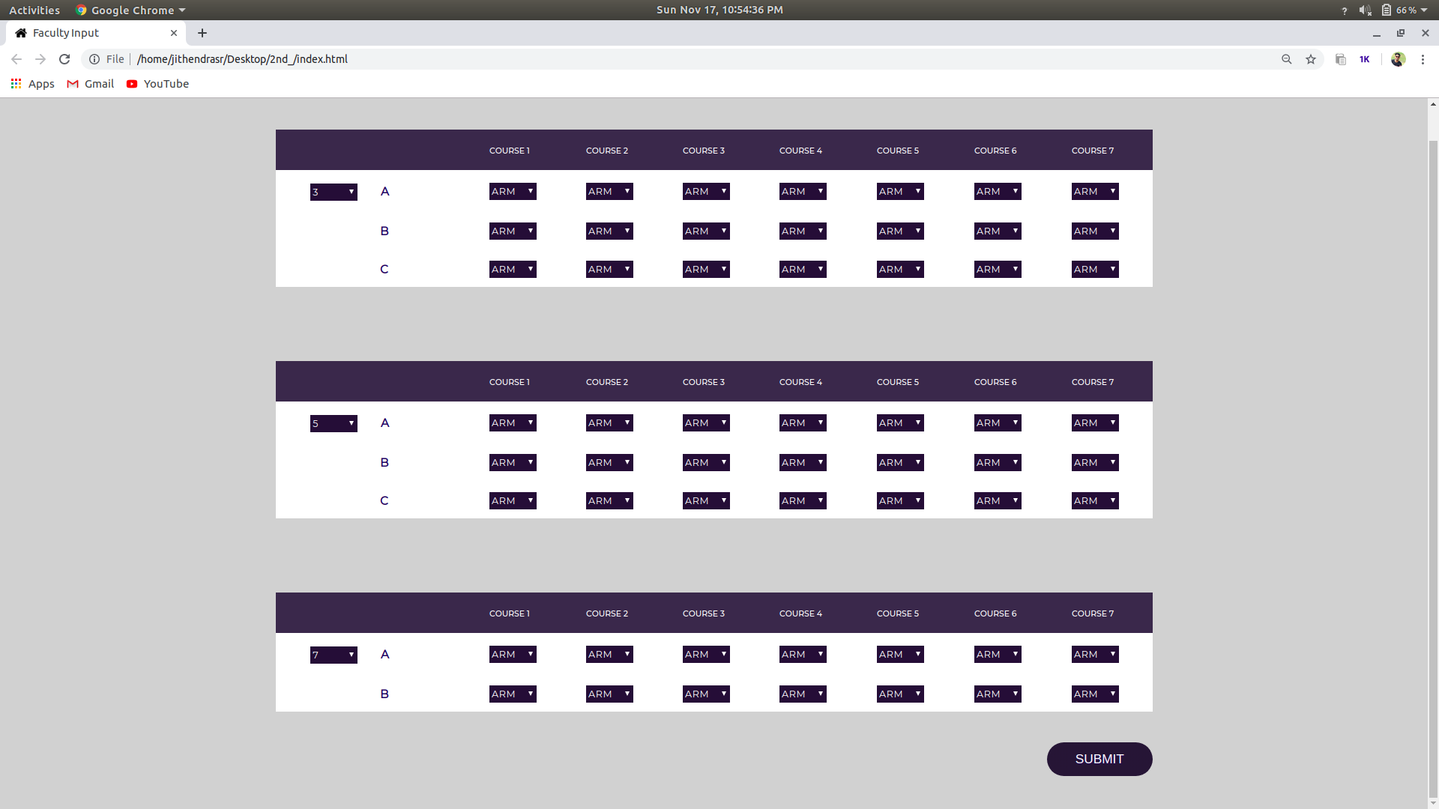

- Finally, the timetable will be displayed.

Assumptions and Dependencies
- System will be installed on a machine running Windows operating system or Ubuntu with Django and SQLite installed with new version.
- Assuming that the HOD or Authority decides which faculty to be assigned to which class and subject, we design the timetable.
- Assuming that there are enough resources to accommodate students including classroom and laboratory.
- Assuming that class hours are from 7:30 AM to 5:30 PM.
- There are short breaks and Lunch break in their respective timings.
- There are no classes after 1:30 PM on Saturday and no classes on Holidays.
- A faculty has a total working hours of 7 hours(max) a day.
- Assuming that tutorials are 2 hours each and Labs are of 2 or 3 hours based on their credits.

External Interface Requirements
This section specifies the detailed requirements which the system shall meet.

User Interface
- This section specifies the user interfaces to the system.
- All user interfacing is done through a web UI.
- The home page is where the user arrives after logging onto the system.
- The preference/exclusion sets, and user preferences are set on this screen.
- The User Interface will be both web as well as mobile view.

Hardware Interface
- The application runs on all computers (desktop, laptops etc) which has a browser.
- The application also runs on all types of mobiles (Android, IOS, Windows phone) which has a browser.
- The above devices should be equipped with internet connection with https protocol available.
- Minimum specifications to run our web application:
  - Processor (Windows) – Intel core i5.
  - Recommended RAM - greater than 2 GB.
  - Recommended Storage Space – greater than 500 GB.
  - Internet connection necessary (not meant for offline use).

Software Interface
- Tools
- Front End
- Html
- CSS
- JavaScript
- Back End
- Django
- Python
- Testing tool
- Selenium

- Database: SQLite.
- Operating System: Works on any operating system with browser installed.
- Processor: Works on Multi-Processing.

System Features
4.1 System Features 1

Privileged user section
- Admin is the privileged user, He/she can make changes on the database.
- He/she can manipulate the time table (if necessary).
- He/she has got the authority to add new courses and new faculty.
- He/she has the full information of all the faculties assigned to their respective classes and subjects.
- In the following section, the admin login screenshot is given,

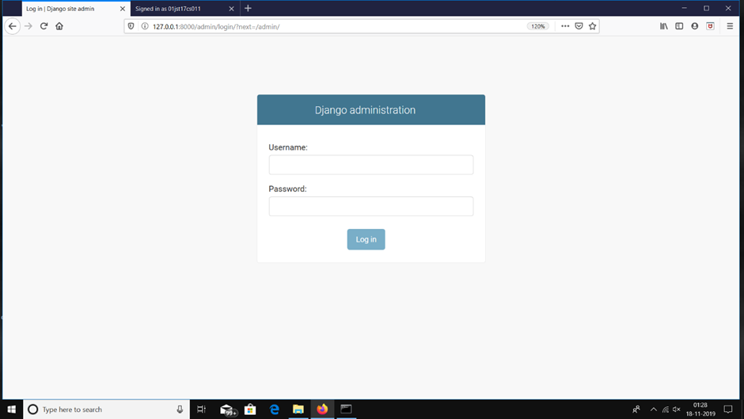

4.2.2 Password Encryption

- Password management is something that should generally not be reinvented unnecessarily, and Django endeavors to provide a secure and flexible set of tools for managing user passwords.
- Django provides a flexible password storage system and uses PBKDF2 by default.
- The password attribute of a User object is a string in this format:
<algorithm>$<iterations>$<salt>$<hash>
- By default, Django uses the PBKDF2 algorithm with a SHA256 hash, a password stretching mechanism recommended by NIST.
- This should be sufficient for most users: it’s quite secure, requiring massive amounts of computing time to break.
- However, depending on your requirements, you may choose a different algorithm, or even use a custom algorithm to match your specific security situation.

System Features 2:

Website Use Case

- Login as Teacher or Student
- View Time Table
- Login as Admin
- Edit Time Table
- Add a Teacher to the Database
- Add a Subject to the Database
- Verify the Device
- Logout

Website Use Case
- Login as Teacher or Student: Teacher or Student should login to his/her account before performing any actions.
- View Time Table: After login, Teacher or Student can view the time-table.
- Login as Admin: Admin should login to his/her account before performing any actions.
- Edit Time Table: After the login, the admin can modify his/her time table.
- Add a Teacher to the Database: After the login, the admin can add a teacher to the database.
- Add a Subject to the Database: After the login, the admin can add a subject to the database.
- Verify the Device: After the login, the admin can verify a newly registered device.
- Logout: Teacher or Student or Admin can logout any time after login.

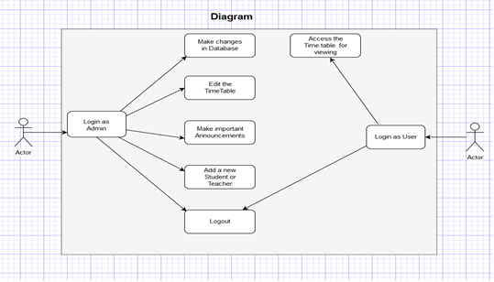

Other Non-Functional Requirements

Performance Requirements:
- The Servers are the main factor affecting the performance of the application as it is a website.
- Also, the Processor is one of the main factors affecting the performance of the algorithm used to generate time table.
- The application is completely dependent on internet. Offline working cannot expect any throughput.

Safety Requirements:
- The application is viewed under the https protocol and biding to all the terms and conditions of https protocol.
- Any threat can occur from external agencies as there are no dedicated safety measures to protect the application from any harm.
- Required domain provides free space to launch the application but doesn’t provide any exclusive safety measures of its own.
- Regular monitoring of the images, reviews, information of the places from the developers side is necessary to provide clean and correct information.
- Developers have the control to delete explicit contents that might be added by some bad agencies to spoil the smooth working of the application.

Security Requirements:
- Every privileged user has a login through which they can modify the time-table as they wish to.
- Non-privileged uses through a login can also view the time table generated. Therefore, the information about time table is open sourced and can be taken by non admin user.
- While the read operation is open sourced for all users, write operation is only for admin user.
- Any content can be added only by privileged users and not by anyone else.
- All the actions are subjected to regular supervision by developers and stakeholders.
- By default, Django uses the PBKDF2 algorithm with a SHA256 hash, a password stretching mechanism recommended by NIST.
- Only developers with the knowledge of the Database can manipulate its contents overriding the privileged users. This action is required for security reasons.

5.4 Software Quality Attributes:

5.4.1 Adaptive:

- The application works on all environment and all Operating systems.
- The codes defining the application is understood and executed by all browsers.

5.4.2 Flexibility:

- The inclusion of bootstrap codes inside the application makes it flexible and adjustable to all kinds of resolutions.
- These includes mobile view, windowed view of any resolution, multi-tab view etc.
- This is a main feature that enables side by side running of other applications or in other words, enables multitasking.

5.4.3 Correctness:

- Incorrect, explicit, unnecessary information is avoided at all cost.
- Regular monitoring of information by the application handling team will be ensured.

5.4.4 Reusability:

- The purpose of the website never changes.
- For information regarding any tourist place inside Karnataka, this is a one stop website.
- Therefore, this website can be reused for all tourism related queries.

5.4.5 Usability:

- The option of category search provides users more choices on the type of place they have in mind.

5.5 Business Rules:

Each group of people have their own roles to play-

- Privileged users – Admin guides
  - Provide adequate information about the place they know about.
  - Accumulate Admin experience and write the same as reviews on the webpage.

- Privileged users – Faculty or students who have visited the site

  - They could use the website properly using the User Manual.
  - They are a valuable asset in providing honest reviews as any changes has to be brought to the website.
  - The main pillars of the application are teachers faculties and the admin.

- Common people – visit and leave group of people

  - They are the maximum in number compared to any other group.
  - These people do not provide any direct asset to the application.
  - But with the other groups functioning to their full potential, this group can act as a medium to spread information about the existence of this application.

- Developers – Backbone of codes running the application

  - This particular application is dynamic, which means that the developers are only required to provide a platform users(faculty and students) have to do their part in upholding the application.
  - For the above to happen, developers should provide a user friendly design, a properly working module, features which matches the real world requirements.

- Stake holders – investors

  - As it is an academic project in the initial stage, no investment can be expected.
  - But when the application gains popularity and goes to a production level it has to have investors, it is the work of stake holders to provide the necessary funding to the project.
  - The role of Stake holders is to give the requirement initially so that we can deploy apt Software Development Model.

Other Requirements

Modern Requirements:

We Modern Requirements (formerly eDev Tech, also known as Modern Requirements4DevOps and MR4DevOps) is an innovative solution used across a variety of sectors including manufacturing, financial services, government, healthcare, and technology. This software offers an array of some of the most unique and cutting-edge features on the market.

The strength of this software is that it can do essentially everything: requirements traceability, online document authoring, online review/approval, and visualization. Additionally, it offers process automation, test case simulation, planning boards, customizable dashboards, and even a AI-inspired business analysis assistant. It’s customizable enough to support any number of methodologies, and it can sync data with an array of ALM systems like Jira and Rational Doors through its Sync Bridge partnership.

That said, it’s obviously a more robust solution that many organizations will require—it’s highly configurable, but it’s not the easiest solution to implement or learn to use.

Highlights of this tool:
- Requirements management
- Requirements visualization
- Traceability and real-time impact analysis
- Collaboration and review
- Integration with other too

Appendix A: Glossary

This is a Glossary of terms you may meet during options-sorting and during scheduling a timetable. The more important or common terms are marked with an asterisk *

1.Activity
A set of timetabling resources.
eg. 7A for 3 periods of Science with Mr Johnson.

2.Availability
Classes and Rooms as well as Teachers (eg. part-time staff) may not be available for the whole week(cycle) and you can specify their un/availability.

3.Basic Data
The basic resources used in timetabling, including: Classes (of students), Teachers, Rooms, Subjects.
See also Resource.

4.Block Time Tabling
Sometimes called ‘Faculty timetabling’.
An overall Block Timetable is sketched out by a senior member of staff, and then the responsibility for staffing the activities is devolved to each faculty.

5.Clashses
A clash table of Subjects chosen by students for their Options (Electives). For more details see the free Tutorial Booklet for the Options program, available from www.timetabler.com.

6.Class
This can be an ambiguous word for a population of students. ‘Class’ can mean:
- A Registration Group (or Tutor Group, Form Group). eg. class 7A This is the normal meaning used in Time Tabler.
- A group of students brought together for the teaching of a particular subject. eg. 7A The more correct name for this is ‘Teaching Group’.

7.Conflicts

Activities with common resources are in conflict.
The conflicting requirements mean that they can’t be timetabled simultaneously. eg. Prof X cannot teach both 7A and 8B on Monday-period-1.

8.Curriculum
The courses of study arranged by the school, to be staffed and timetabled.

9.Curriculum Analysis
A measure of the amount of curriculum time allocated to a class (or student population) in excess of a notional basic provision.

10.Cycle
The Curriculum Cycle, or Timetable Cycle, is the period of time after which the timetable repeats itself. The most common types currently are : 25-period 5-day week, 50-period 10-day fortnight, 30-period 5-day week, 60-period 10-day fortnight, or 33-period 5-day week with fewer periods on Friday.

11.Degrees of Freedom
A measure of how much flexibility exists for the placing of an activity. This in turn has implications for the best sequence of scheduling the activities. Time Table automatically displays a Priority List for you, based on the number of degrees of freedom and many other criteria.

12.Disjoint

Non-over-lapping teams. ie. with no teachers/resources in common. The idea also applies to class-combinations and room-combinations.

13.Fixed Points*
The parts of the timetable which are at pre-determined times and locked in place.
Eg. “Saturday afternoon off for all the sections.”
Eg. “All classes have PSE on Thursday period 1.”
.
14.Priniple of Compatibility.
An important timetabling rule. When dividing a larger set of resources into smaller sets, the sub-sets should ideally be disjoint.

15.Resources

The fundamental data: Classes, Teachers, Time, Rooms, (Subjects). See also Basic Data.

16.Rooms
Areas in which teaching takes place. They can include the Sports Field, Swimming Pool, etc.

17.Scheduling *
The actual constructing of the timetable, assigning the activities to specific time-slots.
By contrast the word ‘timetabling’ is typically used for the entire process, from curriculum planning to final publication of the printouts.

