## Chapter -1

## Introduction

An eCommerce website is an information technology method in which trader, businesses/distributor/marketers can sell products/services and the customer can purchase on that website electronically by using internet on the mobile and computer. It means an e-commerce website is an online shop. e means electronic. Commerce mean business. Website means the group of HTML web pages and that is created to market/sell information/product/services.

In a bigger perspective, every website on the internet is the eCommerce Website. It can be the platform, it can be a marketplace, it can be portal, it can be apps, it can be an entertainment website, shopping website, online courses website and online degree college.

### Problem Statement

E-commerce provides an easy way to sell products to a large customer base. However, there is a lot of competition among multiple e-commerce sites. When users land on an e-commerce site, they expect to find what they are looking for quickly and easily. Also, users are not sure about the brands or the actual products they want to purchase. They have a very broad idea about what they want to buy. Many customers nowadays search for their products on Google rather than visiting specific e-commerce sites. They believe that Google will take them to the e-commerce sites that have their product.

When a consumer wants something, their first port of call is the internet. E-commerce has grown at an incredible rate since its birth, and so has the competition to make the best use of it.

The major issues are:

1. An absence of online identity verification
2. Delivering an omnichannel customer experience
3. Competitor Analysis
4. Maintaining customer loyalty

We are confident that this software package can be readily used by both companies and as well as customers without any issues.

### Chapter -2

### Objective

The main objective of our website is

* The motto of e-commerce activity is to *reach millions of customers easily and to* increase*sales in business*. It generates a high revenue in the online industry as the viewers are turning into the audience every day.
* To spread the small-scale retails into large level business, e-commerce is developed with best-in-class features. In simple, it is a big opportunity for small vendors to huge traffic of customers.
* Profit maximization is the core aim of any organization whether it is a physical business place or the one that runs online. Some organizations even aim to survive with just less or no profit at all.
* The goal is to take costs out of serving customers. Some components of the digital experience—such as discovery, evaluation and support—can be more cost-effective and deliver better results than traditional delivery mechanisms.

### Aim

The proposed software product is the Ecommerce Online Shopping Website for companies as well as customers. Our aim is to provide multi-user interface taking into consideration of concurrency problems. Also our aim is to provide flexible password storage system and uses PBKDF2 with the use of Django framework. Secure payment options are provides with the help of paytm developer gateway by using checksum functionality.

### Chapter -3

### Database schema of Online E-commerce website

A database schema is the skeleton structure that represents the logical view of the entire database. It defines how the data is organized and how the relations among them are associated. It formulates all the constraints that are to be applied on the data.

A database schema can be divided broadly into two categories −

**Physical Database Schema:** This schema pertains to the actual storage of data and its form of storage like files, indices, etc. It defines how the data will be stored in a secondary storage.

**Logical Database Schema:** This schema defines all the logical constraints that need to be applied on the data stored. It defines tables, views, and integrity constraints.

###### List of tables:

* + 1. Admin
    2. Company
    3. Product
    4. Customer
    5. Category
    6. Orders
    7. Shipping

### 

### Chapter-4

### Data Flow Diagram of E-Commerce Portal

The context diagram is the most abstract data flow representation of a system. It represents the entire system as a single bubble and. The various external entities with which the system interacts and the data flows occurring between the system and the external entities are also represented. The name context diagram is well justified because it represents the context in which the system is to exist i.e. the external entities (users) that would interact with the system and specific data items they would be receiving from the system.

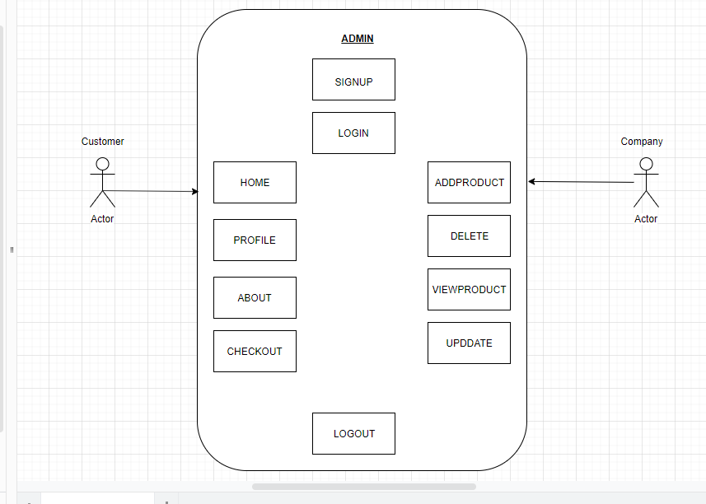Fig:. Data Flow Diagram for Ecommerce Website.

### Modules and SQL queries

### Example Queries:

* Create Table:

CREATE TABLE IF NOT EXISTS "ecom_customer"

("id" integer NOT NULL PRIMARY KEY AUTOINCREMENT,

"username" varchar(50) NOT NULL,

"sex" varchar(10) NOT NULL,

"email" varchar(50) NOT NULL,

"address" varchar(100) NOT NULL,

"phone" bigint NOT NULL, "image" varchar(100) NOT NULL,

"password" varchar(200) NOT NULL);

* Insert into Table:

INSERT INTO ecom_customer(username, sex, email, address, phone, password)

VALUES('akshay', 'male', 'akshay4570@gmail.com', 'sjce', '1234567890', '12345');

INSERT INTO ecom_customer(username, sex, email, address, phone, password)

VALUES('bharath', 'male', ‘bharath@gmail.com', 'sjce', '9080706050', 'abcde');

* Alter :

ALTER TABLE `ecom_customer`

ADD PRIMARY KEY (`email`);

ALTER TABLE `ecom_company`

MODIFY `id` int(11) NOT NULL AUTO_INCREMENT, AUTO_INCREMENT=8;

COMMIT;

* SELECT :

SELECT * FROM ecom_customer;

SELECT * FROM ecom_company;

* DELETE :

DELETE FROM ecom_customer;

DELETE FROM ecom_company where name=’rahul’;

* UPDATE :

UPDATE table ecom_customer SET email=’sample@gmail.com’ where name=’akshay’ ;

UPDATE table ecom_company SET phone=’1234567890’;

**E-R Diagram of E-Commerce Portal**

An entity-relationship diagram (ERD) is an abstract and conceptual representation of data. Entity- relationship modeling is a database modeling method, used to produce a type of conceptual schema or semantic data model of a system, often a relational database, and its requirements in a top-down fashion.

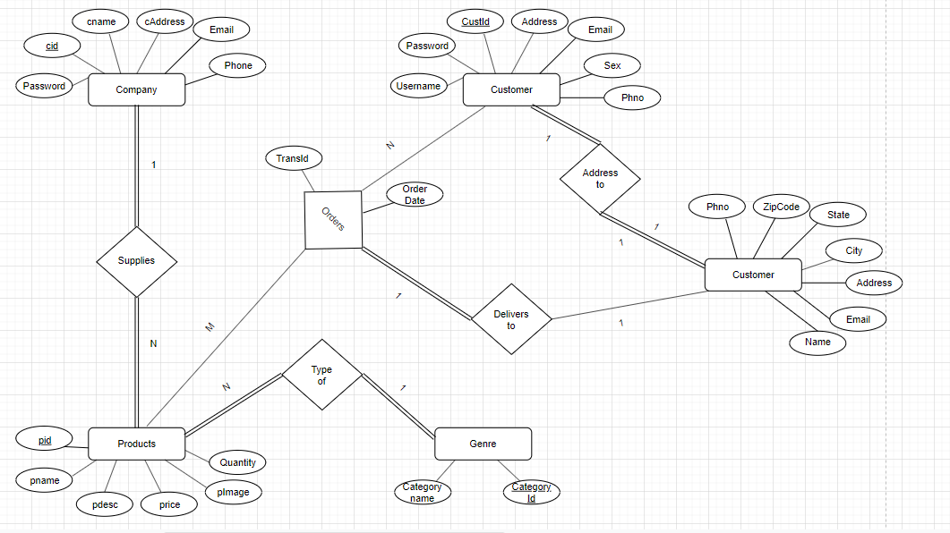

**Fig.:** E-R Diagram of Ecommerce Online Portal

### Chapter -5

### Results and Snapshots

### User Interface

1. Home Page

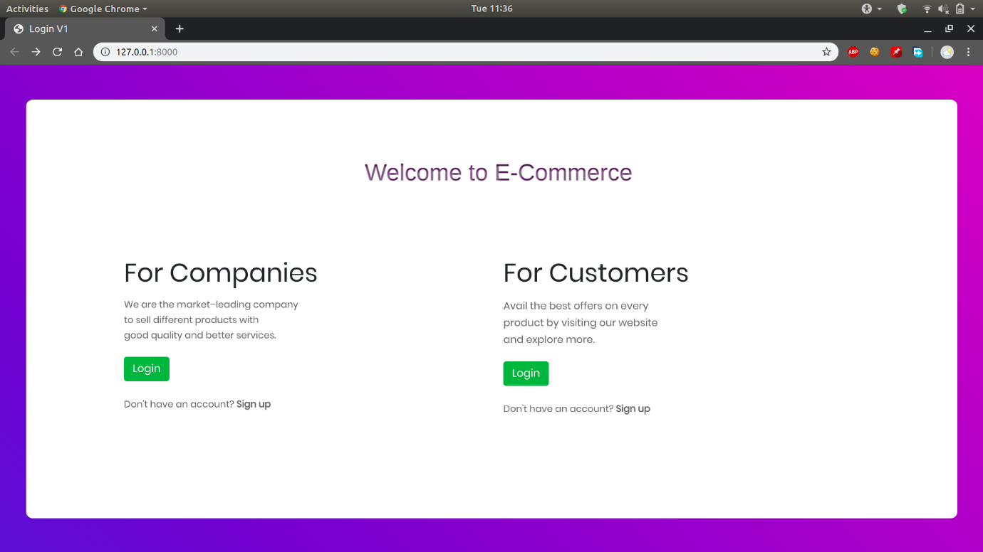

1. Login and signup page

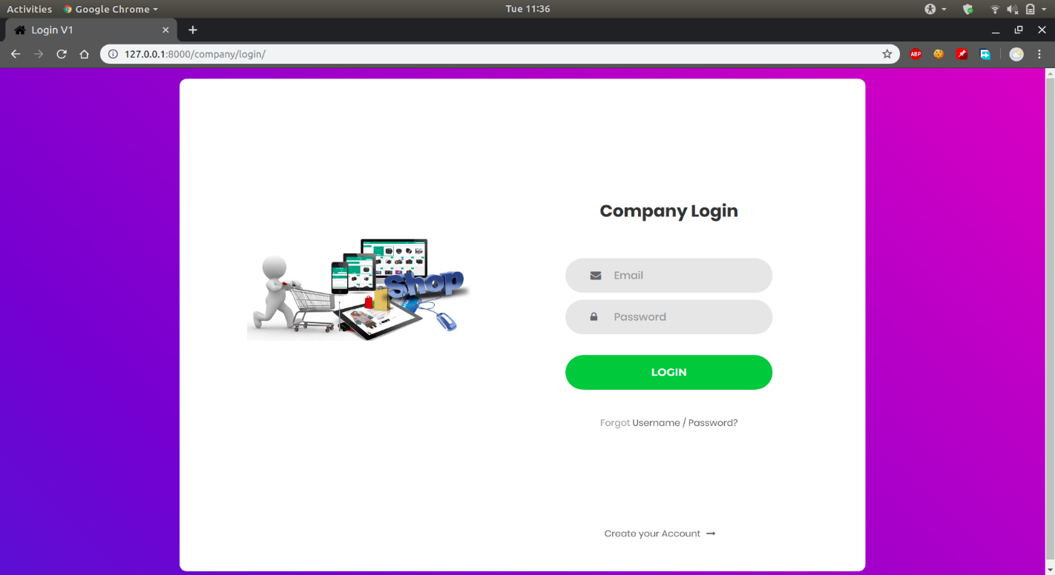

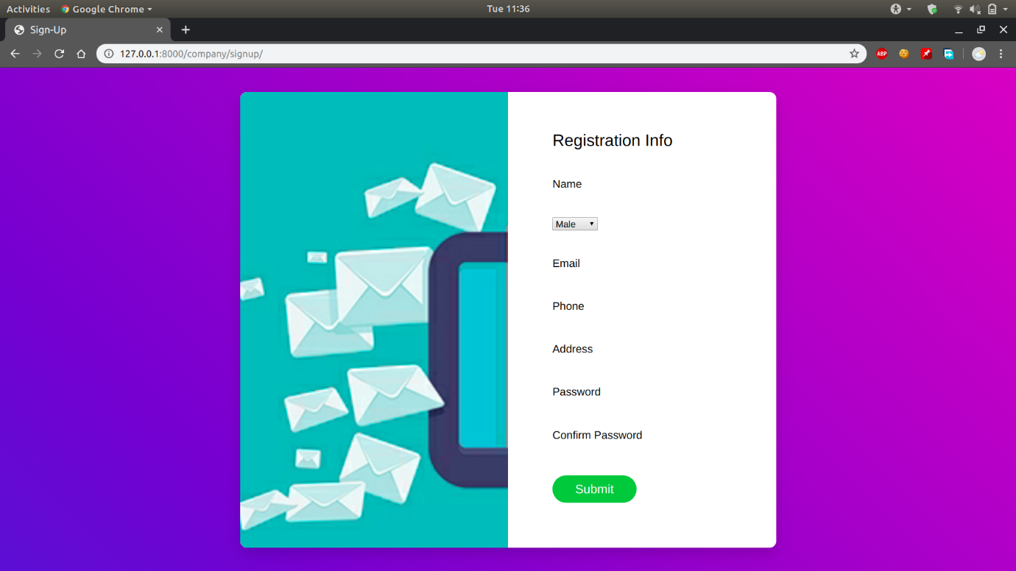

1. Admin Page

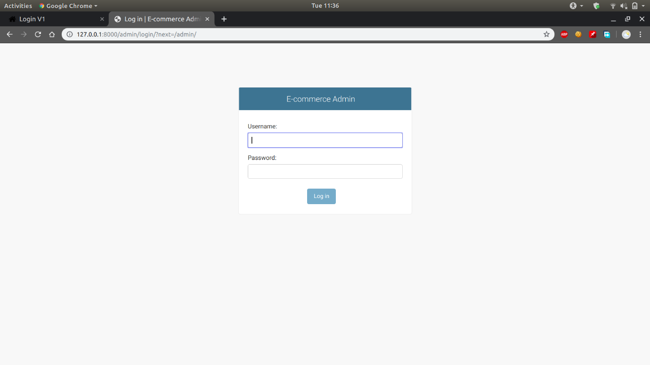

1. Company add and view

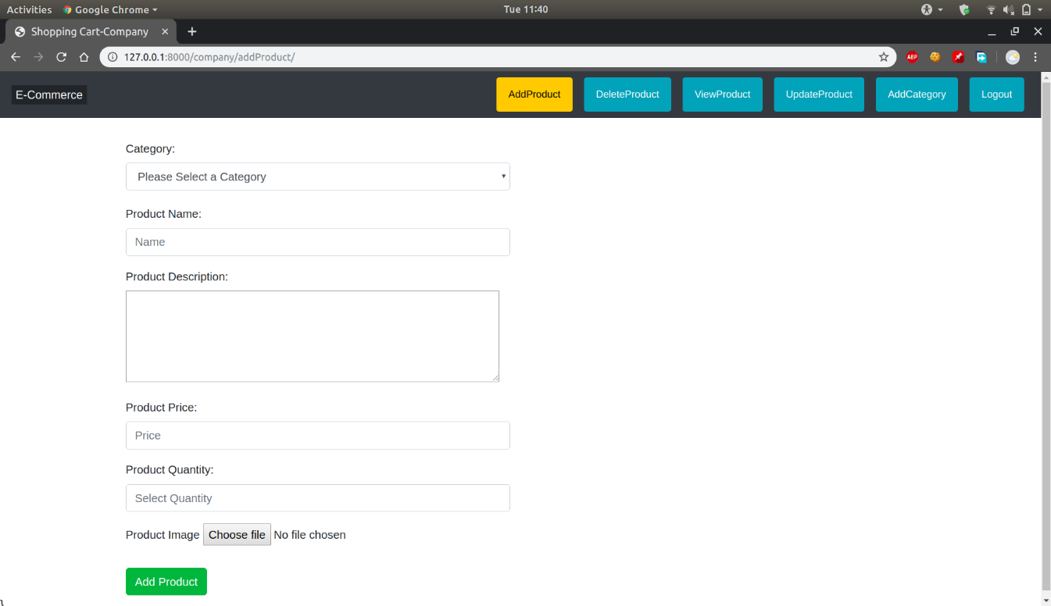

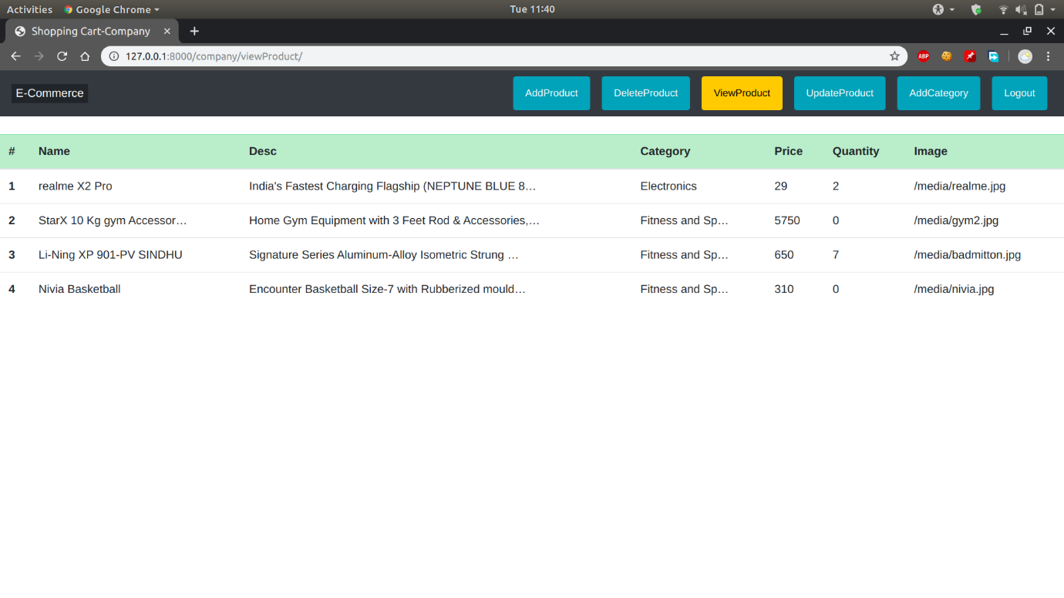

1. Customer Browse page and Checkout

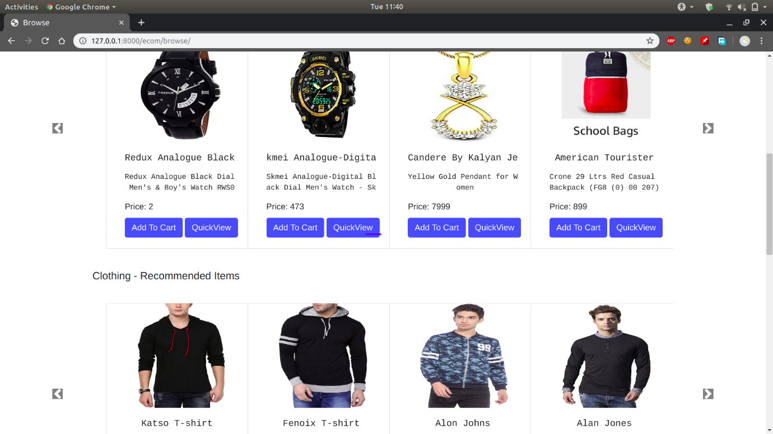

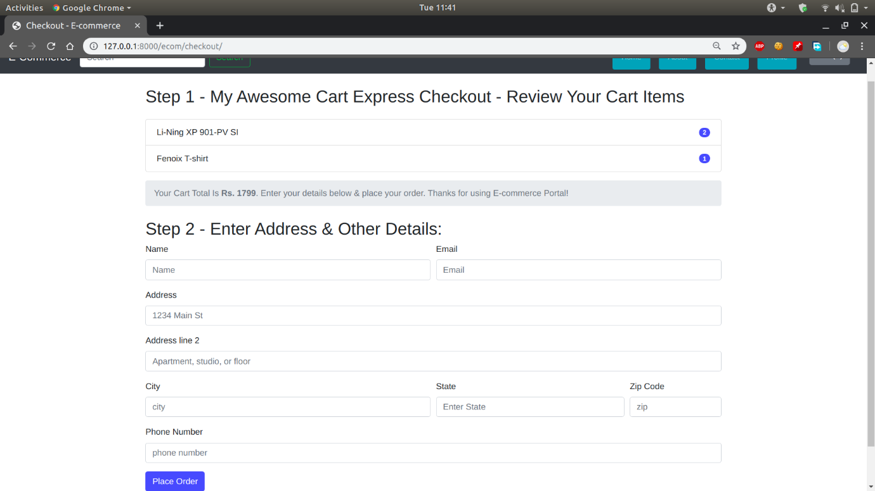

1. Profile and About page

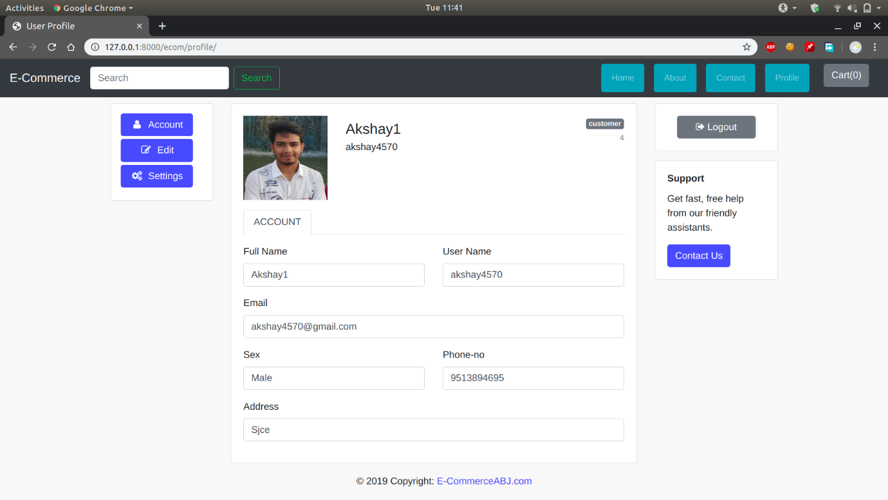

7)About Us

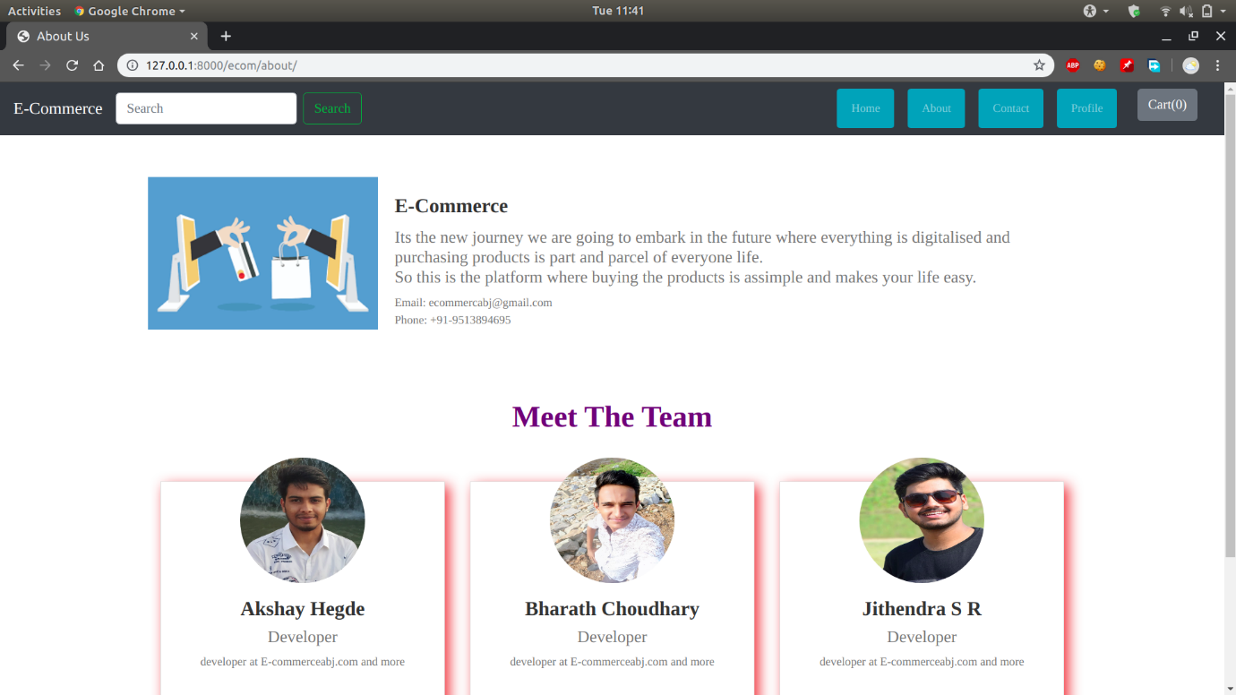

**Chapter -6**

**References**

1. <https://www.codewithharry.com/>
2. <https://docs.djangoproject.com/en/3.0/>
3. <https://getbootstrap.com/docs/4.4/getting-started/introduction/>
4. Fundamentals of Database System by Elmasri and Navathe.
5. <https://www.draw.io/>
6. <https://stackoverflow.com/>