Customer Segmentation Using Machine Learning

Akshay Sreekumar Nair (191IT103)

Information Technology

National Institute Of Technology Karnataka

Surathkal,India 575025

e-mail: a.191it103@nitk.edu.in

Abstract—Effective management of customer’s knowledge leads to efficient Customer Relationship Management.Predicting relevant segmentation groups for customers using clustering, in this case k-means, gives a fair idea about the customer’s behaviour. The data inferred from this data mining then may later be used to segregate customer’s based on their needs and also, improve marketing strategies.

Index Terms—Customer Relationship Management, K-means, Data Mining, Customer satisfaction, Marketing.

- INTRODUCTION

Customer Segmentation plays an important role for a com-pany to customize and make further improvements its relation with the customers.With customer segmented into a variety of groups, we find similar characteristics in each of the customer’s behaviours and need. Then, those are generalized into groups to satisfy demands of those customer segments targeting specific customer groups. This data can then be used to market specific products based on the customer’s need.

- LITERATURE SURVEY

Previously conducted researches on customer segmentation holds the fact of customer satisfaction, marketing strategy improvements and also helped target specific products. Publi-cations suggesting these facts,

H. -H. Zhao, X. -C. Luo, R. Ma and X. Lu, ”An Extended Regularized K-Means Clustering Approach for High-Dimensional Customer Segmentation With Correlated Variables,” in IEEE Access, vol. 9, pp. 48405-48412, 2021, doi: 10.1109/ACCESS.2021.3067499.

Abdulhafedh, Azad. (2021). Incorporating K-means, Hi-erarchical Clustering and PCA in Customer Segmenta-tion. 3. 12-30. 10.12691/jcd-3-1-3.

Zare, Hamed Emadi, Sima. (2020). Determination of Customer Satisfaction using Improved K-means algo-rithm. Soft Computing. 24. 10.1007/s00500-020-04988-4.

- Objectives

Improve customer satisfaction

Reduce wastage of unwanted products Improve marketing strategy

Targeting audience on the basis of their needs.

IV. METHODOLOGY

Clustering is an unsupervised learning method that divides the feature space into clusters or groups of similar objects. In general, clustering is used for pattern recognition. In this paper, we will be following the following steps for achieving our goal,

  - Segmentation Basis

  - Data Preparation

  - Segmentation with K-means Clustering

  - Hyper-parameter Tuning

  - Visualization and Interpretation of the Results A. Segmentation Basis
Approach in terms of customer’s behavioural aspect(other cases might include geographical preferences,etc.) The pri-mary features used in this case are:

Number of products ordered average return rate
total spending.

- Data Preparation

The used dataset comprises of data of about 25000 cus-tomers. The dataset is well formatted without any NULL values. The three features as mentione in the Segmentation Basis will be calculated using customer id. The plotly library will help in data visualization. Pandas and numpy will come in handy for Data preparation.
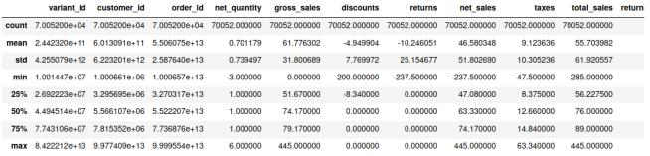

III. PROBLEM STATEMENT

Products are offered randomly without checking the previ-

ous order details or calculating the probability of the customer

buying a product and acting accordingly. This is achieved by

segregating the customers based on their need using k-means
_{clustering.} Fig. 1. Statistics of various columns

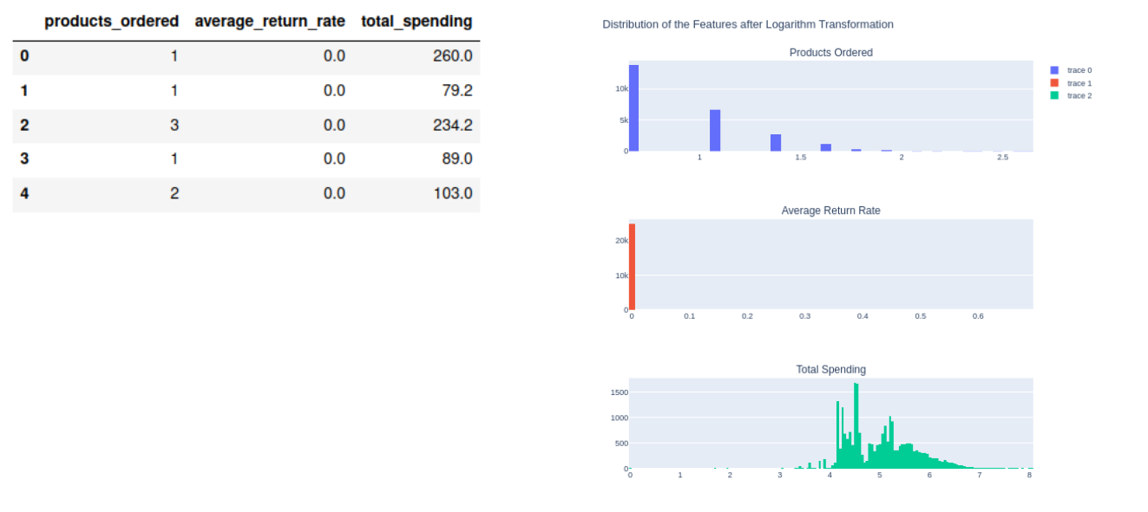

Fig. 2. customers.head()

Fig. 4. Distribution of the features after Scaling
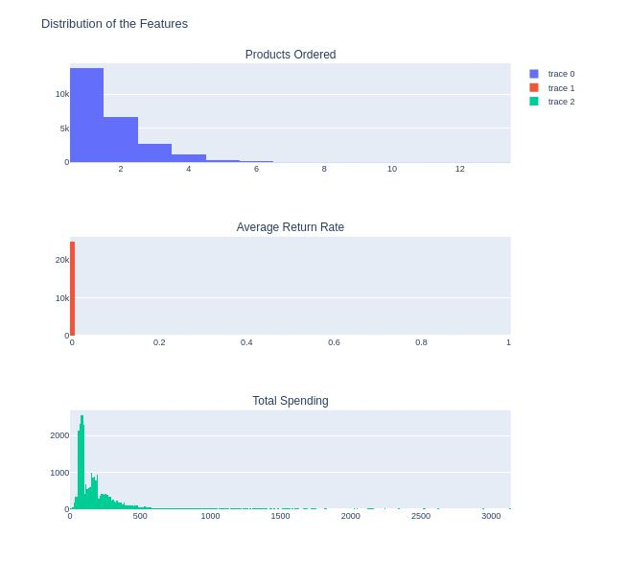

C. Segmentation with K-means Clustering

The outcome is now ready to be clustered using the k-means algorithm. The k-means algorithm works in the way,

- Initialize k=n centroids=number-of-clusters

- Assign each data point to the closest centroid based on euclidean distance, thus forming the groups

- Move centers to the average of all points in the cluster

Repeat steps 2 and 3 until convergence.

The algorithm tries to minimize — optimize the within-cluster sum-of-squared-distances or inertia of each cluster.
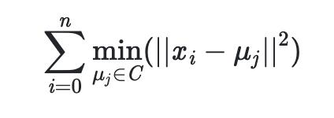

Fig. 3. Distribution of the features

Fig. 5. Mathematical expression of within-cluster sum-of-squared-distances

or inertia where X is the points in the cluster and µ is the current centroid.

All 3 distributions are positively skewed distributions. Prod-ucts ordered shows a power-law distribution and average return rate of 99% of the customers are 0.

The data is to be scaled now, for K-means clustering. Loga-rithmic transformation is a suitable transformation for skewed data. This will scale down proportionally the 3D space which our data is spread, yet preserving the proximity between the points.

One other important aspect is choosing the value of k, which will be discussed in the next stage.

D. Hyper-parameter Tuning

While selecting k, we are going to decide against the optimization criteria of the K-means, inertia, using elbow method. We are going to build different K-means models with k values 1 to 15, and save the corresponding inertia values.With the elbow method, we are going to select the k value where the decrease in the inertia stabilizes.

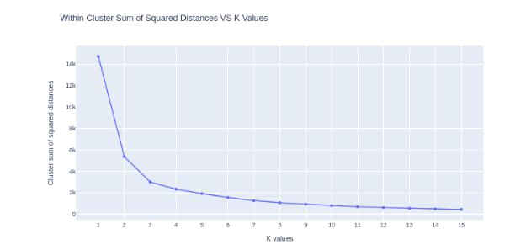

Fig. 6. Visualization for the selection of number of segments

At k=4, the descent stabilizes and continues linearly after-wards, forming an elbow at k=4. This points out the optimal number of customer group is 4.

E. Visualization and Interpretation of the Results

When k is now initialized to 4,the visualization is as represented in the following graph,
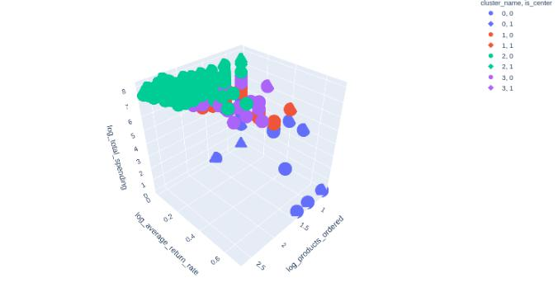

Fig. 8. Cluster Magnitudes
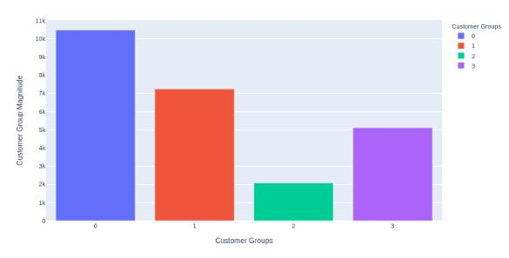

- RESULTS AND ANALYSIS

On taking a further look at the cluster magnitudes,

Blue group comprises of 42% of total customers, marking a huge share. Any further improvements made in this category would indeed contribute to the high increase in revenue.

Red and purple group together comprise of 50% of total customers.

Green group consists of 8% of the total customers, they order multiple products and they are highly likely to keep them.To maintain and possibly expand this group, special deals and pre-product launches might help. Moreover, they can be magnets for new customers impacting the expansion of the customer base.

Fig. 7. Visualizing Customer Segmentation

Data points are shown in spheres and centroids of each group are shown with cubes.

We get 4 different customer groups,

- Blue: Customers who ordered at least one product, with maximum total spending of 100 and having the highest average return rate. They might be the newcomers of the e-commerce website.

- Red: Customers who ordered 1 to 4 products, with average total spending of 150 and a maximum return rate of 0.5.

- Purple: Customers who ordered 1 to 4 products, with average total spending of 300 and a maximum return rate of 0.5.

- Green: Customers who ordered 1 to 13 products, with average total spending of 600 and average return rate as 0. It makes the most favourable customer group for the company.

VI. CONCLUSION

The customer segmentation model was approached from a behavioural point of view, and the primary features taken into account to achieve this effect were number of products ordered, average return rate and total spending for each customer.

The dataset initially was random. It could not differentiate into potential customer sweet spots or categorize them into any certain groups. On applying the k-means clustering the dataset could be categorized into various groups and accordingly the outcomes of target specific audience could be achieved.

ACKNOWLEDGMENT

I would like to express my sincere gratitude towards Pro-fessor Ram Mohana Reddy Guddeti for his continued support and guidance in making this work possible.

REFERENCES

- An Extended Regularized K-Means Clustering Approach for High-Dimensional Customer Segmentation With Correlated Variables. Author image of Hong-Hao Zhao Hong-Hao Zhao, Xi-Chun Luo, Rui Ma

https://ieeexplore.ieee.org/document/9381869
- Incorporating K-means, Hierarchical Clustering and PCA in Customer Segmentation.
Azad Abdulhafedh https://www.researchgate.net/publication/349094412 Incorporating K-means Hierarchical Clustering and PCA in Customer Segmentation

- Determination of Customer Satisfaction using Improved K-means algorithm.

Hamed Zare, Sima Emadi https://www.researchgate.net/publication/341745185 Determination of Customer Satisfaction using Improved K-means algorithm

