in Python –

yammer problem

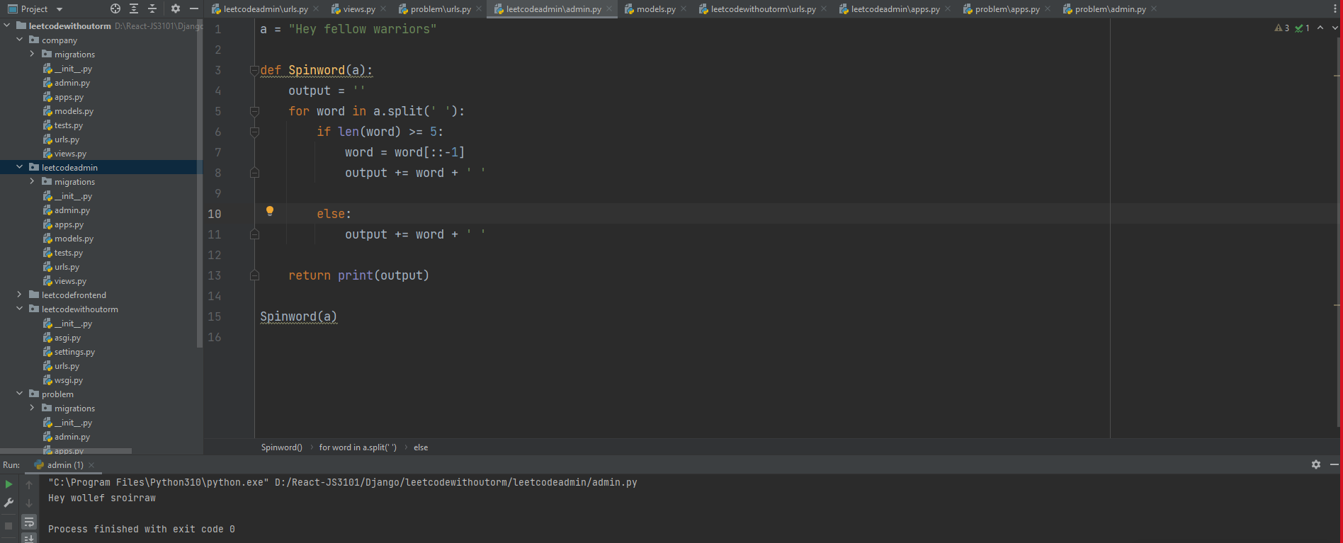

Leetcode –

1--1480. Running Sum of 1d Array - Easy

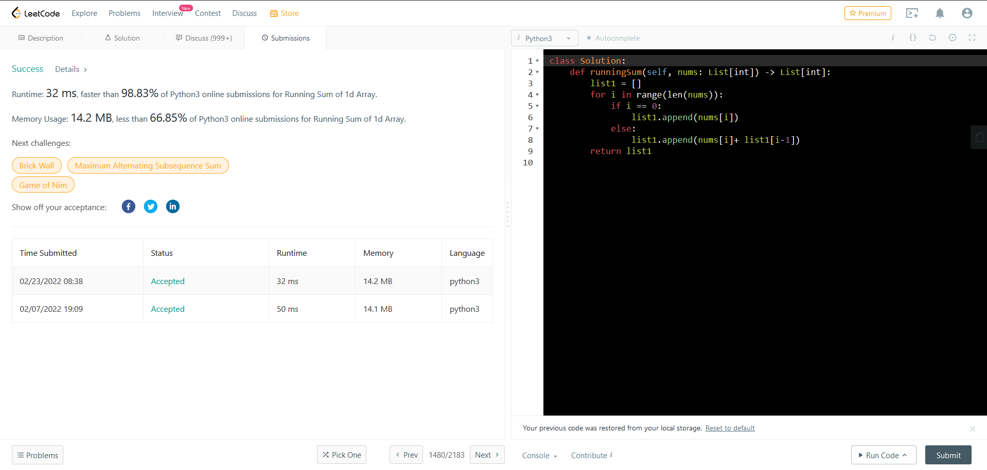

2--1365. How Many Numbers Are Smaller Than the Current Number - Easy

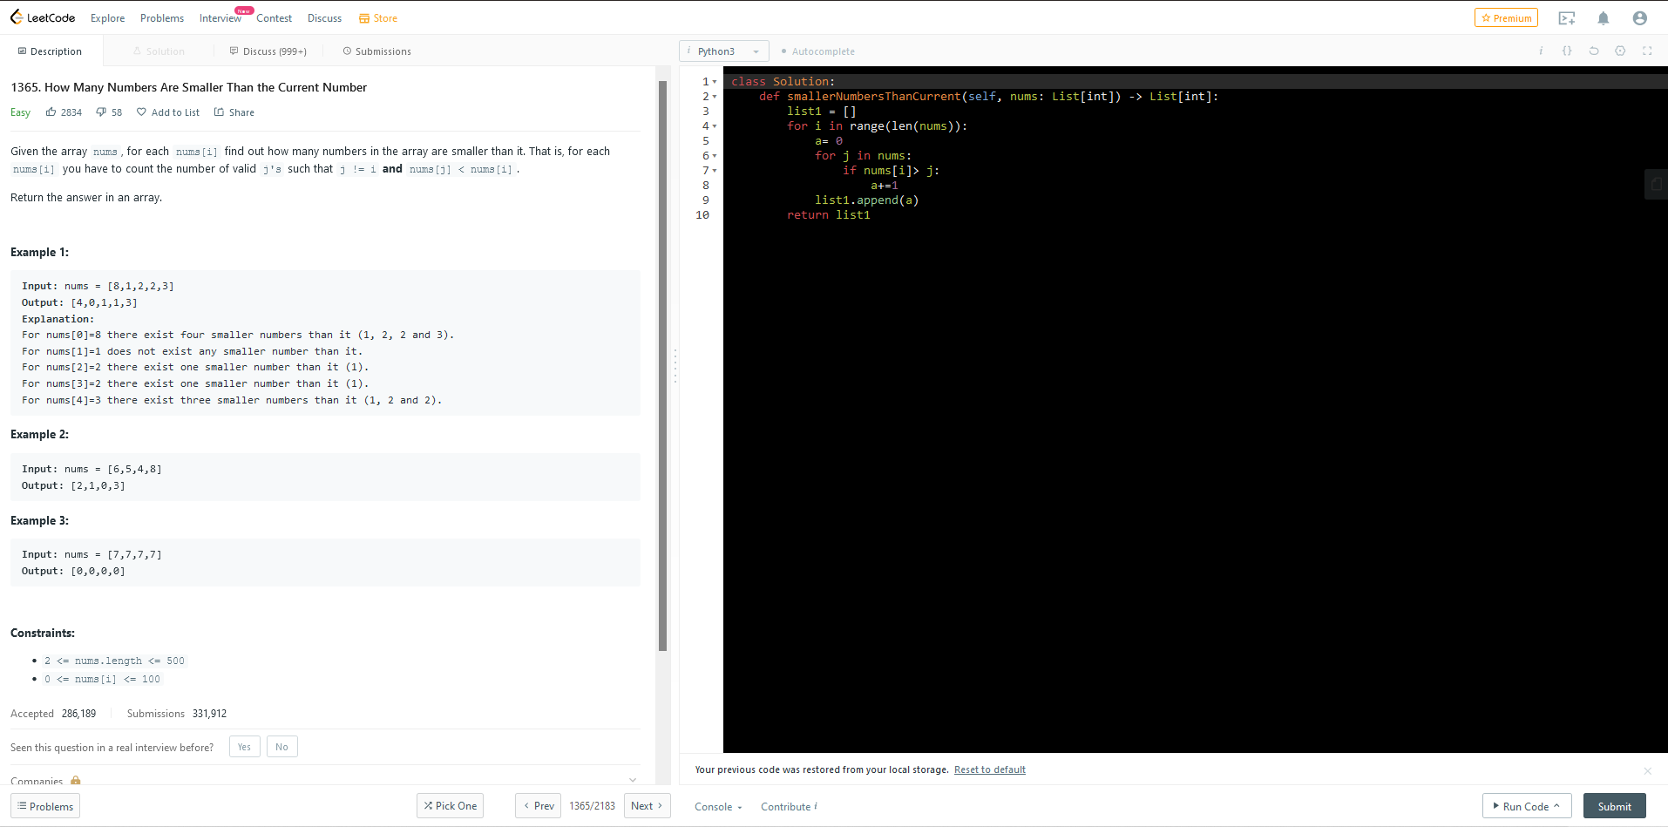

3--1929. Concatenation of Array- Easy

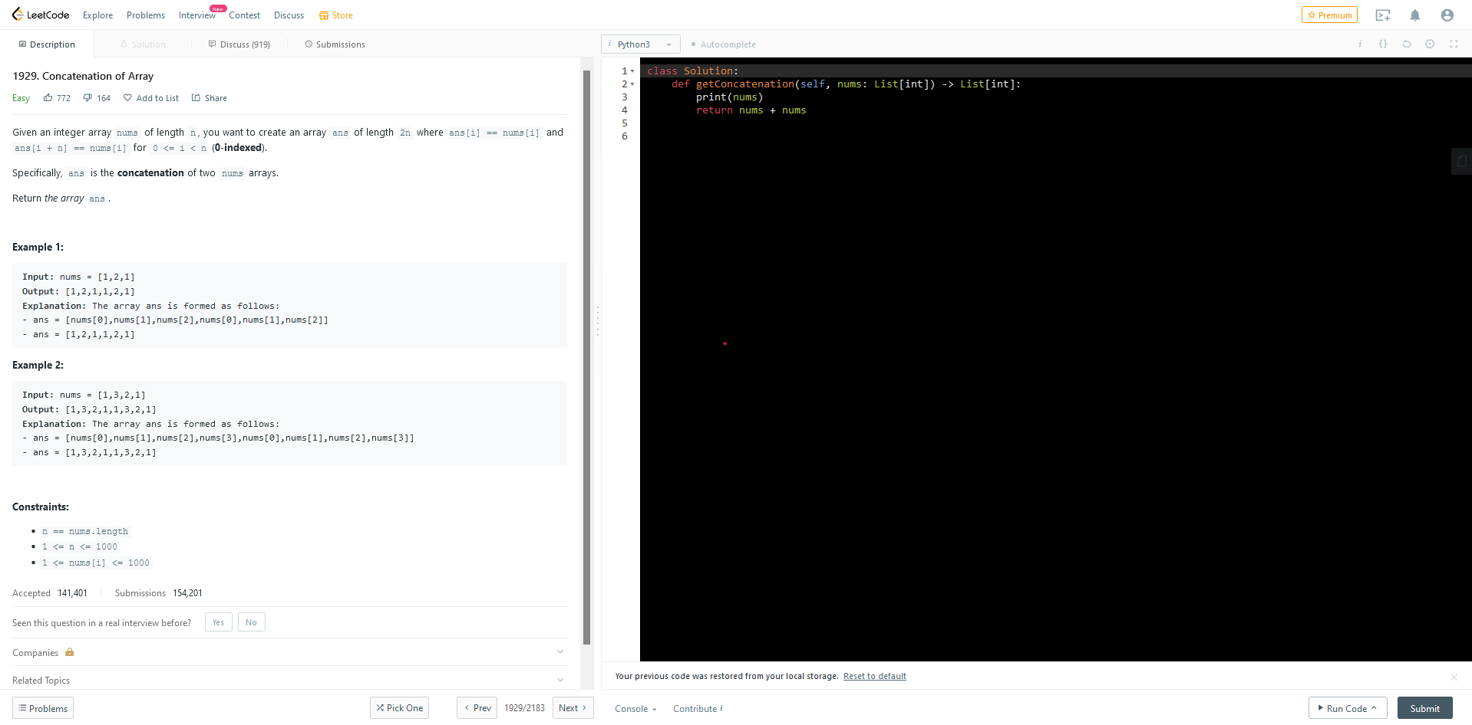

4--2. Add Two Numbers - Medium

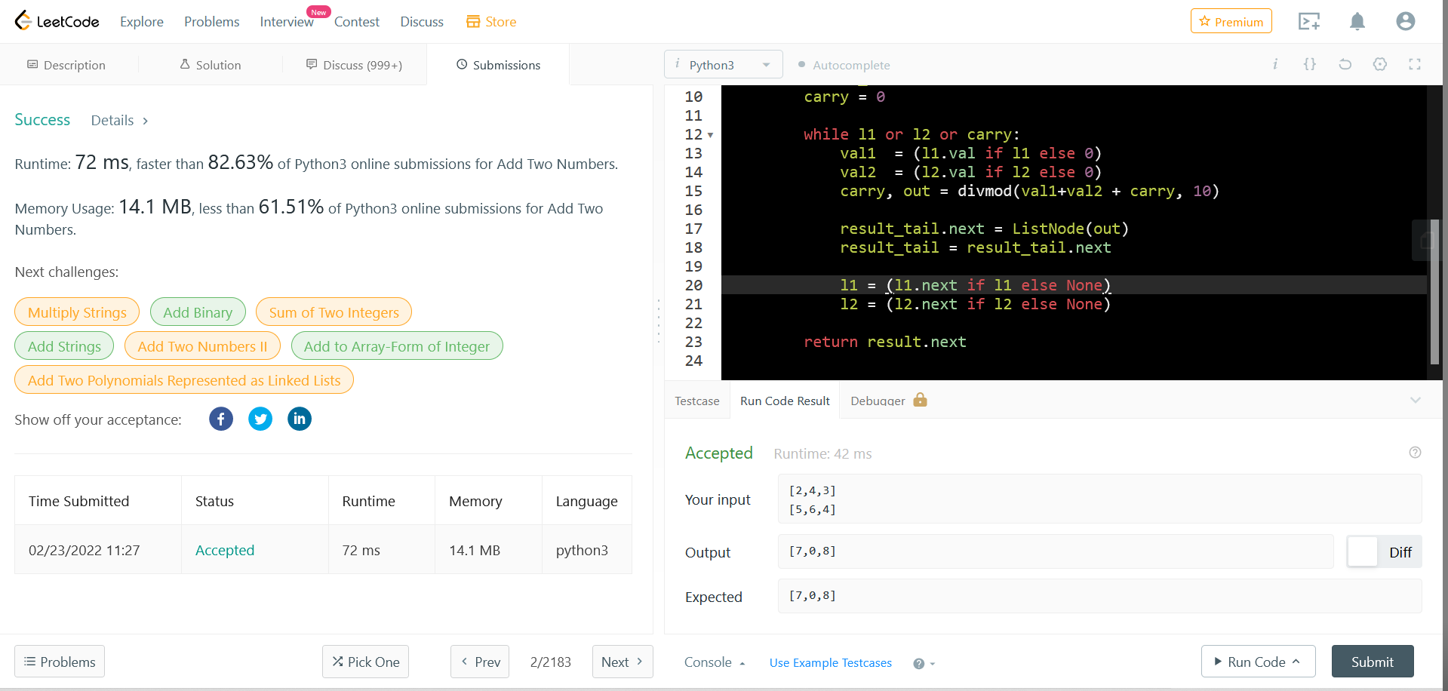

5--13. Roman to Integer - Easy

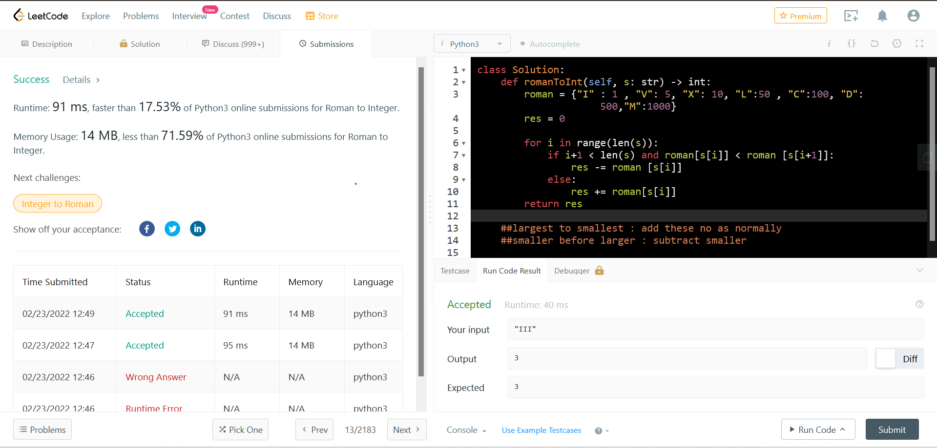

6--2006. Count Number of pairs with absolute difference K - Easy

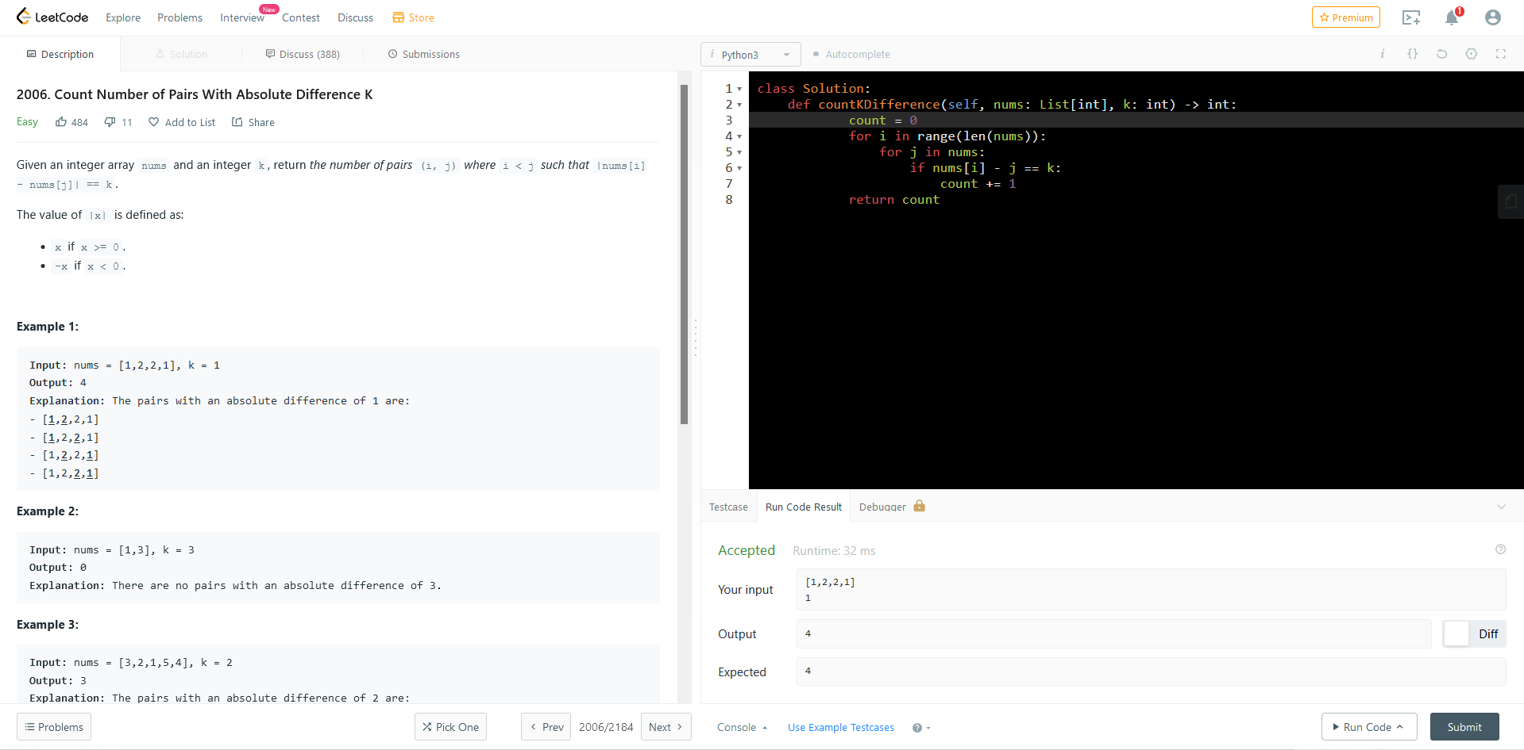

7--1662. Check If Two String Arrays are Equivalent- Easy

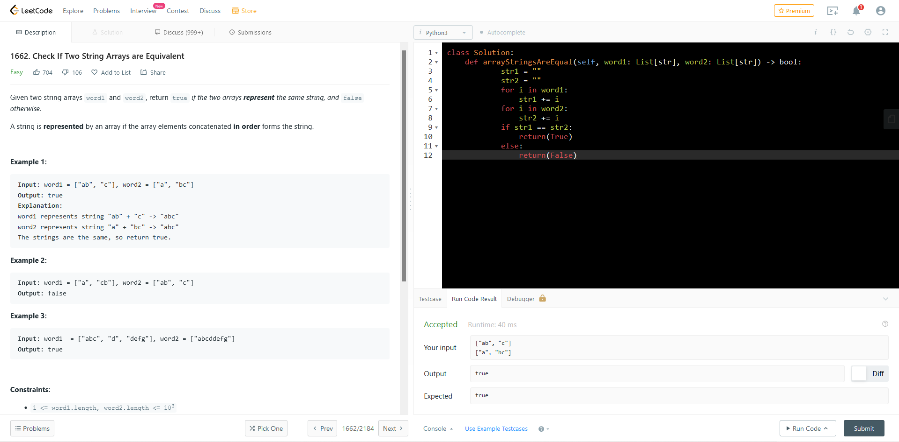

8--2108 Find First Palindromic String in the Array- Easy

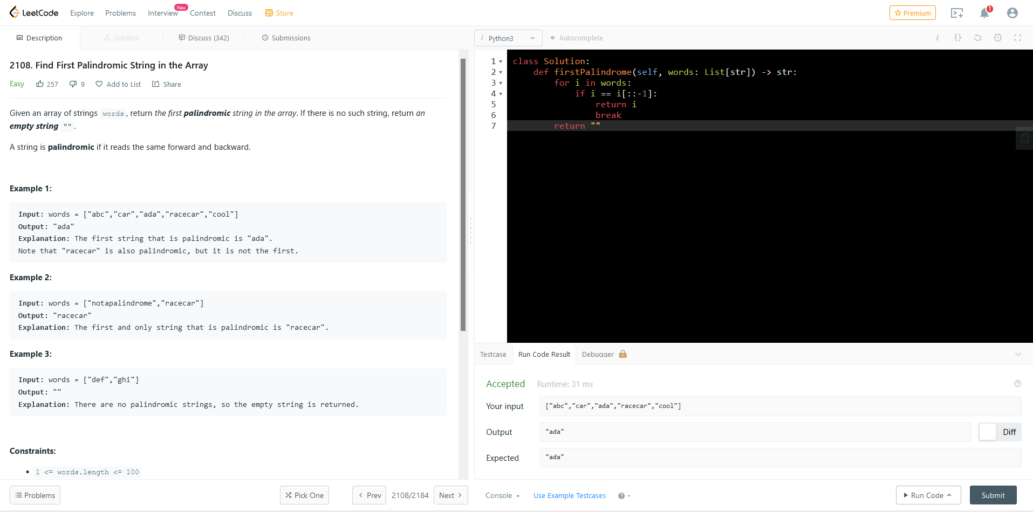

8--1464. Maximum Product of Two Elements in an Array- Easy

