COMPREHENSIVE DATA SCIENCE REPORT
Insights Presentation Plan for a Hypothetical Customer Churn Project
Week 4 | Executive-style analytical communication

Document element | Plan
Project focus | Customer churn prediction and retention insights
Audience | Business leaders, operations managers, customer-success teams
Primary decision | Which customer segments should receive targeted retention action?
Evidence style | Illustrative KPIs, trends, segment comparisons, and model insights
Planned effort | 32 hours across analysis synthesis, visuals, narrative, QA, and presentation design

1. Executive Summary
The hypothetical project evaluates customer behavior to identify patterns associated with service cancellation and translate those patterns into practical retention actions. The objective is not simply to produce a predictive model; the final deliverable must help decision-makers understand what is happening, why it may be happening, which customers are most at risk, and what actions are likely to be most useful.
Illustrative findings suggest that early-tenure customers have the highest churn rate, customers with higher support activity show elevated risk, and longer contract terms are associated with lower cancellation risk. For example, a representative scenario could show churn of 18% among customers with 0–3 months of tenure versus 7% among customers with 13+ months. A model could prioritize contract length, support-ticket volume, monthly charges, tenure, and usage frequency as influential variables. These figures are deliberately illustrative because no dataset is supplied.
The executive recommendation is to focus retention resources on high-risk early-tenure customers, improve onboarding and support resolution, and test targeted offers rather than applying the same intervention to every customer. The presentation will communicate this story through a small number of decision-oriented visuals instead of technical model output alone.

2. Methodology Overview
The analytical approach begins with a clearly defined target variable and a documented data dictionary. Data would be checked for missingness, duplicates, inconsistent categories, impossible values, and potential leakage. Exploratory analysis would then compare distributions and relationships across churn status and important customer segments. Candidate classification models would be trained using a reproducible preprocessing pipeline, with stratified validation used to reduce sampling bias.
Stage | What would be done | Quality check
Problem framing | Define churn outcome, business decision, unit of analysis | Target definition approved and measurable
Data preparation | Clean records, encode categories, scale selected features | Missingness, duplicates, leakage audit
Exploration | Compare churn by tenure, contract, charges, usage, support | At least one univariate + bivariate + multivariate review
Modeling | Compare logistic regression, tree, random forest / boosting | Consistent train/validation protocol
Evaluation | Use precision, recall, F1, ROC-AUC and confusion matrix | Threshold and class-balance effects documented
Insight synthesis | Translate evidence into segments and actions | Every recommendation linked to evidence

3. Findings and Insights (Illustrative)
Because the project is hypothetical, the following values are mock results designed to demonstrate how the final report would communicate evidence. They should be replaced with measured results when a real dataset becomes available.
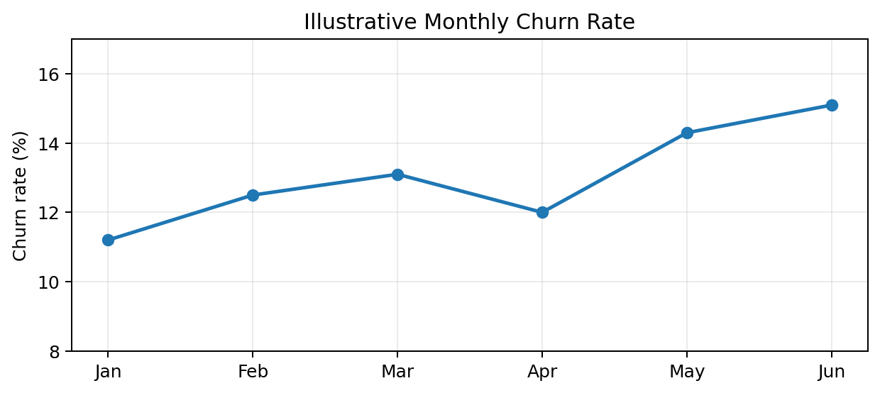
Figure 1. Illustrative trend: churn rises from 11.2% in January to 15.1% in June.
Insight: the rising trend would warrant investigation into pricing, service quality, seasonal effects, customer mix, or changes in acquisition channels. A useful business question is whether the increase is broad-based or concentrated in particular segments.
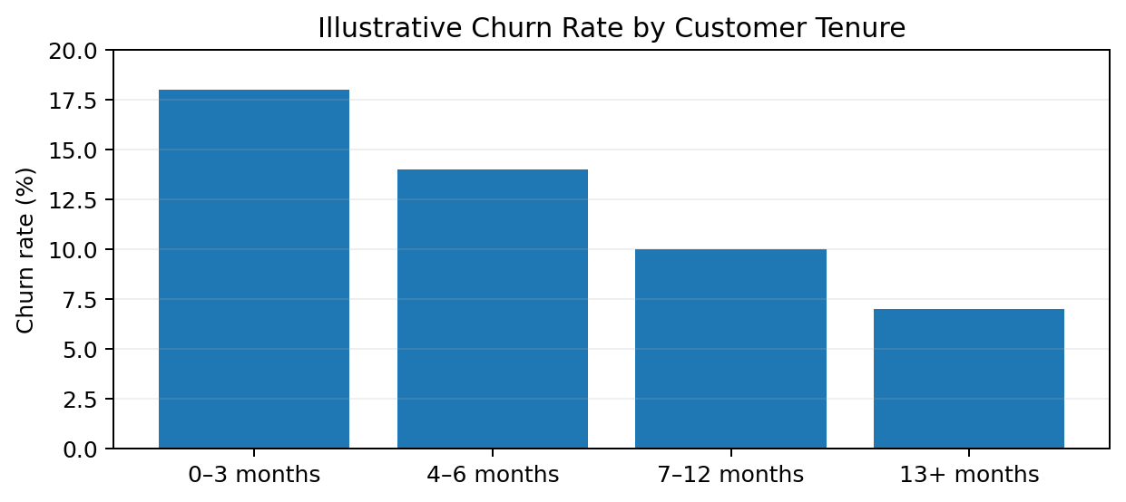
Figure 2. Illustrative segment comparison: churn is highest during the first three months.
Insight: onboarding and first-quarter customer experience are potential intervention points. Rather than offering a blanket discount, the organization could test welcome check-ins, proactive support, or education for customers in the first 90 days.

4. Model and Analytical Evidence
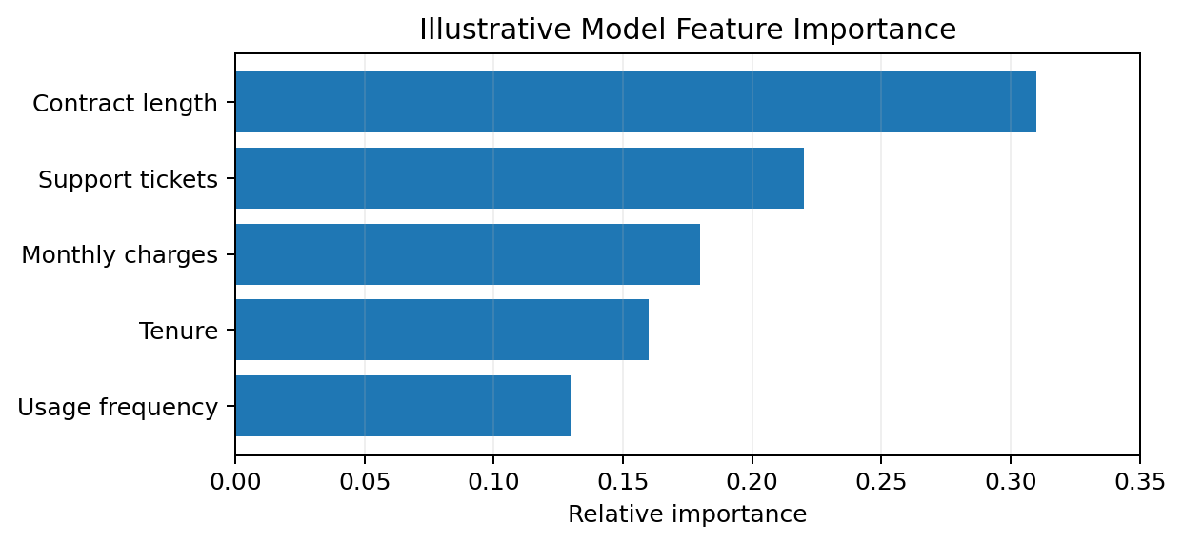
Figure 3. Illustrative feature importance used to explain model drivers.
Illustrative KPI | Example value | Interpretation
ROC-AUC | 0.84 | Good ranking ability for separating higher- and lower-risk customers
Precision at chosen threshold | 0.71 | About 71% of flagged customers are genuinely high-risk in this scenario
Recall at chosen threshold | 0.78 | 78% of high-risk customers are captured
F1-score | 0.74 | Balanced summary of precision and recall
Baseline churn rate | 12.9% | Reference point for interpreting model performance and segment lift
These numbers are examples, not measured results. In an executive report, the business decision should remain central: which threshold produces an acceptable trade-off between outreach cost and missed high-risk customers?

5. Actionable Insights and Recommendations
Evidence pattern | Action | Success measure
High churn in 0–3 month customers | Create a 30/60/90-day onboarding and proactive support program | Reduce early-tenure churn by 15% relative within a test cohort
Support-ticket volume linked with risk | Prioritize unresolved cases and introduce root-cause review | Lower repeat-contact rate and escalation volume
Longer contracts associated with lower churn | Test transparent multi-month plans with clear value communication | Increase plan adoption without harming margin
Higher monthly charges linked with risk | Review pricing clarity and value communication for high-charge segments | Reduce cancellation after renewal notices
Recommendation priority should be determined by expected impact, effort, and risk. The first experiment should usually target a narrowly defined segment so that the organization can estimate causal impact rather than assuming that an observed correlation guarantees an intervention will work.

6. Presentation Strategy for a Non-Technical Audience
The presentation should follow a story rather than a list of technical outputs. Start with the business question, show the magnitude of the problem, explain the most important patterns, identify which customers or behaviors matter most, and end with a small number of decisions the audience can act on.
Slide | Message | Visual
1. The decision | What do leaders need to decide? | One-sentence headline + KPI
2. What changed? | How large and recent is the problem? | Monthly churn trend
3. Who is affected? | Which segment needs attention? | Tenure / contract comparison
4. What predicts risk? | Which variables matter most? | Feature-importance chart
5. What should we do? | Which actions have highest potential? | Prioritized action table
6. How will we know? | How will success be tested? | Pilot metrics / control comparison
- Use plain-language labels: say “customers likely to leave” before saying “positive class.”
- Put the decision takeaway in the chart title or slide headline, not only in speaker notes.
- Use one key message per visual and avoid crowded dashboards with more than 5–7 elements per view.
- State uncertainty and limitations clearly so stakeholders do not interpret correlation as causation.

7. Reporting Structure and Mock-Up Dashboard
The written report would contain: Executive Summary, Business Question, Data Quality Summary, Key Findings, Model Evidence, Segment Insights, Recommendations, Measurement Plan, Limitations, and Future Work. Each finding would use a consistent pattern: observation → evidence → interpretation → business implication → recommended action.
KPI card | Mock value | Decision use
Customers analyzed | 10,000 | Scale of opportunity
Illustrative churn rate | 12.9% | Baseline risk
High-risk customers flagged | 1,050 | Potential outreach population
Illustrative precision | 71% | Expected outreach efficiency
Illustrative recall | 78% | Coverage of high-risk customers

8. Risks, Limitations and Future Work
- Illustrative numbers must be replaced with validated dataset results; they must never be presented as observed business facts.
- Predictive associations may reflect confounding variables, so pilot tests or controlled experiments are needed before claiming causal impact.
- Customer behavior and pricing can change over time; monitoring for drift is required after deployment.
- Fairness and privacy reviews should be performed before using sensitive or proxy variables for customer-level decisions.
- Future work can include calibration, threshold optimization by campaign cost, uplift modeling, and automated monitoring.

9. Work Plan: 32 Hours
Activity | Hours | Output
Executive summary and business framing | 3 | Decision-focused project narrative
Methodology synthesis and quality checks | 5 | End-to-end analytical recap
Mock findings and numerical examples | 6 | Illustrative evidence set
Charts, tables, and visual narrative | 7 | Three core figures + KPI table
Non-technical presentation plan | 4 | Six-slide story structure
Recommendations, limitations, future work | 4 | Prioritized action framework
Editing, consistency, and final QA | 3 | Polished final report
Total | 32 | Complete executive-ready plan

10. Conclusion
A strong data science deliverable is successful only when analysis becomes a clear decision. This report therefore treats communication as part of the analytical workflow: findings are supported by explicit evidence, visuals are selected for a specific purpose, recommendations are linked to measurable outcomes, and limitations are stated openly. The proposed presentation is designed to help non-technical stakeholders quickly understand the business problem, the strongest patterns, the implications of the predictive analysis, and the actions worth testing next.

