Week 3 Task Report
Python-Based Machine Learning Model Development and Evaluation Plan
Hypothetical Project: Customer Churn Prediction

Item | Plan
Problem type | Binary classification: predict whether a customer will churn (1) or stay (0).
Primary language | Python 3.x
Candidate models | Logistic Regression, Decision Tree, Random Forest, Gradient Boosting
Preferred baseline | Logistic Regression for interpretability and probability output
Primary evaluation | Recall, Precision, F1-score, ROC-AUC, confusion matrix
Validation | Stratified train/validation/test split + Stratified K-Fold cross-validation
Planned effort | 32 hours
Deployment concept | FastAPI/Flask service + monitoring + periodic retraining

Executive Summary
This report defines a complete planning framework for developing and evaluating a Python-based machine learning system that predicts customer churn. The objective is to move from a clearly defined business question to a reproducible model pipeline, while preventing data leakage and selecting metrics that reflect the cost of missed churners. The plan uses a hypothetical tabular customer dataset containing demographics, service usage, tenure, billing information, support interactions, and a binary churn label. No real dataset or code execution is required for Week 3; the emphasis is on a logical implementation strategy, model selection, evaluation, validation, and future deployment. The approach intentionally includes numerical examples so that each decision can be checked and communicated clearly.

1. Problem Definition and Business Context
Customer churn occurs when an existing customer stops using a company's service. A predictive model can estimate churn risk before the customer leaves, allowing the business to prioritize retention actions. The planning target is a binary label: Churn = 1 for a customer expected to leave and Churn = 0 for a customer expected to stay.

1.1 Why Machine Learning?
- The relationship between churn and customer behavior is rarely linear; tree ensembles can capture interactions such as low tenure combined with high support complaints.
- Supervised learning is appropriate because historical examples include an observed target label (churn/no churn).
- Probability scores allow the business to rank customers rather than treating every customer as equally risky.

1.2 Example Dataset Design
Feature | Type | Example / meaning | Expected treatment
tenure_months | Numeric | 18 months | Keep numeric; check range 0–120
monthly_charges | Numeric | ₹799.00 | Outlier and skew checks
contract_type | Categorical | Month-to-month | One-hot encode
support_tickets_90d | Numeric | 4 tickets | Check zero-inflation
payment_method | Categorical | UPI / card / bank | One-hot encode
churn | Binary target | 0 or 1 | Stratified split; never use as feature

1.3 Acceptance Criteria
- Reproducible preprocessing and training pipeline.
- No target leakage and no use of post-churn information.
- Evaluation performed on an untouched test set.
- Model scorecard includes precision, recall, F1, ROC-AUC and confusion matrix.
- Threshold recommendation tied to the business cost of missing a true churner.

2. End-to-End Machine Learning Workflow
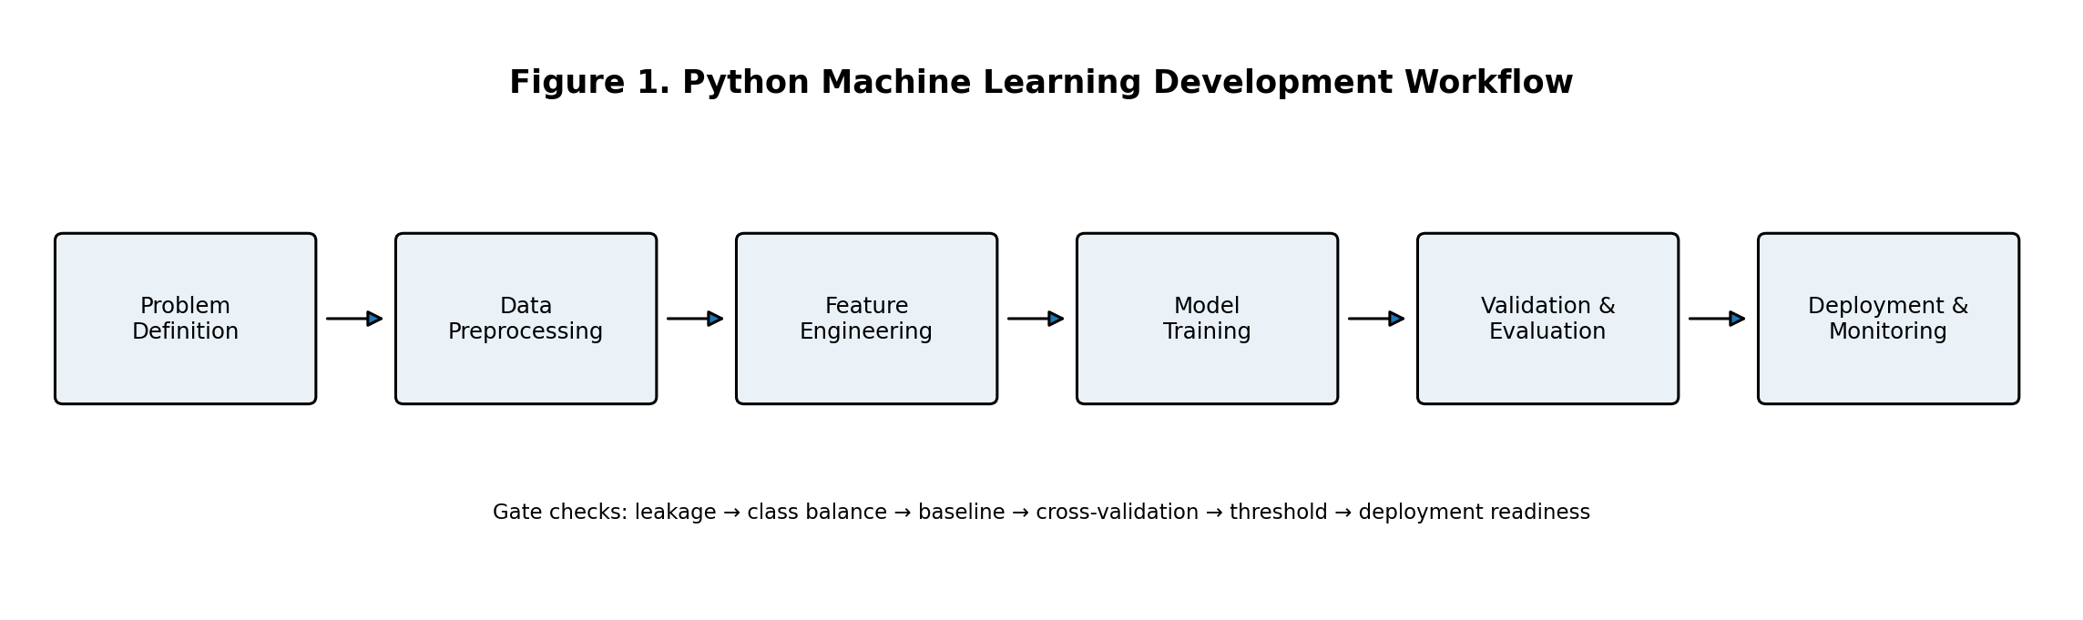
Figure 1. Planned workflow from business problem to deployment and monitoring.

3. Data Preprocessing Plan

3.1 Data Quality Checks
- Schema check: confirm expected columns, data types, and target definition.
- Missingness report: calculate missing count and missing percentage per feature.
- Duplicate detection: compare duplicate rows and customer IDs.
- Range checks: e.g., tenure_months must be >= 0; monthly_charges must be > 0.
- Category consistency: standardize labels such as “Month-to-month”, “Month to month”, and “Monthly”.

3.2 Missing-Value Strategy
Example: if 4,000 records are available and 120 values of monthly_charges are missing, missingness is 120/4,000 × 100 = 3%. A numeric feature with 3% missingness can be imputed with the median computed on the training set. If a feature is 45% missing, the team should investigate why it is missing before deciding whether to retain or remove it.
from sklearn.impute import SimpleImputer
imputer = SimpleImputer(strategy='median')
X_train_num = imputer.fit_transform(X_train_num)
X_test_num = imputer.transform(X_test_num)

3.3 Outlier Strategy
Use box plots and IQR rules to flag unusually large values. For example, if Q1 = 420, Q3 = 980, then IQR = 560 and the upper IQR fence is 980 + 1.5×560 = 1,820. Values above 1,820 should be reviewed rather than automatically deleted because an extreme charge may represent a legitimate enterprise customer.

3.4 Encoding and Scaling
Data type | Transformation | Reason
Numeric | Median imputation + optional StandardScaler | Comparable scale for linear models
Low-cardinality categorical | OneHotEncoder(handle_unknown="ignore") | Convert labels to model-ready features
High-cardinality IDs | Drop or aggregate | Avoid memorization and leakage
Skewed positive numeric | Optional log1p after review | Reduce heavy right tail

4. Feature Engineering and Selection
- Create tenure bands (0–6, 7–12, 13–24, 25+ months) if business interpretation benefits from them.
- Create support_contact_rate = support_tickets_90d / max(tenure_months, 1).
- Create a monthly-value indicator such as monthly_charges / average_plan_charge when reference data exists.
- Remove direct identifiers such as customer_name and customer_id.
- Use model-based importance and permutation importance only after the baseline is established.
- Check correlation and multicollinearity among numeric features; for logistic regression, inspect high correlations before final fitting.

5. Model Selection Strategy
Model | Strengths | Risks / limits | Role
Logistic Regression | Fast, interpretable, probability output | Linear decision boundary | Primary baseline
Decision Tree | Easy to explain, nonlinear rules | Can overfit | Diagnostic comparison
Random Forest | Strong tabular baseline, robust to nonlinear patterns | Less interpretable than a single tree | Candidate production model
Gradient Boosting | Often strong predictive performance | More tuning complexity | Performance challenger

5.1 Recommended Decision Rule
Start with Logistic Regression as the baseline because it offers interpretable coefficients and fast training. Then compare Random Forest and Gradient Boosting. The final model should not be chosen solely on accuracy. If the business cost of missing a likely churner is high, a model with higher recall may be preferred even if it sacrifices some precision.

6. Training, Validation, and Hyperparameter Tuning

6.1 Split Strategy
Use a stratified 70/15/15 split: 70% training, 15% validation, 15% final test. Example for 10,000 records: 7,000 training, 1,500 validation, and 1,500 test. Stratification keeps the churn class proportion similar across splits.

6.2 Cross-Validation
Within the training set, use Stratified K-Fold cross-validation with k = 5. If five F1 scores are 0.71, 0.74, 0.69, 0.72, and 0.73, the mean is 0.718 and the standard deviation is approximately 0.019. A small standard deviation indicates that performance is relatively stable across folds.
from sklearn.model_selection import StratifiedKFold, cross_validate
cv = StratifiedKFold(n_splits=5, shuffle=True, random_state=42)
# Fit preprocessing and model inside a Pipeline to prevent leakage

6.3 Hyperparameter Tuning
- Random Forest: n_estimators = [200, 400], max_depth = [None, 10, 20], min_samples_leaf = [1, 3].
- Logistic Regression: C = [0.1, 1, 10], penalty = ["l2"].
- Use RandomizedSearchCV or GridSearchCV with stratified 5-fold CV and optimize for F1 or recall depending on the business objective.
- Keep the final test set untouched until model and threshold choices are locked.

7. Evaluation Metrics and Worked Example

7.1 Confusion Matrix
 | Actual Churn | Actual Stay
Predicted Churn | TP = 180 | FP = 60
Predicted Stay | FN = 40 | TN = 720

From the example above: Precision = 180/(180+60) = 0.75; Recall = 180/(180+40) = 0.818; F1 = 2×(0.75×0.818)/(0.75+0.818) ≈ 0.783. Accuracy = (180+720)/(180+60+40+720) = 0.90. The example shows why accuracy alone can hide the cost of false negatives.

7.2 Metric Selection
Metric | Meaning | Use in churn project
Accuracy | Overall share of correct predictions | Secondary; useful when classes are balanced
Precision | Share of predicted churners who truly churn | Controls unnecessary retention actions
Recall | Share of actual churners detected | Critical when missed churners are costly
F1-score | Harmonic mean of precision and recall | Useful balanced metric for churn detection
ROC-AUC | Ranking quality across thresholds | Compare models before choosing threshold

8. Evaluation and Decision Framework
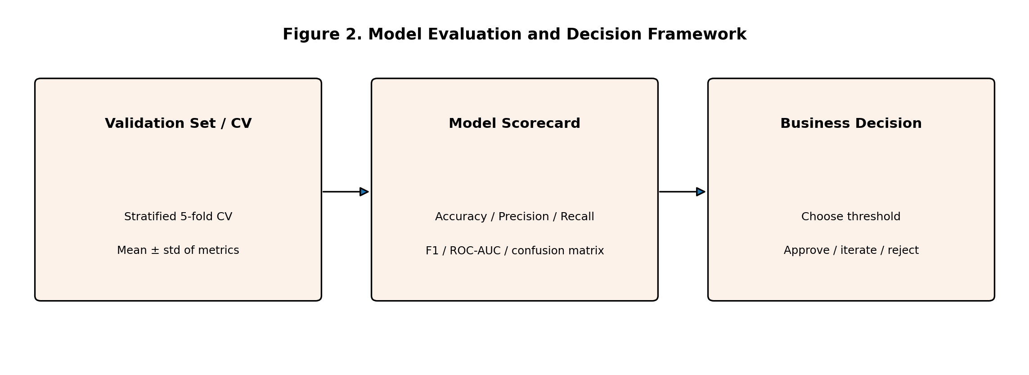
Figure 2. Validation, scorecard, and business decision framework.

8.1 Threshold Selection
The default classification threshold is 0.50, but it should be tuned using the validation set. Example: if threshold 0.50 gives recall 0.82 and precision 0.75, while threshold 0.40 gives recall 0.90 and precision 0.66, the lower threshold may be justified if the cost of missing a churner is high. The final threshold must then be frozen and evaluated once on the untouched test set.

8.2 Leakage Prevention Checklist
- Fit imputers, scalers, and encoders only on training folds.
- Do not calculate future features using information that would not be known at prediction time.
- Do not tune hyperparameters against the final test set.
- Keep customer IDs and post-churn fields out of model features.
- Use a single Pipeline so preprocessing is repeated consistently during cross-validation and inference.

9. Python Implementation Plan
import pandas as pd
from sklearn.model_selection import train_test_split, StratifiedKFold, GridSearchCV
from sklearn.compose import ColumnTransformer
from sklearn.pipeline import Pipeline
from sklearn.preprocessing import OneHotEncoder, StandardScaler
from sklearn.impute import SimpleImputer
from sklearn.linear_model import LogisticRegression
from sklearn.ensemble import RandomForestClassifier
from sklearn.metrics import classification_report, roc_auc_score, confusion_matrix
The implementation should use one reproducible Pipeline per model family. This minimizes differences between training and inference and makes the experiment traceable. Each run should record the dataset version, random seed, feature set, model parameters, cross-validation metrics, selected threshold, and final test metrics.

10. Optional Deployment and Maintenance Plan

10.1 Deployment Architecture
- Serialize the trained pipeline with joblib or a model registry.
- Expose a prediction endpoint using FastAPI or Flask.
- Validate incoming features and return probability of churn plus recommended class.
- Log prediction metadata without storing unnecessary personal information.
- Monitor data drift, prediction distribution, latency, and eventual model performance.

10.2 Retraining Trigger
A monthly review is proposed initially. Retraining should be triggered earlier when feature distributions drift materially, when recall falls below an agreed threshold, or when confirmed churn outcomes show a sustained performance decline. A simple example policy is: retrain when validation recall falls below 0.75 for two consecutive monitoring windows.

11. Risks and Mitigation
Risk | Impact | Mitigation
Class imbalance | Model favors majority class | Stratified split, class weights, PR/ROC analysis, threshold tuning
Data leakage | Inflated test performance | Pipeline, time-aware feature review, untouched test set
Overfitting | Poor generalization | Cross-validation, regularization, depth/leaf constraints
Drift | Performance degradation after deployment | Monitoring and scheduled retraining
Interpretability concerns | Low stakeholder trust | Logistic coefficients, feature importance, explanation report

12. Planned 32-Hour Work Allocation
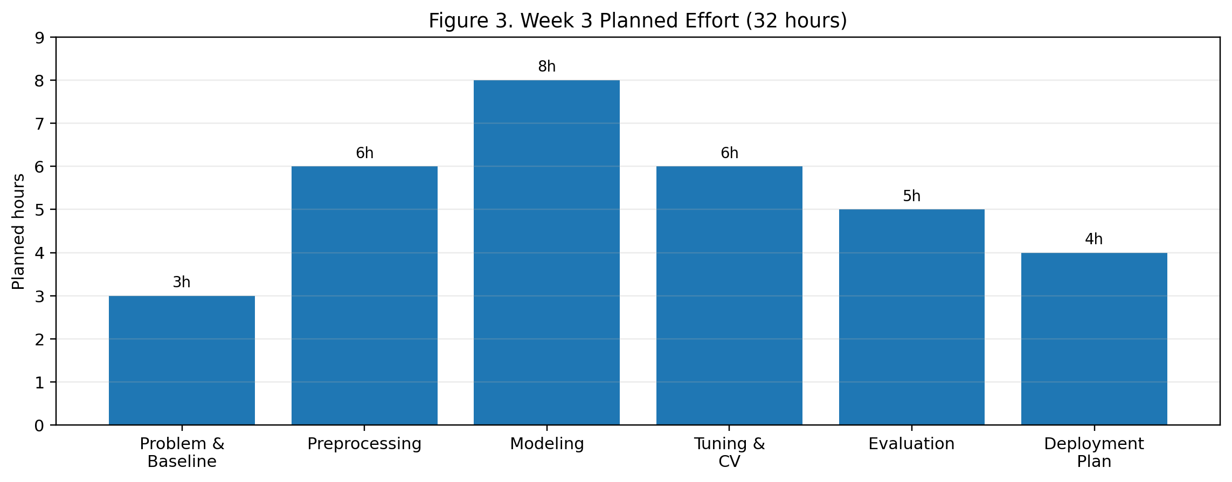
Phase | Hours | Main output
Problem definition & baseline | 3 | Target definition, success criteria, baseline metric
Preprocessing design | 6 | Cleaning, encoding, scaling, leakage controls
Model design & training plan | 8 | Candidate models and training workflow
Tuning & cross-validation | 6 | Search space, CV design, selection rule
Evaluation & threshold analysis | 5 | Metrics, confusion matrix, threshold comparison
Deployment & monitoring plan | 4 | Serving concept, drift checks, retraining policy

13. Expected Outcomes
- A reproducible machine learning workflow that can be implemented when a real dataset becomes available.
- A defensible model selection process rather than choosing a model by intuition alone.
- Clear understanding of the trade-off between false positives and false negatives.
- A validation framework that reduces overfitting and gives a more reliable estimate of generalization.
- A deployment-ready conceptual architecture with monitoring and retraining controls.

14. Conclusion
This Week 3 plan provides a structured roadmap for developing a Python-based customer churn prediction model from problem definition through evaluation and future deployment. It emphasizes reproducible preprocessing, multiple model candidates, stratified validation, numerical evaluation, threshold selection, and leakage prevention. The worked examples make the plan concrete while remaining hypothetical, and the 32-hour schedule fits the requested 30–35 hour effort window. Once a real dataset is supplied, the same framework can be translated into a notebook or Python project with minimal structural change.

