Week 2: Exploratory Data Analysis (EDA)
and Visualization Framework Design
Hypothetical Python Data Science Project | Customer Churn Analytics
Item | Project Plan
Purpose | Design a reusable EDA and visualization framework without a supplied dataset.
Project Context | Customer churn analysis for a subscription-based service; all example values are illustrative.
Primary Tools | Python, pandas, NumPy, Matplotlib, Seaborn, Plotly, Jupyter Notebook.
Planned Effort | 32 hours (within the requested 30–35 hour range).
Main Outputs | EDA checklist, visualization plan, quality rules, reporting structure, and reproducible notebook strategy.

1. Introduction to Exploratory Data Analysis
Exploratory Data Analysis (EDA) is the structured process of inspecting, cleaning, summarizing, and visualizing data before formal modeling. Its purpose is to understand the dataset’s shape, data types, distributions, quality issues, relationships, and unusual observations. EDA is essential because a predictive model can be misleading when the underlying data contains missing values, duplicates, inconsistent categories, extreme outliers, leakage, or measurement errors.
For the hypothetical customer churn project, EDA would be used to understand which customer characteristics are associated with churn. Example variables might include tenure, monthly charges, contract type, payment method, support tickets, and a binary churn flag. The examples in this report use small illustrative numbers only; they are not measured results from a real dataset.

2. Potential Dataset and Data Types
A generic churn dataset might contain approximately 10,000 customer records and 18–25 variables. The exact size is hypothetical because no dataset is supplied.
Variable | Example Type | Example Values | EDA Focus
customer_id | Identifier | C001245 | Uniqueness; duplicates
tenure_months | Integer | 3, 18, 42 | Distribution; skew; outliers
monthly_charges | Float | 49.99, 79.50 | Mean, median, spread
contract_type | Categorical | Monthly, Annual | Frequency; churn rate by group
payment_method | Categorical | Card, UPI, Bank transfer | Frequency; category consistency
support_tickets | Integer | 0, 2, 11 | Count distribution; outliers
auto_pay | Boolean | True / False | Group comparison
last_login | Datetime | 2026-07-21 | Recency; trend patterns
churn | Binary target | 0 / 1 | Target balance; relationship with predictors

3. EDA Process and Data Exploration Techniques

3.1 Initial Data Audit
The first pass establishes a quality baseline before deeper analysis. The following checks are planned:
- Load the dataset with pandas and record row/column counts using shape.
- Inspect data types with info() and compare them against the data dictionary.
- Check missing values with isna().sum() and calculate missingness percentage per column.
- Count duplicate rows and investigate duplicate customer identifiers.
- Check categorical columns for spelling variations such as “Monthly”, “monthly”, and “Month-to-month”.
- Profile numerical ranges, including impossible values such as negative charges or negative tenure.
- Check the target variable for class imbalance before interpreting churn comparisons.
missing_pct = df.isna().mean().mul(100).sort_values(ascending=False)
summary = pd.DataFrame({'missing_pct': missing_pct, 'dtype': df.dtypes.astype(str)})

3.2 Missing Data Strategy
Missingness should be measured before deciding how to treat it. An illustrative profile might show: tenure_months = 0.0%, monthly_charges = 2.4%, contract_type = 1.1%, payment_method = 3.8%. These percentages are examples for planning, not observed results.
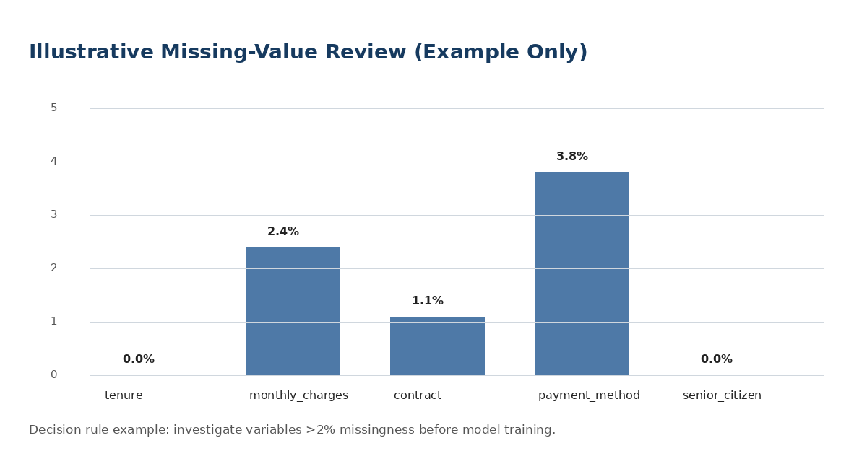
Figure 1. Illustrative missing-value profile used to define treatment rules.
Situation | Planned Treatment | Reason
<1% missing numeric values | Median imputation if values are plausibly missing at random | Robust to skew and preserves row count
1–5% missing categorical values | Mode or explicit “Unknown” category | Keeps records and preserves missingness signal
>30% missing in a feature | Investigate business meaning; consider excluding | High missingness can weaken reliability
Missing target label | Exclude from supervised model training | Target cannot be imputed safely without assumptions

3.3 Outlier Detection and Treatment
Outliers can represent genuine high-value customers, data-entry errors, or rare events. The plan therefore avoids deleting points automatically. A combination of domain rules, boxplots, IQR, and percentile checks will be used.
Method | Illustrative Rule | Action
IQR | Flag x < Q1 − 1.5×IQR or x > Q3 + 1.5×IQR | Investigate; cap, transform, or retain depending on context
Percentiles | Compare P1, P50, P99 | Review extreme tails and measurement plausibility
Domain rule | Monthly charges cannot be negative | Correct or remove impossible records
Log transform | For highly right-skewed count/amount features | Reduce skew while retaining information

3.4 Univariate Analysis
Univariate analysis studies one variable at a time. Numerical variables will be summarized with mean, median, standard deviation, quartiles, minimum, and maximum. Categorical variables will be summarized using counts and percentages.
Variable | Example Question | Planned Output
monthly_charges | Are charges concentrated around a typical range? | Histogram + KDE; mean/median
tenure_months | How many long-tenure customers are present? | Histogram + boxplot
contract_type | Which contract dominates? | Countplot + percentage table
churn | Is the target balanced? | Bar chart; class proportions

3.5 Bivariate Analysis
Bivariate analysis examines relationships between two variables. For example, average monthly charges can be compared across churn groups, while contract type can be compared using churn rates rather than raw counts alone.
Pair | Example Metric | Visualization
monthly_charges vs churn | Mean / median by churn class | Boxplot or violin plot
contract_type vs churn | Churn rate = churned / total within category | Bar chart of churn rate
tenure_months vs monthly_charges | Pearson/Spearman correlation | Scatter plot + trend line
support_tickets vs churn | Churn rate by ticket-count band | Grouped bar chart

3.6 Multivariate Analysis
Multivariate analysis combines several variables to reveal interactions and hidden segments. Planned techniques include correlation matrices, pairplots for a small subset of variables, pivot-table summaries, grouped aggregations, and segment analysis. For example, a high churn rate may occur specifically among customers with monthly contracts AND low tenure, even if each factor alone appears only moderately related to churn.
segment = df.groupby(['contract_type','auto_pay'])['churn'].mean().sort_values(ascending=False)

4. Proposed EDA Workflow
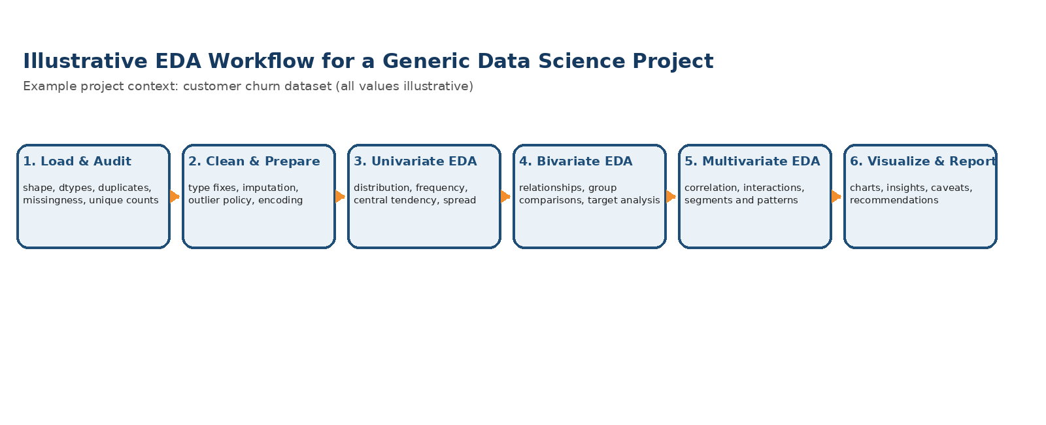
Figure 2. Planned sequence from data audit to reporting.

5. Visualization Strategy
Visualization will be selected to answer a specific question, not merely to create charts. Each figure will have a clear title, axis labels, units, legend where required, and a one- or two-sentence interpretation.
Analytical Question | Recommended Chart | Why It Helps | Example Interpretation
What is the distribution of monthly charges? | Histogram + KDE | Shows center, spread, and skew | A long right tail suggests a small group of high-charge customers.
Are there extreme tenure values? | Boxplot | Shows quartiles and potential outliers | Several points beyond the upper whisker may need domain review.
Which categories have higher churn? | Sorted bar chart | Easy category comparison | Annual contracts may show lower churn than monthly contracts.
How do two numeric variables move together? | Scatter plot + trend line | Shows direction, spread, clusters | Higher support-ticket counts may coincide with higher churn.
Which numeric variables are correlated? | Correlation heatmap | Compact matrix view | Values near +1 or −1 indicate strong linear association.
How do multiple numeric features interact? | Pairplot (small subset) | Reveals clusters and class separation | Churn classes may overlap heavily, suggesting nonlinear effects.

5.1 Worked Visualization Examples (Illustrative)
Example 1 — churn-rate comparison: suppose Monthly = 27%, Annual = 12%, Two-year = 6%. The chart should show percentages rather than raw counts so categories of different sizes are comparable. The conclusion would be: contract structure appears associated with churn, but association is not proof of causation.
Example 2 — missingness: if payment_method has 3.8% missingness and contract_type has 1.1%, a bar chart can make the difference obvious. The action could be to treat the former as a moderate data-quality issue and validate whether missing values are concentrated in a particular customer segment.
Example 3 — correlation: an illustrative correlation of +0.62 between monthly_charges and total_charges would indicate a moderately strong positive linear relationship. It would not imply that one variable causes the other; it would instead inform feature redundancy and interpretation.

6. Python Tools and Libraries
Tool | Primary Use in EDA | Planned Example
pandas | Loading, cleaning, grouping, summarizing | read_csv(), info(), groupby(), pivot_table()
NumPy | Numerical operations and missing-value-safe calculations | percentile(), where(), log transforms
Matplotlib | Core plotting and fine-grained customization | hist(), bar(), scatter(), subplots()
Seaborn | Statistical plots with concise syntax | boxplot(), heatmap(), pairplot(), countplot()
Plotly | Interactive charts for exploratory review | px.scatter(), px.histogram()
Jupyter Notebook | Narrative analysis, code, charts, and conclusions | One notebook with ordered sections and Markdown
SciPy (optional) | Statistical tests when justified | spearmanr(), distributions
OpenPyXL (optional) | Reading/writing Excel-based input/output | Validation checks for spreadsheet sources

6.1 Representative Plotting Snippets
import pandas as pd
import seaborn as sns
import matplotlib.pyplot as plt
# Distribution
sns.histplot(df['monthly_charges'], kde=True)
plt.title('Distribution of Monthly Charges')
plt.xlabel('Monthly Charges')
plt.ylabel('Customer Count')
plt.show()
# Churn rate by contract
churn_rate = df.groupby('contract_type')['churn'].mean().sort_values(ascending=False)
churn_rate.plot(kind='bar')
plt.ylabel('Churn Rate')
plt.title('Illustrative Churn Rate by Contract Type')
plt.show()

7. Reporting and Documentation Plan
- Executive Summary: one paragraph describing the dataset, key EDA findings, and business implications.
- Data Overview: source, record count, variable definitions, data types, target definition, and quality checks.
- Data Quality: missingness table, duplicate check, outlier policy, and any transformations.
- Univariate Findings: major distributions, skewness, category frequencies, and target balance.
- Relationship Findings: strongest associations, group differences, and relevant caveats.
- Visualization Gallery: final charts with titles, captions, and one-sentence insights.
- Business Interpretation: translate statistical patterns into practical observations without claiming causation.
- Limitations and Next Steps: sampling risk, missing fields, leakage risk, bias, and modeling recommendations.
- Reproducibility: keep source code, environment/library versions, and a fixed notebook section order.
QA Check | Pass Condition | Example Evidence
Missing values | Every column has a documented missingness decision | Missingness table + treatment note
Duplicates | Duplicate identifiers reviewed | Count and action recorded
Data types | Types match data dictionary | df.dtypes output
Outliers | Extreme values are investigated, not blindly removed | IQR/percentile notes + chart
Charts | Each figure has title, labels, units, interpretation | Annotated chart gallery
Reproducibility | Notebook runs top-to-bottom without manual steps | Kernel restart + Run All test

8. 32-Hour Work Plan
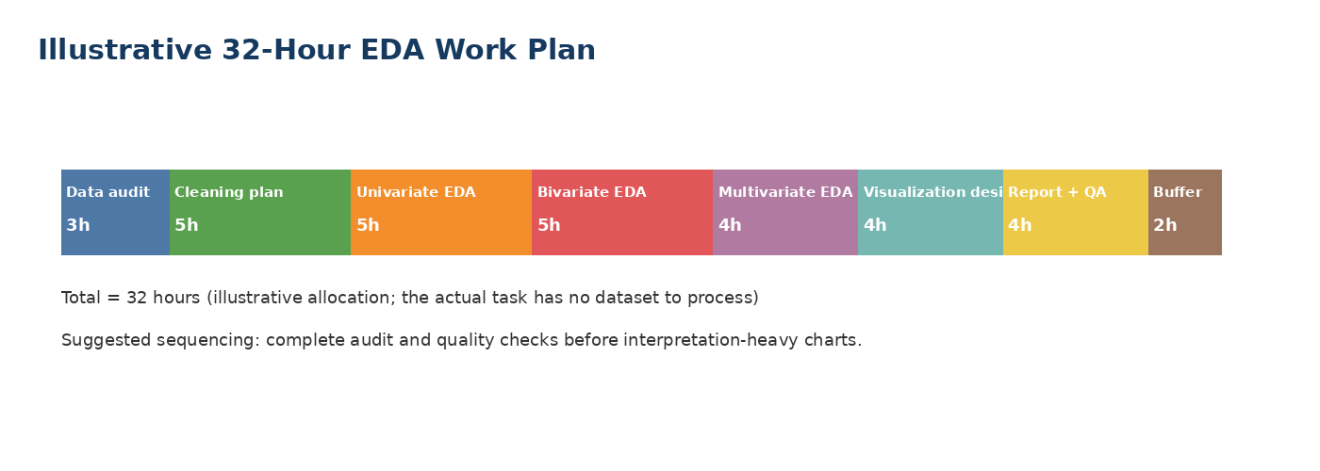
Figure 3. Illustrative allocation totaling 32 hours.
Stage | Hours | Activities | Output
Data audit & profiling | 3 | schema, dtypes, missingness, duplicates | quality checklist
Cleaning strategy | 5 | missing-value rules, outliers, category validation | data-quality plan
Univariate analysis | 5 | distributions, summaries, target balance | univariate findings
Bivariate analysis | 5 | group comparisons, rates, correlations | relationship findings
Multivariate analysis | 4 | interaction patterns, segmentation | multivariate insights
Visualization design | 4 | plot selection, formatting, chart interpretation | visualization set
Report + QA | 4 | documentation, reproducibility, final review | EDA framework DOC
Buffer | 2 | revision and unexpected issues | contingency time

9. Anticipated Challenges and Mitigation
Challenge | Impact | Mitigation
Heavy skew in numeric variables | Means may be misleading; plots become compressed | Use median/IQR, log-scale where appropriate, and compare distributions
High-cardinality categories | Charts become unreadable | Group rare levels into “Other” after checking business meaning
Class imbalance | Raw counts may hide minority churn class | Use percentages, stratified summaries, and balance-aware metrics later
Potential data leakage | EDA may accidentally use future information | Define a data cutoff and document feature availability at prediction time
Ambiguous missingness | Wrong imputation can introduce bias | Profile missingness by segment and retain “Unknown” where meaningful
Chart overload | Too many figures obscure the story | Keep only decision-relevant charts and pair each with a clear takeaway

10. Expected Outcomes
By the end of this EDA framework stage, the project should have a repeatable checklist for understanding a new dataset, a documented policy for common quality issues, a library-specific visualization strategy, and a reporting structure that can be carried directly into a Jupyter notebook or final analysis report. The framework is intentionally dataset-agnostic while still using concrete examples and numerical rules so that it can be adapted to future datasets without redesigning the entire process.
Note: All percentages, counts, correlations, and customer examples in this document are illustrative planning values because the internship task does not provide a real dataset. They are included to demonstrate how the EDA framework would interpret and document evidence once actual data are available.

