WEEK 1 DATA SCIENCE INTERNSHIP TASK
Python-Based Customer Churn Prediction Project Plan
Hypothetical Data Science Project | Strategic Planning & Methodology
Project Type | Hypothetical Data Science / Machine Learning
Primary Language | Python
Estimated Effort | 31 hours
Prepared For | YuvaIntern Week 1 Task

Executive Summary
This project proposes a Python-based customer churn prediction system for a subscription business. The purpose is to identify customers who are likely to discontinue their subscriptions so that the business can prioritize retention actions. The plan covers the complete data science lifecycle—from problem definition and data acquisition to data preparation, exploratory analysis, model development, evaluation, and delivery. The approach is designed to be reproducible, measurable, and practical while recognizing issues such as class imbalance, missing data, data leakage, model explainability, and changing customer behavior.

1. Project Background
Business context. Subscription businesses lose revenue when customers cancel or fail to renew. A data-driven churn prediction system can help the retention team identify high-risk customers early and use limited outreach resources more effectively.
Hypothetical problem. Assume a subscription company collects customer demographic information, plan details, usage activity, billing history, support interactions, and previous renewal outcomes. The proposed system will use Python to learn patterns associated with churn and produce a probability score for each customer.
Motivation. The project is justified because proactive retention is generally more useful than waiting until a customer has already left. A predictive model can support prioritization, while business teams remain responsible for deciding what action to take.

2. Project Objectives
- Define a reproducible data science workflow for customer churn prediction.
- Identify relevant features that may be associated with churn, such as tenure, usage, plan type, payment method, and support contacts.
- Prepare a clean modeling dataset with appropriate handling of missing values, duplicate records, categorical variables, and inconsistent data.
- Compare multiple classification approaches and select a model using business-relevant evaluation metrics.
- Produce interpretable outputs that help retention teams understand the most important churn drivers.
- Document a deployment and monitoring strategy for future production use.

3. Project Scope
In Scope | Out of Scope
Business problem definition and KPI alignment | Live production deployment
Data collection plan and schema design | Automated customer outreach
Data cleaning and preprocessing | Collecting sensitive personal data
Exploratory data analysis | Real-time streaming infrastructure
Baseline and advanced classification models | Mobile application development
Model evaluation and interpretation | Final business ROI claims without production evidence
Prototype reporting/dashboard design | Guaranteeing that predictions will always be correct
Deployment and monitoring roadmap | Replacing human decision-making

4. Methodology & Strategy
The planned methodology follows a standard, iterative data science lifecycle. Each stage produces an output that becomes an input to the next stage, while evaluation findings can trigger a return to earlier steps.
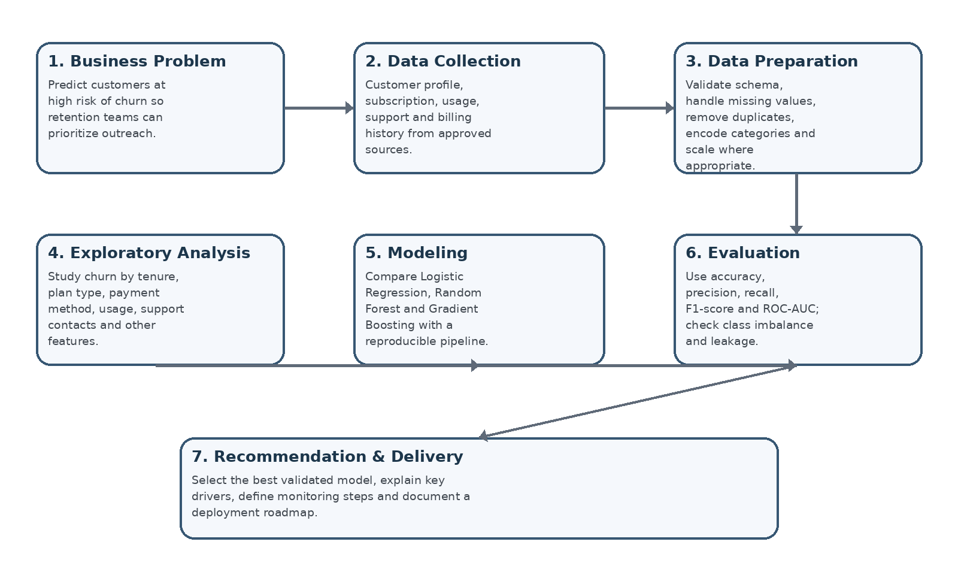
Figure 1. Planned data science workflow for the hypothetical churn project.

4.1 Data Collection Strategy
The hypothetical dataset would be assembled from approved business sources such as customer master records, subscription tables, billing history, product-usage logs, and customer-support systems. A data dictionary would define each field, data type, business meaning, permitted values, and source. The collection plan would minimize unnecessary personal information and follow access-control rules.

4.2 Data Cleaning Strategy
The pipeline would validate row counts and schemas, detect duplicates, standardize categorical values, inspect missingness, identify impossible values, and document every transformation. Missing values would be handled according to feature meaning rather than with a single universal rule. Outliers would be reviewed for data quality first, not removed automatically.

4.3 Exploratory Data Analysis Strategy
EDA would examine churn rates overall and across important segments, including tenure bands, plan types, payment methods, usage patterns, and support interactions. Histograms, bar charts, box plots, correlation checks, and group-level summaries would be used to identify patterns and possible leakage or bias.

4.4 Modeling Strategy
The modeling pipeline would begin with a simple baseline such as Logistic Regression, followed by tree-based methods such as Random Forest and Gradient Boosting. Preprocessing would be built with scikit-learn pipelines so that training and evaluation transformations are applied consistently.

4.5 Evaluation Strategy
Because churn datasets may be imbalanced, accuracy would not be the only decision criterion. Precision, recall, F1-score and ROC-AUC would be reported, with special attention to recall if the business wants to identify as many potential churners as practical. Cross-validation would be used during model comparison, and the final model would be tested on a held-out test set.

4.6 Delivery Strategy
The project would conclude with a reproducible notebook or Python package, a model artifact, a concise results report, and a deployment roadmap. A future production version could expose predictions through an API or scheduled batch pipeline and provide monitoring for data drift, model performance, and operational failures.
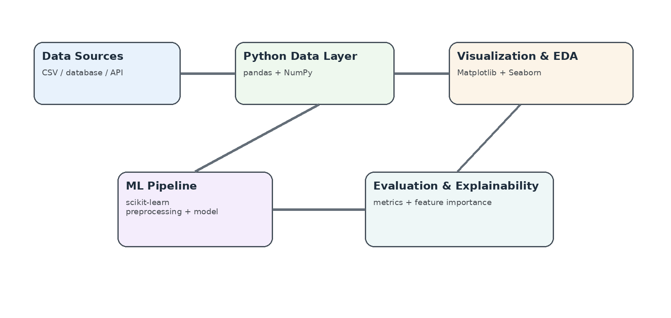
Figure 2. High-level technical architecture and tool flow.

5. Timeline & Work Allocation (31 Hours)
The task requirement calls for roughly 30–35 hours. The proposed plan allocates 31 hours across six practical work packages.
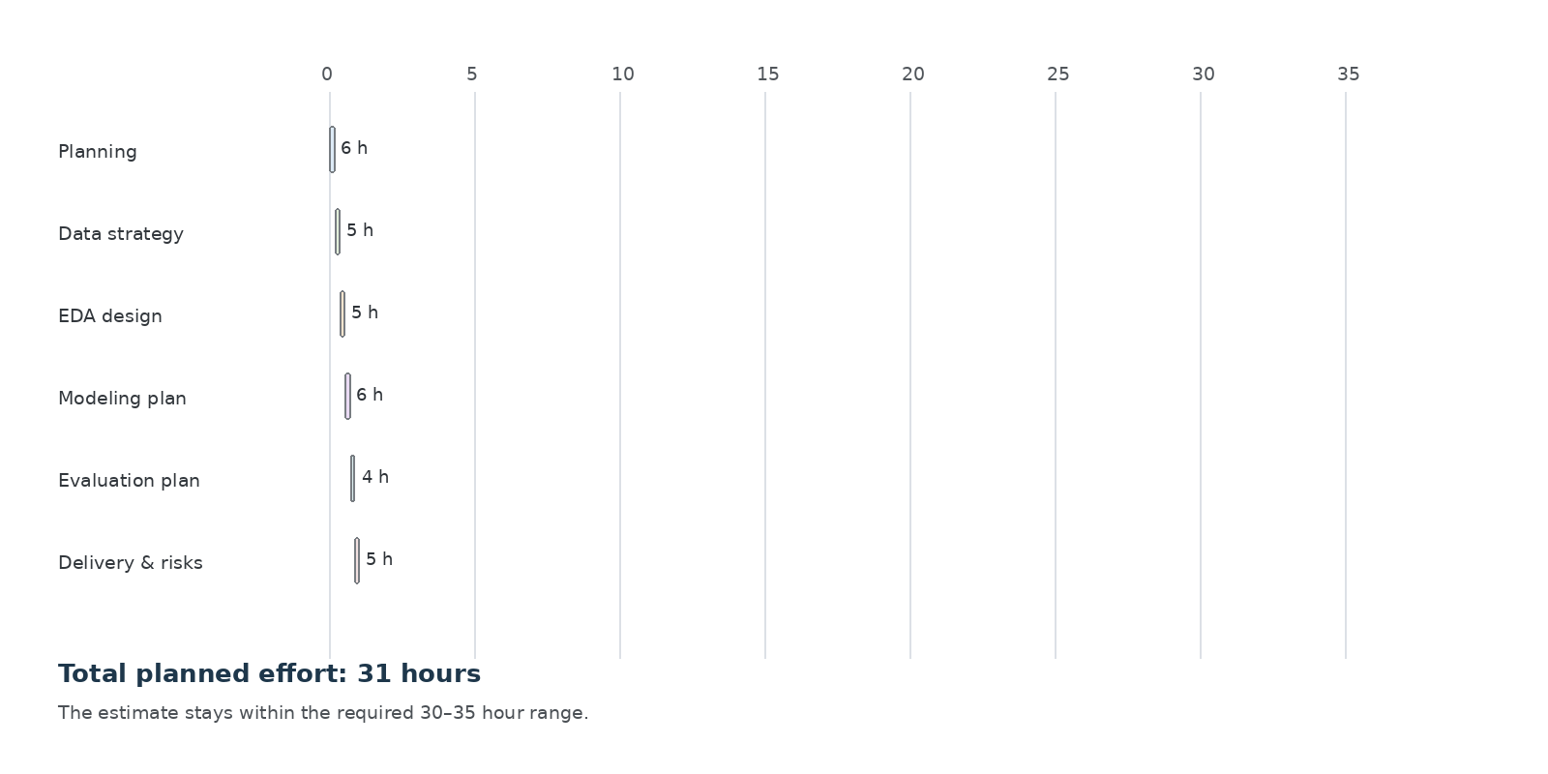
Figure 3. Planned 31-hour effort allocation.
Work Package | Hours | Main Activities
Project planning | 6 | Define problem, stakeholders, KPIs, scope and assumptions
Data strategy | 5 | Design data sources, schema, data dictionary and quality rules
EDA design | 5 | Plan distributions, segmentation, correlations and leakage checks
Modeling plan | 6 | Choose baseline, candidate models and preprocessing workflow
Evaluation plan | 4 | Define metrics, validation approach, error analysis and thresholds
Delivery & risks | 5 | Create architecture, deployment roadmap, risk controls and documentation

6. Tools, Libraries & Technology Stack
Tool / Library | Planned Use | Why It Fits
Python | Core development language | Large ecosystem and reproducible workflows
Pandas | Data manipulation and cleaning | Convenient tabular operations
NumPy | Numerical computation | Efficient array operations
Matplotlib / Seaborn | EDA and visualization | Clear charts for patterns and diagnostics
scikit-learn | Preprocessing, modeling and evaluation | Integrated pipelines and standard metrics
Jupyter Notebook / Google Colab | Experimentation and documentation | Easy iterative analysis and sharing
Git / GitHub | Version control | Tracks changes and supports reproducibility
MS Word / Google Docs | Final project report | Professional documentation deliverable

7. Expected Outcomes
- A documented end-to-end Python data science plan for churn prediction.
- A clearly defined data schema and quality-control approach.
- A structured EDA and modeling workflow suitable for later implementation.
- A justified set of candidate models and evaluation metrics.
- A high-level architecture and deployment/monitoring roadmap.
- A professional project report that can guide the next technical phase.

8. Anticipated Challenges & Mitigation
Challenge | Potential Impact | Mitigation
Class imbalance | Model may favor non-churn cases | Use stratified splits, class weights and recall/F1/ROC-AUC
Missing or inconsistent values | Unreliable analysis and biased results | Profile missingness, validate ranges and document transformations
Data leakage | Overly optimistic evaluation | Separate train/test data and fit preprocessing only on training data
Changing customer behavior | Model performance may degrade over time | Monitor drift and define periodic retraining rules
Limited explainability | Business users may distrust predictions | Report feature importance and keep a human review step
Privacy and access controls | Risk of unnecessary exposure of personal data | Use minimum necessary fields, permissions and anonymized identifiers

9. Success Criteria
- Project scope, assumptions and business objective are clearly defined.
- Every stage of the data science lifecycle has a documented strategy and output.
- The proposed workflow prevents common issues such as leakage and inconsistent preprocessing.
- The model selection plan uses metrics aligned with the business objective rather than accuracy alone.
- The final plan can be implemented in Python in a later technical phase.
- The final report is complete, professionally formatted, and supported by clear strategic diagrams.

10. Conclusion
This project plan provides a practical foundation for a hypothetical customer churn prediction system using Python. It translates a business problem into measurable objectives, a controlled data science workflow, a realistic 31-hour effort plan, an appropriate technology stack, and a delivery strategy. The next phase would move from planning into implementation using a suitable dataset, followed by experimentation, model comparison, and validation.

