SQL
- MYSQL workbench
  - Test_db
    - Tables
      - Employees
        - Columns
        - Indexes
        - Foreign Keys
        - Triggers
    - Views
    - Stored Procedures
    - Functions
SQL Datatypes
Binary Datatypes | Binary | The maximum length of 8000 bytes(Fixed-Length binary data)
 | varbinary | The maximum length of 8000 bytes(Variable Length binary data)
 | varbinary(max) | The maximum length of 231 byte
 | image | Maximum Length of 2,147,483,647 bytes(Variable Length binary data)
Exact Numeric Datatype | BigInt
 | Int | -2e31 (-2,147,483,648)  to  2e31 (2,147,483,647)
 | smallint
 | tinyint
 | bit
 | decimal
 | numerical
 | money
 | small money
Approximate Numeric Datatype | float | -1.79E+308  to  1.79E+308
 | real | -3.40E+38  to  3.40E+38
Character String Datatype | char | The maximum length of 8000 characters.(Fixed-Length non-Unicode Characters)
 | varchar | The maximum length of 8000 characters.(Variable-Length non-Unicode Characters)
 | text | The maximum length of 2,127,483,647 characters(Variable Length non-Unicode data)
date time | date
 | time
 | datetime
XML | XML | A Datatype used to store data in the format of XML datatype
spatial | Geometry | A datatype is used for storing planar spatial data, such as points, lines, and polygons, in a database table.
array | ARRAY
 | JSON

SQL Comments
-- this is a comment
/*this is a comment*/
SQL Alias
Temporary name, only exists for the duration of the query.
Select c.customer_id as id, c.customer_name AS name, o.order_region
From customers AS c, orders o

Databases
A database is used to store the collection of records in an organized form. It allows us to hold the data into tables, rows, columns, and indexes to find the relevant information frequently.
CREATE DATABASE employees_db;
CREATE DATABASE IF NOT EXISTS employees_db;
SHOW CREATE DATABASE employee_db;

SHOW DATABASES;
SHOW DATABASES LIKE "%schema";

SELECT schema_name
FROM information_schema.schemata;

USE emplyees_db;

DROP DATABASE employees_db;
DROP DATABASE IF EXISTS employees_db;
# schema is the synonym for database
DROP SCHEMA employees_db;

MySQL copy or clone database is a feature that allows us to create a duplicate copy of an existing database, including the table structure, indexes, constraints, default values, etc. Making a duplicate copy of an original database into a new database is very useful when accidentally our database is lost or failure. The most common use of making a duplicate copy of the database is for data backups. It is also useful when planning the major changes to the structure of the original database. In MySQL, making the clone of an original database is a three-step process:
- The original database records are dumped (copied) to a temporary file that holds the SQL commands for reinserting the data into the new database.
- It is required to create a new database.
- The SQL file is processed, and the data will be copied into the new database.
BACKUP DATABASE testDB
TO DISK = 'D:\backups\testDB.bak'
WITH DIFFERENTIAL;

# only backs up the parts of the database that have changed since the last full database backup.

Tables
Creating table
Needed: - Name of table, name of fields, field constraints
CREATE TABLE employee_table(
emp_id int NOT NULL AUTO_INCREMENT,
name varchar(45) NOT NULL,
occupation varchar(35) NOT NULL,
age int NOT NULL,
city varchar(30) DEFAULT ‘Germany’
PRIMARY KEY (emp_id)
);
SHOW TABLES;
SHOW TABLES FROM mystudentdb;
SHOW TABLES FROM mystudentdb LIKE "stud%";

# tables could be either base/view type
SHOW TABLES FROM sakila WHERE table_type= "VIEW";

DESCRIBE employee_table;

Alter table
### Add column
ALTER TABLE cus_tbl
ADD cus_address varchar(100) NOT NULL
ADD cus_salary int(100) NOT NULL
AFTER cus_name; --Optional

### To modify existing column’s datatype; in mysql use MODIFY COLUMN
ALTER TABLE Persons
ALTER COLUMN DateOfBirth year NULL;

### to drop column
ALTER TABLE cus_tbl
DROP COLUMN cus_address;

### to rename
ALTER TABLE cus_tbl
RENAME TO cus_table;

ALTER TABLE employees
RENAME COLUMN old_name to new_name;

Deleting tables: - Drop/Truncate
The TRUNCATE TABLE statement is used to delete the data inside a table, but not the table itself. Whereas drop table drops the entire table from database.
DROP TABLE Shippers;
TRUNCATE TABLE Shippers;

Records in table: - Insert/Update/Delete/Select
Insert Into
INSERT INTO People (id, name, occupation, age)
VALUES (101, 'Peter', 'Engineer', 32);
INSERT INTO People
VALUES
(102, 'Joseph', 'Developer', 30),
(103, 'Mike', 'Leader', 28),
(104, 'Stephen', 'Scientist', 45);
INSERT INTO table_name (column_name, column_date)
VALUES ('DATE: Manual Date', '2008-7-04');

Select Into / Insert Into Select
Copying data from one table to another.
INSERT INTO SELECT inserts into an existing table. Requires that datatype in source and target tables matches.
SELECT INTO creates a new table and puts the data in it. Uses the schema of old table to create a new table.
SELECT *
INTO CustomerGermany
FROM Customers
WHERE Country=’Germany’;
INSERT INTO Customers (CustomerName, City, Country)
SELECT SupplierName, City, Country
FROM Suppliers
WHERE Country=’Germany’;

Update
The UPDATE statement is used with the SET and WHERE clauses.
Notice the WHERE clause in the UPDATE statement. The WHERE clause specifies which record(s) that should be updated. If you omit the WHERE clause, all records in the table will be updated!
UPDATE Customers
SET ContactName = 'Alfred Schmidt', City= 'Frankfurt'
WHERE CustomerID = 1;
UPDATE Trainer_table
SET email = REPLACE(
email,'@javatpoint.com','@tutorialandexample.com'
)
WHERE course_name = 'Testing';

Delete
This query in MySQL deletes a full row from the table and produces the count of deleted rows. Once we delete the records using this query, we cannot recover it. If we omit the WHERE clause into the statement, this query will remove whole records from the database table.
If we want to delete all records from a table without knowing the count of deleted rows, we must use the TRUNCATE TABLE statement that gives better performance.
DELETE FROM Employees
WHERE emp_id=107;

# to delete only top n records
DELETE FROM Employees
ORDER BY name
LIMIT 3;
# to delete records from multiple tables using a single query

DELETE Employees, Payment FROM Employees
INNER JOIN Payment
ON Employees.emp_id = Payment.emp_id
WHERE Employees.emp_id = 102;

Drop – drops entire table
Truncate – deletes all records from table
Delete – deletes mentioned records from table

SQL Constraints
Not Null | column cannot have a NULL value
Unique | all values in a column are different
Primary Key | (NotNull + Unique) Uniquely identifies each row in a table.  Only one per table.  Can be made up of multiple columns, called (Composite Key)
Foreign Key | Prevents actions that would destroy links between tables
Check | Ensures that the values in a column satisfies a specific condition.  To limit the value range that can be placed.
Default | Sets a default value for a column if no value is specified
Create Index | Used to create and retrieve data from the database very quickly.

Create Table employees (
ID int NOT NULL AUTO_INCREMENT=1,
Age int NOT NULL,
Year int,
City CHAR(20) DEFAULT (‘Bombay’),
UNIQUE(Age),
CHECK(Age>=18),
Age int DEFAULT (18),
PRIMARY KEY (Age, Year),
FOREIGN KEY (ID) REFERENCES persons(id),
CREATE INDEX
);

ALTER TABLE employees
DROP PRIMARY KEY;

ALTER TABLE employyes
ADD CHECK(Year>=2011)

ALTER TABLE employees
ALTER Year SET DEFAULT 2015;
-- ALTER City DROP DEFAULT;

SQL INDEXES
- Used by the server to speed up the retrieval of rows by using a pointer (based on index column), rather than having to scan the entire table.
- Helps to speed up select queries and where clauses, but it slows down data input, with the update and the insert statements.
- Can be created or dropped with no effect on the data.
- Users can NOT see the indexes.
- Each table can have more than one index.
- We can create an index by using one or more columns of the table for efficient access to the records.
- When a table is created with a primary key or unique key, it automatically creates a special index named PRIMARY. We called this index as a clustered index. All indexes other than PRIMARY indexes are known as a non-clustered index or secondary index.
When should indexes be created:
- A column contains a wide range of values.
- A column does not contain a large number of null values.
- One or more columns are frequently used columns together in a where clause or a join condition.
When should indexes be avoided:
- The table is small table
- The columns are NOT often used col as a condition in the query
- The column is updated frequently
- Do not make an index for each query as creating indexes also take storage
- periodically review the indexes in your database and remove any that are no longer needed.
- Updating a table with indexes takes more time than updating a table without.
-- create table
CREATE TABLE Colleges (
college_id INT PRIMARY KEY,
college_code VARCHAR(20) NOT NULL,
college_name VARCHAR(50)
);

-- create index
CREATE INDEX college_index
ON Colleges(college_code);

-- create unique index
CREATE UNIQUE INDEX college_index
ON Colleges(college_code);
ALTER TABLE Colleges
DROP INDEX college_index;

SQL Clauses
Where
SELECT *
FROM officers
WHERE (address = 'Mau' AND officer_name = 'Ajeet')
OR (officer_id < 5);

Distinct
SELECT DISTINCT officer_name, address
FROM officers;

From
SELECT *
FROM officers

Order by
SELECT officer_name, address
FROM officers
WHERE officer_id < 5
ORDER BY officer_name DESC, address ASC;

Group by
SELECT emp_name, SUM(working_hours) AS "Total working hours"
FROM employees
GROUP BY emp_name;
Aggregate functions available:-
- Count
- Sum
- Min
- Max
- Avg

Having
HAVING Clause is used with GROUP BY clause. It always returns the rows where condition is TRUE. It was added to the SQL because where condition can not be used with aggregated functions.
SELECT emp_name,
SUM(working_hours) AS "Total working hours"
FROM employees
GROUP BY emp_name
HAVING SUM(working_hours) > 5;

window
A window function performs a calculation across a set of table rows that are somehow related to the current row. This is comparable to the type of calculation that can be done with an aggregate function. But unlike regular aggregate functions, use of a window function does not cause rows to become grouped into a single output row — the rows retain their separate identities. It means window functions perform operations on a set of rows and produces an aggregated value for each row.
Helps constructs comparison with data from current row WITHOUT LOSING THE GRANULARITY.
Types of window functions:
- Aggregating Functions
AVG, SUM, MIN, MAX, COUNT, STRING_AGG, ARRAY_AGG
- Ranking functions.
RANK, DENSE_RANK, PERCENT_RANK, ROW_NUMBER
- Analytical functions
LAG, LEAD,

Window functions are executed after all other filter, aggregations, etc. Hence windw functions are NOT allowed in where, having, or group by clause. To filter results based on window function outputs, we can use sub queries/CTEs.
# Clauses:
OVER | Must have clause  Decides how postgres divides and sorts data for window function calculations  With no additional arguments, it gets applied to entire table rows.
PARTITION BY | Determines how data is grouped.  If no partitionby clause, then group is the entire table.  If all columns are included then each group is one row.
ORDER BY | Determines how data is sorted for windows calculations.
WINDOW | In order to reuse the same winodw for multiple calculations.  Enables us to define the reusable window after the from clause.

SELECT Year, Product, SUM(Sale) AS Total_Sales  FROM Sales  GROUP BY Year  ORDER BY Product; | SELECT Year, Product, Sale, SUM(Sale)  OVER(PARTITION BY Year) AS Total_Sales  FROM Sales;
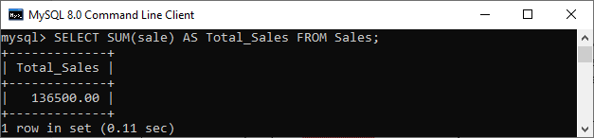 | 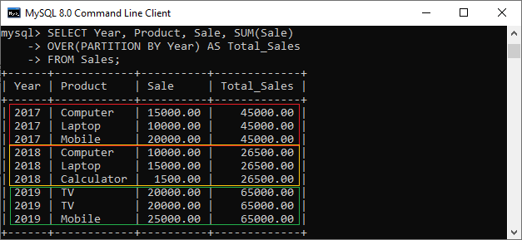

select
surgery_id,
(discharge_date - admission_date) as length_of_stay,
avg(discharge_date - admission_date)
over() as average_length_of_stay
from surgical_encounters;
SELECT
account_id,
acct_icd,
total_acct_balance,
rank()
over(PARTITION BY acct_icd
ORDER BY total_acct_balance desc)
as rank_by_accnt_icd
from accounts;
SELECT
s.surgery_id,
p.full_name,
s.total_profit,
avg(total_profit)
over w as avg_total_profit,
s.total_cost,
sum(total_cost) over w as total_surgeon_cost
from surgical_encounters s
left outer join pysicians p
on p.id = s.surgeon_id
window w as (partition by s.surgery_id);
SELECT
patient_encounter_id,
master_patient_id,
admission_date,
discharge_date,
lag(discharge_date) over w as previous_discharge_date,
lead(admission_date) over w as next_admission_date
from encounters
window w as (partition by master_patient_id
order by admission_date asc)
order by master_patient_id, admission_date;
SELECT Year, Product, Sale,
LEAD(Sale,1) OVER(ORDER BY Year) AS Total_Sales
FROM Sales;
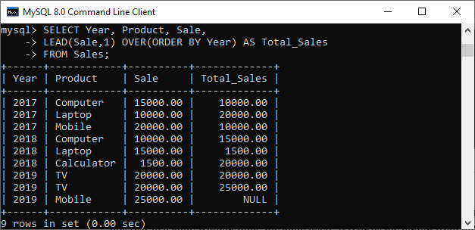

Control flow functions
IF()
The IF function returns a value YES when the given condition evaluates to true and returns a NO value when the condition evaluates to false.
The IF function takes three expressions, where the first expression will be evaluated. If the first expression evaluates to true, not null, and not zero, it returns the second expression. If the result is false, it returns the third expression.
If() functions is different from If statement.
# Syntax
IF ( expression 1, expression 2, expression 3)

SELECT IF(251 = 251,' Correct','Wrong');

SELECT IF(STRCMP('Rinky Ponting','Yuvraj Singh')=0, 'Correct', 'Wrong');

SELECT lastname,
IF(age>20, "Mature", "Immature") As Result
FROM student

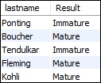

IFNULL()
You should avoid the use of the IFNULL() function in the WHERE clause because this function reduces the performance of the query.
SELECT IFNULL(NULL,5);
>>> 5

SELECT IFNULL("Hello", "javaTpoint");
>>> Hello
# return the home phone number if the cell phone is NULL.
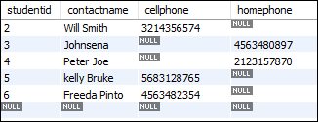
SELECT
contactname,
IFNULL(cellphone, homephone) AS phone
FROM
student_contact;
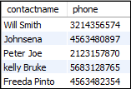

NULLIF()
If both expressions are the same, it returns NULL. Otherwise, it will return the first expression.
SELECT NULLIF("javaTpoint", "javaTpoint");
>>> NULL

SELECT NULLIF("Hello", "404");
>>> Hello

# helps prevents division by zero
SELECT 1/NULLIF(0,0);
>>> NULL
SELECT cust_name,
occupation,
qualification,
NULLIF (qualification,"Btech") AS result
FROM myproductdb.customer;
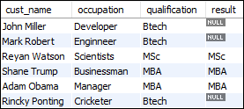

CASE
if-else or if-then-else logic
alongwith SELECT, WHERE, ORDER BY clause, etc.
Once the condition is met, it stops traversing and gives the output. If it will not find any condition true, it executes the else block.
When the else block is not found, it returns a NULL value.
SELECT CASE 1
WHEN 1 THEN 'one'
WHEN 2 THEN 'two'
ELSE 'more'
END;
SELECT studentid,
firstname,
CASE class
WHEN 'CS' THEN 'Computer Science'
WHEN 'EC' THEN 'Electronics and Communication'
ELSE 'Electrical Engineering'
END AS department
from students;
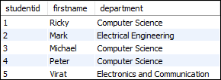
SELECT orderid,
quantity,
CASE
WHEN quantity>30 THEN ‘greater than 30’
WHEN quantity<30 THEN ‘lesser than 30’
ELSE ‘equal to 30'
END AS quantity_text
from order_details;
select customer_name, city, country
from customers
order by
(CASE
WHEN city IS NULL THEN country
ELSE city
END);

If Statement
The IF statement is used in stored procedure programs that implement the basic conditional construct in MySQL. Based on a certain condition, it allows us to execute a set of SQL statements. It returns one of the three values True, False, or NULL.

SQL OPERATORS and Conditions
SQL Operators

...

AND & OR
WHERE cus_firstname = 'Ajeet' AND cus_id > 3;

WHERE cus_firstname = 'Ajeet' OR cus_id > 100;

WHERE (course_name = 'Java' AND student_name = 'Aryan')
OR (student_id < 2);
Boolean
...
LIKE & NOT LIKE & RLIKE
Used to find the pattern matching, used in SELECT, INSERT, UPDATE and DELETE statement with the combination of WHERE clause.
Two wildcards (wildcard nothing but representing character):
- (%) – represents zero, one or multiple characters
- (_) – represents one, single character
SELECT officer_name
FROM officers
WHERE address LIKE 'Luck%';
WHERE country LIKE ‘a%’ | find any values that start with a
WHERE country LIKE ‘%a’ | find any values that ends with a
WHERE country LIKE ‘%st%’ | find any values that have ‘st’ in any position
WHERE country LIKE ‘_r%’ | find any values that have ‘r’ in second position
WHERE country LIKE ‘a_%’ | find any values that start with ‘a’ and are at least 2 chars in length

WHERE address NOT LIKE 'Luck%';
IN & NOT IN
SELECT *
FROM officers
WHERE officer_name IN ('Ajeet', 'Vimal', 'Deepika');

WHERE country NOT IN (‘’, ‘’, ‘’);

SELECT * FROM customers
WHERE country IN (SELECT country FROM suppliers);
ANY & ALL
ANY : -
- Returns the Boolean value TRUE if the comparison is TRUE for ANY of the subquery condition
- The keyword must follow the comparison operator
- works like comparing the value of a table to each value in the result set provided by the subquery condition
- to make coparison between a single column value and a range of other values
ALL : -
- Returns true when all the subquery values are satisfied by the condition.

# lists the Product Names if it finds ANY records in the Order Details table has Quantity equal to 10

SELECT prod_name
FROM products
WHERE prod_id = ANY (SELECT prod_id FROM orders WHERE qty=10);
BETWEEN
The BETWEEN operator selects values within a given range. The values can be numbers, text, or dates.
The BETWEEN operator is inclusive: begin and end values are included.

SELECT * FROM Products
WHERE Price BETWEEN 10 AND 20;

SELECT * FROM Products
WHERE ProductName NOT BETWEEN 'Carnarvon’ AND 'Mozzarella’
ORDER BY ProductName;

SELECT * FROM Orders
WHERE OrderDate BETWEEN '1996-07-01' AND '1996-07-31';
EXISTS
The EXISTS operator is used to test for the existence of any record in a subquery.
The EXISTS operator returns TRUE if the subquery returns one or more records.

SELECT SupplierName
FROM Suppliers
WHERE EXISTS (
SELECT ProductName
FROM Products
WHERE Products.SupplierID = Suppliers.supplierID AND Price < 20
);

# to find the customers who has placed at least 1 order
SELECT name, occupation FROM customer
WHERE EXISTS (SELECT *
FROM Orders
WHERE customer.cust_id = Orders.cust_id
);

DELETE FROM Orders WHERE EXISTS (
SELECT * FROM customer
WHERE order_id=3);

# to check whether a row exists in a table or not
SELECT EXISTS(SELECT * from customer WHERE cust_id=104)
AS Result;

IN | EXISTS
It is used to minimize the multiple OR conditions in MySQL. | It is used to check the existence of data in a subquery.
SELECT col_names FROM tab_name WHERE col_name IN (subquery); | SELECT col_names  FROM tab_name  WHERE [NOT] EXISTS (subquery);
It compares all values inside the IN operator. | It stops for further execution as soon as it finds the first true occurrence.
It can use for comparing NULL values. | It cannot use for comparing NULL values.
It executes faster when the subquery result is less. | It executes faster when the subquery result is large.
It performs a comparison between parent query and child query or subquery. | It does not perform a comparison between parent query and child query or subquery.
.
IS NULL & IS NOT NULL
SELECT *
FROM officers
WHERE officer_name IS NULL;

WHERE officer_name IS NOT NULL;
NOT & NOT EQUAL
SELECT * FROM customers
WHERE NOT (country=’india’ or region=’asia’);

SELECT * FROM students WHERE city <> "England";

SELECT * FROM students WHERE city != "England";

SQL Regex
Regular expressions allow us to search data matching even more complex ways compared to wildcards.
The advantage of using regular expression is that we are not limited to search for a string based on a fixed pattern with the percent (%) sign and underscore (_) in the LIKE operator. The regular expression has more meta-characters that allow more flexibility and control while performing pattern matching.
We can use either RLIKE or REGEXP, both are same.
For finding the negation of a specific string pattern we can use NOT_RLIKE also.
SELECT column_lists
FROM table_name
WHERE field_name RLIKE 'pattern';
^ | the beginning | # student names starting with a or b  WHERE stud_name RLIKE '^[ab]'
$ | the end | WHERE stud_name RLIKE 'k$'
. | any single character except for a new line. | # name contains exactly six characters  WHERE stud_name RLIKE '^.{6}$'
[abc] | to match any characters enclosed in the square brackets
[^abc] | any characters not specified in the square brackets.
* | matches zero (0) or more instances of the preceding strings.
+ | matches one or more instances of preceding strings.
{n} | match n instances of the preceding element.
{m, n} | match m to n instance of the preceding element
p1|p2 | It is used to isolate alternatives that match any of the patterns p1 or p2.
? | The question mark (?) character matches zero (0) or one instance of preceding strings.
[A-Z] | match any upper case character
[a-z] | any lower case character
[0-9] | It is used to match numeric digits from 0 to 9

Regular expression functions and operators: -
NOT_REGEXP | It is the negation of a REGEXP operator.
REGEXP | This operator represents whether the string matches regular expression or not.
RLIKE | This operator represents whether the string matches regular expression or not.
REGEXP_INSTR() | It is a function that gives a result when the starting index of substring matches a regular expression.
REGEXP_LIKE() | This function represents whether the string matches regular expression or not.
REGEXP_REPLACE() | This function replaces the specified string character by matching characters and then returns the resulting string. If any expression, pattern, or replaceable string is not found, it will return NULL.  # Examines the string, looking for two or more dashes. Each occurrence of two or more dashes will be replaced by a single astrik sign.  SELECT  REGEXP_REPLACE(  'the---web-----development---tutorial--w3',  '( ){2,}',  ' ') AS "trimmed_name"  FROM DUAL;  >>> the*web*development*tutorial*w3  # Examines country_name and puts a space after each non-null character in the string.  SELECT REGEXP_REPLACE(  country_name,  '(.)',  '\1 ') AS country_name_explanded  FROM countries;  >>> A u s t r a l i a
REGEXP_SUBSTRING() | This function return substring that matches a regular expression.

SQL Joins
Inner
The MySQL Inner Join is used to returns only those results from the tables that match the specified condition and hides other rows and columns. MySQL assumes it as a default Join, so it is optional to use the Inner Join keyword with the query.
Sometimes, the name of the columns is the same in both the tables. In that case, we can use a USING keyword to access the records.
SELECT s.stud_fname, s.stud_lname, s.city, t.technology
FROM students s
INNER JOIN technologies t
ON s.student_id = t.tech_id
GROUP BY inst_name;
# if name of common column is exactly same
SELECT student_id, inst_name, city, technology
FROM students
INNER JOIN technologies
USING (student_id);
# joining multiple tables
SELECT student_id, inst_name, city, technology, cellphone
FROM students
INNER JOIN technologies USING (student_id)
INNER JOIN contact ORDER BY student_id;

Left
It will return all the records from the first (left-side) table, even no matching records found from the second (right side) table. If it will not find any matches record from the right side table, then returns null.
SELECT customers.customer_id, cust_name, price, date
FROM customers
LEFT JOIN orders
ON customers.customer_id = orders.customer_id
-- USING(customer_id)
GROUP BY price
HAVING price>200;
SELECT customers.customer_id, cust_name, order_id, price, cellphone
FROM customers
LEFT JOIN contacts
ON customer_id = contact_id
LEFT JOIN orders
ON customers.customer_id = orders.customer_id ORDER BY income;

The LEFT JOIN clause is also useful in such a case when we want to get records in the table that does not contain any matching rows of data from another table.
SELECT customer_id, cust_name, cellphone, homephone
FROM customers
LEFT JOIN contacts ON customer_id = contact_id
WHERE cellphone IS NULL;

Que. To find non-matching records between two tables
table_a  id account  1 Acc1  2 Acc2  3 Acc3 | table_b  opp_num account_id  Opp1 1  Opp2 2  Opp3 4

select account_id
from tableB
where account_id NOT IN table_a.id;

SELECT B.Accountid
FROM TableB AS B
LEFT
JOIN TableA AS A
ON A.ID = B.Accountid
WHERE A.ID IS NULL;

Right
Same as left join except...right table is the base table.
Full Outer / Outer
The FULL OUTER JOIN keyword returns all records when there is a match in left (table1) or right (table2) table records.
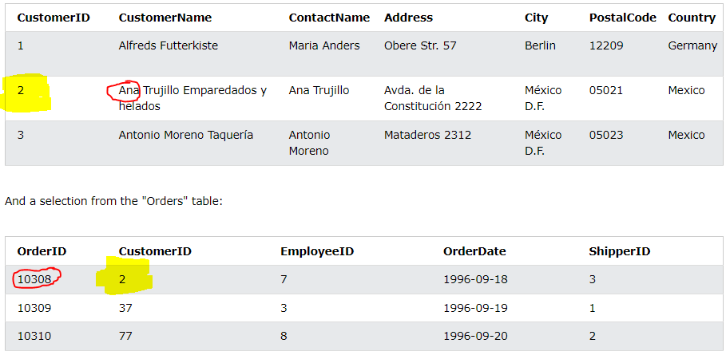
SELECT c.CustomerName, o.OrderID
FROM Customers c
FULL OUTER JOIN Orders o
ON c.CustomerID=o.CustomerID
ORDER BY c.CustomerName;
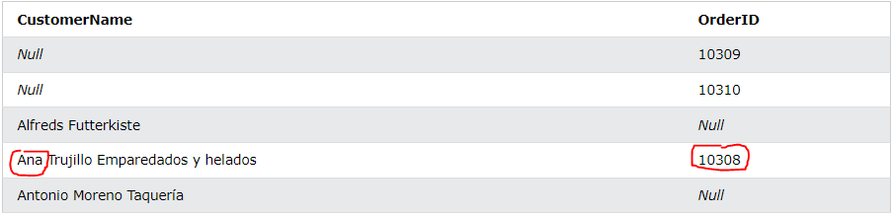

Cross
CROSS JOIN is used to combine all possibilities of the two or more tables and returns the result that contains every row from all contributing tables. The CROSS JOIN is also known as CARTESIAN JOIN, which provides the Cartesian product of all associated tables. The Cartesian product can be explained as all rows present in the first table multiplied by all rows present in the second table.
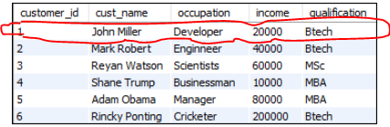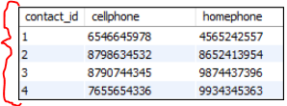
SELECT *
FROM customers
CROSS JOIN contacts;
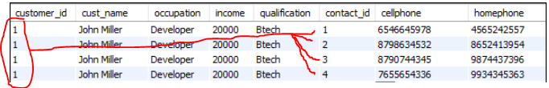
SELECT customers.customer_id, customers.cust_name, customers.income, orders.order_id, orders.price
FROM customers
CROSS JOIN orders
USING(customer_id) WHERE price>1500 AND price<5000;

SELECT * FROM customer
LEFT JOIN(orders CROSS JOIN contacts)
ON customer.customer_id=contact_id
ORDER BY income;

Self
...
Union
### Union Vs Join
They produce a result by combining data from two or more tables. But, the way of combining the data from two or more relations differ in both clauses.
MySQL Union clause allows us to combine two or more relations using multiple SELECT queries into a single result set. By default, it has a feature to remove the duplicate rows from the result set.
- The order and number of the columns must be the same in all tables.
- The data type must be compatible with the corresponding positions of each select query.
- The column name in the SELECT queries should be in the same order.
Join in MySQL is used with SELECT statement to retrieve data from multiple tables. It is performed whenever we need to fetch records from more than one tables. It returns only those records from the tables that match the specified conditions.
UNION | JOIN
It is used to combine the result from multiple tables using SQL queries. | It is used to fetch the record from more than one table using SQL queries.
It combines the records into new rows. | It combines the records into new columns.
It allows us to connect the tables vertically. | It will enable us to join the tables vertically.
It works as the conjunction of the more than one tables that sum ups all records. | It produces results in the intersection of the tables.
In this, the order and number of the columns must be the same in all tables. | In this, the order and number of the columns do not need to be the same in all tables.
It has a default feature to remove the duplicate rows from the result set. | It does not eliminate the duplicate rows from the result set.
In this, the data type must be the same in all SELECT statements. | In this, there is no need to be the same data type. It can be different.
The Union clause is applicable only when the number of columns and corresponding attributes has the same domain. | The Join clause is applicable only when the two tables that are going to be used have at least one column.
The Union clause can have mainly two types that are given below:  - Union  - Union All | The Join clause can have different types that are given below:  - Inner Join (Sometimes Join)  - Left Join (Left Outer Join)  - Right Join (Right Outer Join)  - Full Join (Outer Join)
A union always combines the result set vertically while the join appends the output horizontally.
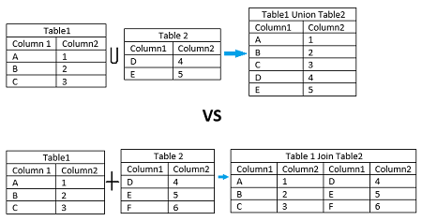

### Union Vs Union All
This operator returns all rows by combining two or more results from multiple SELECT queries into a single result set. It does not remove the duplicate rows from the result set.
# syntax
SELECT column_name(s) FROM table_1
UNION
SELECT column_name(s) FROM table_2;
SELECT stud_name AS student_name, subject AS course FROM student1
UNION
SELECT stud_name, subject FROM student2;
(SELECT stud_name, subject, marks FROM students)
UNION
(SELECT stud_name, subject, marks FROM student2)
ORDER BY marks;
SELECT column_list FROM table1
UNION ALL
SELECT column_list FROM table2;
(SELECT stud_name, subject, marks FROM students)
UNION ALL
(SELECT stud_name, subject, marks FROM student2)
ORDER BY marks;

SQL Functions
SQL Coalesce() function
The COALESCE(v1, v2, v3, ...) function in MySQL is used to return the first non-null value in a specified series of expressions. If this function evaluates all values of the list are null, or it does not find any non-null value, then it returns NULL.
IFNULL(v1, v2) function takes only two expressions. After doing an evaluation, it returns the first expression if this expression is not NULL; otherwise, it returns the second expression.
SELECT COALESCE('Mango', 'Apple', 'Orange', NULL);
>>> Mango

SELECT COALESCE(NULL, 'A', 'B', NULL);
>>> A

# to returns only the mobile number if the employee has all contacts number, else Office no., else Phone number.
SELECT Emp_id,
Name,
COALESCE(Mobile, Office, Phone)
FROM employee;

Aggregate functions
To perform calculations on multiple values and return the result in a single value.
We mostly use the aggregate functions with SELECT statements.
count() | It returns the number of rows, including rows with NULL values in a group. | SELECT COUNT(name) FROM employee;  SELECT COUNT(*) FROM employee;  SELECT COUNT(DISTINCT(name)) FROM employee;  # returns the count of the element in each group  SELECT emp_name, city, COUNT(*)  FROM employees GROUP BY city;  SELECT emp_name, emp_age, COUNT(*) FROM employees  GROUP BY emp_age  HAVING COUNT(*)>=2  ORDER BY COUNT(*);
sum() | It returns the total summed values (Non-NULL) in a set. | SELECT SUM(working_hours) AS "Total working hours" FROM employee;  # to return the total summed value for each group.  SELECT emp_id, emp_name, occupation, SUM(working_hours) AS "Total working hours"  FROM employees  GROUP BY occupation  HAVING SUM(working_hours)>24;
avg() | It returns the average value of an expression. | SELECT AVG(working_hours) AS "Average working hours" FROM employee;  SELECT emp_name, occupation,  AVG(DISTINCT working_hours)  FROM employees  GROUP BY occupation;
min() |  | SELECT MIN(working_hours) AS Minimum_working_hours FROM employee;
max() |  | SELECT MAX(working_hours) AS Maximum_working_hours FROM employee;  SELECT * FROM employees  WHERE emp_age = (  SELECT MAX(emp_age) FROM employees  );
first() | It returns the first value of an expression. Supported only in MS Access. | SELECT working_date  FROM employee  LIMIT 1;
last() | It returns the last value of an expression. Supported only in MS Access. | SELECT working_hours  FROM employee  ORDER BY name DESC  LIMIT 1;
groutp_concat() | It returns a concatenated string. It returns the concatenated string from multiple rows into a single string. | 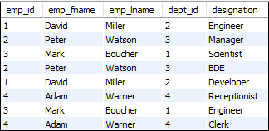  SELECT emp_id,  emp_fname,  emp_lname,  dept_id,  GROUP_CONCAT(designation)  FROM employee  GROUP BY emp_id;  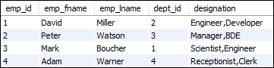  # can mention your own separator  GROUP_CONCAT(DISTINCT designation SEPARATOR '; ')

SQL Subquery
Query within another query.
Subquery is a query that is embedded in WHERE clause of another SQL query.
You can place the Subquery in a number of SQL clauses: WHERE clause, HAVING clause, FROM clause, JOIN clause.
Subqueries can be used with SELECT, UPDATE, INSERT, DELETE statements along with expression operator. It could be equality operator or comparison operator such as =, >, =, <= and Like operator.
ORDER BY command cannot be used in a Subquery. GROUPBY command can be used to perform same function as ORDER BY command.
Using from clause
select *
from (
select *
from patients
where dob >= "2000-01-01"
order by master_ids
) p
where p.name ilike '%m';

Using where clause

Just like arithmatic operators subqueries can be used with IN and NOT IN statements. With operators with compare with a single value but with IN statement we compare with a column.

Select NAME, LOCATION, PHONE_NUMBER
from DATABASE
WHERE ROLL_NO IN
(
SELECT ROLL_NO
from STUDENT
where SECTION=’A’
);
DELETE FROM Student2
WHERE ROLL_NO IN ( SELECT ROLL_NO
FROM Student1
WHERE LOCATION = ’chennai’);
UPDATE Student2
SET NAME=’geeks’
WHERE LOCATION NOT IN ( SELECT LOCATION
FROM Student1
WHERE NAME IN (‘Raju’,’Ravi’)
);
select *
from surgical_encounters
where total_profit > ALL (
select avg(total_cost)
from surgical_encounters
group by diagnosis_description
);

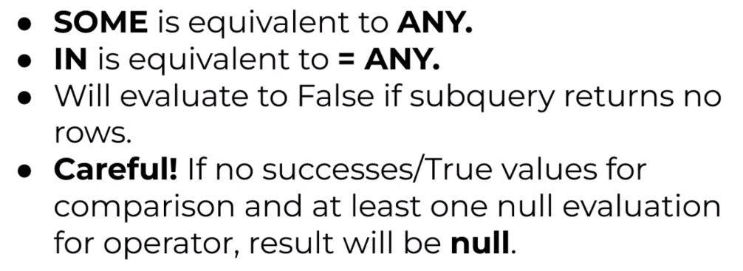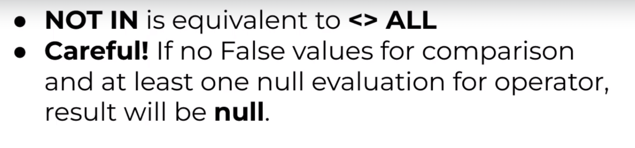
To see if the subquery returns any result
When subquery returns NULL, result of EXISTS evaluates to True.

select *
from encounters e
where EXISTS(
select 1
from orders o
where e.id = o.id
);

Using CTEs
- Used to break down complex queries into simpler one's.
- CTEs create table that exists only for that query and can be reused multiple times within that single query.
- As compared to FROM clause options, CTEs can be kept at start of query can be resued later multiple times, making it more readable.
- WITH table_name as (select ...)
- can be used with create, update, delete, select (CRUD) operations.

with young_patients as (
select *
from patients
where dob >= '2000-01-01'
)

select *
from young_patients
where name ilike 'm%';
with top_counties as (
select county, count(*) as num_patients
from patients
group by county
having count(*) > 1500
),
county_patients as (
select p.master_ids, p.county
from patients as p
inner join top_counties as t
on p.county = t.county
)

select cp.county, count(se.surgery_id) as num_surgeries
from surgical_encounters as se
inner join county_patients cp
on cp.master_id = se.master_id
group by cp.county;

Using Joins
select se.*
from (
select *
from surgical_encounters
where surgery_adimssion_date
between '2016-11-01' and '2016-11-30'
) se
inner join (
select *
from patients
where dob >= '2000-12-31'
) p
on p.master_ids = se.master_ids;

Views
- Its is basically a stored SELECT query.
- Has no data of its own
- It does NOT store the underlying data.
- The View and table have one main difference that the views are definitions built on top of other tables (or views).
- If any changes occur in the underlying table, the same changes reflected in the View also.
Why create views?
- Simplify/replace complex queries.
- Avoid breakage with schema changes.
- Restrict data access.
CREATE view v_monthly_surgery_stats_by_deparment AS (
select
unit_name,
count(surgery_id) as num_surgeries,
sum(total_cost) as total_cost,
sum(total_profit) as total_profit
from surgical_encounters
group by departments
order by units
);

select *
from v_monthly_surgery_stats_by_deparment
limit 5;

Modifying and Deleting views
SELECT *
FROM information_schema.views;

CREATE OR REPLACE view my_view AS (
Select ...
);

ALTER VIEW if exists v_monthly_surgey_stats
rename to view_monthly_stats;

DROP VIEW v_monthly_surgey_stats;
DROP VIEW IF EXISTS v_monthly_surgey_stats;

By default, view in postgress are updatable. INSERT, UPDATE, DELETE will work when certain conditions are met. Useful for certain users to update certain columns.
View can be updatable if it has:
- No window function
- No aggregate function
- No limit
- No groupby/having clause
- No set operations
- Is built on single table.
with check option
Issue is that, users can alter/insert into the underlying table data through the view. So to avoid this we can use with check option where user can alter/insrto into underlying table only if they have access to that particular id in the given view.
create or replace view v_monthly_surgeries_22100005 as
select
deparmnt_id,
encounter_id,
patinet_flag
from encounters
where department_id = 22100005
with check option;

insert into v_monthly_surgeries values_22100005 values
(12346, 5611, 22100006, 'Yes');

-- this query throws error because, id 22100006 is not visible in view v_monthly_surgeries_22100005, so it can not be inserted also into the underlying encounters table

Recursive Views
...
Materialized view
We know, views don’t store underlying data inside the view. With materialized views, we can store the underlying data in a view. This helps give speed of access along with conveneince of view.
WITH DATA: the view is populated with the underlying data
WITH NO DATA: the view is populated without the underlying data.
CREATE MATERIALIZED VIEW
v_high_frequency_calls AS (
select prod_vod_c
from call2_vod_c
group by product_vod_c
)
WITH DATA;

# to refresh the view from the updated underlying data
REFRESH MATERIALIZED VIEW
v_monthly_surgeries;

DROP materialized view
If exists v_monthly_surgeries;

ALTER materialized view v_monthly_surgeries
rename to view_monthly_stats;

Stored Procedures
A procedure (often called a stored procedure) is a collection of pre-compiled SQL statements stored inside the database. It is a subroutine or a subprogram in the regular computing language. A procedure always contains a name, parameter lists, and SQL statements. We can invoke the procedures by using triggers, other procedures and applications such as Java, Python, PHP, etc.
First select a database that will store the newly created procedure.
- Stored Procedure increases the performance of the applications. Once stored procedures are created, they are compiled and stored in the database.
- Stored procedure reduces the traffic between application and database server. Because the application has to send only the stored procedure's name and parameters instead of sending multiple SQL statements.
- Stored procedures are reusable and transparent to any applications.
- A procedure is always secure. The database administrator can grant permissions to applications that access stored procedures in the database without giving any permissions on the database tables.
- if we overuse many logical applications inside stored procedures, the CPU usage will increase. It is because the database server is not well designed for logical operations.
- Stored procedure's constructs are not designed to develop complex and flexible business logic.
- It is difficult to debug stored procedures. Only a few database management systems allow us to debug stored procedures.
- Developing and maintaining stored procedures are often required a specialized skill set that not all application developers possess.
### MySQL
USE employee_db;

CREATE PROCEDURE us_customers ()
BEGIN
SELECT customer_id, first_name
FROM Customers
WHERE Country = 'USA';
END;

CALL us_customers();
DROP PROCEDURE us_customers;

### SQL Server
CREATE PROCEDURE us_customers
AS
SELECT customer_id, first_name
FROM Customers
WHERE Country = 'USA';

EXEC us_customers;
CREATE PROCEDURE get_merit_student ()
BEGIN
SELECT * FROM student_info WHERE marks > 70;
SELECT COUNT(stud_code) AS Total_Student FROM student_info;
END;
### Used the IN parameter as 'var1' of integer type to accept a number from users.
CREATE PROCEDURE get_student (IN var1 INT)
BEGIN
SELECT * FROM student_info LIMIT var1;
SELECT COUNT(stud_code) AS Total_Student FROM student_info;
END;
mysql>>> CALL get_student(4);
###
CREATE PROCEDURE display_max_mark (OUT highestmark INT)
BEGIN
SELECT MAX(marks) INTO highestmark FROM student_info;
END;
mysql>>> CALL display_max_mark(@M);
mysql>>> SELECT @M;
SHOW PROCEDURE STATUS WHERE db = 'mystudentdb';

DROP PROCEDURE display_marks;

Triggers (a specific class of stored procudeure)
A trigger is a stored procedure in a database that automatically invokes whenever a special event in the database occurs.
For example, a trigger can be invoked when a row is inserted into a specified table or when specific table columns are updated in simple words a trigger is a collection of SQL statements with particular names that are stored in system memory.
It belongs to a specific class of stored procedures that are automatically invoked in response to database server events. Every trigger has a table attached to it.
Because a trigger cannot be called directly, unlike a stored procedure, it is referred to as a special procedure. A trigger is automatically called whenever a data modification event against a table takes place, which is the main distinction between a trigger and a procedure. On the other hand, a stored procedure must be called directly.

The following are the key differences between triggers and stored procedures:
- Not Manual - Triggers cannot be manually invoked or executed.
- Not Automatic - There is no chance that triggers will receive parameters.
- No rollback - A transaction cannot be committed or rolled back inside a trigger.
Ex. we could create a trigger to insert the required data into a different table if the primary table underwent any changes.
Disadvantage of Triggers
- Only triggers permit the use of extended validations.
- Automatic triggers are used, and the user is unaware of when they are being executed. Consequently, it is difficult to troubleshoot issues that arise in the database layer.
- The database server’s overhead may increase as a result of triggers.
- In a single CREATE TRIGGER statement, we can specify the same trigger action for multiple user actions, such as INSERT and UPDATE.
- Only the current database is available for creating triggers, but they can still make references to objects outside the database.
Advantage of Triggers
- Database object rules are established by triggers, which cause changes to be undone if they are not met.
- We can enforce data integrity thanks to triggers.
- Data is validated using triggers before being inserted or updated.
- Triggers assist us in maintaining a records log.
- Due to the fact that they do not need to be compiled each time they are run, triggers improve the performance of SQL queries.
- The client-side code is reduced by triggers, saving time and labor.
- Trigger maintenance is simple.
Types of triggers:
- DDL trigger
- DML trigger
- LOGON trigger - When a user session is created with a SQL Server instance after the authentication process of logging is finished. Used to track login activity or set a limit on the number of sessions that a given login can have in order to audit.
Before Triggers are used to update or validate record values before they’re saved to the database. After Triggers are used to access field values that are set by the system and to effect changes in other records. The records that activate the after trigger are read-only. We cannot use After trigger if we want to update a record because it will lead to read-only error. Row-level trigger gets executed before or after any column value of a row changes. Column Level Trigger gets executed before or after the specified column changes.
The trigger body can access the column's values, which are affected by the DML statement. The NEW and OLD modifiers are used to distinguish the column values BEFORE and AFTER the execution of the DML statement. We can use the column name with NEW and OLD modifiers as OLD.col_name and NEW.col_name. The OLD.column_name indicates the column of an existing row before the updation or deletion occurs. NEW.col_name indicates the column of a new row that will be inserted or an existing row after it is updated.
Trigger Event | OLD | NEW
INSERT | No | Yes
UPDATE | Yes | Yes
DELETE | Yes | No

# SYNTAX

CREATE TRIGGER Trigger_Name
(Before | After) [ Insert | Update | Delete]
ON [Table_Name]
[ for each row | for each column ]
BEGIN
[ trigger_body ]
END;
DROP TRIGGER trigger name;

DROP TRIGGER IF EXISTS employeedb.before_update_salaries;
SHOW TRIGGERS;

SHOW TRIGGERS
IN database_name;

SHOW TRIGGERS
FROM mysqltestdb
WHERE table = 'employee';
# calculate percentage of the student as soon as his details are updated to the database.

CREATE TRIGGER sample_trigger
before INSERT
ON student
FOR EACH ROW
SET new.total = new.marks/6;
# Automatically add 100 to marks column.

CREATE TRIGGER calculate_total
before INSERT
ON student
FOR EACH ROW
SET new.marks = new.marks+100;
CREATE TRIGGER total_mark
after insert
ON student
FOR EACH ROW
insert into Final_mark values(new.marks);
# automatically insert the working_hrs = 0 if someone tries to insert working_hrs < 0.

Create Trigger before_insert_empworkinghours
BEFORE INSERT
ON employee
FOR EACH ROW
BEGIN
IF NEW.working_hours < 0 THEN SET NEW.working_hours = 0;
END IF
END;
# automatically insert new record in another table also

Create Trigger after_insert_details
AFTER INSERT
ON student_info
FOR EACH ROW
BEGIN
INSERT INTO student_detail VALUES (new.stud_id, new.stud_code,
new.stud_name, new.subject, new.marks, new.phone, CURTIME());
END;
# create the backup of records before it is deleted

CREATE TRIGGER before_delete_salaries
BEFORE DELETE
ON salaries
FOR EACH ROW
BEGIN
INSERT INTO salary_archives (emp_num, valid_from, amount)
VALUES(OLD. emp_num, OLD.valid_from, OLD.amount);
END;
# updates the total salary into the total_salary_budget table after a row is deleted from the salaries table.

CREATE TRIGGER after_delete_salaries
AFTER DELETE
ON salaries FOR EACH ROW
BEGIN
UPDATE total_salary_budget SET total_budget = total_budget - old.amount;
END;

SQL Injection
SQL injection is a code injection technique that might destroy your database.
SQL injection is one of the most common web hacking techniques.
SQL injection is the placement of malicious code in SQL statements, via web page input.

Normalization in SQL
Normalization is a database design technique that reduces data redundancy and eliminates undesirable characteristics like Insertion, Update and Deletion Anomalies.
Normalization rules divides larger tables into smaller tables and links them using relationships.
Data Integrity: The purpose of Normalisation in SQL is to eliminate redundant (repetitive) data and ensure data is stored logically.
Data consistent by storing the data in one table and referencing it everywhere else.
Storage optimization although that is not an issue these days because Database storage is cheap.
It is a multi-step process that puts data into tabular form, removes duplicate data, and set up the relationship between tables.
Insertion, Updation, and Deletion Anomalies are very frequent if the database is not normalized.
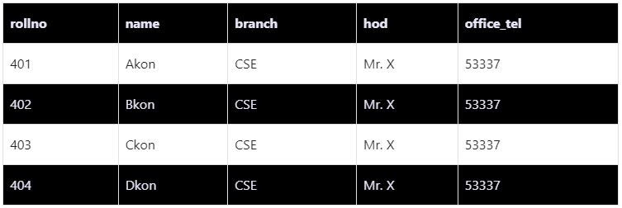
Insertion Anomaly :
If you have to repeat the same data in every row of data, it's better to keep the data separately and reference that data in each row. We can keep the branch information separately, and just use the branch_id in the student table
Updation Anomaly :
What if Mr. X leaves the college? or Mr. X is no longer the HOD of the computer science department? In that case, all the student records will have to be updated, and if by mistake we miss any record, it will lead to data inconsistency. This is an Updation anomaly because you need to update all the records in your table just because one piece of information got changed.
Deletion Anomaly :
If only a single student is enrolled in a branch, and that student leaves the college, or for some reason, the entry for the student is deleted, we will lose the branch information too. So never in DBMS, we should keep two different entities together, which in the above example is Student information and Branch information.

The inventor of the relational model Edgar Codd proposed the theory of normalization of data with the introduction of the First Normal Form, and he continued to extend theory with Second and Third Normal Form. Later he joined Raymond F. Boyce to develop the theory of Boyce-Codd Normal Form.
- 1NF (First Normal Form)
- 2NF (Second Normal Form)
- 3NF (Third Normal Form)
- BCNF (Boyce-Codd Normal Form)
- 4NF (Fourth Normal Form)
- 5NF (Fifth Normal Form)
- 6NF (Sixth Normal Form)
However, in most practical applications, normalization achieves its best in 3rd Normal Form.
1NF (First Normal Form) Rules
- Each table cell should contain a single value.
- Each record needs to be unique.
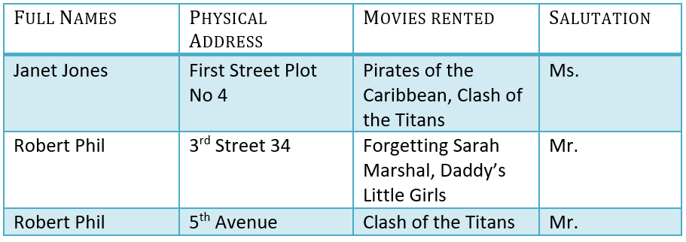 | 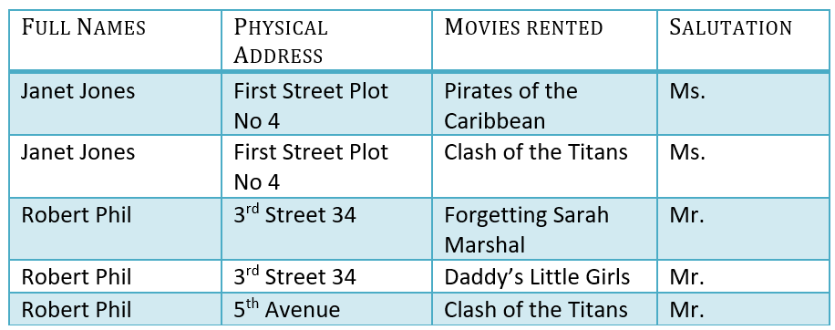
Solution: -
- Remove the movies_rented column from the table and keep it in some other table. OR
- Add multiple rows for the names and each row is linked with one rented movie.
2NF
A primary is a single column value used to identify a database record uniquely. A composite key is a primary key composed of multiple columns used to identify a record uniquely.
- Rule 1- Be in 1NF
- Rule 2- It should not have partial dependency. Single Column Primary Key that does not functionally dependant on any subset of candidate key relation.
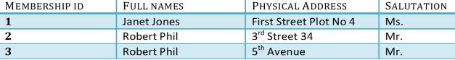

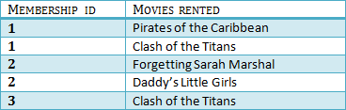
You will only be able to insert values into your foreign key that exist in the unique key in the parent table. This helps in referential integrity.
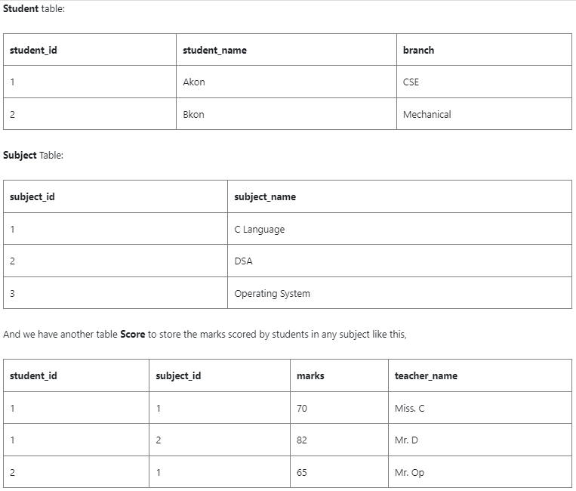
Now in the above table, the primary key is student_id + subject_id, because both these information are required to select any row of data.
But in the Score table, we have a column teacher_name, which depends on the subject information or just the subject_id, so we should not keep that information in the Score table.
The column teacher_name should be in the Subjects table. And then the entire system will be Normalized as per the Second Normal Form.

3NF
A transitive functional dependency is when changing a non-key column, might cause any of the other non-key columns to change. Ex. A value from full name (Robert) if changed to (Lia) might cause value in column salutation to change from (Mr.) to (Mrs.).
- Rule 1- Be in 2NF
- Rule 2- Has no transitive functional dependencies
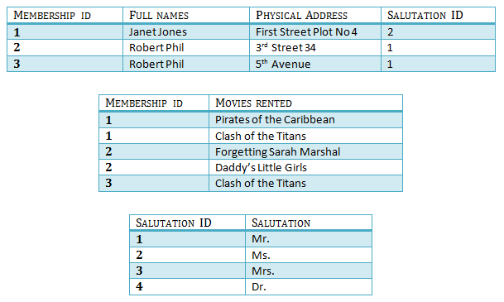

BCNF
Boyce and Codd Normal Form is a higher version of the Third Normal Form.

Transaction
...
Grouping Sets
...
Table Inheritence
...

