**Instructions for Chat Server + Client**

**Both programs are written in Python - Version 3**

* **CHAT SERVER**
  + 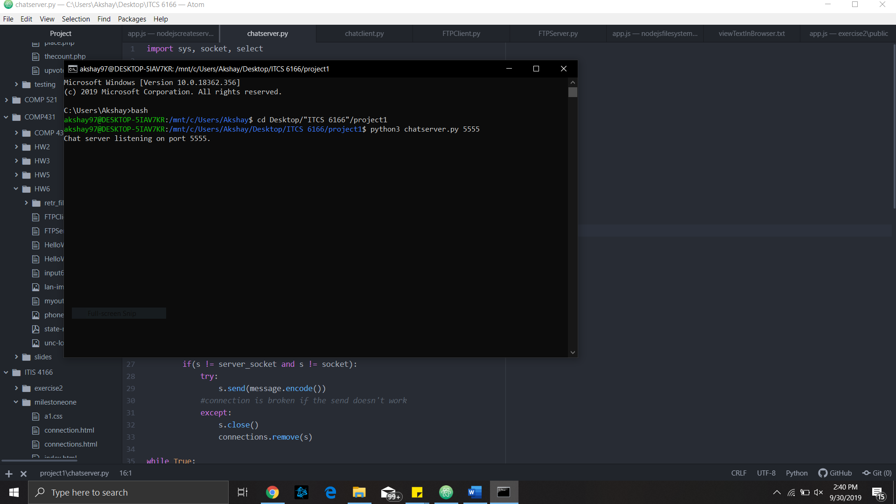To start the chat server, please run the program with 1 parameter being the port number which you would like your server to run on.
  + If the port number is busy or invalid, then there will be an error message and the program will exit automatically telling you to please try again. Once started, the server logs all messages in the chat along with the user that said the message.
  + To stop the server simply press ctrl+c to exit.
* **CHAT CLIENT**
  + To use the chat client, make sure your server is up and running first and note the port number it is running on.
  + 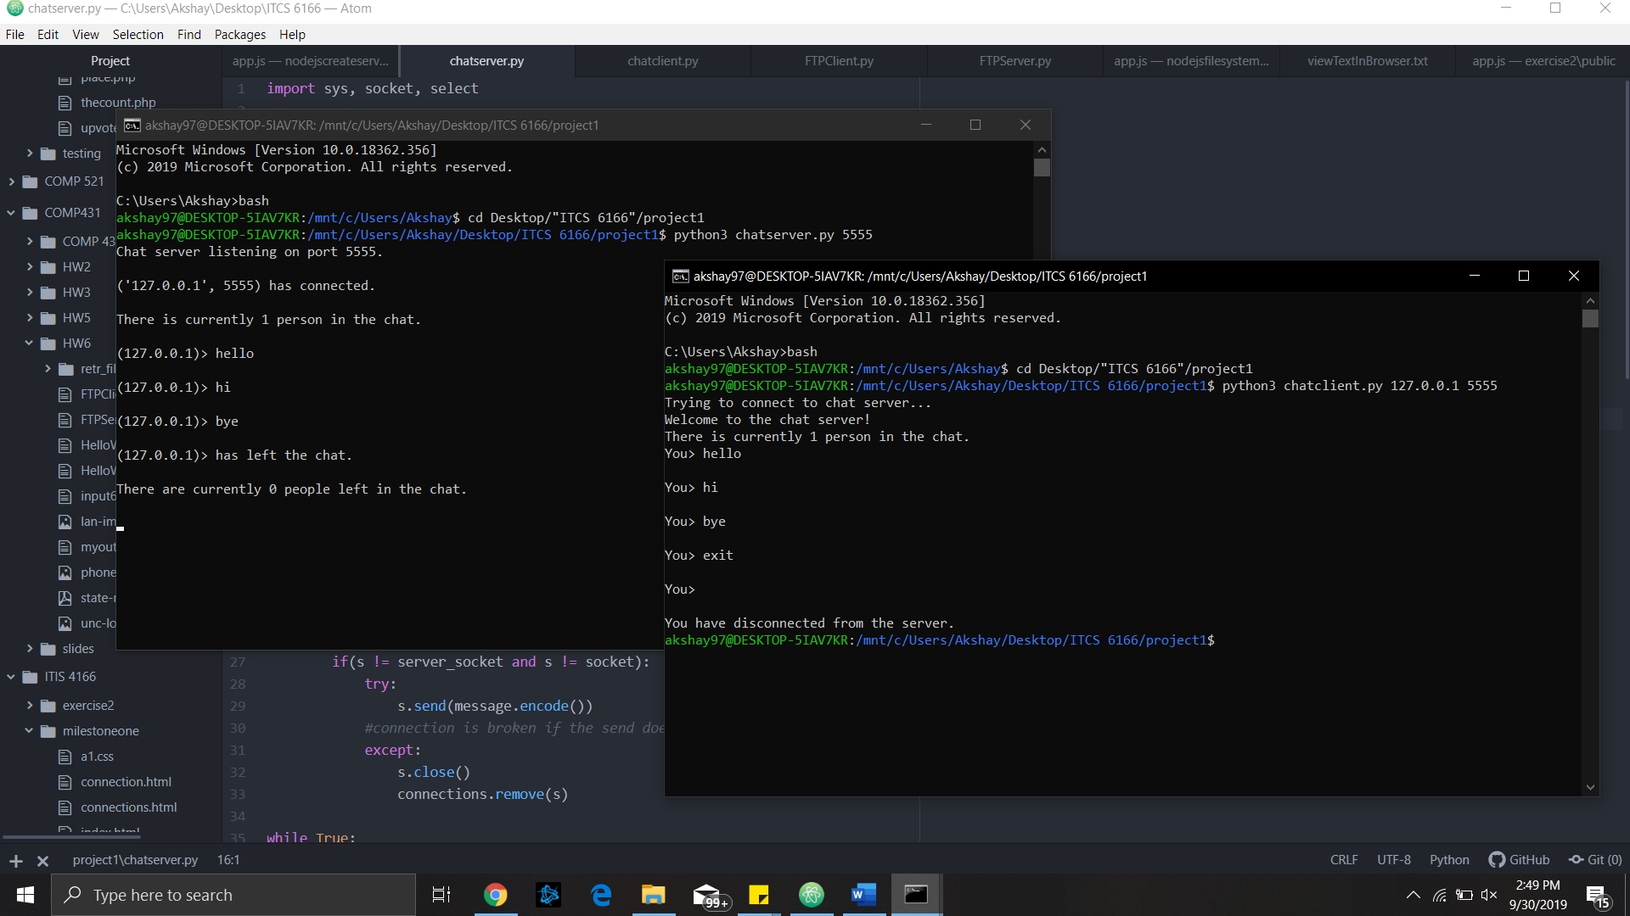To connect, run the program with 2 parameters. The first is the IP address of the machine running the server, most likely local host “127.0.0.1”. The second parameter should be the port number the server is running on. If either of these are incorrect, there should be appropriate error messages and the program should exit for you to try again.
  + Type messages into the chat as you would normally in any chat server.
  + To exit, type “EXIT” (upper or lower case for any letter) and press enter. The connection to the server will close as well as the program.