1. **Project Overview**
   * This is a website for a guild in Classic WoW. Users will most likely be guild members but anybody can create an account and sign up for events that members have created. Anyone who has signed in is able to create new events, update those events, or delete them if they so choose. User-specific rsvp’s are saved in the user’s profile persistently. Delete functionality is also available to the creator if they no longer wish to hold the event; a creator deleting a connection will remove it for everyone. This web application is targeted to anybody who plays Classic WoW because even people without a guild can still join in on guild events and create events of their own. The events are up to the members, whether it be for “PvP”, “Raiding”, a “Social Event”, or anything else players can think of. If an event type doesn’t exist already, it will simply be created and added to the connections page. Everyone can view this connections page as well as the about and contact pages for information about the guild. Furthermore, everyone is able to view connection information for any connection on the connections page. Every connection is created by a member and its information can only be updated by the member who created that connection.
   * Sample User Information
     + Username: “jspringer”, Password: “1234” for Jerry
     + Username: “bbuilder”, Password: “qwer” for Bob
     + Username: “bhader”, Password: “asdf” for Bill
     + Username: “hpotter”, Password: “zxcv” for Harry
     + Username: “jswanson”, Password: “5678” for Joe
2. **Site Map**

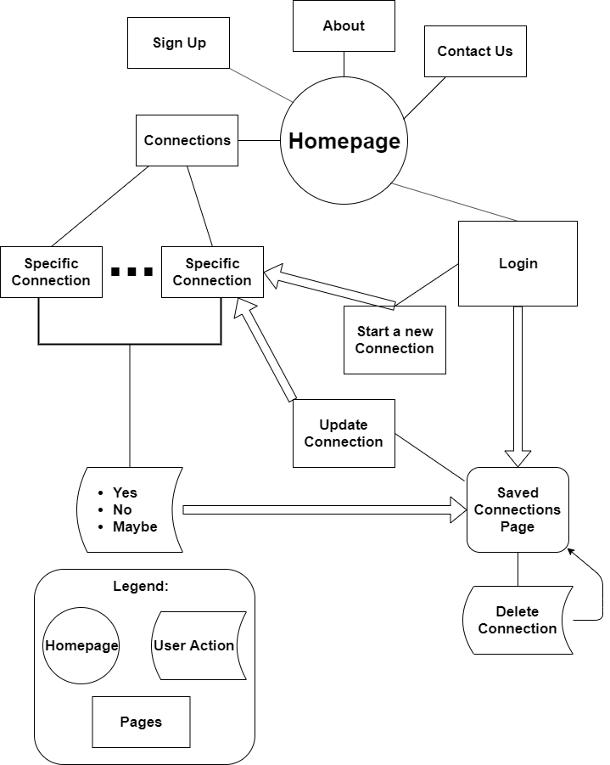

1. **Page Design**

* Headers and Footers
  + 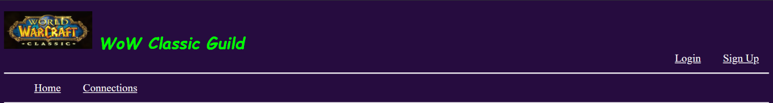All pages have similar headers and footers. Only the header changes while the user is logged in. If not logged in the header shown is
  + When not logged in the user can use the header to visit the homepage (by clicking link or icon), connections page, login page, or sign up page.
  + 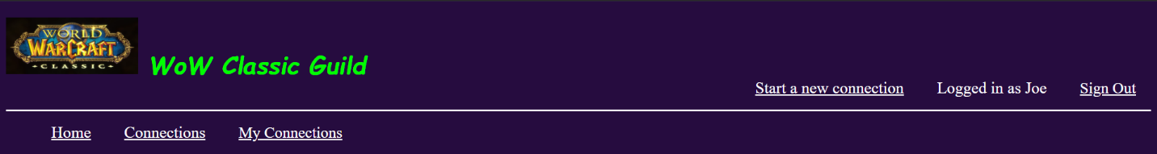While logged in, the header shown is
  + ****When logged in the user can use the header to visit the homepage (by clicking link or icon), connections, login, or sign up pages as before. However, now they are also able to view their profile by the “My Connections” link, as well as visit the “Start a new connection” page to create their own connection. While logged in and browsing the site, the first name is shown of the logged-in user. A “Sign Out” link is also provided to sign-out of the web application whenever the user wants to. Clicking on it will destroy the current session, log out the currently logged in user, and redirect to the homepage with the not logged in header.
  + The same footer is shown on all pages while logged in or not. It provides links to the “about” and “contact us” pages.
* Homepage
  + The homepage provides information about the web application and other very general information about the website.
  + The audience is for everyone (new or returning) to have a welcome page when they visit the website.
  + 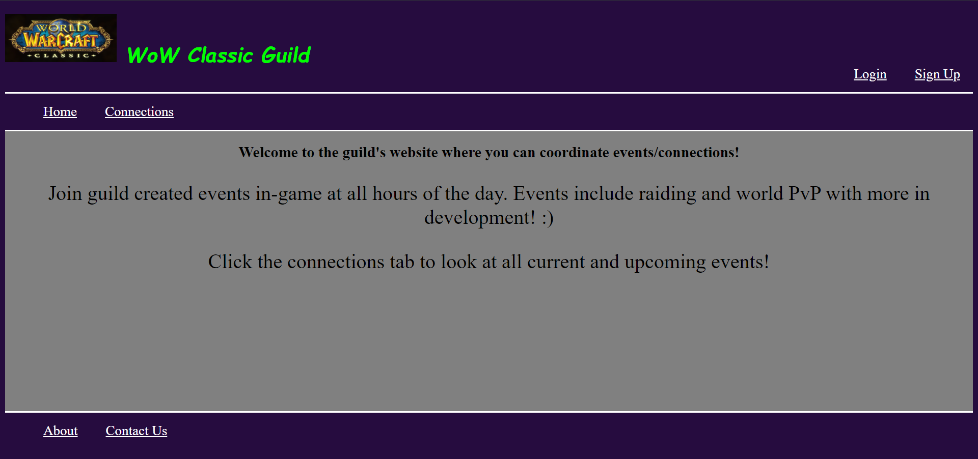Everything displayed is static data, no validation necessary, hyperlinks for navigation exist in the header and footer.
* About Page
  + The “about” page provides information about the guild and its members. It also says which server they are located in.
  + The audience is for anyone new seeking more information about the guild or wishing to join it
  + 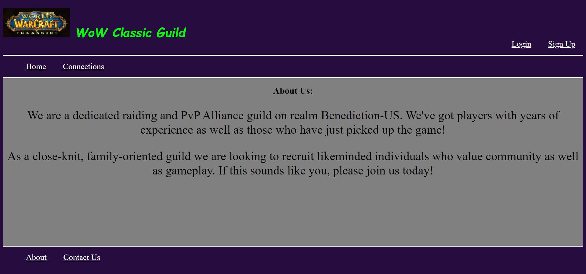All data is static.
* Contact Page
  + The “contact” page provides information on how to reach the guild for questions or information on joining.
  + The audience is for anyone that wishes to contact the guild.
  + 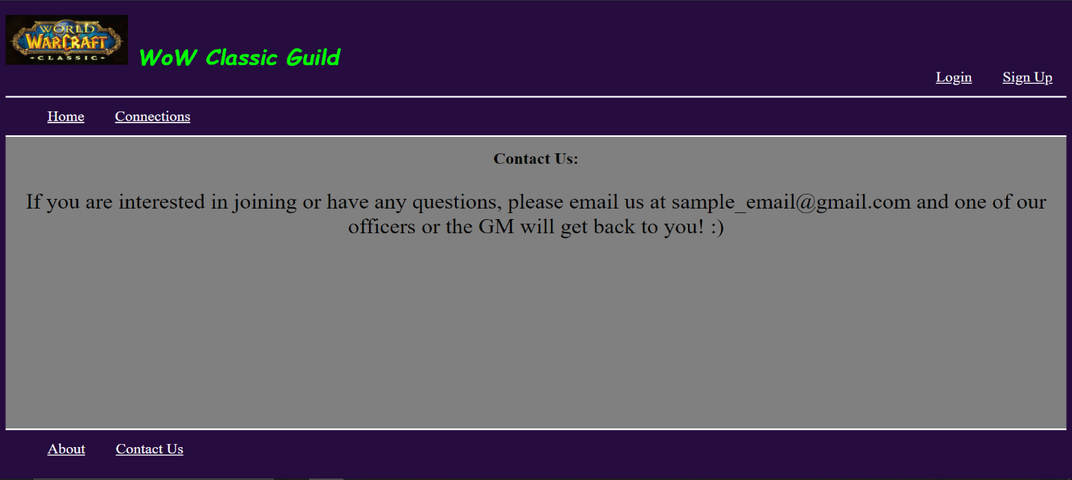All data is static.
* Connections Page
  + The connections page features a dynamic list of connections created by users of the guild’s website and stored on the website’s mongoDB. Their titles are displayed under their user-provided categories and can be clicked on to be sent to their specific connection page.
  + The audience is for everyone and the purpose is to see what connections are available at any time.
  + 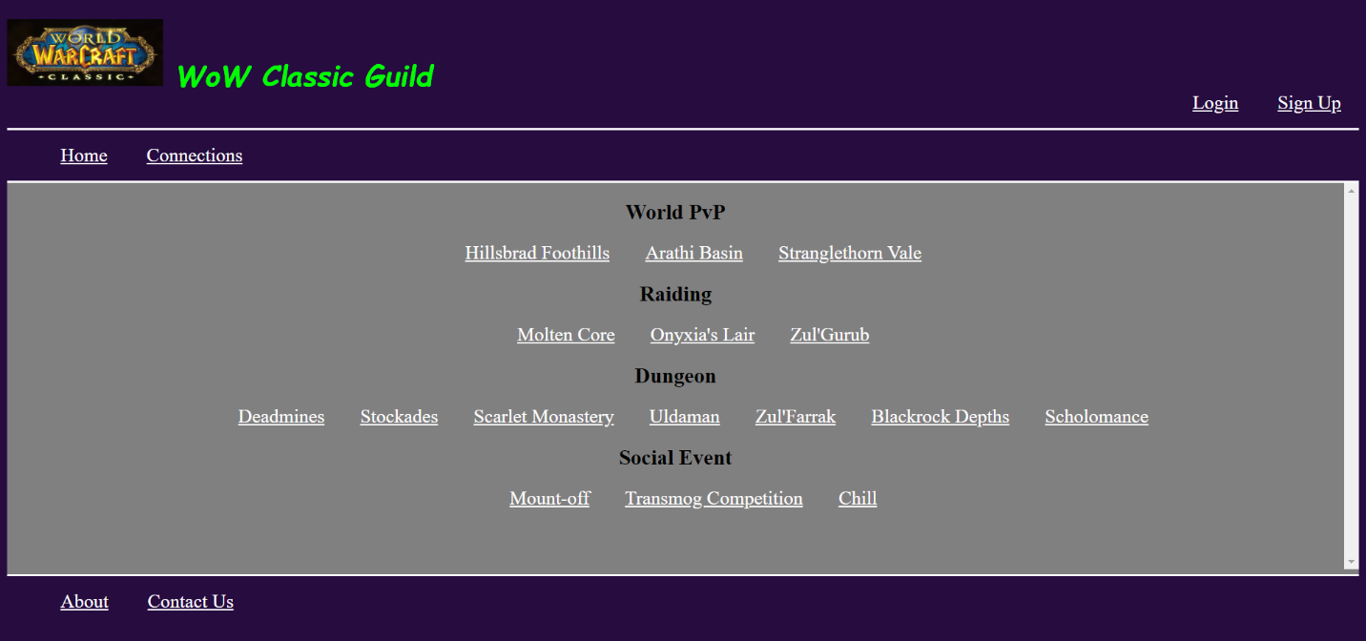Everything displayed is dynamic. No XSS provided through title or category will run for security.
* Specific Connection Page
  + There is a connection page for every connection that exists in the database. The layout of the connection page is the same for every connection. Displayed is the photo of the user, connection information and “Yes”, “No” and “Maybe” buttons.
  + The audience is for everyone, but those that are logged in may use the “Yes”, “No” and “Maybe” buttons to rsvp to the specific connection and save it in their profile with whatever rsvp they chose. Choosing to rsvp to a connection already saved will update the rsvp for the user. If a user is not logged in, the buttons simply redirect to the login page.
  + 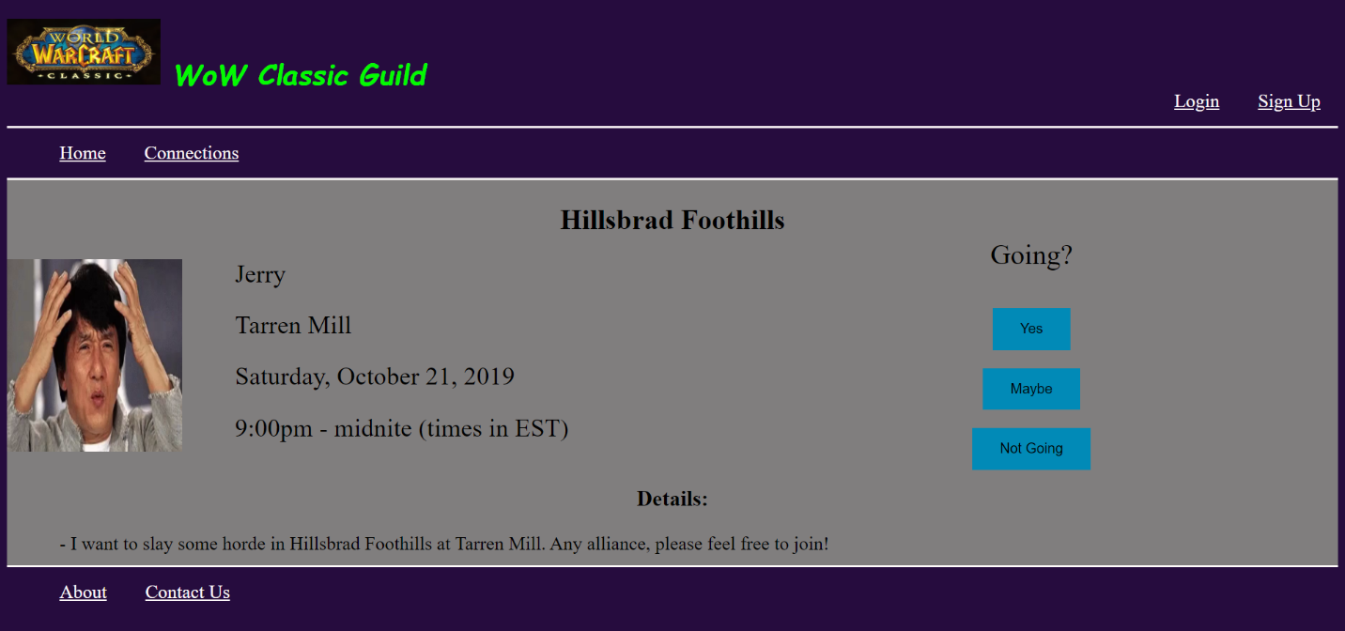All of the information is dynamic and retrieved from the mongoDB hosted by the web application. Information can be updated by the creator by clicking update on the connection in their saved connections list. No XSS can be entered through the connection fields.
* Sign Up Page
  + The sign-up page features a form for users to fill in their information and create an account for the website.
  + The audience is for new users who wish to create an account with the website.
  + 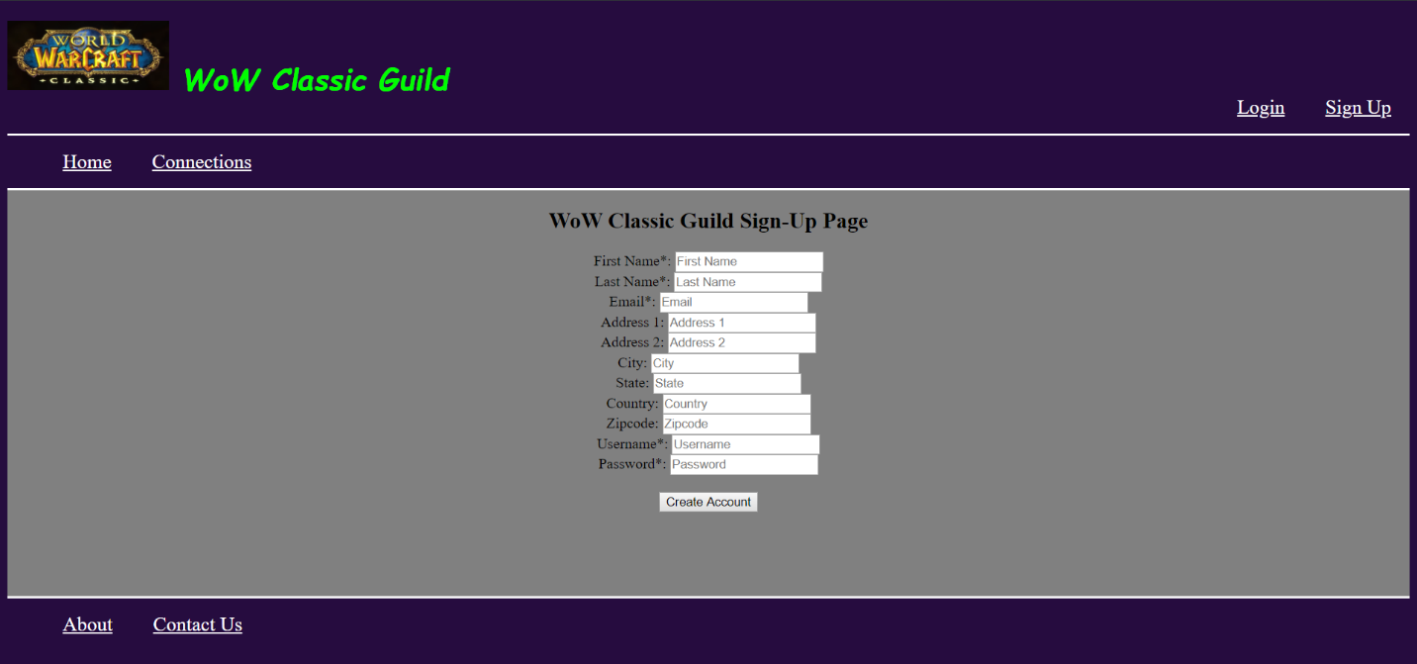All of the input is validated upon form submission and escaped. All of the required fields are marked with an asterisk. Everything is stored in the mongodb and passwords are hashed using the sha-256 algorithm and salted (with the first name of the user) and then stored. Only hashes of passwords are stored for security. Upon successful sign-up, the user is redirected to their profile which will be empty at first and will update as they add/save/update/delete connections.
* Login Page
  + The login page features a simple login form with a field for username and a field for password.
  + The audience is for users who wish to login to the website.
  + 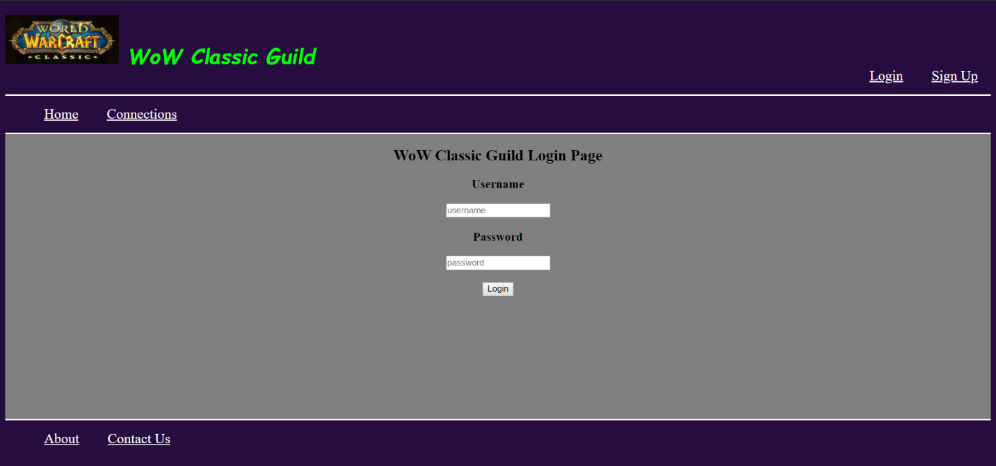Inputs are escaped and the password entered is hashed and checked against the hashed password stored in the mongoDB for the specific user. If either field does not match a user in the database, login will be unsuccessful and a message displayed for invalid username or password. Requirements are also stated if they are not met (username must be alphanumeric and password must be at least 2 characters).
* Saved Connections or Profile Page
  + The saved connections page features a table with four columns of currently saved connections for the user including the connection’s title, category, and currently saved rsvp. The fourth column provides buttons for each specific connection on whether to update the user’s rsvp or delete it from their list of connections.
  + If the “Update” button is clicked the user is navigated to the specific connection’s page where they can then click “Yes”, “No”, or “Maybe” to update their rsvp. Clicking the “Delete” button will remove the connection from their list of saved connections. The “Update” button is changed to the “Update Connection Info” button for connections for which they are the creator. When clicked, this will redirect the user to the “update a connection” page which provides a form that allows the creator of the connection to update connection info at any time. Clicking on the “Delete” button for created connections will remove the connection from the database as well as remove it from any user’s table who had saved the connection.
  + The audience is for all registered and successfully authenticated users.
  + 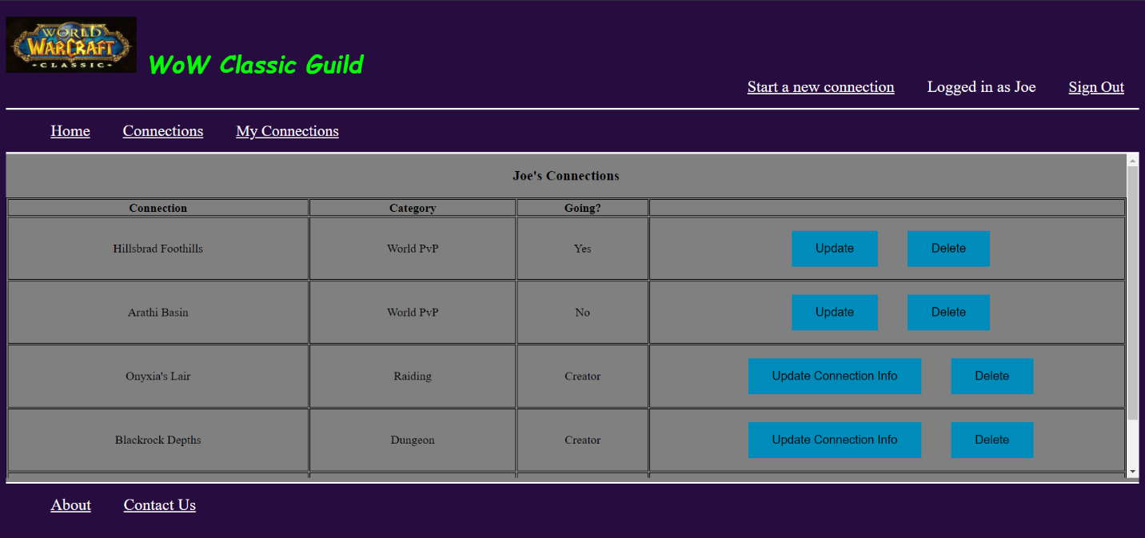All of the data displayed is dynamic, there is no input but as before there is no XSS possible with connection titles and categories.
* Start a new connection page
  + The start a new connection pages features a form which allows the currently logged in user to start a new connection. Users provide the connection type, title, name of their character, details about the connection, where it will happen in-game, and the date and time of the connection.
  + The audience is for users who are logged in and who wish to start a new connection for others to see and subsequently rsvp for.
  + 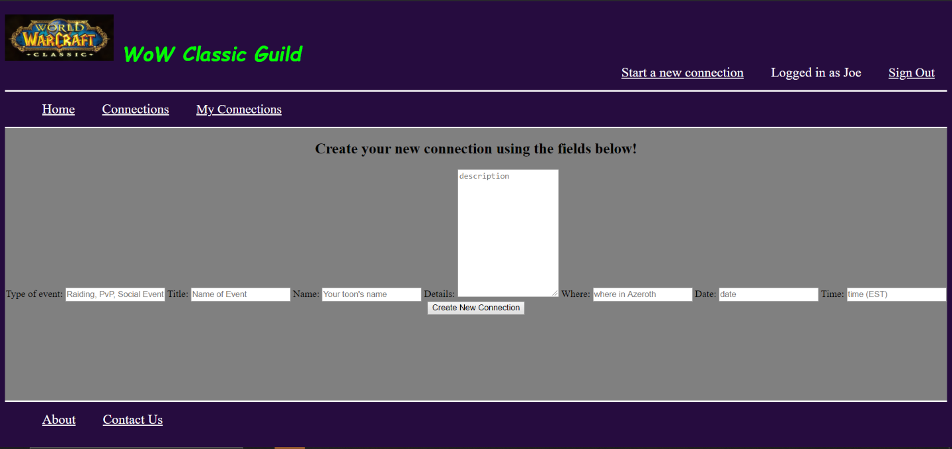Upon form submission all of the inputs are validated and escaped for security. If unsuccessful, an error message is displayed to the user so they know to try again. Upon success, the connection is added to the database and added to the user’s list of connections with the rsvp of “Creator”. Creators are expected to go to their own events. Once the connection is saved the user is redirected to their recently updated profile and the connection is viewable via the connections page for everyone.
* Update a connection page
  + This page features a form identical to the start a new connection form in order for a creator to update an existing connection. This page can only be accessed after clicking the button “Update Connection Info” on the user’s saved connections table. For whichever created connection the user clicks the button for, the form will show the title of the connection they chose to update directly above the form.
  + The audience is for users who are logged in that wish to update connection information for a connection they have created.
  + 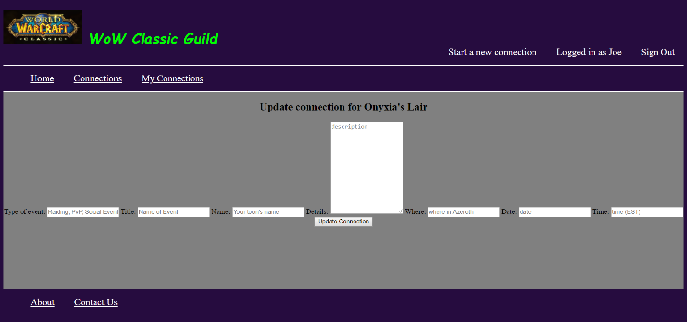This form features the same validation and escapes as the “start a new connection” form. Upon successful submission the form will update the connection in the database and subsequently update its information for anyone who had saved the connection.

1. **ER Diagram**

