DATA VISUALIZATION
AND COMMUNICATION
What do annual CO₂ emissions reveal about the global emissions landscape?
Week 5 Task | Data Visualization and Communication
Prepared by: [Your Full Name] | Date: 19 October 2026

1. Abstract
This report uses data from Our World in Data (OWID), drawing on the Global Carbon Budget (2025), to communicate patterns in annual territorial carbon dioxide (CO₂) emissions. The analysis focuses on a 2024 comparison of selected major emitting countries and a rounded, high-level trend comparison for China, the United States and India. Three visualizations—a ranked horizontal bar chart, a global-share chart and a multi-series trend chart—were selected to answer different questions: who emits the most, how the selected countries compare with the rest of the world, and how the largest emitters' trajectories differ over time. The results show that China is the largest emitter among the selected countries, while the United States and India are the next two in the comparison. The charts also highlight that emissions trajectories are not identical across countries. These patterns are useful for communicating the scale and distribution of emissions, but they should not be interpreted as a complete measure of climate responsibility: the data represent territorial emissions and exclude land-use change. Historical trend points are rounded for exploratory communication; precise analysis should use the source dataset directly.

2. Objective and research questions
The objective is to transform emissions data into clear, accessible visual evidence and a coherent narrative. The analysis asks: (1) Which selected countries have the largest annual CO₂ emissions in 2024? (2) How large is the combined contribution of these selected countries compared with the global total? (3) How have China, the United States and India differed in their broad emissions trajectories since 2000?

3. Dataset and preparation
The source is Our World in Data's “Annual CO₂ emissions” indicator, with the Global Carbon Budget (2025) identified as the data source. The indicator measures annual CO₂ emissions from fossil fuels and industry; land-use change emissions are not included. The 2024 values shown on the source page are approximately 12.3 billion tonnes for China, 4.9 billion for the United States, 3.19 billion for India, 572 million for Germany, 483 million for Brazil, 313 million for the United Kingdom and 264 million for France. The reported global total is approximately 38.6 billion tonnes. For readability, the project stores the selected values in a compact CSV. The trend chart uses rounded, exploratory values at four selected years; those values are explicitly labeled as rounded and should not be used for precise scientific comparisons.
Source: https://ourworldindata.org/grapher/annual-co2-emissions-per-country
Preparation steps: select the relevant country/year values; express all country values in billion tonnes; retain units in chart labels; sort the comparison chart in ascending order so the largest bar appears at the top; calculate the remainder as the global total minus the selected countries' combined total; and label the trend series and years consistently. The source dataset can change as it is updated, so this report records the access date and uses a clear limitation statement.

4. Visualization 1 — Country ranking
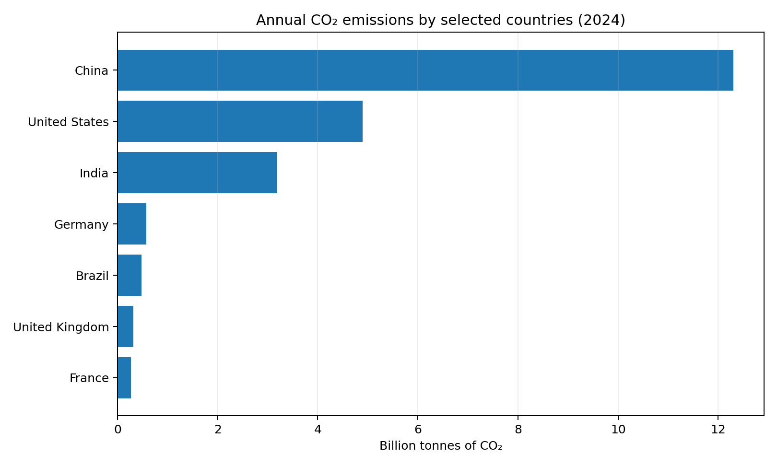
Why this chart: a horizontal bar chart is effective for comparing categories because bar length shares a common baseline, while country names remain easy to read. Sorting the values supports rapid ranking. The chart shows China clearly ahead of the other selected countries; the United States and India form the next two positions, with a noticeable gap between China and the United States. Germany, Brazil, the United Kingdom and France are much smaller in this selected-country comparison. This finding is about annual territorial emissions, not per-person emissions or historical responsibility.

5. Visualization 2 — Global share
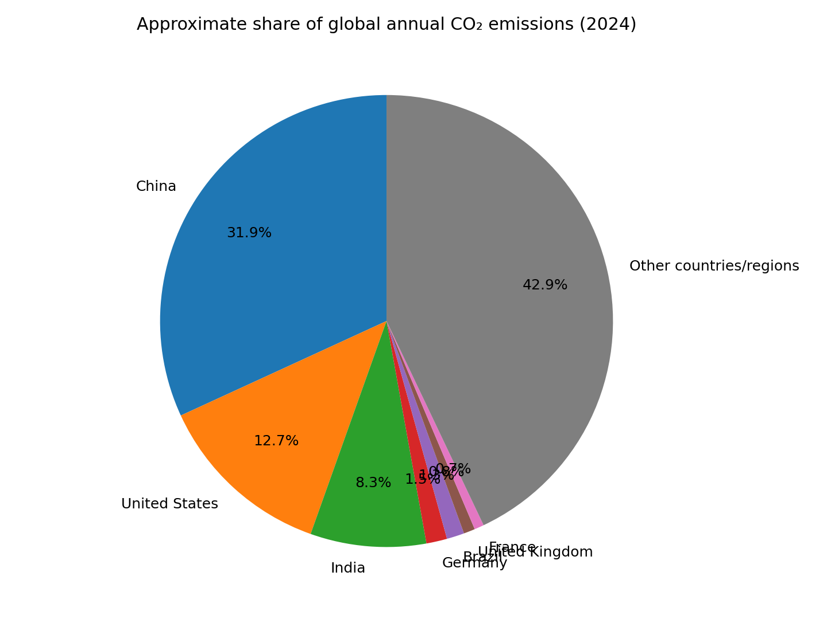
Why this chart: the share chart gives a broad sense of scale by comparing the selected countries with the remainder of the global total. The “other countries/regions” segment is calculated as the global total minus the seven selected values. China represents the largest single segment among the selected countries. The chart is intentionally approximate because the published values are rounded; percentages should therefore be read as indicative rather than exact. A bar chart would be preferable if the goal were to compare very similar shares precisely.

6. Visualization 3 — Trend comparison
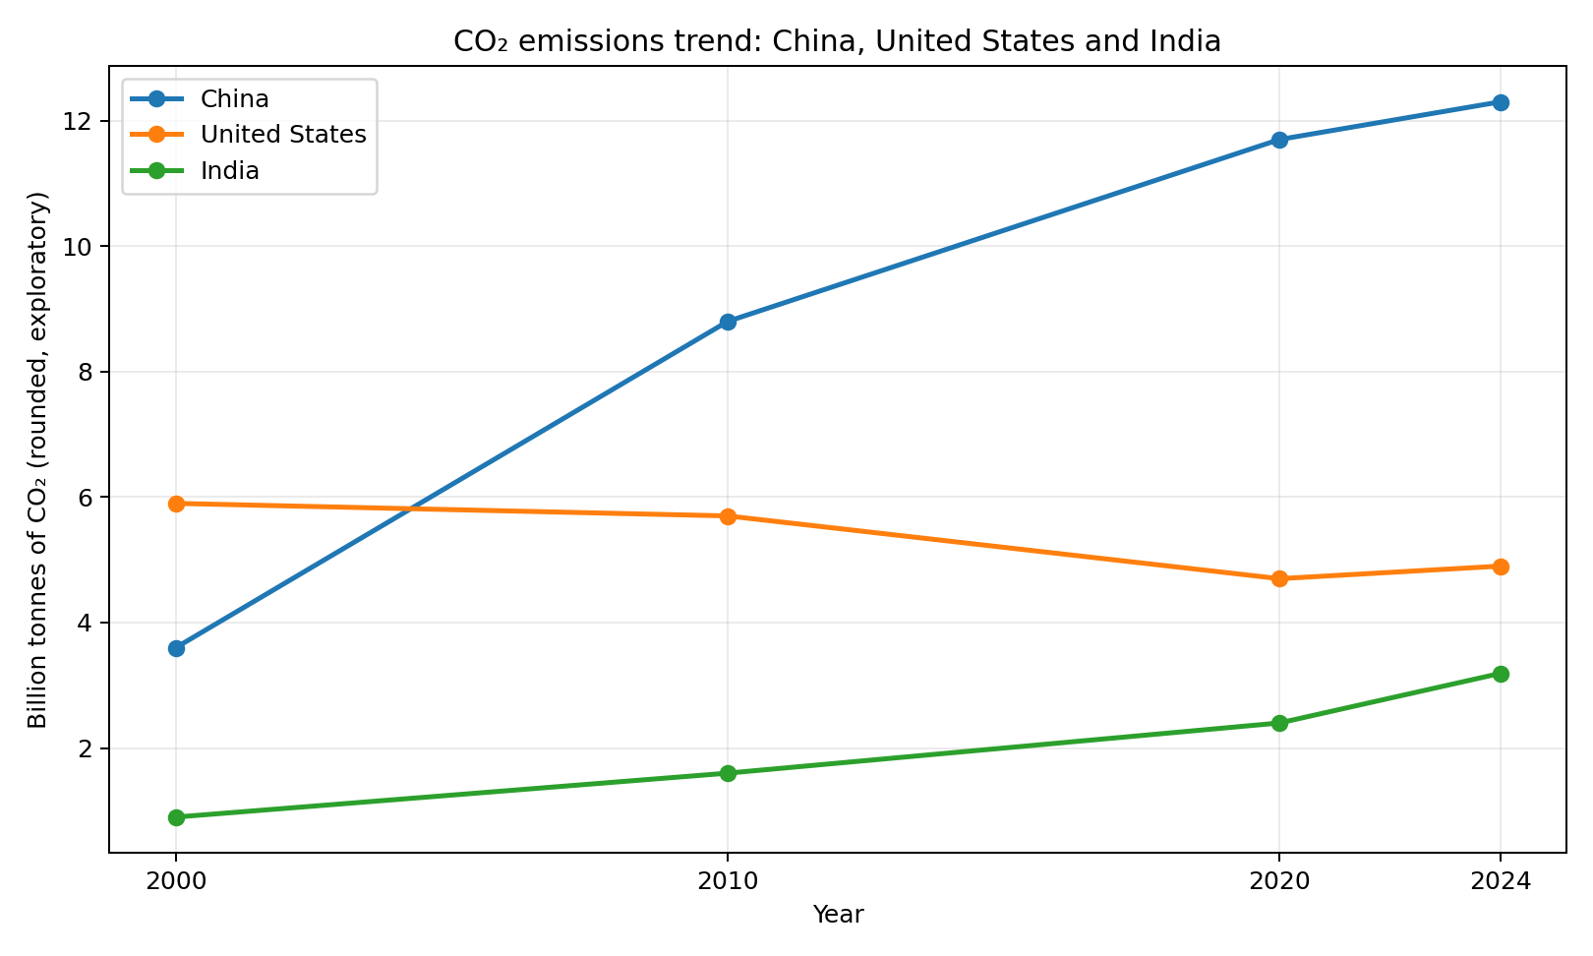
Why this chart: a line chart emphasizes change over time and makes it easier to compare trajectories. The rounded series show a strong rise for China and India across the selected years, while the United States is lower in 2020 than in 2000 and rises slightly by 2024. The pattern suggests that the countries face different emissions trajectories and therefore should not be described as if their recent trends were identical. Because the points are rounded exploratory values, the chart is intended to communicate the broad story only. For exact rates of change, use the year-by-year source data and document the calculation method.

7. Narrative and interpretation
Taken together, the visualizations tell a three-part story. First, annual emissions are highly uneven across the selected countries: China is substantially larger than the next two countries in the comparison. Second, the global-share view shows that emissions are not limited to a single country; a substantial remainder comes from the many other countries and regions. Third, the trend view suggests that the direction and pace of change differ between major emitters. The most responsible interpretation is therefore to combine scale, distribution and time rather than relying on a single ranking. The results can inform public communication and further questions about energy systems, population, economic activity and decarbonization, but the charts alone do not establish causes or policy effectiveness.

8. Limitations and ethical communication
The indicator uses territorial accounting: emissions are attributed to the place where they occur, so emissions embedded in imported goods are not reassigned to consumers. Land-use change is excluded from this indicator. The country values are rounded, and the trend values are rounded exploratory points; the trend chart must not be presented as a precision dataset. Countries also differ in population and economic structure, so total emissions alone do not measure per-capita emissions, historical contribution or fairness. To avoid misleading readers, the charts state the year, unit and scope, and this report explains the limitations next to the findings.

9. Conclusion and future work
The project demonstrates how complementary visual forms can turn a complex environmental topic into a concise narrative. The bar chart supports ranking, the share chart communicates approximate contribution to a total, and the line chart supports temporal comparison. The central finding is that selected countries differ greatly in annual emissions and do not share identical trajectories. Future work should replace the rounded trend points with the complete OWID CSV, add per-capita and consumption-based measures, include uncertainty and source metadata, and build an interactive dashboard with year and country filters.

10. Tools and reproducibility
Python, pandas and Matplotlib were used to prepare the CSV files and export charts as PNG images. The project includes the source data snapshot, the analysis script, visualizations and README instructions. To reproduce the figures, install Python 3.10 or later, run `python -m pip install pandas matplotlib`, then run `python src/analysis.py` from the project folder.

References
Our World in Data. (2025). Annual CO₂ emissions. Data source: Global Carbon Budget (2025). https://ourworldindata.org/grapher/annual-co2-emissions-per-country
Our World in Data. CO₂ and greenhouse gas emissions dataset repository. https://github.com/owid/co2-data

