WEEK 02
EXPLORATORY DATA ANALYSIS (EDA)
Weekly Internship Progress Report
Intern Name | A. Akshay
Internship Role | Junior Data Scientist
Reporting Period | Week 02
Dataset | Iris Flower Measurements

1. Executive Summary
This report presents an Exploratory Data Analysis (EDA) of the publicly available Iris flower dataset. It contains 150 observations, four numerical measurements, and one species label. The analysis uses data-quality checks, descriptive statistics, species-wise comparisons, histograms, scatter plots, a box plot, and a correlation heatmap. Petal length and petal width have a strong positive Pearson correlation (r = 0.96).

2. Objectives
- Understand the dataset structure and check data quality.
- Summarise numerical variables using central tendency and dispersion.
- Create visualisations to explore distributions and relationships.
- Compare measurements across species and document insights.
- Provide reproducible code and clear limitations.

3. Dataset and Source
The Iris dataset records sepal length, sepal width, petal length, and petal width in centimetres for setosa, versicolor, and virginica. It is commonly used for introductory statistics and machine-learning exercises.
Public source: UCI Machine Learning Repository — Iris: https://archive.ics.uci.edu/dataset/53/iris

4. Data Overview and Quality Checks
Check | Result
Rows | 150
Columns | 5
Missing values | 0
Duplicate rows | 1
Species groups | 3

5. Descriptive Statistics
Mean represents the average; standard deviation indicates spread; minimum and maximum show the observed range.
Feature | Mean | Std. Dev. | Min | Max
sepal length cm | 5.84 | 0.83 | 4.3 | 7.9
sepal width cm | 3.06 | 0.44 | 2.0 | 4.4
petal length cm | 3.76 | 1.77 | 1.0 | 6.9
petal width cm | 1.20 | 0.76 | 0.1 | 2.5

6. Visual Analysis

6.1 Petal Length Histogram
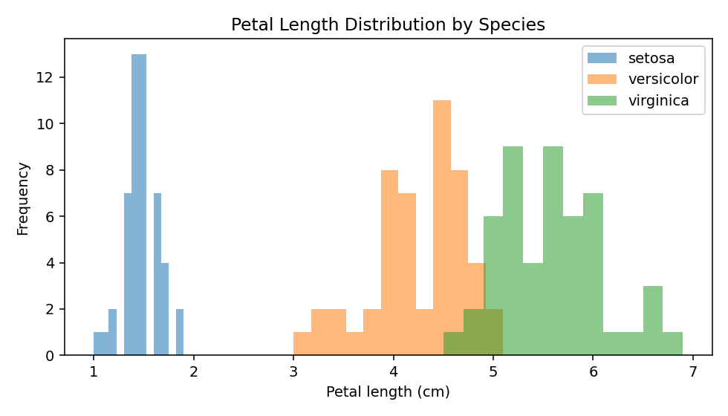
Setosa tends to have shorter petals; versicolor and virginica generally have longer petal lengths.

6.2 Petal Length vs Petal Width
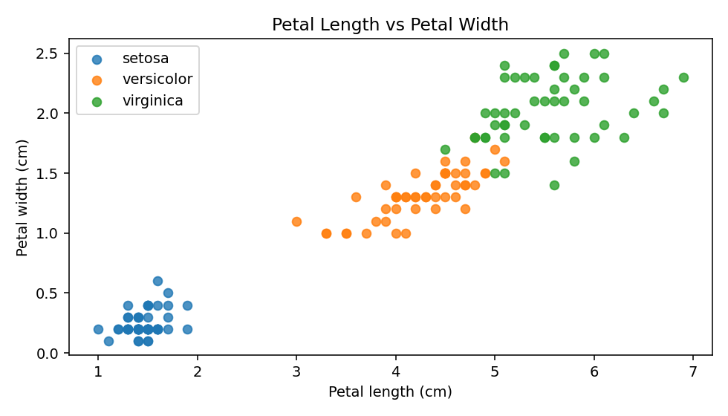
The scatter plot shows a strong positive relationship (r = 0.96); species clusters are visible.

6.3 Sepal Length Box Plot
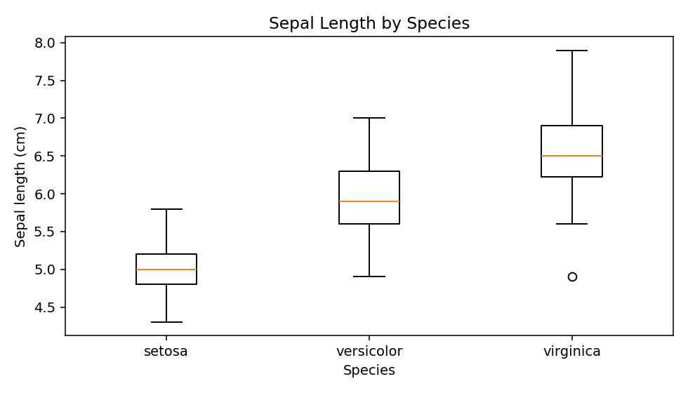
The plot compares medians, spread, and possible outliers. Sepal-length distributions overlap between species.

6.4 Correlation Heatmap
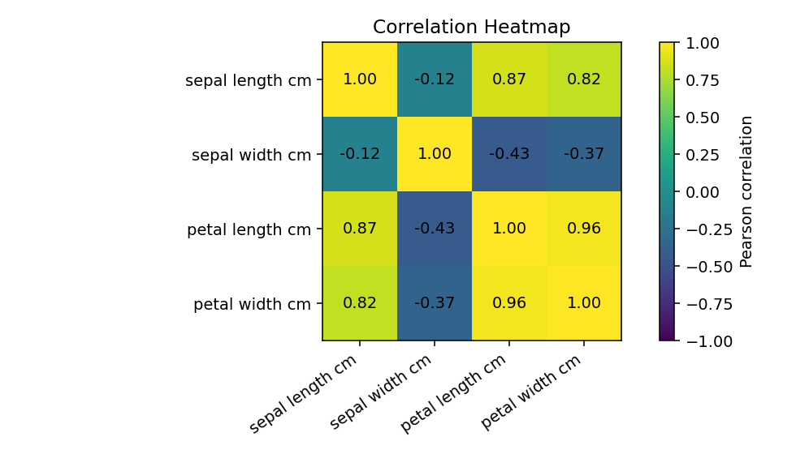
Petal length and petal width have the strongest positive linear relationship. Correlation does not prove causation.

7. Species-wise Mean Measurements
Species | Sepal L. | Sepal W. | Petal L. | Petal W.
setosa | 5.01 | 3.43 | 1.46 | 0.25
versicolor | 5.94 | 2.77 | 4.26 | 1.33
virginica | 6.59 | 2.97 | 5.55 | 2.03
Setosa has notably smaller average petal measurements than the other two species. Virginica has the largest average petal measurements in this dataset.

8. Hypothesis and Interpretation
Exploratory hypothesis: petal length and petal width are positively associated. The observed Pearson correlation is 0.96, supporting a strong positive linear association in this sample. This is a descriptive result; it does not establish causation, and no formal significance test was performed.

9. Key Findings
- The dataset contains 150 observations and four numerical features.
- Petal length and width have a strong positive correlation (r = 0.96).
- Petal measurements differ visibly by species and may be useful for classification.
- Sepal measurements show more overlap than petal measurements.

10. Limitations and Next Steps
The Iris dataset is small and educational, so results should not automatically be generalised to all iris flowers. The analysis assumes recorded measurements and labels are accurate. Further work could include formal hypothesis testing and a baseline classification model evaluated on separate training and test data.

11. Reproducibility and Deliverables
The included Jupyter Notebook contains code for loading the CSV, inspecting data quality, calculating descriptive statistics, creating visualisations, and comparing species means. Keep the notebook and CSV in the same folder and run the cells from top to bottom.

12. Conclusion
EDA revealed meaningful differences in petal measurements among species and a strong positive relationship between petal length and petal width. Summary statistics and visualisations provide a useful overview and a foundation for further data analysis.
Prepared by: A. Akshay
Role: Junior Data Scientist Intern

