WEEK 6
INTEGRATED DATA SCIENCE PROJECT
Breast Cancer Diagnosis Classification: An End-to-End Pipeline
Prepared by: [Your Full Name] | Internship Week 6 | Date: 19 October 2026

Executive Summary
This project demonstrates a complete, reproducible data science workflow using the Wisconsin Diagnostic Breast Cancer benchmark dataset. The objective is to classify samples as benign or malignant from numeric measurements extracted from digitized fine needle aspirate images. The workflow covers data loading, validation, exploratory analysis, preprocessing, model training, evaluation, visualization, and documentation. A logistic regression model is trained using an 80/20 stratified train-test split with a fixed random seed. Imputation and standardization are placed inside a scikit-learn pipeline so they are fitted on training data only. The held-out test metrics are reported below. This is an educational benchmark and must not be used to diagnose patients or guide treatment.

1. Problem Definition
Early and reliable classification of suspicious tissue samples is an important research problem. This project uses an established benchmark to demonstrate how supervised machine learning can learn patterns from measured features. The target classes are benign and malignant. The positive class is defined as malignant so that recall and precision can be interpreted explicitly for that class. The project does not claim clinical readiness.

2. Dataset Description
The dataset is available through scikit-learn's bundled Wisconsin Diagnostic Breast Cancer dataset and is based on the UCI dataset. It contains 569 samples, 30 numeric predictor features, and a diagnosis label. Features describe characteristics of cell nuclei, including radius, texture, perimeter, area, smoothness, compactness and related measurements. The included CSV makes the data snapshot easy to inspect and share. Source documentation: https://scikit-learn.org/stable/modules/generated/sklearn.datasets.load_breast_cancer.html

3. Methodology and Workflow
- Load the dataset and map target labels to readable benign/malignant values.
- Inspect shape, column types, missing values, duplicate rows and target-class distribution.
- Use exploratory visualizations to inspect class balance and compare the mean-radius feature across classes.
- Separate predictors from the target; use an 80% training set and 20% test set with stratification and random_state=42.
- Use median imputation and StandardScaler inside a Pipeline. Fitting preprocessing only on training data reduces data leakage.
- Train LogisticRegression with an increased iteration limit for convergence.
- Evaluate once on the held-out test set with accuracy, precision, recall, F1 and ROC-AUC; save predictions and metrics.
- Document assumptions, limitations, responsible-use requirements and reproducibility instructions.

4. Exploratory Data Analysis
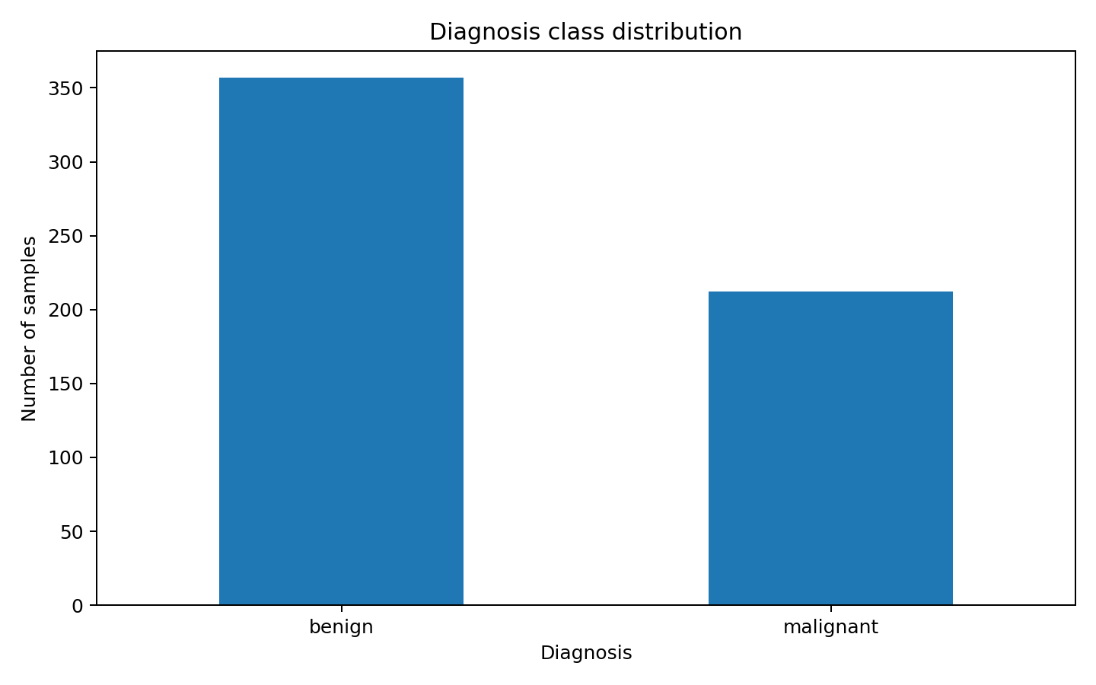
Figure 1. Class distribution. The dataset contains both benign and malignant samples. Stratification helps retain a similar class ratio in training and testing.
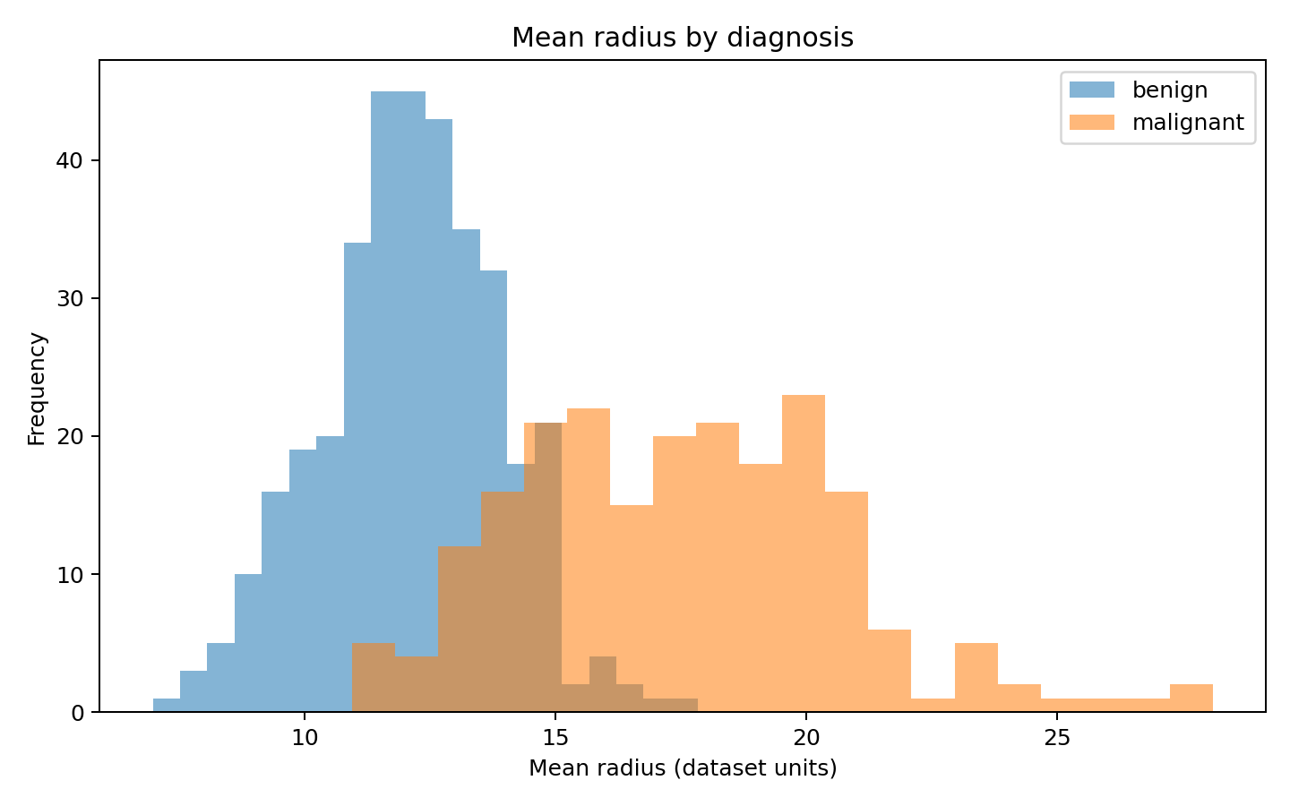
Figure 2. Mean-radius distributions. The distributions differ across labels, illustrating why feature patterns can be informative. A single feature alone is not sufficient for reliable diagnosis.

5. Model and Evaluation
Logistic regression is used as an interpretable baseline for a binary classification task. Numeric features are standardized after median imputation. The fixed stratified split supports reproducibility, but one split is only one estimate of generalization performance. Accuracy measures the proportion of correct predictions; precision measures how many predicted malignant cases are malignant; recall measures how many malignant cases the model detects; F1 combines precision and recall; ROC-AUC measures ranking performance across thresholds.
Metric | Held-out test result
Accuracy | 0.9649 (96.49%)
Precision — malignant | 0.9750 (97.50%)
Recall — malignant | 0.9286 (92.86%)
F1 — malignant | 0.9512 (95.12%)
ROC-AUC | 0.9960 (99.60%)
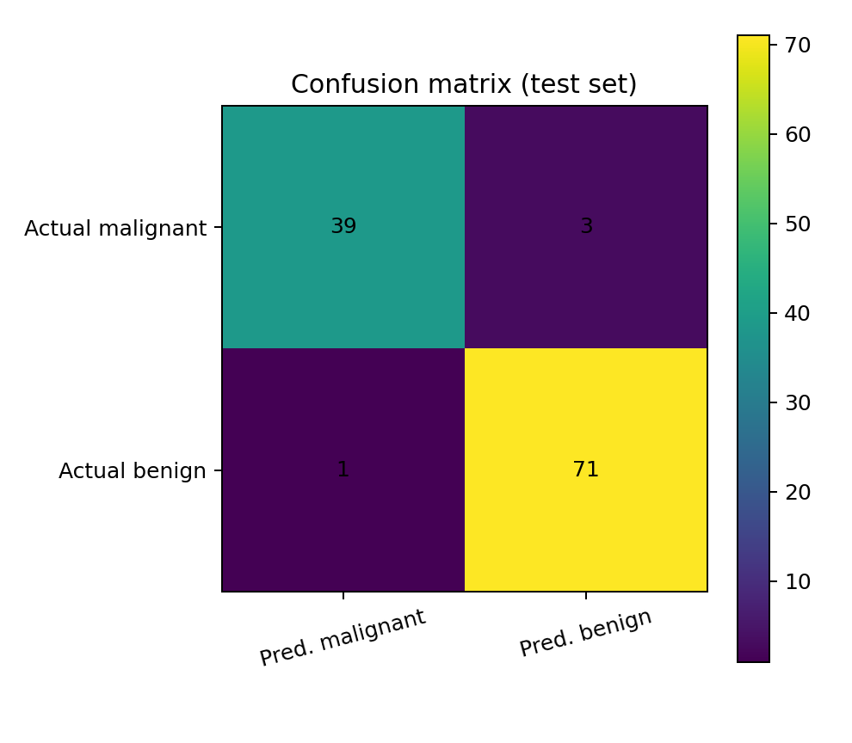
Figure 3. Confusion matrix on the held-out test set. False negatives and false positives should be reviewed separately because they have different implications.
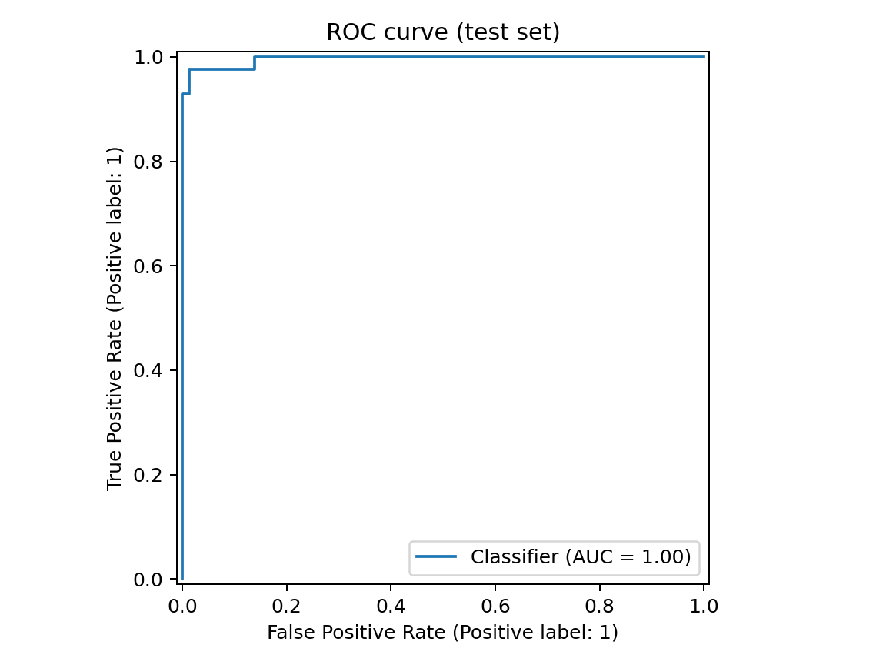
Figure 4. ROC curve for the held-out test set.

6. Findings and Interpretation
The model provides a measurable baseline for the selected split. The metrics should be considered together rather than relying on accuracy alone. In a medical context, recall for malignant cases is particularly important, but maximizing recall can increase false positives. Threshold selection requires clinical context and cannot be decided from this classroom project alone. The EDA plots also show that class distributions and individual feature patterns can help motivate further modelling, but they do not establish causation.

7. Limitations, Ethics, and Future Work
This is a small, curated benchmark dataset, not a representative sample of all patients, devices, laboratories or populations. Performance may change under distribution shift. The held-out split is not external validation, and no accuracy figure establishes clinical safety. Future work should include repeated stratified cross-validation, calibration, threshold analysis, confidence intervals, external validation, subgroup performance evaluation, model comparison, and expert review. Any clinical deployment would require appropriate regulatory, privacy, safety and clinician-governance processes. This model must not be used for diagnosis or treatment decisions.

8. Reproducibility and Deliverables
The repository contains the CSV data snapshot, Python script, Jupyter notebook, charts, test predictions, saved metric JSON, README, and this report. To run the script, install Python 3.10 or later and run `python -m pip install pandas matplotlib scikit-learn jupyter nbformat`, then `python src/analysis.py`. Open the notebook with `jupyter notebook notebooks/week6_integrated_project.ipynb`. A fixed random seed is used to support repeatability.

References
scikit-learn developers. load_breast_cancer dataset documentation. https://scikit-learn.org/stable/modules/generated/sklearn.datasets.load_breast_cancer.html
UCI Machine Learning Repository. Breast Cancer Wisconsin (Diagnostic) dataset. https://archive.ics.uci.edu/dataset/17/breast+cancer+wisconsin+diagnostic

