SCHOOL OF COMPUTER SCIENCE AND ARTIFICIAL INTELLIGENCE |  |  |  |  | DEPARTMENT OF COMPUTER SCIENCE ENGINEERING
Program Name: B. Tech |  |  |  | Assignment Type: Lab |  |  | Academic Year:2025-2026
Course Coordinator Name |  |  |  | Venkataramana Veeramsetty
Instructor(s) Name |  |  |  | Dr. V. Venkataramana (Co-ordinator)  Dr. T. Sampath Kumar  Dr. Pramoda Patro  Dr. Brij Kishor Tiwari  Dr.J.Ravichander  Dr. Mohammand Ali Shaik  Dr. Anirodh Kumar  Mr. S.Naresh Kumar  Dr. RAJESH VELPULA  Mr. Kundhan Kumar  Ms. Ch.Rajitha  Mr. M Prakash  Mr. B.Raju  Intern 1 (Dharma teja)  Intern 2 (Sai Prasad)  Intern 3 (Sowmya)  NS_2 ( Mounika)
Course Code |  |  | 24CS002PC215 | Course Title |  | AI Assisted Coding
Year/Sem |  |  | II/I | Regulation |  | R24
Date and Day  of Assignment |  |  | Week5 - Monday | Time(s)
Duration |  |  | 2 Hours | Applicable to  Batches
AssignmentNumber: 9.1(Present assignment number)/24(Total number of assignments)
 | Q.No. | Question |  |  |  |  |  | Expected Time  to complete
 | 1 | Lab 9 – Documentation Generation: Automatic Documentation and Code Comments  Lab Objectives  - Inline comments  - Docstrings  - Auto-documentation tools  - AI-assisted summarization  Task Description #1 (Automatic Code Commenting)  Scenario: You have been given a Python function without comments.  def calculate_discount(price, discount_rate):  return price - (price * discount_rate / 100)  - Use an AI tool (or manually simulate it) to generate line-by-line comments for the function.  - Modify the function so that it includes a docstring in Google-style or NumPy-style format.  - Compare the auto-generated comments with your manually written version.  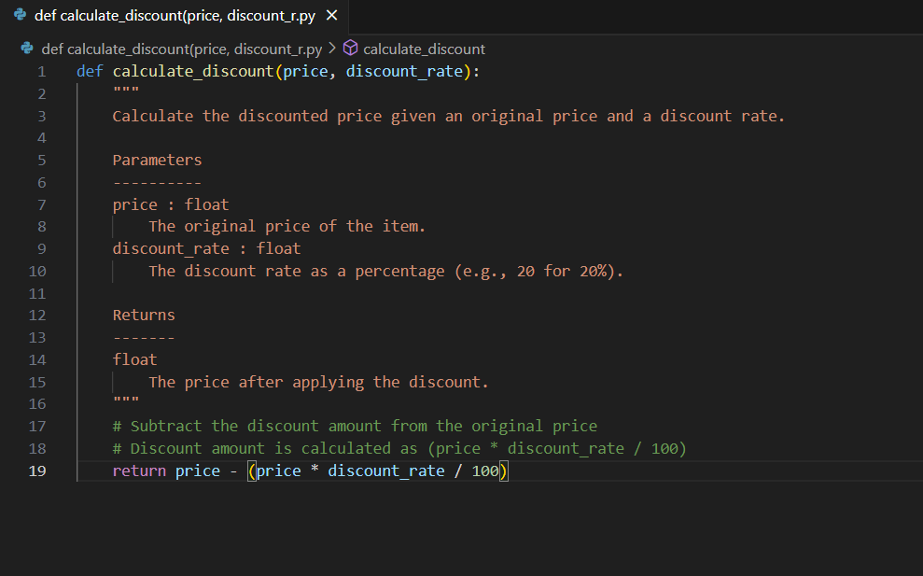  Task Description #2 (API Documentation Generator)  Scenario: A team is building a Library Management System with multiple functions.  def add_book(title, author, year):  # code to add book  pass  def issue_book(book_id, user_id):  # code to issue book  Pass  - Write a Python script that uses docstrings for each function (with input, output, and description).  - Use a documentation generator tool (like pdoc, Sphinx, or MkDocs) to automatically create HTML documentation.  - Submit both the code and the generated documentation as output.  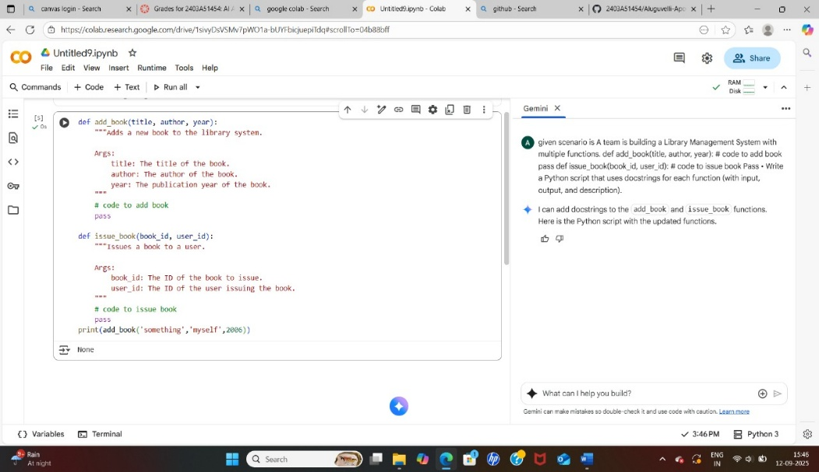  Task Description #3 (AI-Assisted Code Summarization)  Scenario: You are reviewing a colleague’s codebase containing long functions.  def process_sensor_data(data):  cleaned = [x for x in data if x is not None]  avg = sum(cleaned)/len(cleaned)  anomalies = [x for x in cleaned if abs(x - avg) > 10]  return {"average": avg, "anomalies": anomalies}  - Generate a summary comment explaining the purpose of the function in 2–3 lines.  - Create a flow-style comment (step-by-step explanation).  - Write a short paragraph of documentation describing possible use cases of this function in real-world scenarios.  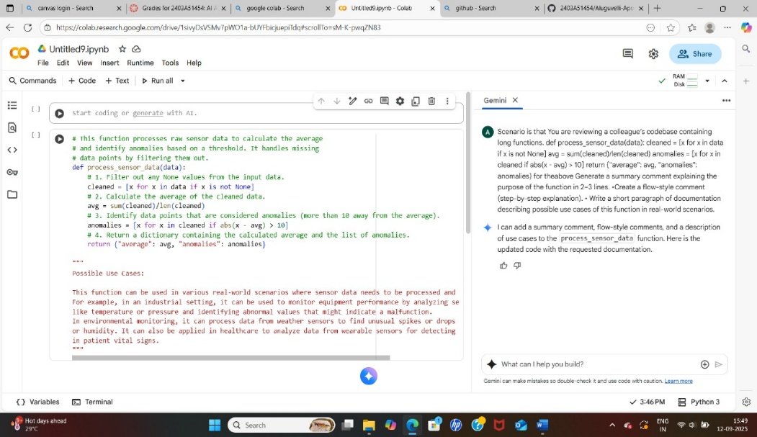  Task Description #4 (Real-Time Project Documentation)  Scenario: You are part of a project team that develops a Chatbot Application. The team needs documentation for maintainability.  - Write a README.md file for the chatbot project (include project description, installation steps, usage, and example).  - Add inline comments in the chatbot’s main Python script (focus on explaining logic, not trivial code).  - Use an AI-assisted tool (or simulate it) to generate a usage guide in plain English from your code comments.  - Reflect: How does automated documentation help in real-time projects compared to manual documentation?  - 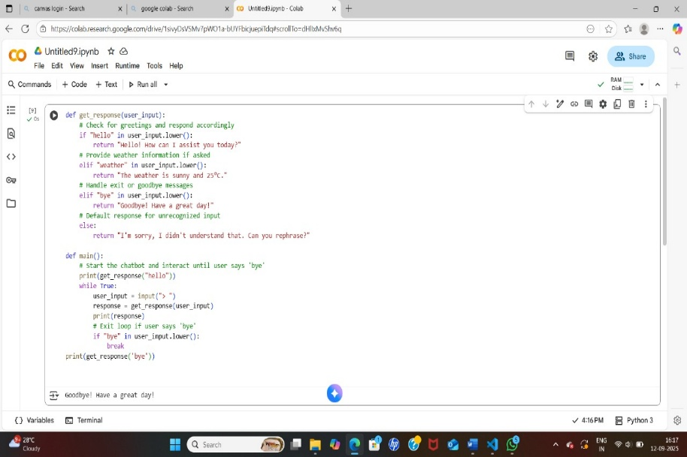 |  |  |  |  |  | Week5 - Monday

