SCHOOL OF COMPUTER SCIENCE AND ARTIFICIAL INTELLIGENCE |  |  |  |  | DEPARTMENT OF COMPUTER SCIENCE ENGINEERING
Program Name: B. Tech |  |  |  | Assignment Type: Lab |  |  | Academic Year:2025-2026
Course Coordinator Name |  |  |  | Venkataramana Veeramsetty
Instructor(s) Name |  |  |  | Dr. V. Venkataramana (Co-ordinator)  Dr. T. Sampath Kumar  Dr. Pramoda Patro  Dr. Brij Kishor Tiwari  Dr.J.Ravichander  Dr. Mohammand Ali Shaik  Dr. Anirodh Kumar  Mr. S.Naresh Kumar  Dr. RAJESH VELPULA  Mr. Kundhan Kumar  Ms. Ch.Rajitha  Mr. M Prakash  Mr. B.Raju  Intern 1 (Dharma teja)  Intern 2 (Sai Prasad)  Intern 3 (Sowmya)  NS_2 ( Mounika)
Course Code |  |  | 24CS002PC215 | Course Title |  | AI Assisted Coding
Year/Sem |  |  | II/III | Regulation |  | R24
Date and Day  of Assignment |  |  | Week4 - Monday | Time(s)
Duration |  |  | 2 Hours | Applicable to  Batches
Assignment Number:7.1 (Present assignment number)/24(Total number of assignments)
 | Q.No. | Question |  |  |  |  |  | Expected Time  to complete
 | 1 | Lab 7: Error Debugging with AI: Systematic approaches to finding and fixing bugs  Lab Objectives:  - To identify and correct syntax, logic, and runtime errors in Python programs using AI tools.  - To understand common programming bugs and AI-assisted debugging suggestions.  - To evaluate how AI explains, detects, and fixes different types of coding errors.  - To build confidence in using AI to perform structured debugging practices.  Lab Outcomes (LOs):  After completing this lab, students will be able to:  - Use AI tools to detect and correct syntax, logic, and runtime errors.  - Interpret AI-suggested bug fixes and explanations.  - Apply systematic debugging strategies supported by AI-generated insights.  - Refactor buggy code using responsible and reliable programming patterns.  Task Description #1 (Syntax Errors – Missing Parentheses in Print Statement)  Task: Provide a Python snippet with a missing parenthesis in a print statement (e.g., print "Hello"). Use AI to detect and fix the syntax error.  # Bug: Missing parentheses in print statement  def greet():  print "Hello, AI Debugging Lab!"  greet()  Requirements:  - Run the given code to observe the error.  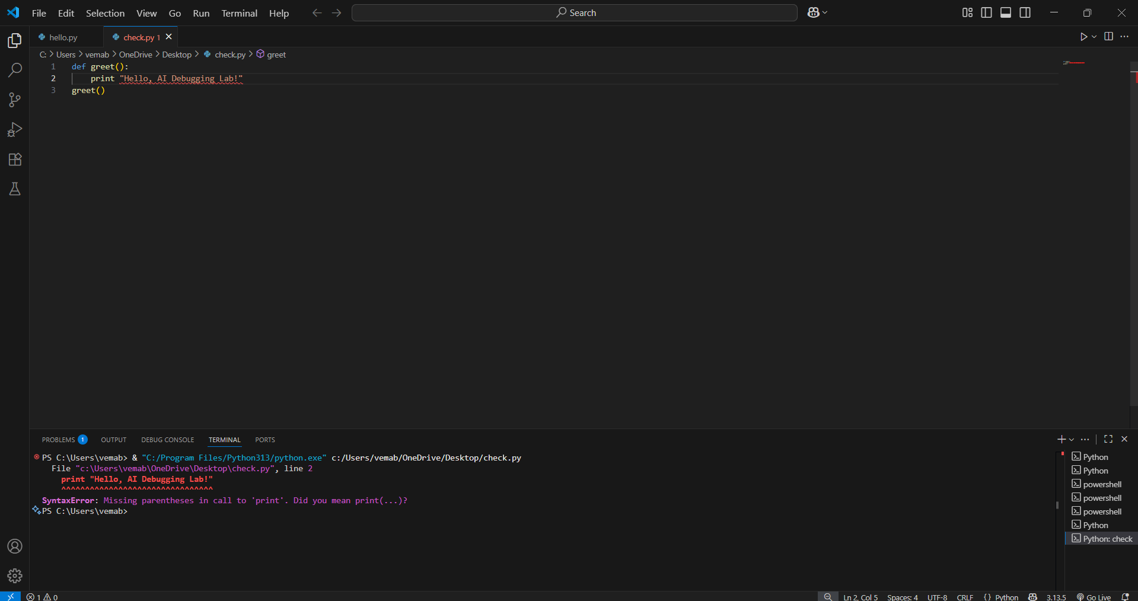  - Apply AI suggestions to correct the syntax.  - Use at least 3 assert test cases to confirm the corrected code works.  Expected Output #1:  - Corrected code with proper syntax and AI explanation.  Corrected code:  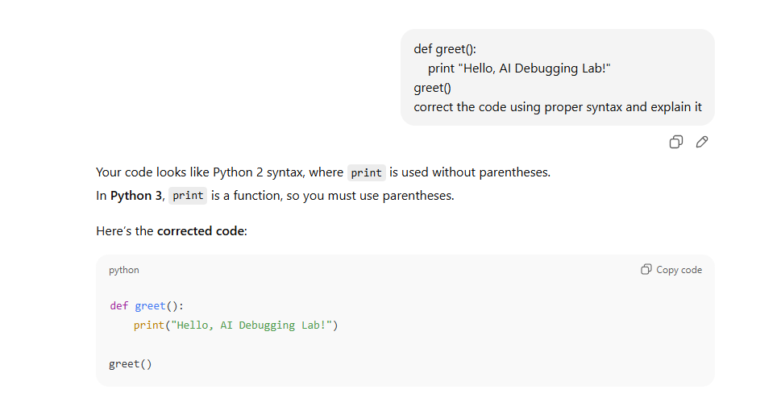  Code:  def greet():  print("Hello, AI Debugging Lab!")  greet()  explanation:  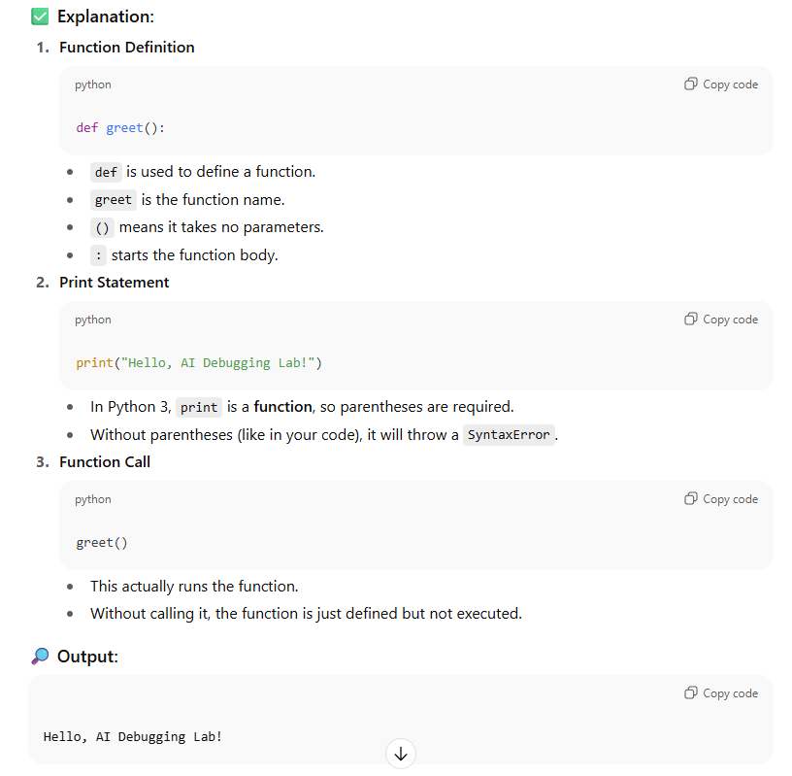  Task Description #2 (Logic Error – Incorrect Condition in an If Statement)  Task: Supply a function where an if-condition mistakenly uses = instead of ==. Let AI identify and fix the issue.  # Bug: Using assignment (=) instead of comparison (==)  def check_number(n):  if n = 10:  return "Ten"  else:  return "Not Ten"  Requirements:  - Ask AI to explain why this causes a bug.  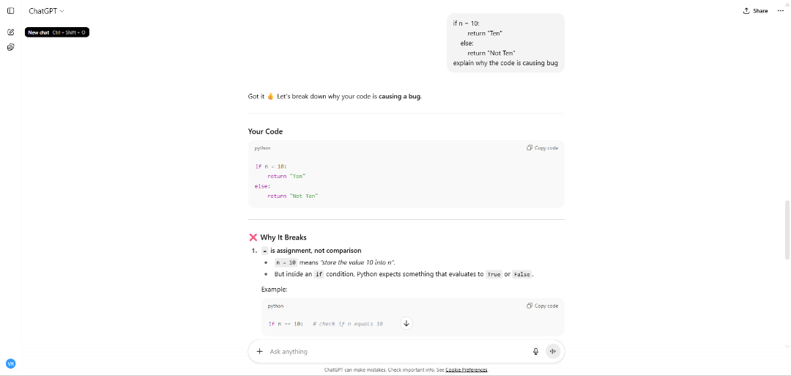  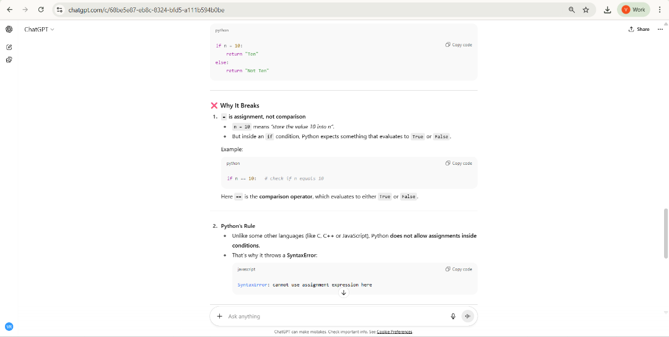  - Correct the code and verify with 3 assert test cases.  Expected Output #2:  - Corrected code using == with explanation and successful test execution.  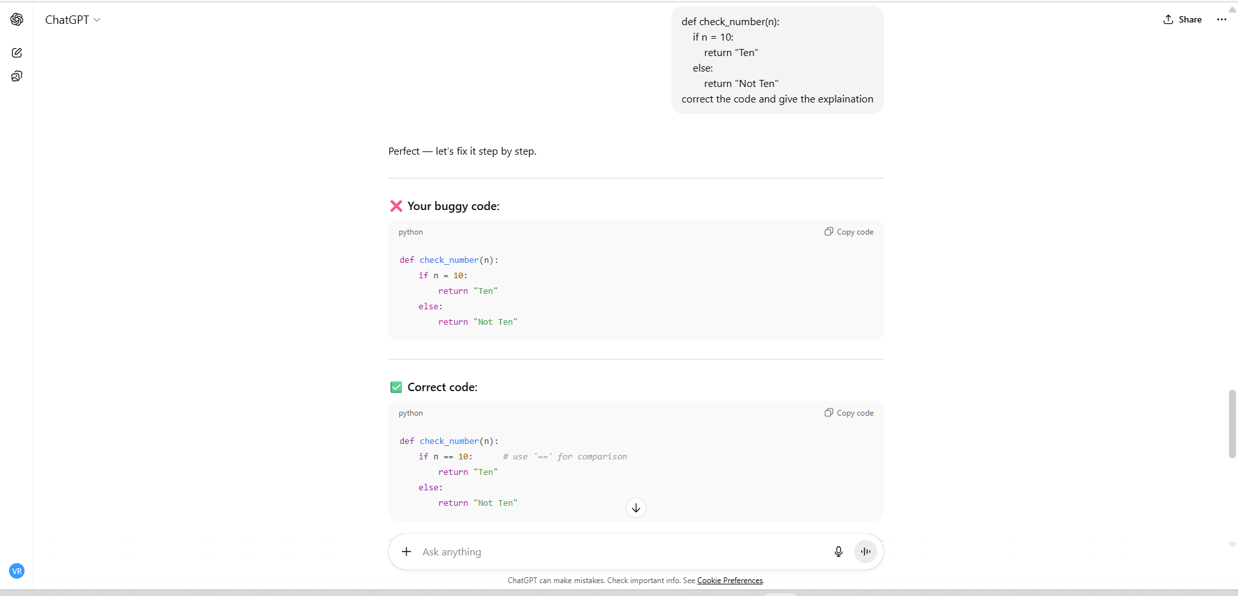  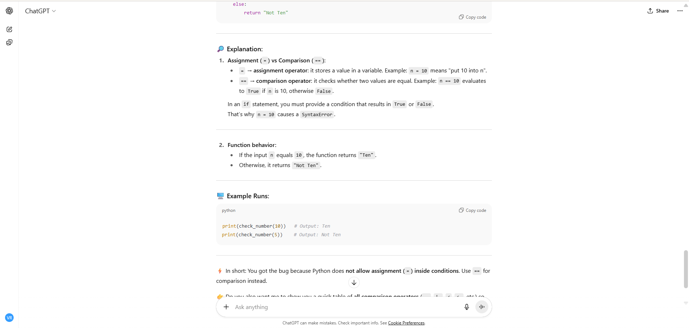  Code and output: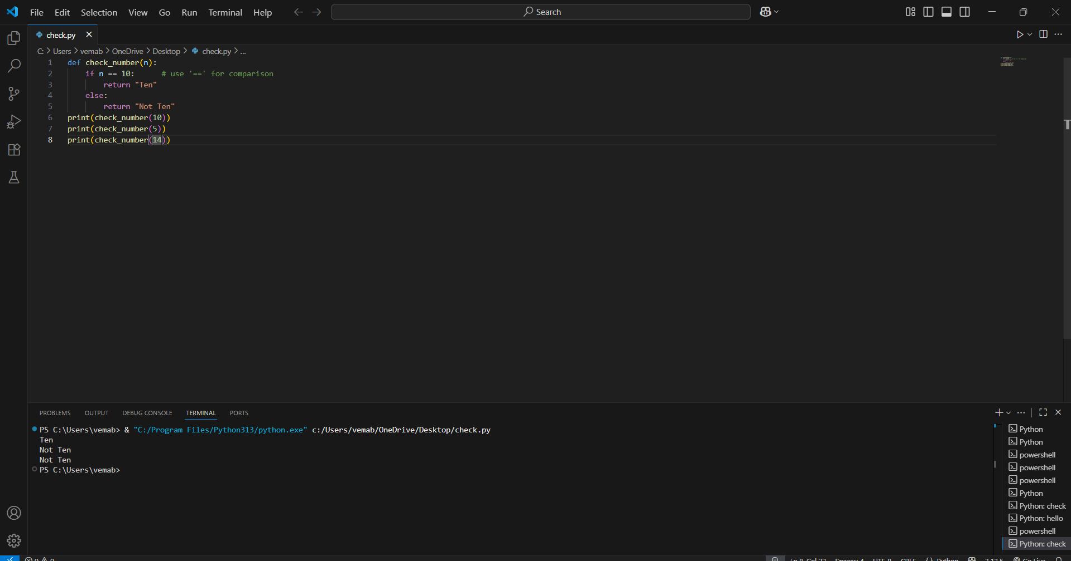  Task Description #3 (Runtime Error – File Not Found)  Task: Provide code that attempts to open a non-existent file and crashes. Use AI to apply safe error handling.  # Bug: Program crashes if file is missing  def read_file(filename):  with open(filename, 'r') as f:  return f.read()  print(read_file("nonexistent.txt"))  Requirements:  - Implement a try-except block suggested by AI.  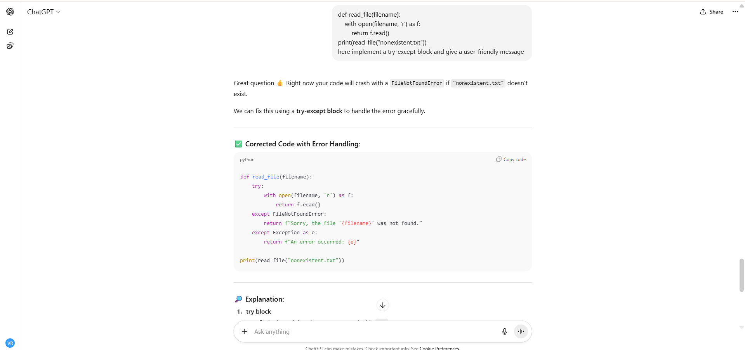  - Add a user-friendly error message.  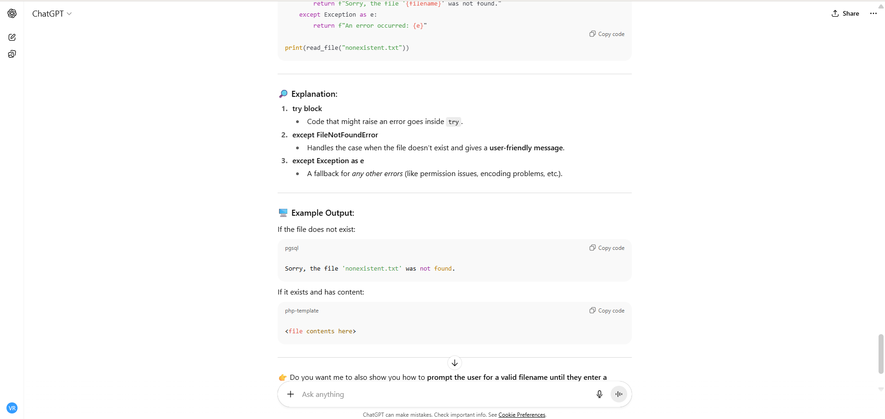  - Test with at least 3 scenarios: file exists, file missing, invalid path.  Expected Output #3:  - Safe file handling with exception management.  File missing:  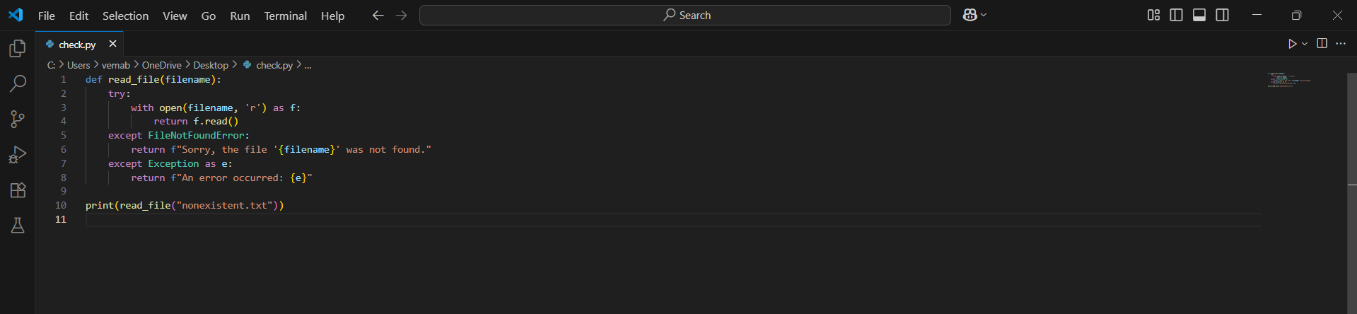  Output:  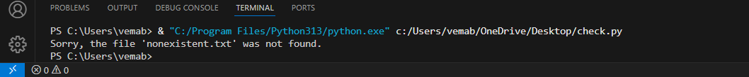  Task Description #4 (AttributeError – Calling a Non-Existent Method)  Task: Give a class where a non-existent method is called (e.g., obj.undefined_method()). Use AI to debug and fix.  # Bug: Calling an undefined method  class Car:  def start(self):  return "Car started"  my_car = Car()  print(my_car.drive()) # drive() is not defined  Requirements:  - Students must analyze whether to define the missing method or correct the method call.  - Use 3 assert tests to confirm the corrected class works.  Expected Output #4:  - Corrected class with clear AI explanation.  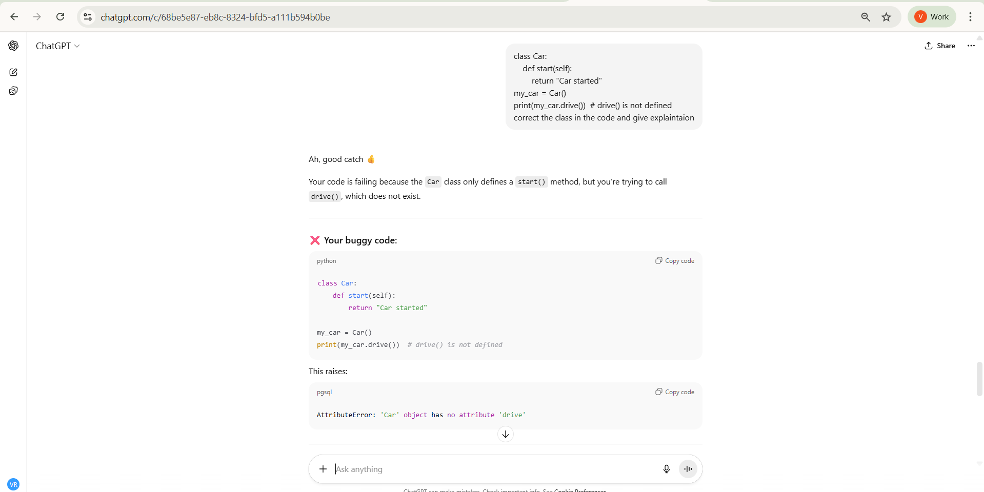  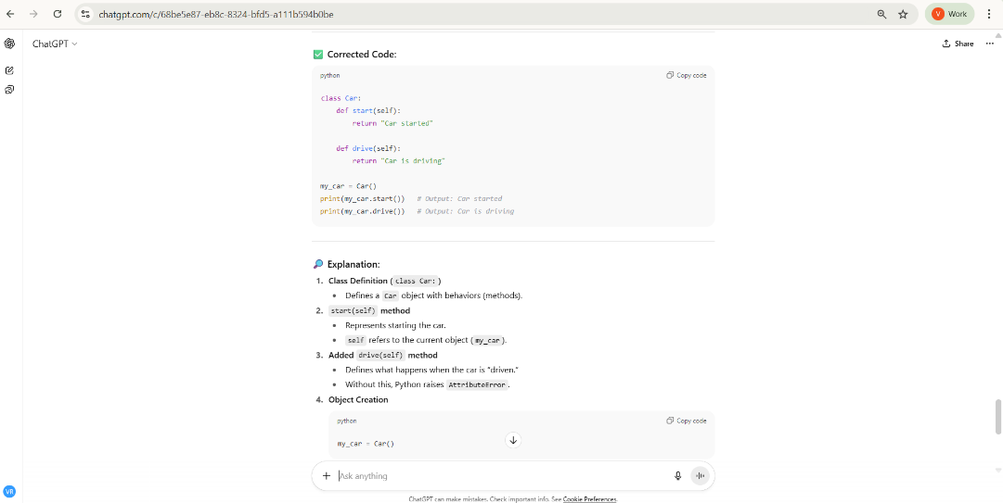  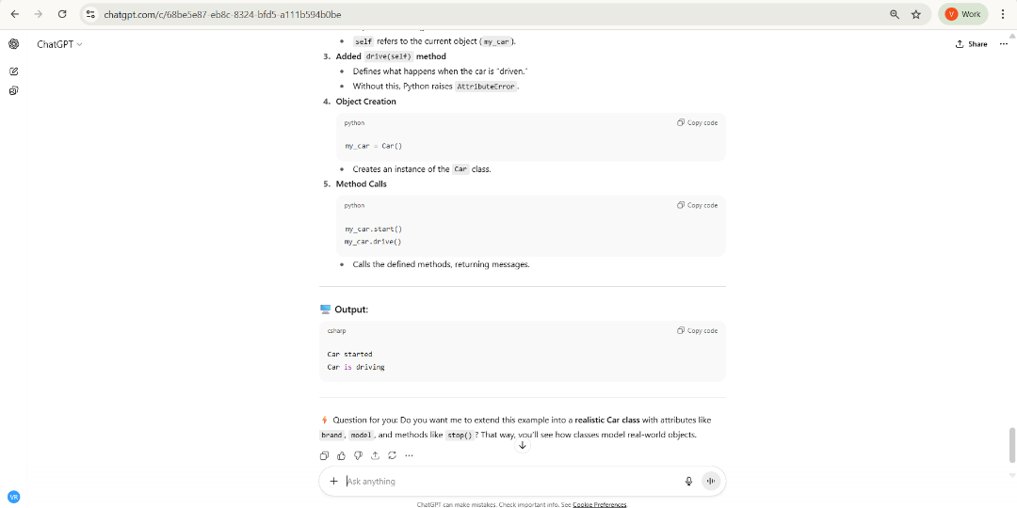  Task Description #5 (TypeError – Mixing Strings and Integers in Addition)  Task: Provide code that adds an integer and string ("5" + 2) causing a TypeError. Use AI to resolve the bug.  # Bug: TypeError due to mixing string and integer  def add_five(value):  return value + 5  print(add_five("10"))  Requirements:  - Ask AI for two solutions: type casting and string concatenation.  - Validate with 3 assert test cases.  Expected Output #5:  - Corrected code that runs successfully for multiple inputs.  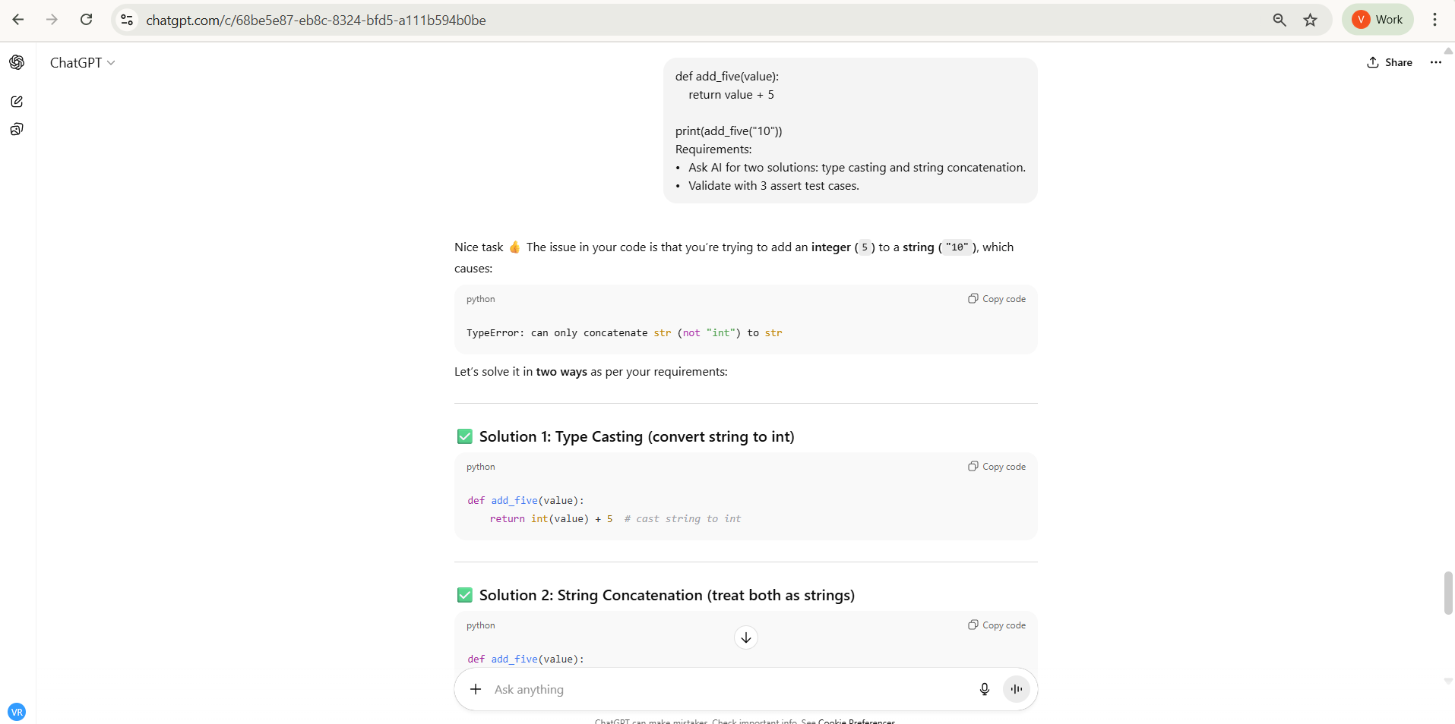  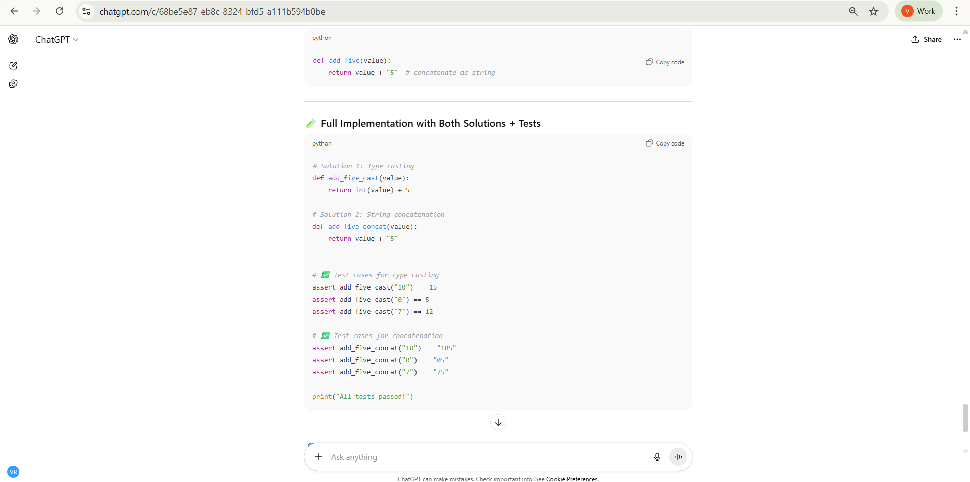  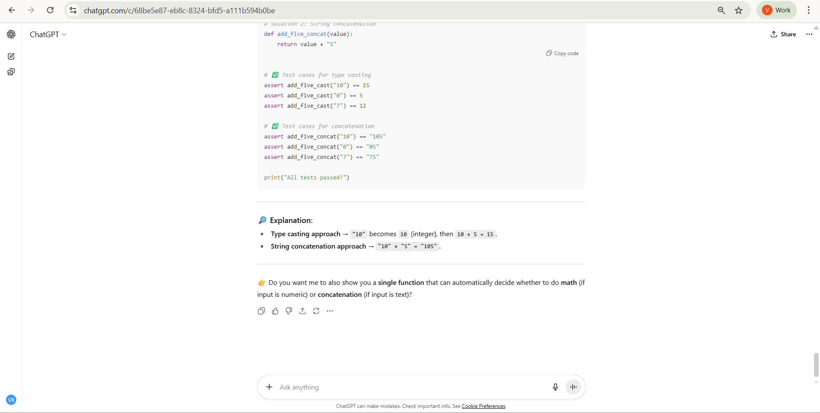  Code and output:  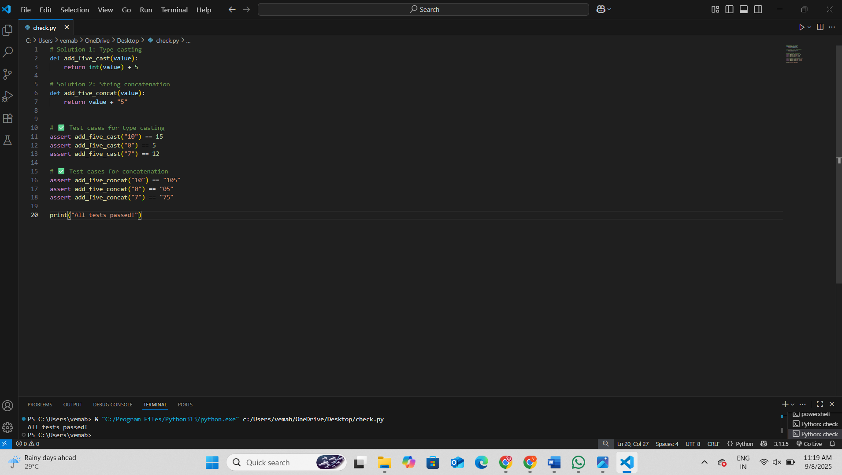  Note: Report should be submitted a word document for all tasks in a single document with prompts, comments & code explanation, and output and if required, screenshots  Evaluation Criteria:  Criteria Max Marks  Identification of bugs 0.5  Application of AI-suggested fixes 0.5  Explanation and understanding of errors 0.5  Corrected code functionality 0.5  Report structure and reflection 0.5  Total 2.5 Marks |  |  |  |  |  | Week4 - Monday

