SCHOOL OF COMPUTER SCIENCE AND ARTIFICIAL INTELLIGENCE |  |  |  |  | DEPARTMENT OF COMPUTER SCIENCE ENGINEERING
Program Name: B. Tech |  |  |  | Assignment Type: Lab |  |  | Academic Year:2025-2026
Course Coordinator Name |  |  |  | Venkataramana Veeramsetty
Instructor(s) Name |  |  |  | Dr. V. Venkataramana (Co-Ordinator)  Dr. T. Sampath Kumar  Dr. Pramoda Patro  Dr. Brij Kishor Tiwari  Dr.J.Ravichander  Dr. Mohammand Ali Shaik  Dr. Anirodh Kumar  Mr. S.Naresh Kumar  Dr. RAJESH VELPULA  Mr. Kundhan Kumar  Ms. Ch.Rajitha  Mr. M Prakash  Mr. B.Raju  Intern 1 (Dharma teja)  Intern 2 (Sai Prasad)  Intern 3 (Sowmya)  NS_2 ( Mounika)
CourseCode |  |  | 24CS002PC215 | Course Title |  | AI Assisted Coding
Year/Sem |  |  | II/I | Regulation |  | R24
Date and Day  of Assignment |  |  | Week1 - Monday | Time(s) |  | 24CSBTB01 To 24CSBTB39
Duration |  |  | 2 Hours | Applicable to  Batches |  | All batches
Assignment Number:1.1(Present assignment number)/24(Total number of assignments)
 | Q.No. | Question |  |  |  |  |  | Expected Time  to complete
 | 1 | Lab 1: Environment Setup – GitHub Copilot and VS Code Integration  Lab Objectives:  - To install and configure GitHub Copilot in Visual Studio Code.  - To explore AI-assisted code generation using GitHub Copilot.  - To analyze the accuracy and effectiveness of Copilot's code suggestions.  - To understand prompt-based programming using comments and code context  Lab Outcomes (LOs):  After completing this lab, students will be able to:  - Set up GitHub Copilot in VS Code successfully.  - Use inline comments and context to generate code with Copilot.  - Evaluate AI-generated code for correctness and readability.  - Compare code suggestions based on different prompts and programming styles.  Task 0  - Install and configure GitHub Copilot in VS Code. Take screenshots of each step.  Expected Output  - Install and configure GitHub Copilot in VS Code. Take screenshots of each step.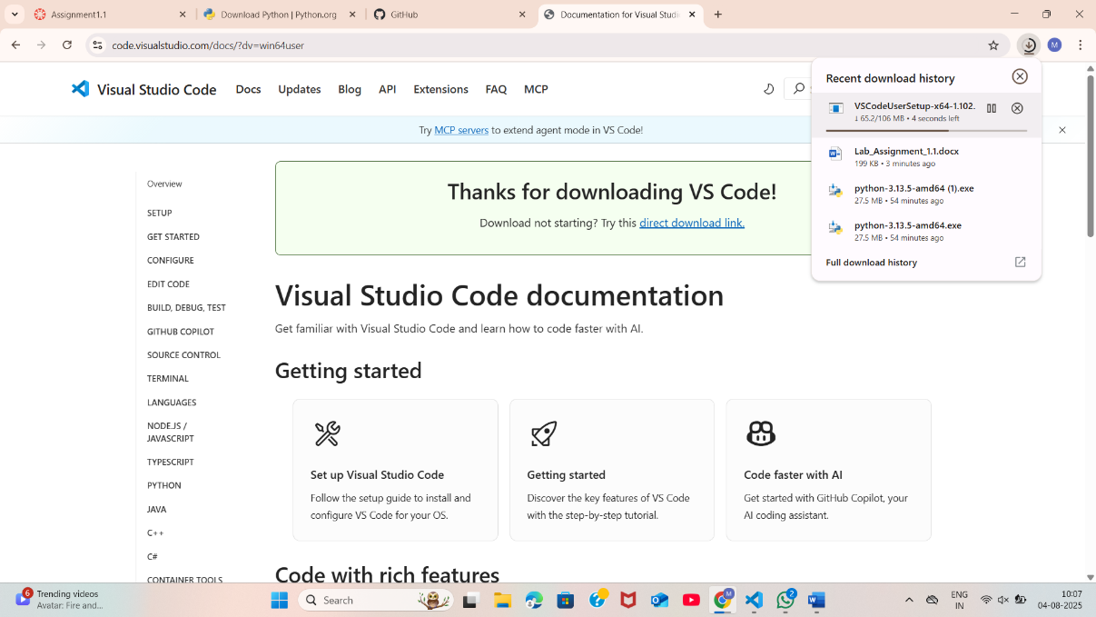  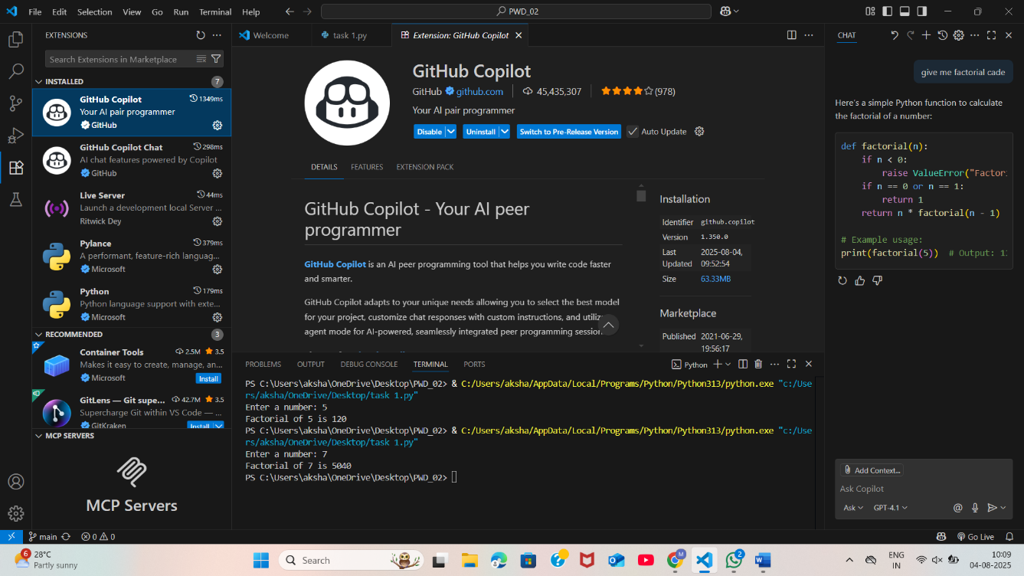  Task 1: Factorial without Functions  - Description:  Use GitHub Copilot to generate a Python program that calculates the factorial of a number without defining any functions (using loops directly in the main code).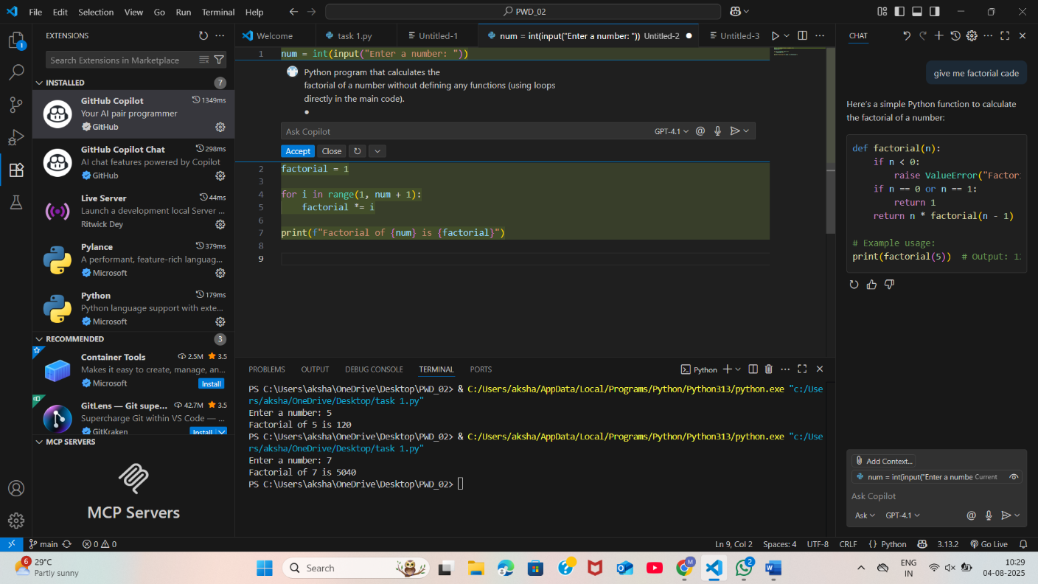  - Expected Output:  - A working program that correctly calculates the factorial for user-provided input.  - Screenshots of the code generation process.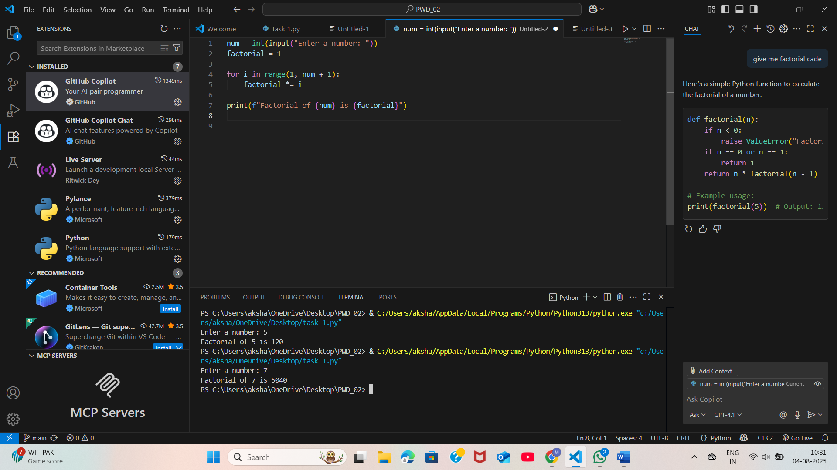  Task 2: Improving Efficiency  - Description:  Examine the Copilot-generated code from Task 1 and demonstrate how its efficiency can be improved (e.g., removing unnecessary variables, optimizing loops).  - Expected Output:  - Original and improved versions of the code.  - Explanation of how the improvements enhance performance.  - 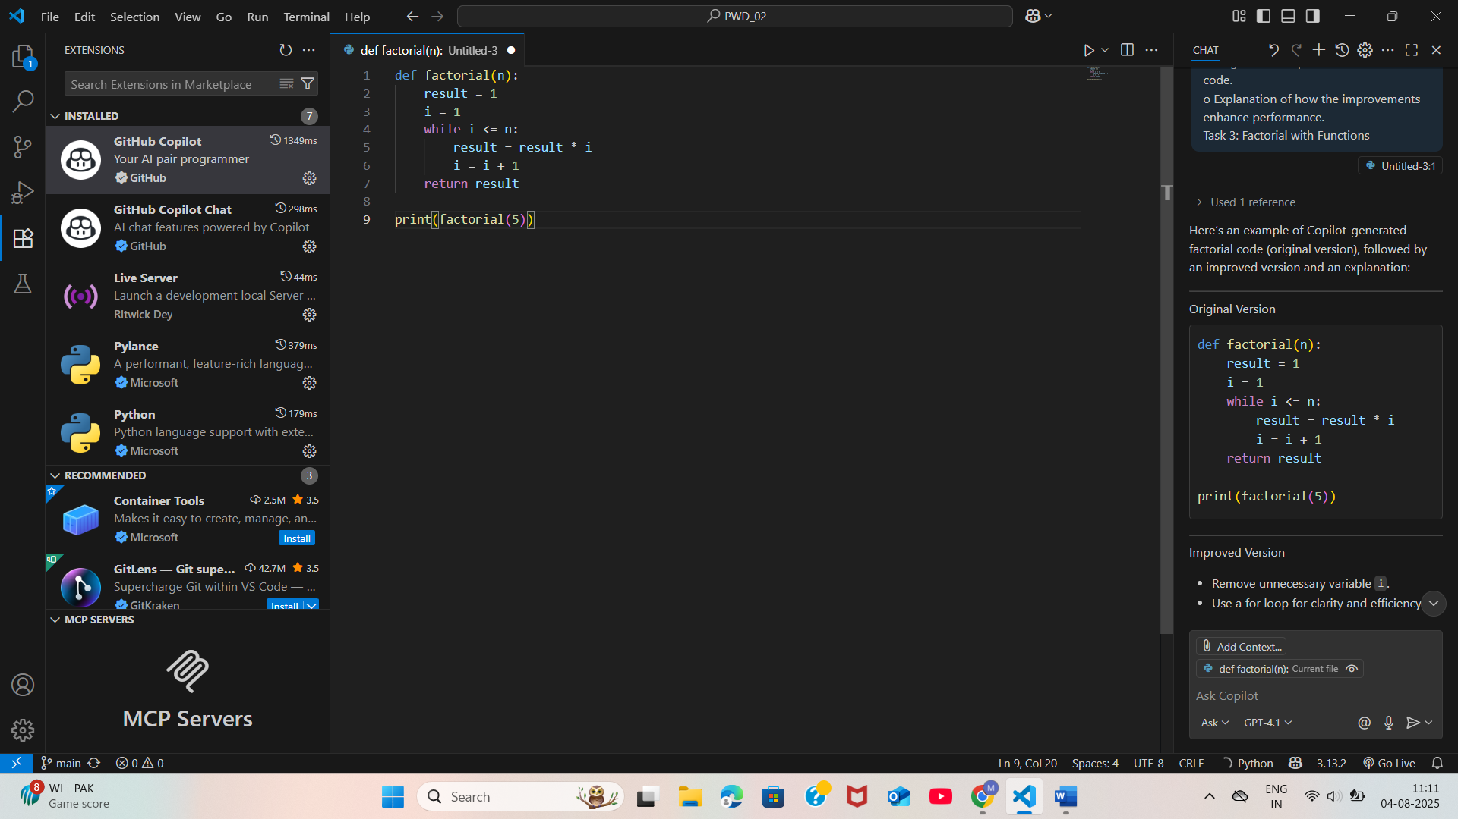  Task 3: Factorial with Functions  - Description:  Use GitHub Copilot to generate a Python program that calculates the factorial of a number using a user-defined function.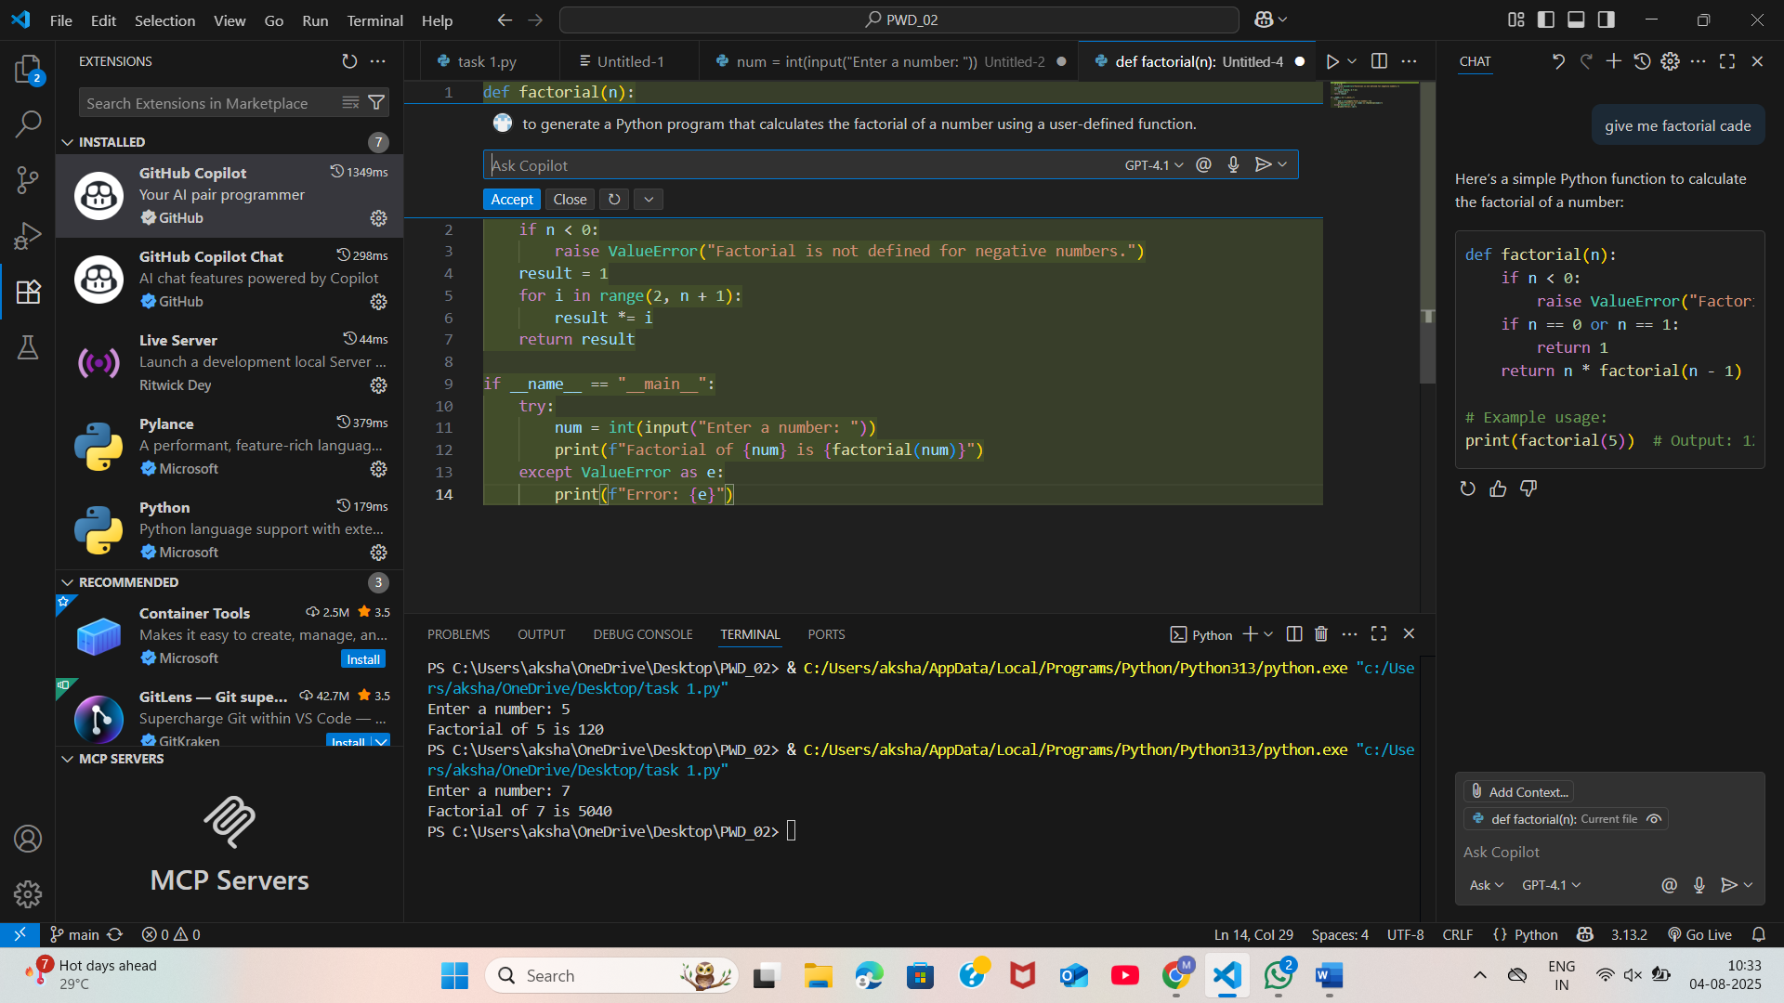  - Expected Output:  - Correctly working factorial function with sample outputs.  - Documentation of the steps Copilot followed to generate the function.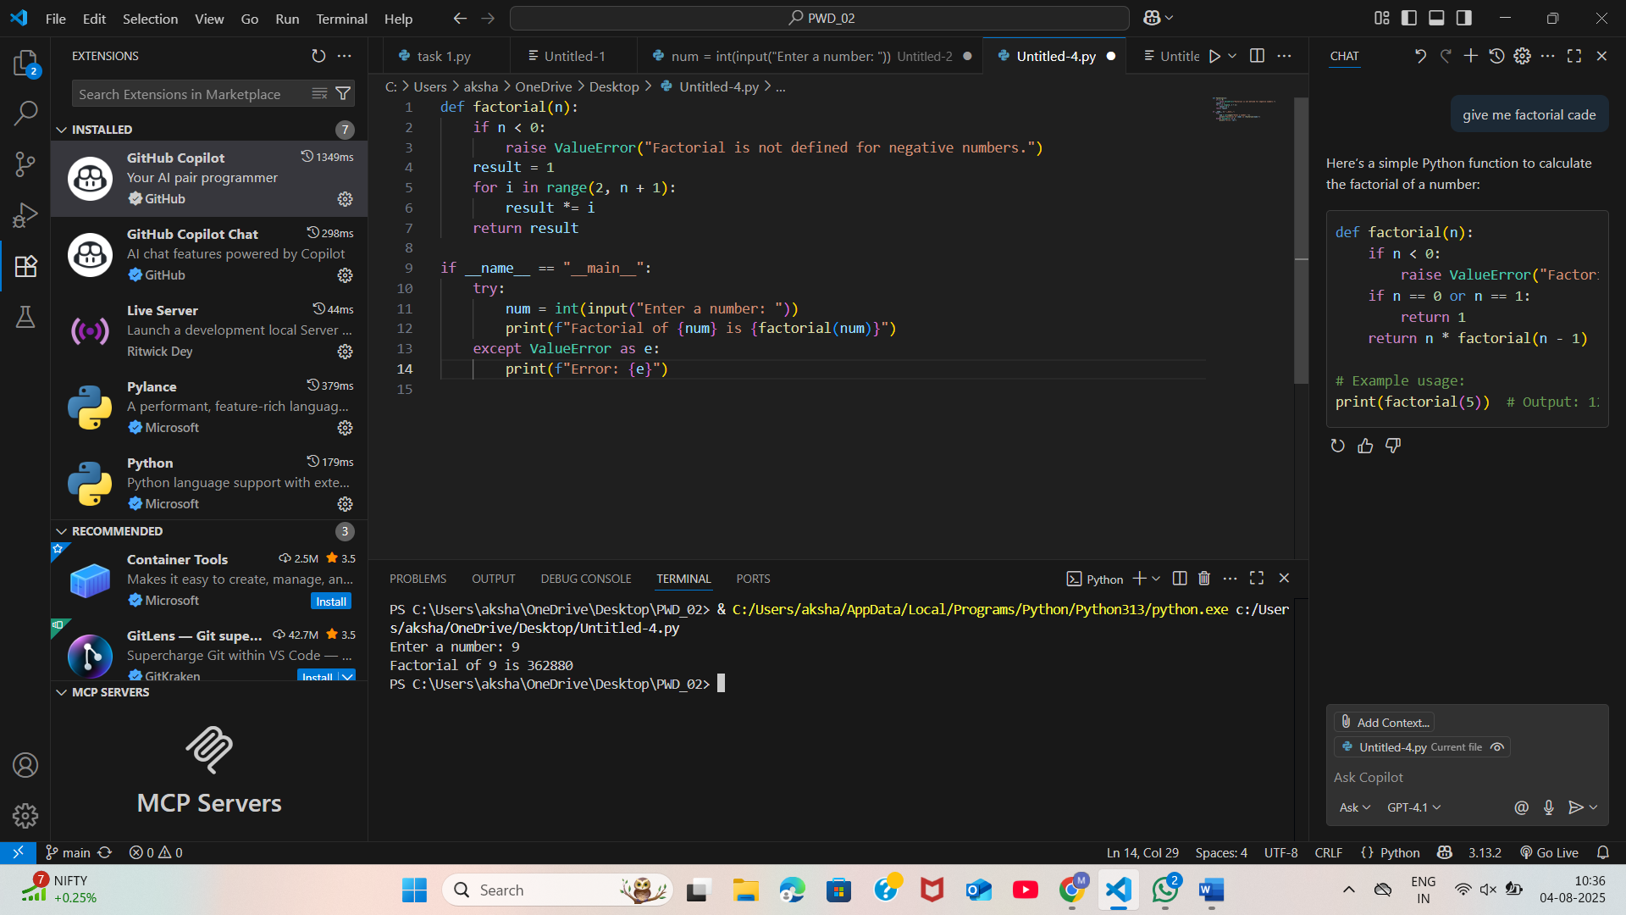  Task 4: Comparative Analysis – With vs Without Functions  - Description:  Differentiate between the Copilot-generated factorial program with functions and without functions in terms of logic, reusability, and execution.  - Expected Output:  - A comparison table or short report explaining the differences.  - ### With Functions  - ````python  - def factorial(n):  - result = 1  - for i in range(2, n + 1):  - result *= i  - return result  - print(factorial(5))  - ````  - **Logic:**  - Encapsulates the factorial calculation in a reusable function.  - **Reusability:**  - Highly reusable. You can call `factorial(n)` anywhere in your code with any value of `n`.  - **Execution:**  - Efficient and clear. Function calls are fast and the logic is easy to follow.  - ---  - ### Without Functions  - ````python  - n = 5  - result = 1  - for i in range(2, n + 1):  - result *= i  - print(result)  - ````  - **Logic:**  - All logic is written inline, without encapsulation.  - **Reusability:**  - Not reusable. To calculate another factorial, you must rewrite or copy the code.  - **Execution:**  - Works for a single value, but not flexible for multiple calls or larger programs.  - ---  - ### Summary  - - **With functions:** Better for modularity, reusability, and maintainability.  - - **Without functions:** Simple for one-off calculations, but not suitable for larger or more complex programs.  - Using functions is recommended for clean, reusable, and organized code.  Task 5: Iterative vs Recursive Factorial  - Description:  Prompt GitHub Copilot to generate both iterative and recursive versions of the factorial function.  - Expected Output:  - Two correct implementations.  - A documented comparison of logic, performance, and execution flow between iterative and recursive approaches.  - 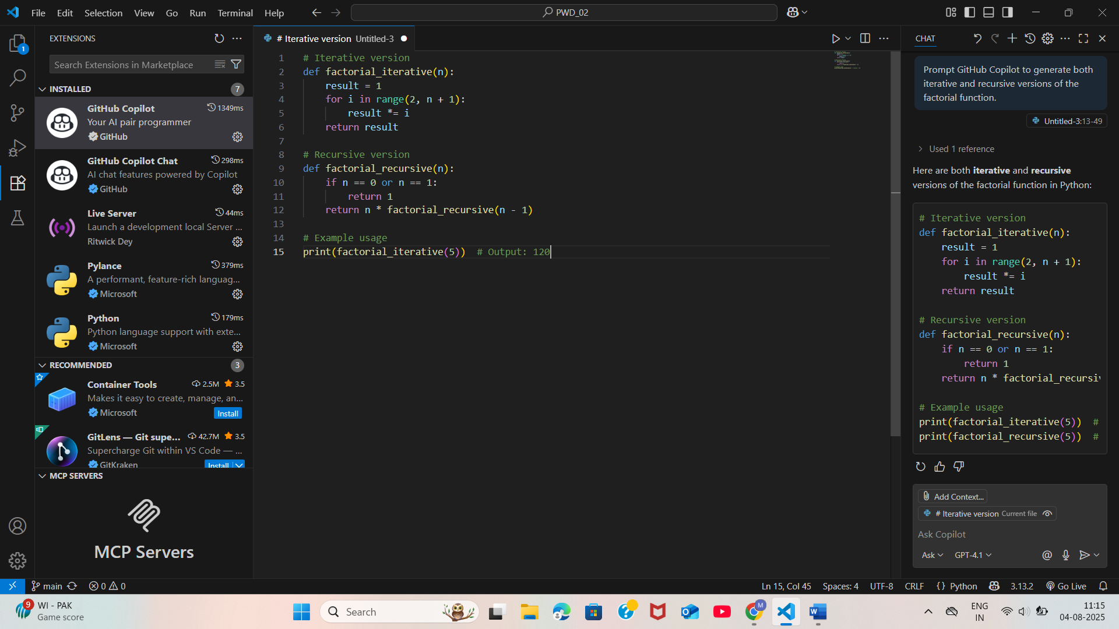  Submission Requirements  - Generate code for each task with comments.  - Screenshots of Copilot suggestions.  - Comparative analysis reports (Task 4 and Task 5).  - Sample inputs/outputs demonstrating correctness.  Note: Report should be submitted a word document for all tasks in a single document with prompts, comments & code explanation, and output and if required, screenshots  Evaluation Criteria:  Criteria Max Marks  Successful Setup of Copilot 0.5  Comparative Analysis – With vs Without Functions 1  Iterative vs Recursive Factorial 1  Total 2.5 Marks |  |  |  |  |  | Week1 - Monday

