## Salesforce-AutoCRM-Hub

## Phase 1: Problem Understanding & Industry Analysis

### **A. Requirements Gathering**

* Creation of custom objects to model core entities: **Order**, **Vehicle**, **Dealer**, **Customer**, **Inventory/Stock**, **TestDriveSchedule**.
* Importing or simulating datasets for these entities: sample data for customers, dealer locations, vehicle stock levels, and order history.

### **B. Stakeholder Simulation (Roles in Salesforce Context)**

* **Customer Role (simulated records):** interacts with ordering system, requests test drives, expects status updates and reminders.
* **Dealer Role (via Dealer custom object):** receives orders auto-assigned, holds inventory, updates stock; sees alerts for low stock.
* **Sales / Order Management Role:** monitors order pipeline, resolves exceptions (stock mismatch, unassigned orders), reviews dashboards.
* **Administrator / Developer Role:** defines custom objects, implements logic (Apex triggers, batch jobs, workflows), maintains the system.

### **C. Business Process Mapping**

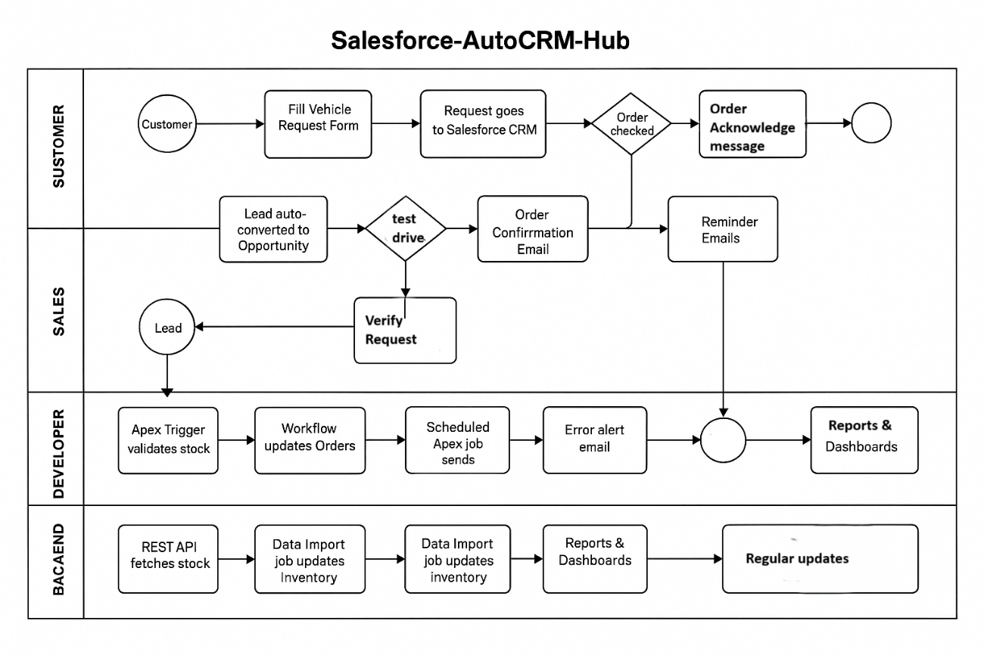

**Process Map Components:**

1. **Customer Order Entry** → order request submitted (fields: customer details, vehicle model, quantity).
2. **Stock Validation** → an Apex trigger checks Inventory to ensure requested vehicle is available.
3. **Dealer Assignment** → if stock OK, system locates nearest dealer (based on customer geolocation or predefined zones) and assigns order.
4. **Order Status Updates** → workflows or triggers update order status (Pending → Assigned → In Transit / Ready for Test Drive → Delivered).
5. **Notifications/Reminders** → scheduled Apex / workflow sends reminders to customer (e.g. for test drive appointment) and dealers.
6. **Stock Updates** → batch jobs run at set intervals to sync inventory across dealers or update stock levels.
7. **Reporting & Dashboard** → system aggregates data to show metrics (order volume, stock shortages, dealer load, customer satisfaction).

### **D. Industry-Specific Use Case Analysis (Research Based)**

In the automotive sector, CRMs face unique challenges:

* **Large Dealer Networks:** Must assign the nearest dealer fairly & quickly.
* **Dynamic Inventory:** Vehicles go in/out of stock rapidly.
* **Customer Expectations:** Real-time communication is the norm.

**Competitive Benchmarking:**

* Some automotive companies already use CRMs but lack automated dealer assignment.
* Salesforce-AutoCRM-Hub differentiates itself by combining **order automation, dealer assignment, and proactive communication**.

### **E. AppExchange Exploration**

Explore Salesforce marketplace (AppExchange) for reference solutions

* Dealer Management apps
* Vehicle Inventory add-ons
* Email/SMS automation tools

Building custom solution.