**PHASE 2 - Org Setup & Configuration**

**Company Profile Setup**

Basic org details are configured under **Setup → Company Information → Edit** to establish the foundational settings for the AutoCRM org.

* **Name**: AutoCRM
* **Time Zone**: GMT+05:30 Asia/Kolkata
* **Locale**: English (India)
* **Language**: English
* **Currency**: INR

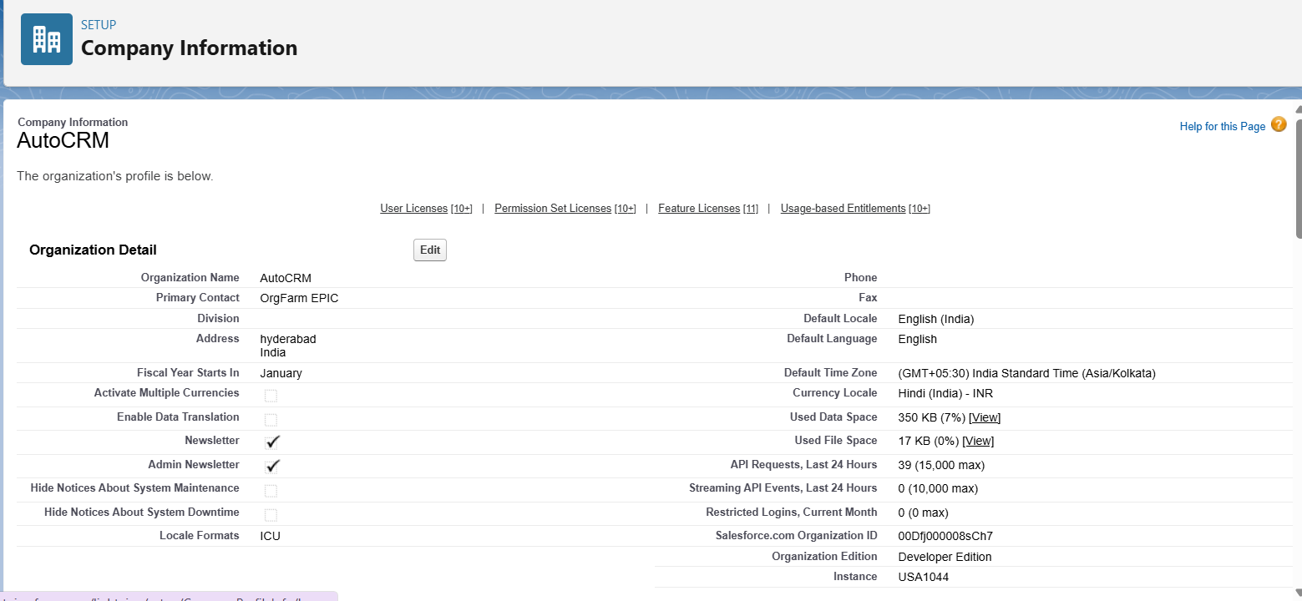

**Business Hours Setup**

Working hours are configured to reflect operating times for future case management and SLA tracking.

* **Path**: Setup → Business Hours → New.
* **Name**: Standard Restaurant Hours.
* **Time Zone**: GMT+05:30 Asia/Kolkata.
* **Working Hours**: Mon-Sun 10:00 AM–10:00 PM.

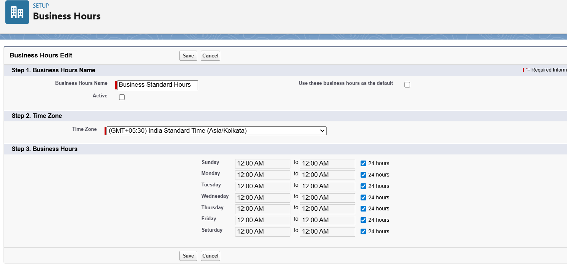

**Fiscal Year Setup**

A standard fiscal year is established to define reporting periods for sales and order analysis.

* **Path**: Setup → Fiscal Year.
* **Type**: Standard Fiscal Year.
* **Configuration**: The starting month is set to **January**.

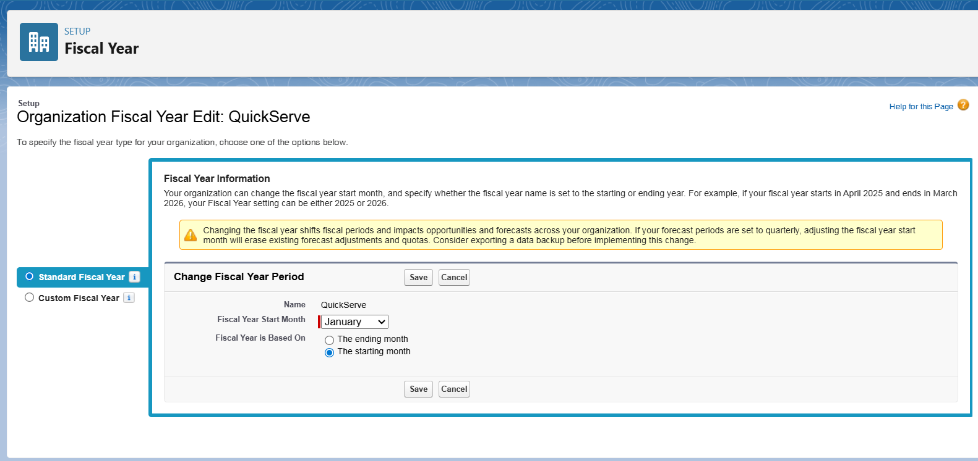

**User Setup (Profiles, Roles, Permission Sets, Users)**

* **Profiles**: Custom profiles were created by cloning standard profiles to provide baseline access.
  + **Dealer Manager**: For daily order entry and customer interaction.

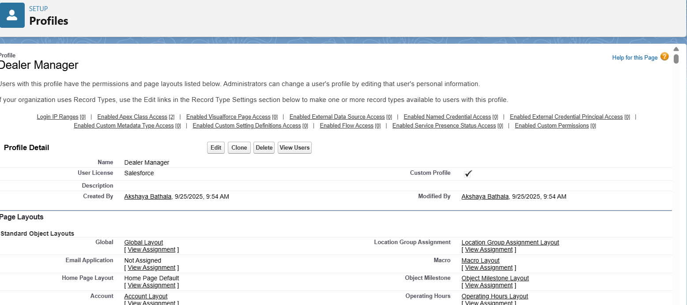

* + **Sales Manager**: For operational oversight, reporting, and manual adjustments.

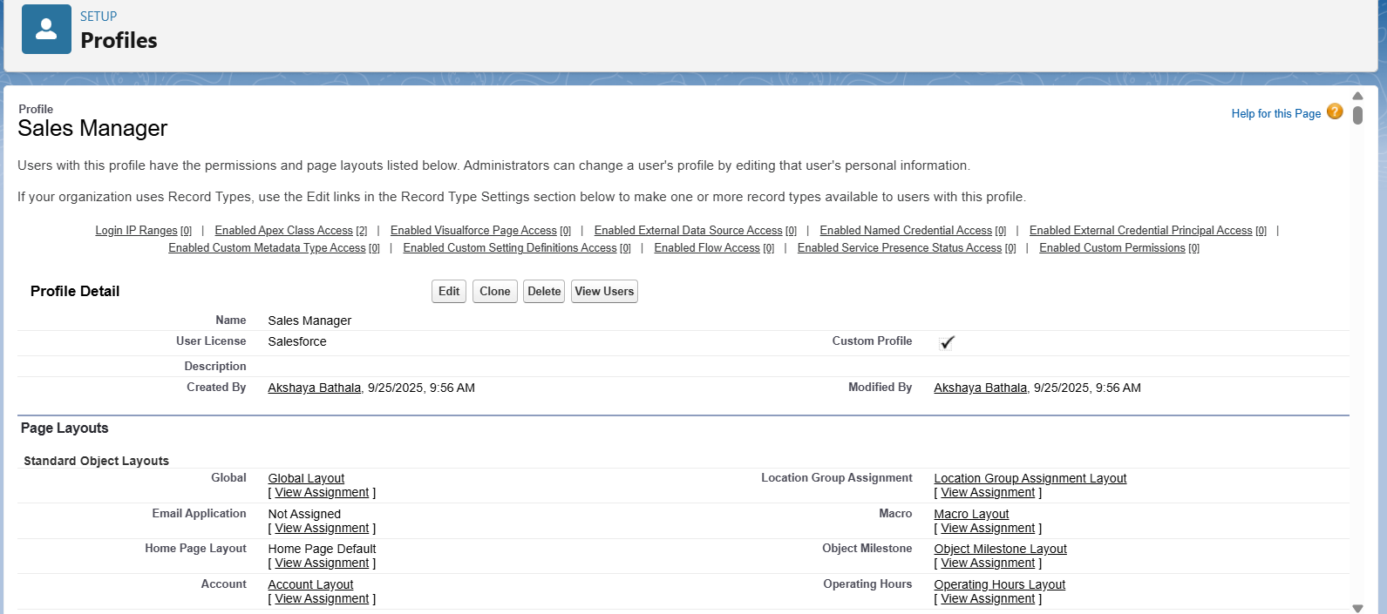

* **Roles**: A role hierarchy was defined for data visibility and report roll-ups.
  + Manager and customer.
* **Users**: Sample users were created and assigned the appropriate profiles and roles.
  + **manager1** → Dealer_Manager, Role: Manager

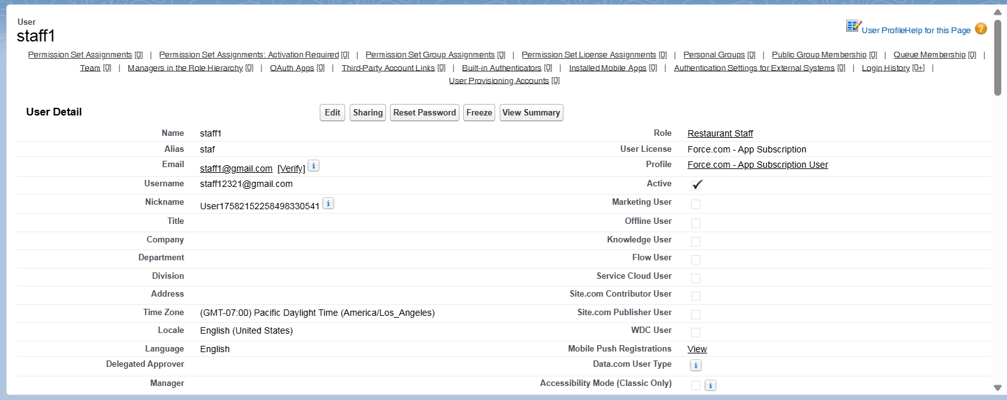

* + **customer1** → Customer_Profile, Role: Customer

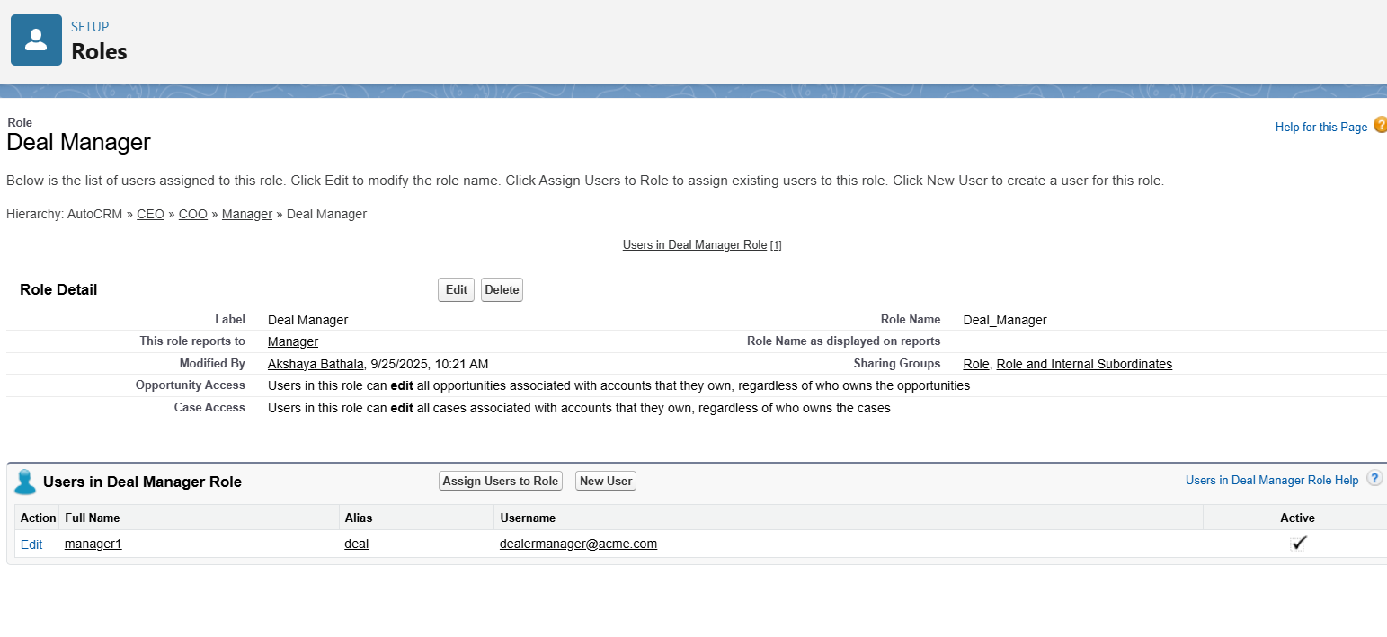

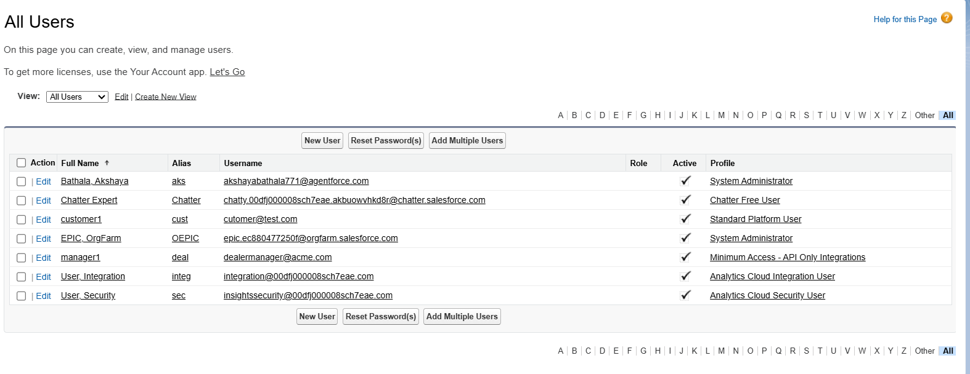

**Role Hierarchy Setup**

The hierarchy defines the data access and reporting structure within the organization.

* **Path**: Setup → Roles → Set Up Roles.
* **Top-Level Role**: CEO.
* **Manager Role**: Added as a child of the CEO.
* **Customer Role**: Added as a child under the Manager.
* **Resulting Hierarchy**: CEO → Manager → Restaurant Staff

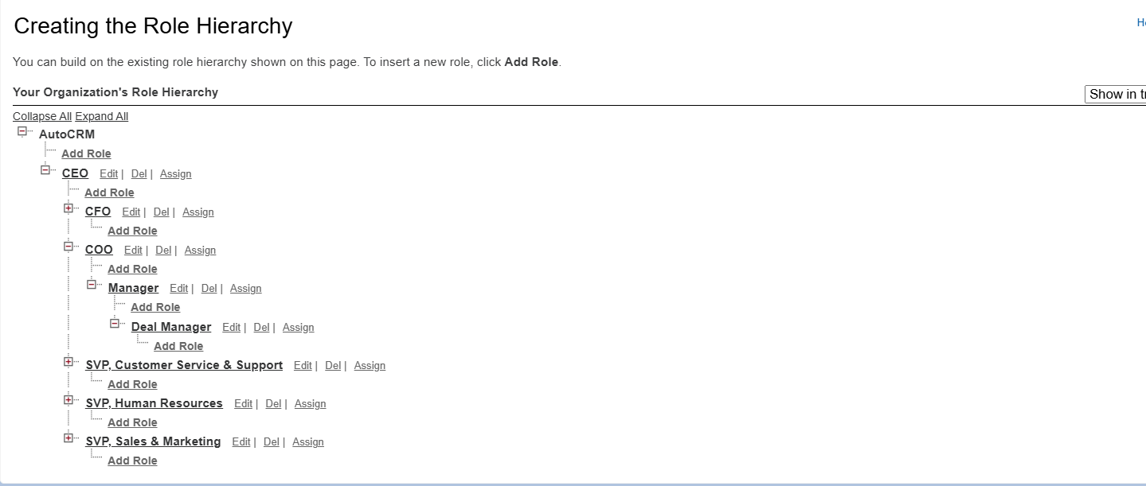

**OWD & Sharing Rules**

* **OWD (Org-Wide Default):** These settings will be configured during Phase 3, once the necessary custom objects are created.
* **Sharing Rule:** Implementation will follow in Phase 3, after the custom objects and OWD settings are established.

**Dev Org Setup**

The development environment was prepared to facilitate project development.

* A Salesforce Developer Edition org was provisioned for building the application.
* A GitHub repository was initialized to manage source code versions.
* VS Code and SFDX were set up to develop Apex classes and future Lightning Web Components.