**PHASE 3 – Data Modeling & Relationships**

🔹 **Standard & Custom Objects**  
The data model utilizes both standard and custom objects to create a robust structure for the AutoCRM application.

* **Standard Objects:**
  + **Report**: Used for generating analytical insights on vehicles, dealers, orders, test drives, and service requests.
  + **Dashboard**: Used for visualizing summarized reports for tracking sales, vehicle availability, and service performance.
* **Custom Objects:** Six custom objects form the core of the application:
  + **Vehicle__c**: Stores information about vehicles available in stock.
  + **Vehicle_Dealer__c**: Captures dealer information such as name, location, and contact details.
  + **Vehicle_Order__c**: Manages all customer orders for vehicles.
  + **Vehicle_Customer__c**: Holds customer records with personal details and preferences.
  + **Vehicle_Test_Drive__c**: Tracks customer test-drive bookings and statuses.
  + **Vehicle_Service_Request__c**: Logs service requests raised by customers for their vehicles.

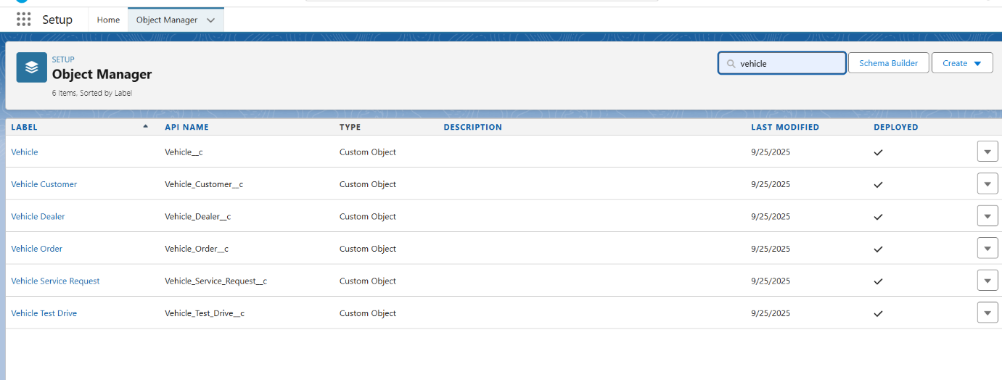

🔹 **Fields & Relationships**

Custom fields capture the required business data, and relationships link the objects together.

**Relationships**

* **Vehicle__c (Lookup to Vehicle_Dealer__c):** Each vehicle record is tied to a dealer, establishing dealer-vehicle association.
* **Vehicle_Order__c (Lookup to Vehicle__c and Vehicle_Customer__c):** Orders are linked to both the vehicle being purchased and the customer making the purchase.
* **Vehicle_Test_Drive__c (Lookup to Vehicle__c and Vehicle_Customer__c):** Test drives are connected to both the customer and the chosen vehicle.
* **Vehicle_Service_Request__c (Lookup to Vehicle__c and Vehicle_Customer__c):** Service requests are tied to both the vehicle and the requesting customer.

Lookup relationships are chosen instead of Master-Detail so that vehicle orders, test drives, and service requests can exist independently if the parent record (vehicle/customer) is deleted or not yet created.

**Custom Fields**

**On Vehicle__c:**

* Vehicle_Name__c (Text)
* Vehicle_Model__c (Picklist: Sedan, SUV, EV, etc.)
* Stock_Quantity__c (Number)
* Price__c (Currency)
* Dealer__c (Lookup to Vehicle_Dealer__c)
* Status__c (Picklist: Available, Out of Stock, Discontinued)

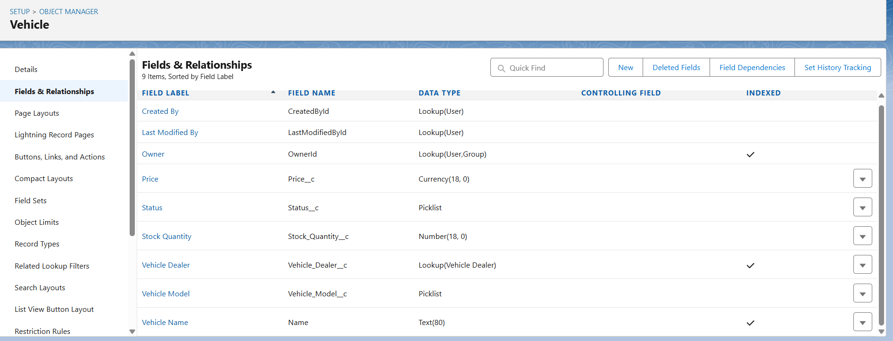

**On Vehicle_Dealer__c:**

* Dealer_Name__c (Text)
* Dealer_Location__c (Text)
* Dealer_Code__c (Auto Number)
* Phone__c (Phone)
* Email__c (Email)

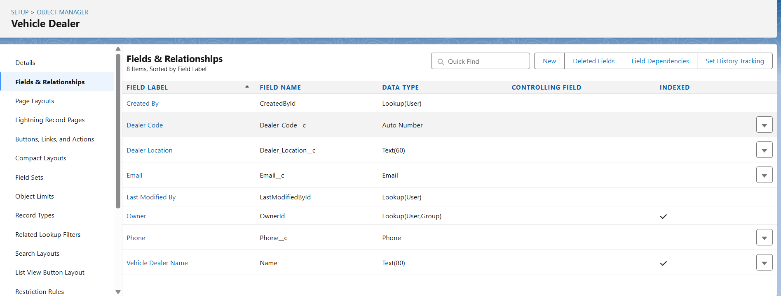

**On Vehicle_Order__c:**

* Customer__c (Lookup to Vehicle_Customer__c)
* Vehicle__c (Lookup to Vehicle__c)
* Order_Date__c (Date)
* Status__c (Picklist: Pending, Confirmed, Delivered, Canceled)

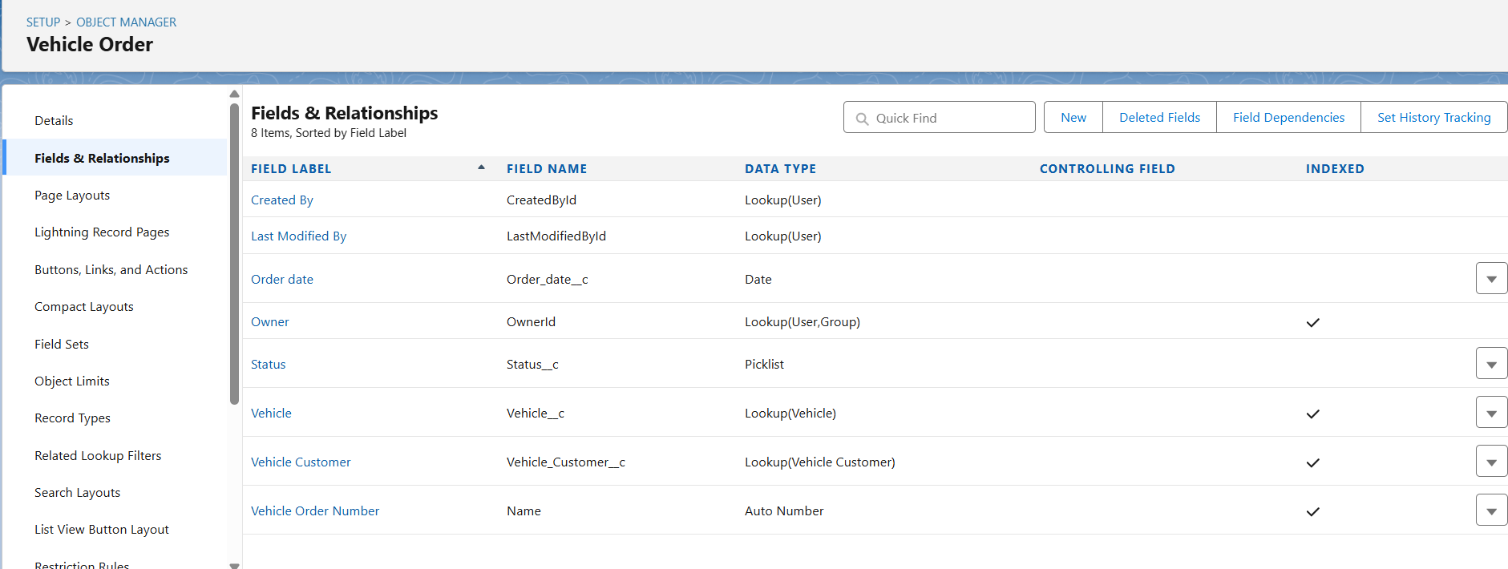

**On Vehicle_Customer__c:**

* Customer_Name__c (Text)
* Email__c (Email)
* Phone__c (Phone)
* Address__c (Text)
* Preferred_Vehicle_Type__c (Picklist: Sedan, SUV, EV, etc.)

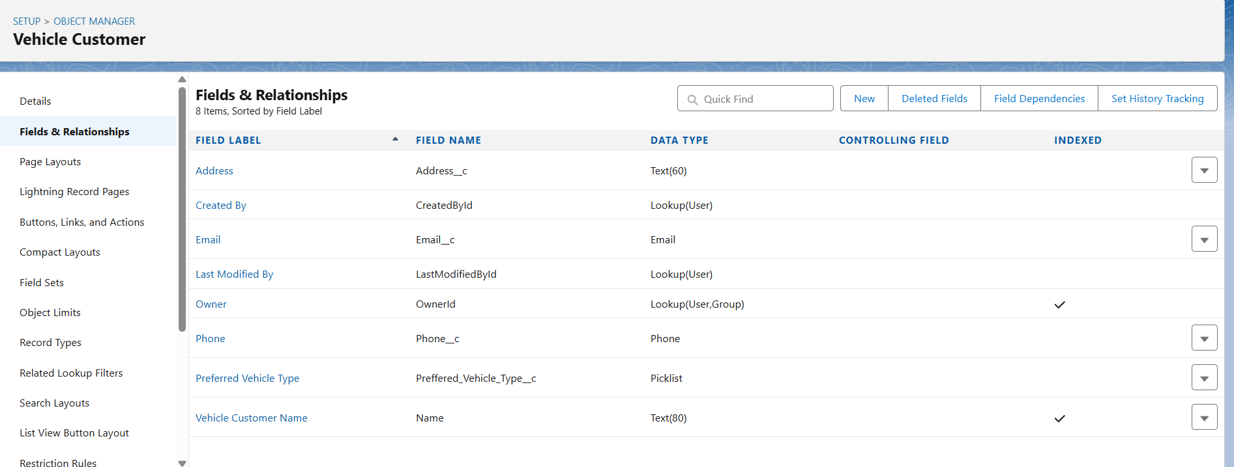

**On Vehicle_Test_Drive__c:**

* Customer__c (Lookup to Vehicle_Customer__c)
* Vehicle__c (Lookup to Vehicle__c)
* Test_Drive_Date__c (Date)
* Status__c (Picklist: Scheduled, Completed, Canceled)

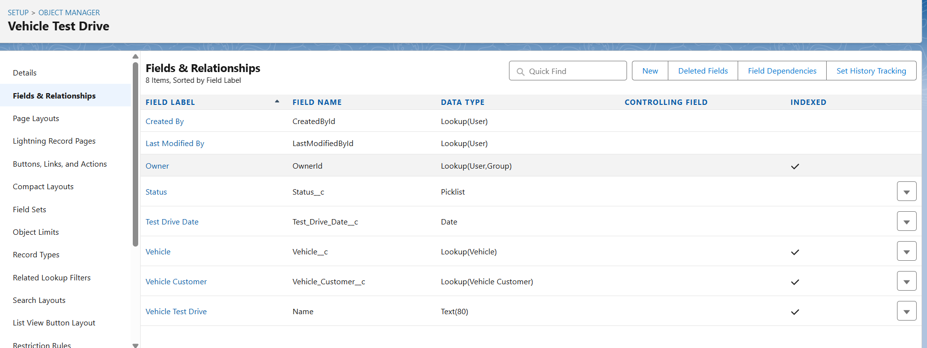

**On Vehicle_Service_Request__c:**

* Customer__c (Lookup to Vehicle_Customer__c)
* Vehicle__c (Lookup to Vehicle__c)
* Service_Date__c (Date)
* Issue_Description__c (Text)
* Status__c (Picklist: Requested, In Progress, Completed)

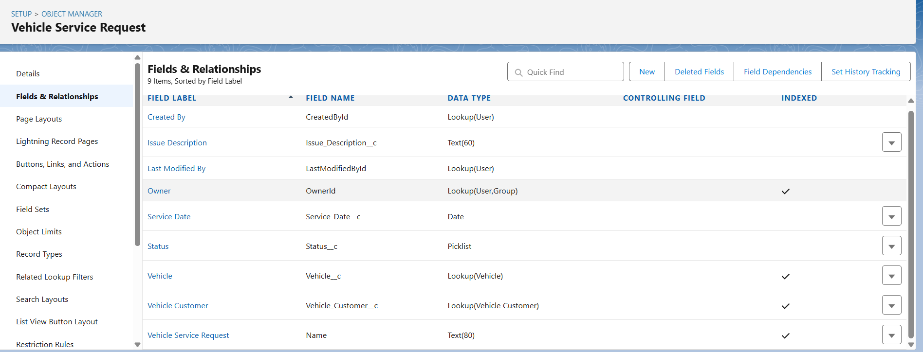

🔹 **Data Architecture**

* **Schema Builder:**  
  The Schema Builder tool will be used to visualize the complete Vehicle CRM data model, showing **Vehicle_Customer__c** at the center with lookup relationships from **Vehicle_Order__c, Vehicle_Test_Drive__c, and Vehicle_Service_Request__c**. Similarly, **Vehicle__c** is related to both **Vehicle_Dealer__c** (dealer-vehicle association) and transactional records (orders, test drives, services).

