**PHASE 4 - Process Automation (Admin)**

The goal of this phase is to use Salesforce's declarative tools to automate the core business logic, enforce data quality, and handle notifications.

**♦️ Validation Rules**

**Validation Rule:** Order_Customer_Vehicle_Required  
**Object:** Vehicle_Order__c  
**Purpose:** Ensure both Customer and Vehicle are selected  
**Formula:** ISBLANK( Vehicle_Customer__c ) || ISBLANK( Vehicle__c )  
**Error Message:** “Order must have both a Customer and a Vehicle assigned.”  
**Field:** Customer__c / Vehicle__c  
**Steps:** Object Manager → Vehicle_Order__c → Validation Rules → New → Enter formula → Error Message → Field → Save

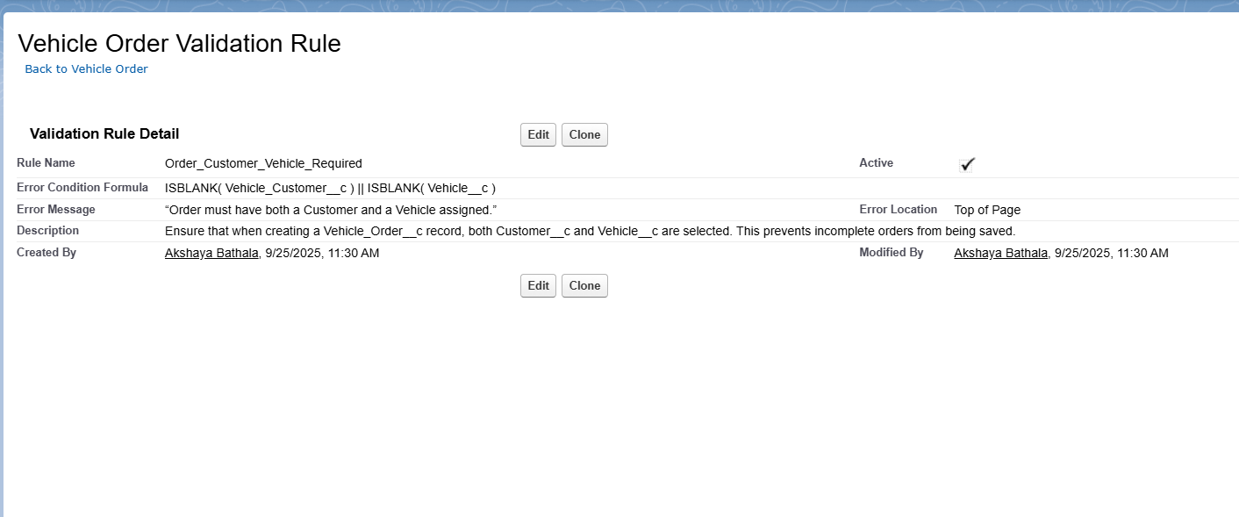

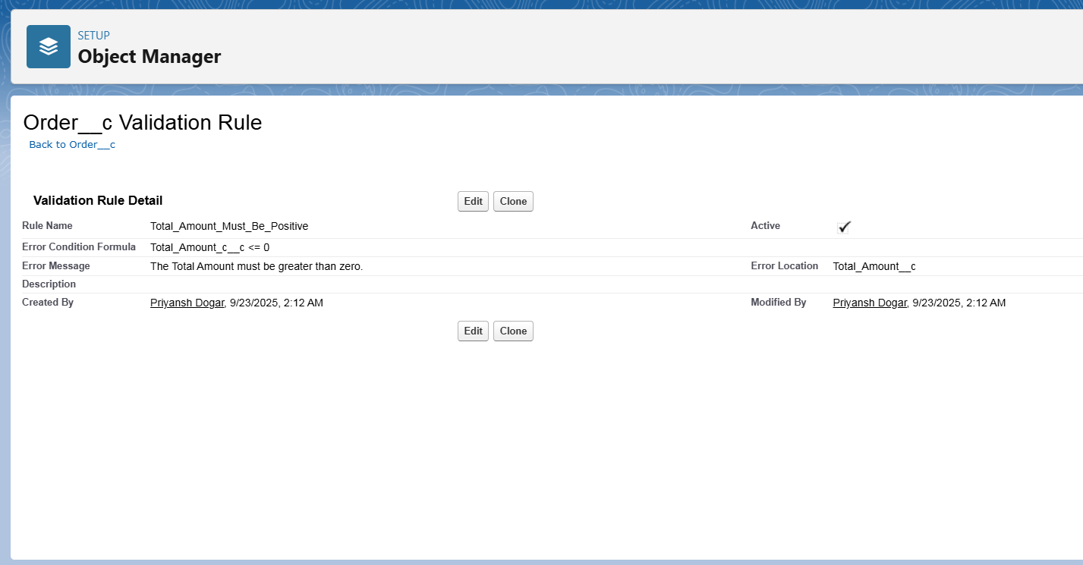

**♦️ Flow Builder (Record-Triggered Flow)**

**Objective**

Automatically assign the nearest dealer to a new **Vehicle_Order__c** record based on the customer’s address.

**Flow Type and Trigger Configuration**

* **Flow Type:** Record-Triggered Flow
* **Object:** Vehicle_Order__c
* **Trigger:** When a record is **created**
* **Run Flow:** **After the record is saved** (to allow related record lookup and update)

**Flow Logic / Steps**

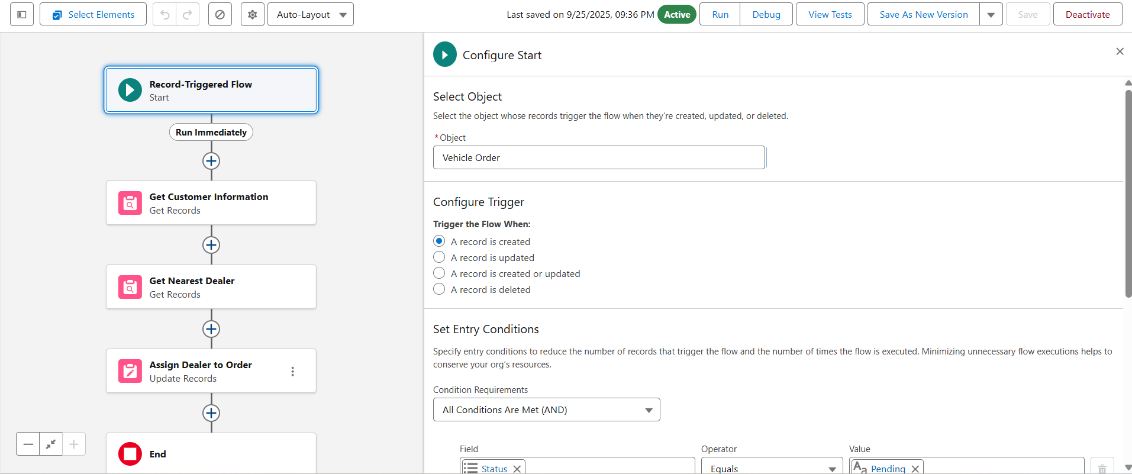

1. **Get Customer Information**
   * **Element:** Get Records
   * **Object:** Vehicle_Customer__c
   * Get the customer record whose **Id matches the Customer__c field on the triggering Vehicle_Order__c**.
   * **Output:** Store customer address for further use

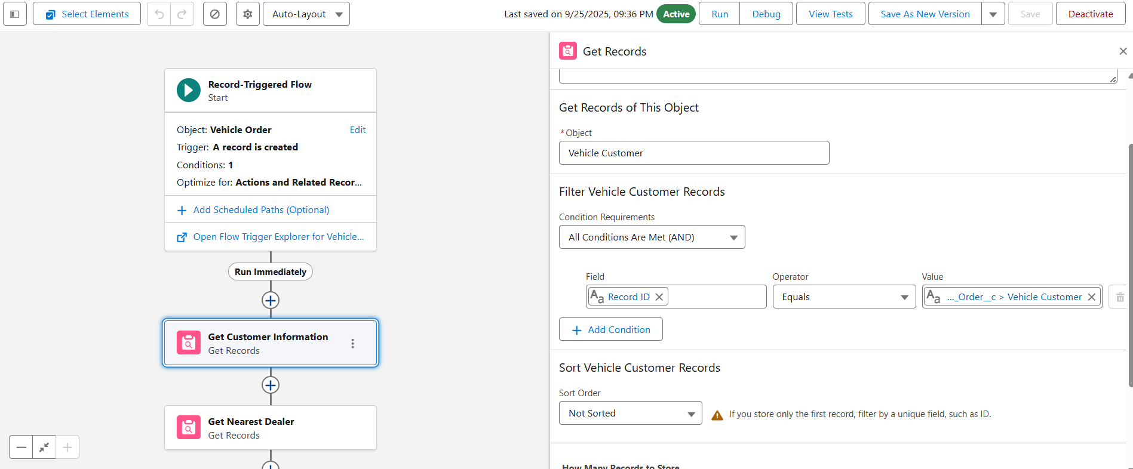

1. **Get Nearest Dealer**
   * **Element:** Get Records
   * **Object:** Vehicle_Dealer__c
   * Get the dealer whose **Dealer_Location__c matches the Address field of the customer linked to this Vehicle_Order__c**.
   * **Sort:** Optionally by distance or priority if available
   * **Output:** Store the nearest dealer record

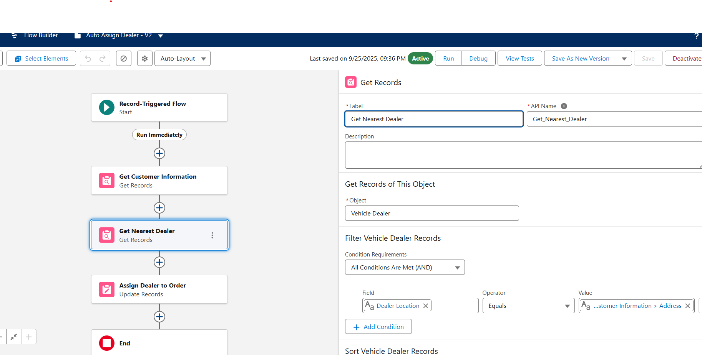

1. **Assign Dealer to Order**
   * **Element:** Update Records
   * **Record to Update:** Triggering Vehicle_Order__c record
   * Update the triggering **Vehicle_Order__c** record by setting **Dealer__c = Id of the nearest dealer**

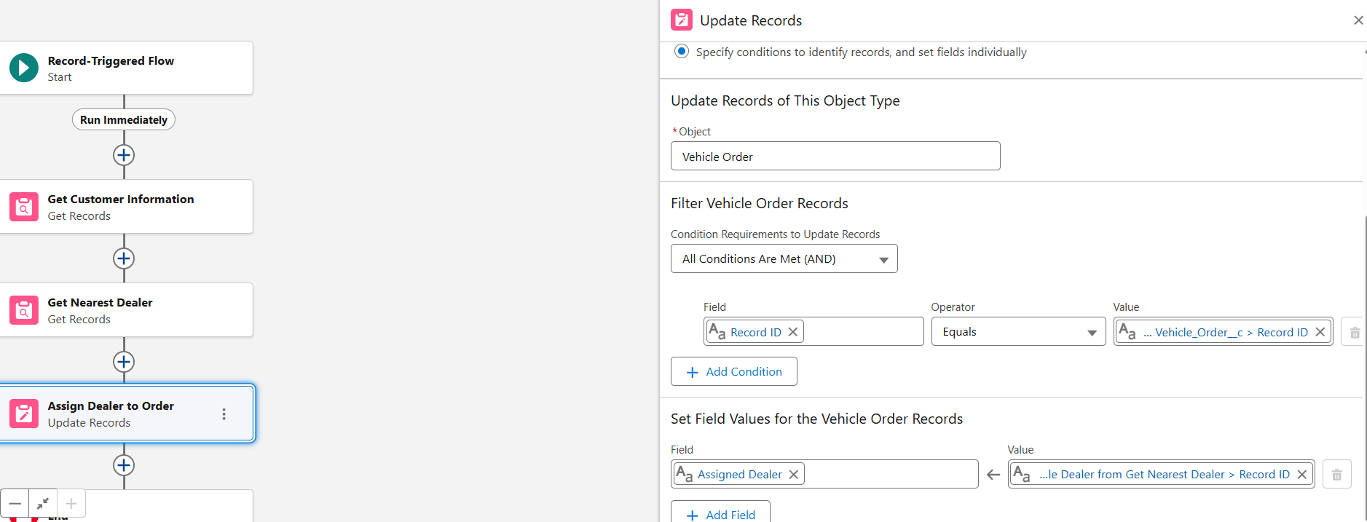

**♦️ Approval Process**

An approval process automates how records are approved. **While not part of the initial build, a potential future use case has been identified**:

* **Objective:** Require a Dealer Manager’s approval for any Vehicle_Order__c with a Total_Amount__c exceeding a set value (e.g., 50,000 INR).
* **Process:** When an order meets the criteria, it is automatically submitted to the Dealer Manager for approval or rejection, and the order’s Status__c is updated accordingly.

**♦️ Workflow Rules & Process Builder**

These are legacy automation tools in Salesforce. For this project, all new automation, including the loyalty points calculation, was built using **Flow Builder** to align with current Salesforce best practices.