Student Grade Calculator
Project Overview
Project Title: Student Grade Calculator
Objective
The Student Grade Calculator is a Python-based application that calculates a student's grade based on the marks entered by the user. The program validates the input, determines the appropriate grade using conditional statements, and displays an encouraging message according to the student's performance. This project demonstrates the use of basic Python programming concepts such as functions,loops, conditional statements, and input validation.
Goals
- Accept student name and marks as input.
- Validate that the entered marks are between 0 and 100.
- Calculate the student's grade using if-elif-else statements.
- Display an encouraging message based on the grade obtained.
- Improve understanding of Python programming fundamentals.
Setup Instructions
Software Requirements
- Python 3.x
- Jupyter Notebook
- Git
- GitHub Account
Installation Steps
- Install Python 3.x on your computer from the official Python website.
- Install Jupyter Notebook by opening Command Prompt and running:
- pip install notebook
- Create a new project folder (grade_calculator).
- Open Command Prompt, navigate to the project folder, and start Jupyter Notebook by running:
- jupyter notebook
- Create a new Python notebook named grade_calculator.ipynb.
- Write and execute the program in the notebook by running each cell using Shift + Enter.
- Verify the output by testing different student names and marks.
10.Initialize a Git repository in the project folder using:
11.git init
12.Add the project files, commit the changes, and push the project to a GitHub repository.
13.The project is now successfully stored on GitHub for version control and sharing.

Code Structure
grade_calculator/
│── README.md
│── grade_calculator.py
│── test_cases.txt
└── screenshots/
├── output1.png
├── output2.png
└── output3.png
File Description
- README.md – Contains project description, setup instructions, and usage details.
- grade_calculator.py – Main Python program containing the grading logic.
- test_cases.txt – Contains sample inputs and expected outputs for testing.
- screenshots/ – Contains screenshots demonstrating the program execution.

Visual Documentation
- The screenshots folder contains images showing the execution of the program.

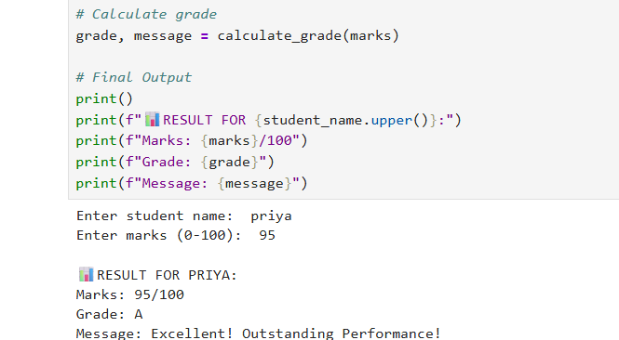

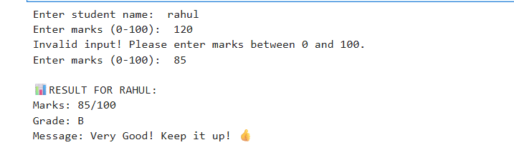
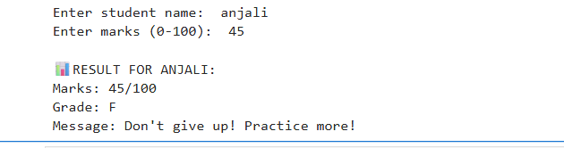
Technical Details
Programming Language
Python 3
Concepts Used
- Variables
- User Input (input())
- Output (print())
- Functions
- Conditional Statements (if-elif-else)
- While Loop
- Input Validation
- Return Statements
Algorithm
- Start the program.
- Read the student's name.
- Read the student's marks.
- Validate the entered marks using a while loop.
- If the marks are invalid, ask the user to enter the marks again.
- Call the calculate_grade() function.
- Determine the grade using if-elif-else statements.
- Display the student's result.
- End the program.
Data Structures Used
This project uses simple Python variables and functions. No advanced data structures or external libraries are required.

Grading Logic and Functions
Grading Logic
The student's marks are evaluated using if-elif-else conditions.
Marks | Grade | Encouraging Message
90–100 | A | Excellent! Outstanding Performance! 🌟
80–89 | B | Very Good! Keep it up! 👍
70–79 | C | Good Job! Keep improving! 😊
60–69 | D | You Passed! Work harder! 💪
0–59 | F | Don't give up! Practice more! 📚
Function Used
calculate_grade(marks)
Purpose:
Determines the student's grade and returns an encouraging message.
Input:
- Student Name
- Student marks
Output:
- Grade
- Encouraging message
The function improves code readability and avoids repetition by separating the grading logic from the main program.
Testing Evidence:The Student Grade Calculator was tested with different input values to ensure that the grading logic, input validation, and encouraging messages work correctly.
Test Case 1 – Grade A
Input:
- Student Name: Priya
- Marks: 95
Expected Output:
- Grade: A
- Message: Excellent! Outstanding Performance!
Actual Output:
- Grade: A
- Message: Excellent! Outstanding Performance!
Status: Passed

Test Case 2 – Grade B
Input:
- Student Name: Rahul
- Marks: 85
Expected Output:
- Grade: B
- Message: Very Good! Keep it up!
Actual Output:
- Grade: B
- Message: Very Good! Keep it up!
Status: Passed

Test Case 3 – Grade C
Input:
- Student Name: Anjali
- Marks: 45
Expected Output:
- Grade: F
- Message: Don't give up! Practice more!

Actual Output:
- Grade: F
- Message: Don't give up! Practice more! 📚

Status: Passed

Test Case 4 – Invalid Input
Input:
- Student Name: Rahul
- Marks: 120
Expected Output:
- Display an error message and request valid marks between 0 and 100.
Actual Output:
- Invalid input! Please enter marks between 0 and 100.
- User entered a valid mark (85).
- Grade calculated successfully.
Status: Passed

Overall Result
All test cases were executed successfully. The application correctly validates user input, calculates grades based on the grading criteria, and displays appropriate encouraging messages. The project satisfies all the specified functional requirements.

