NAME: | Akshaya Karande
UID: | 2021300056
SUBJECT: | DAA
CLASS: | SE COMPS A
BATCH: | D
EXPERIMENT NO.: | 1a
AIM: | To implement the various functions e.g. linear, non-linear, quadratic, exponential etc.
PROGRAM: | #include <stdio.h>  #include <math.h>  int main()  {  printf(" Function 1 : n^3\n");  for(int i=0;i<=100;i++)  {  printf("%d\n",i*i*i);  }  printf("-----------------------------------------------\n");  printf(" Function 2 : ln n\n");  for(double i=0;i<=100;i++)  {  printf("%f\n",log(i));  }  printf("-----------------------------------------------\n");  printf(" Function 3 : ln ln n\n");  for(double i=0;i<=100;i++)  {  printf("%f\n",log(log(i)));  }  printf("-----------------------------------------------\n");  printf(" Function 4 : 2^n\n");  for(double i=0;i<=100;i++)  {  printf("%f\n",pow(2,i));  }  printf("-----------------------------------------------\n");  printf(" Function 5 : n.2^n\n");  for(double i=0;i<=100;i++)  {  printf("%f\n",i*pow(2,i));  }  printf("-----------------------------------------------\n");  printf(" Function 6 : 2^(2^n)\n");  for(double i=0;i<=100;i++)  {  printf("%f\n",pow(2,pow(2,i)));  }  printf("-----------------------------------------------\n");  printf(" Function 7 : (3/2)^n\n");  for(double i=0;i<=100;i++)  {  printf("%f\n",pow(1.5,i));  }  printf("-----------------------------------------------\n");  printf(" Function 8 : 2^(2^n+1)\n");  for(double i=0;i<=100;i++)  {  printf("%f\n",pow(2,pow(2,i+1)));  }  printf("-----------------------------------------------\n");  printf(" Function 9 : log n\n");  for(double i=0;i<=100;i++)  {  printf("%f\n",log10(i));  }  printf("-----------------------------------------------\n");  printf(" Function 10 : log log n\n");  for(double i=0;i<=100;i++)  {  printf("%f\n",log10(log10(i)));  }  }
OBSERVATION: | 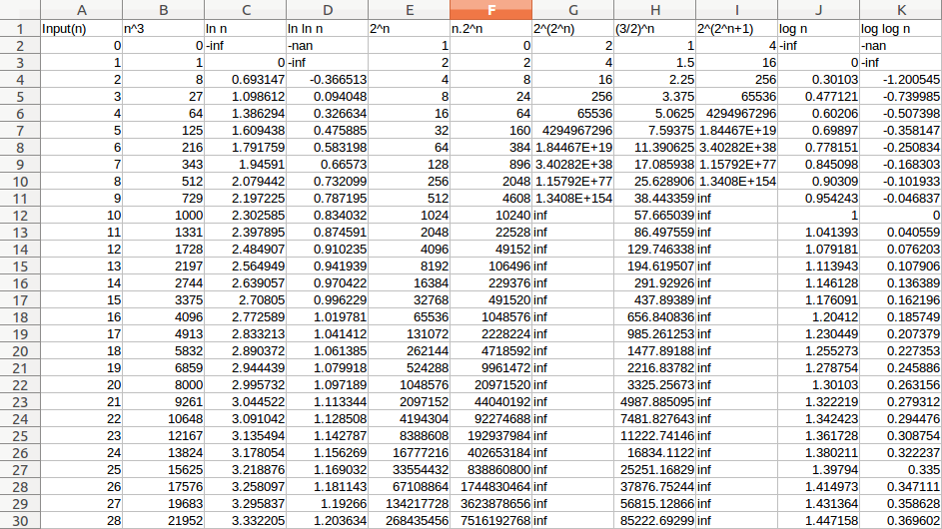  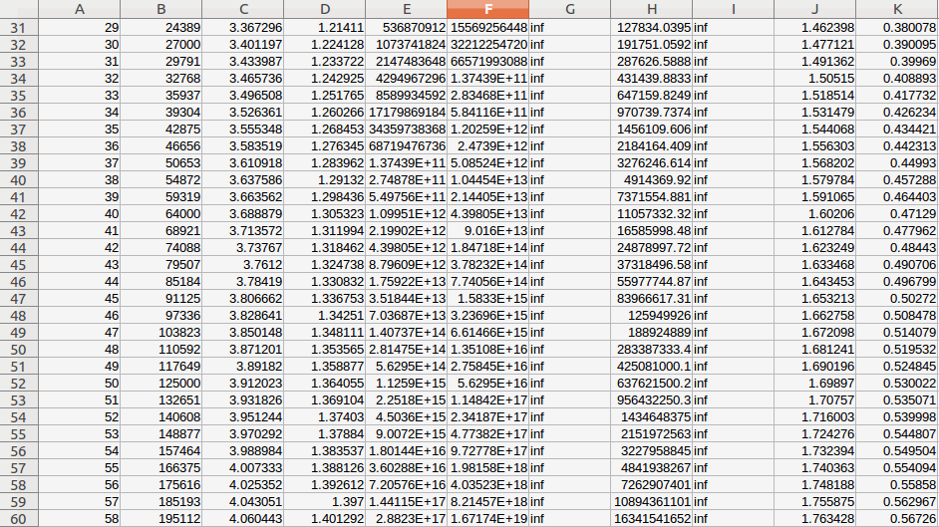  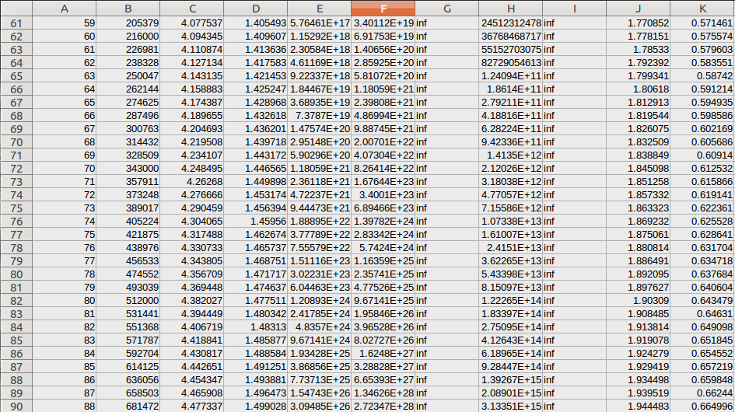  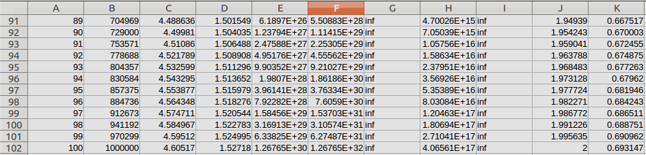  1) n^3  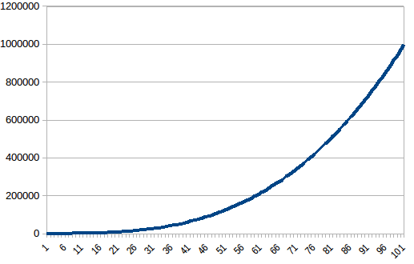  2) ln n  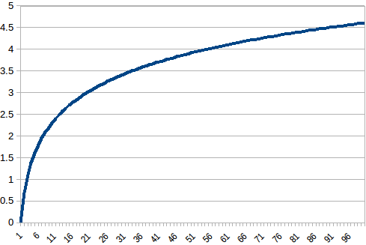  3)ln ln n  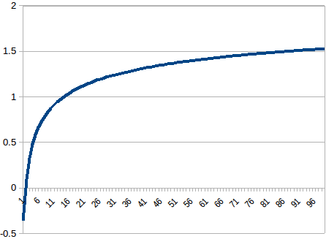  4)2^n  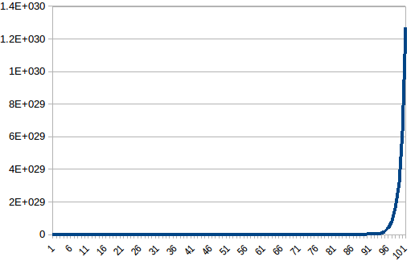  5) n.2^n  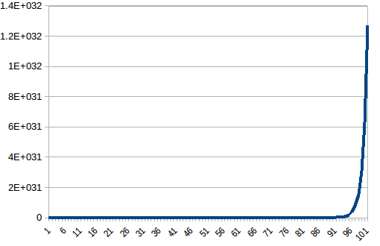  6)2^(2^n)  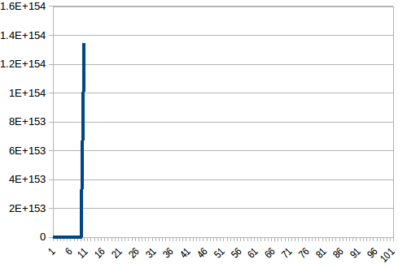  7)(3/2)^n  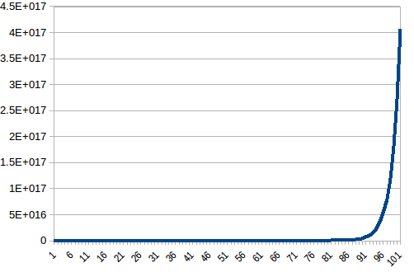  8)2^(2^n+1)  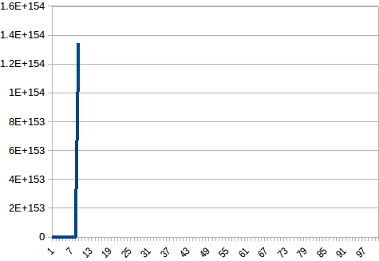  9)log n  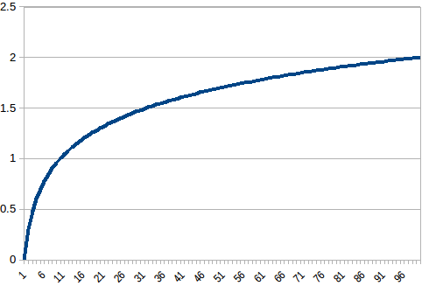  10)log log n  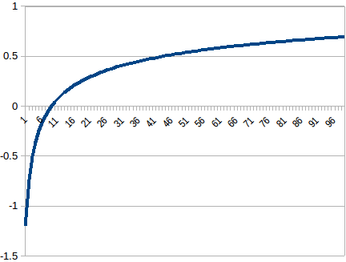
CONCLUSION: | In conclusion, by performing the experiment of plotting graphs of different function I have understood the behavior of various mathematical functions and how they relate to each other. By analyzing the graphs, we were able to identify the domain and range of each function, as well as their key characteristics such as symmetry, intercepts, and asymptotes. Furthermore, the experiment demonstrated the importance of using graphical representations to better understand mathematical concepts. Graphs can provide insights and visualizations that may be difficult to discern from equations alone. Overall, this experiment has enhanced our understanding of the properties and behaviors of various functions, and has shown us the importance of visualizing mathematical concepts through graphing.

