PROGRAM:7
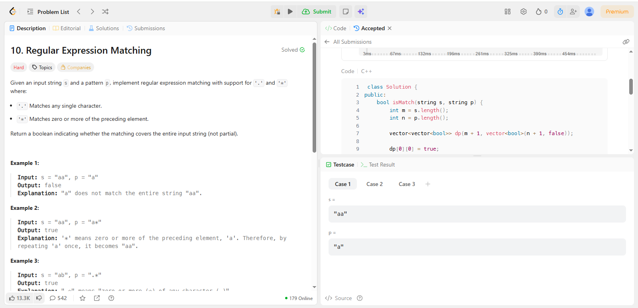
CODE:
class Solution {
public:
bool isMatch(string s, string p) {
int m = s.length();
int n = p.length();

vector<vector<bool>> dp(m + 1, vector<bool>(n + 1, false));

dp[0][0] = true;

// Handle patterns like a*, a*b*, etc.
for (int j = 2; j <= n; j++) {
if (p[j - 1] == '*') {
dp[0][j] = dp[0][j - 2];
}
}

for (int i = 1; i <= m; i++) {
for (int j = 1; j <= n; j++) {

if (p[j - 1] == s[i - 1] || p[j - 1] == '.') {
dp[i][j] = dp[i - 1][j - 1];
}

else if (p[j - 1] == '*') {

// Zero occurrence
dp[i][j] = dp[i][j - 2];

// One or more occurrence
if (p[j - 2] == s[i - 1] || p[j - 2] == '.') {
dp[i][j] = dp[i][j] || dp[i - 1][j];
}
}
}
}

return dp[m][n];
}
};

