PROGRAM:5
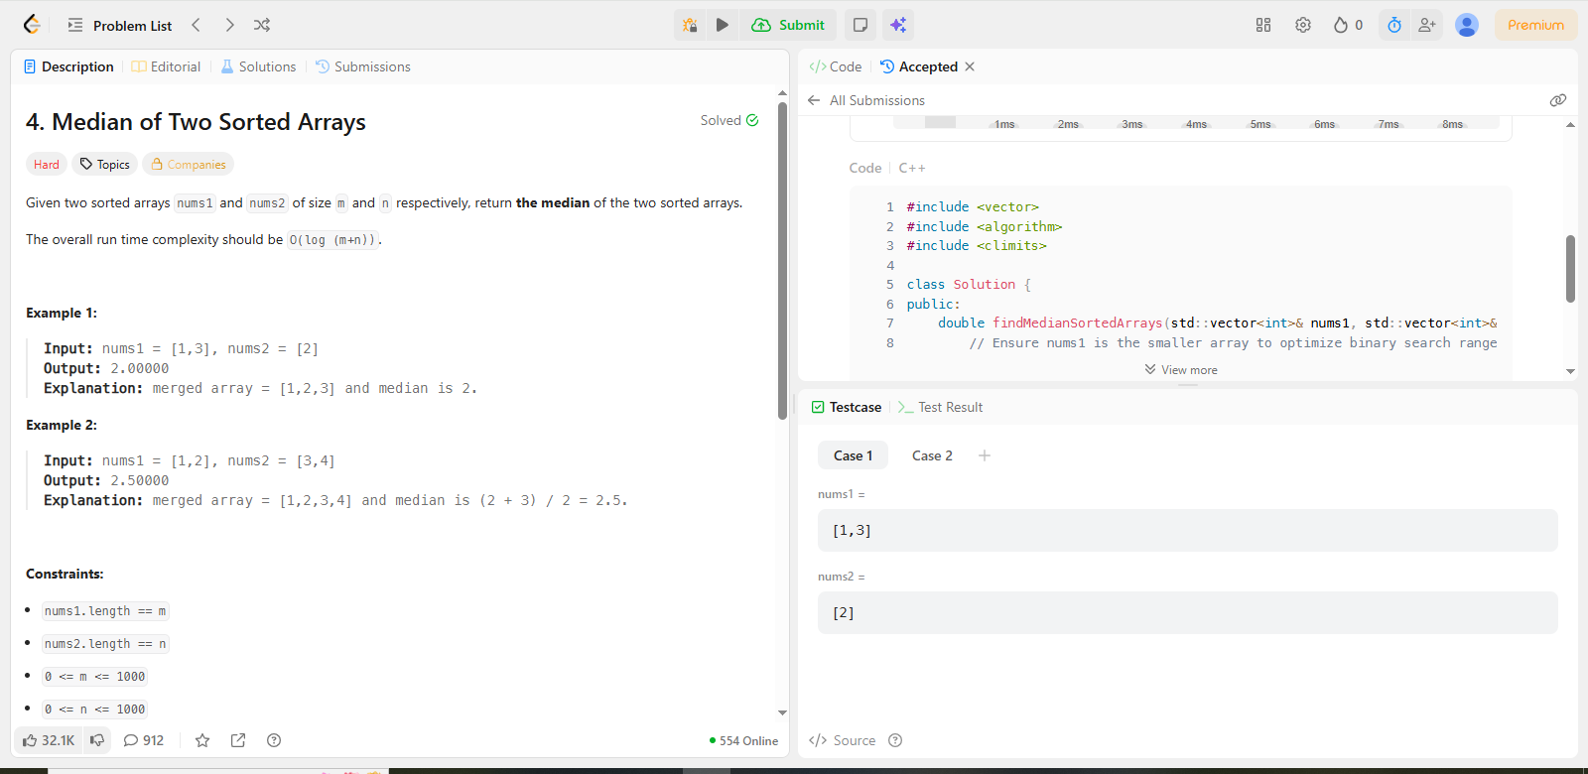
CODE:
#include <vector>
#include <algorithm>
#include <climits>

class Solution {
public:
double findMedianSortedArrays(std::vector<int>& nums1, std::vector<int>& nums2) {
// Ensure nums1 is the smaller array to optimize binary search range
if (nums1.size() > nums2.size()) {
return findMedianSortedArrays(nums2, nums1);
}

int m = nums1.size();
int n = nums2.size();
int low = 0, high = m;

while (low <= high) {
// Partition index for nums1 and nums2
int partitionX = (low + high) / 2;
int partitionY = (m + n + 1) / 2 - partitionX;

// Edge cases: if partition is at the 0 index or the end of the array
int maxLeftX = (partitionX == 0) ? INT_MIN : nums1[partitionX - 1];
int minRightX = (partitionX == m) ? INT_MAX : nums1[partitionX];

int maxLeftY = (partitionY == 0) ? INT_MIN : nums2[partitionY - 1];
int minRightY = (partitionY == n) ? INT_MAX : nums2[partitionY];

// Check if we found the correct partition
if (maxLeftX <= minRightY && maxLeftY <= minRightX) {
// If total elements are even
if ((m + n) % 2 == 0) {
return (std::max(maxLeftX, maxLeftY) + std::min(minRightX, minRightY)) / 2.0;
}
// If total elements are odd
else {
return std::max(maxLeftX, maxLeftY);
}
}
// We are too far to the right in nums1, move left
else if (maxLeftX > minRightY) {
high = partitionX - 1;
}
// We are too far to the left in nums1, move right
else {
low = partitionX + 1;
}
}

return 0.0; // Should never reach here if inputs are sorted
}
};

