PROGRAM:1
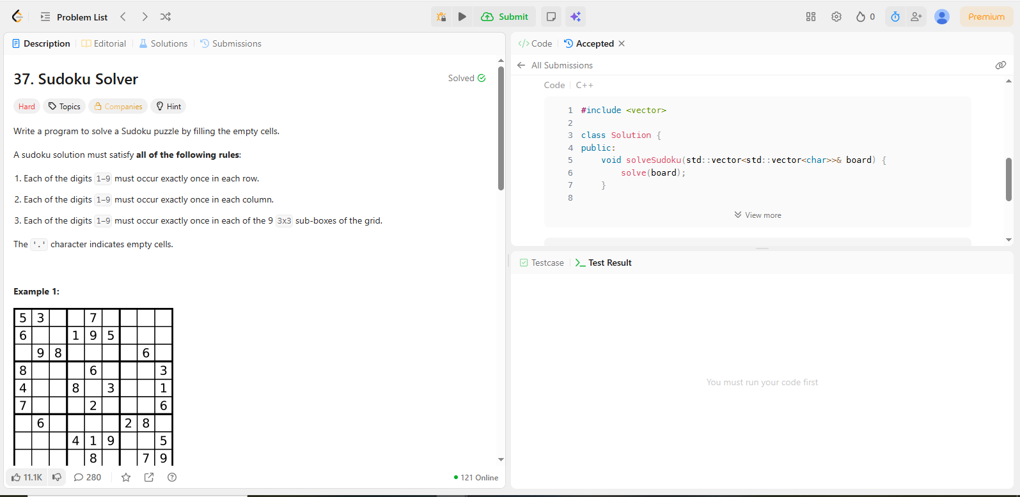
CODE:
#include <vector>
class Solution {
public:
void solveSudoku(std::vector<std::vector<char>>& board) {
solve(board);
}

