PROGRAM:8
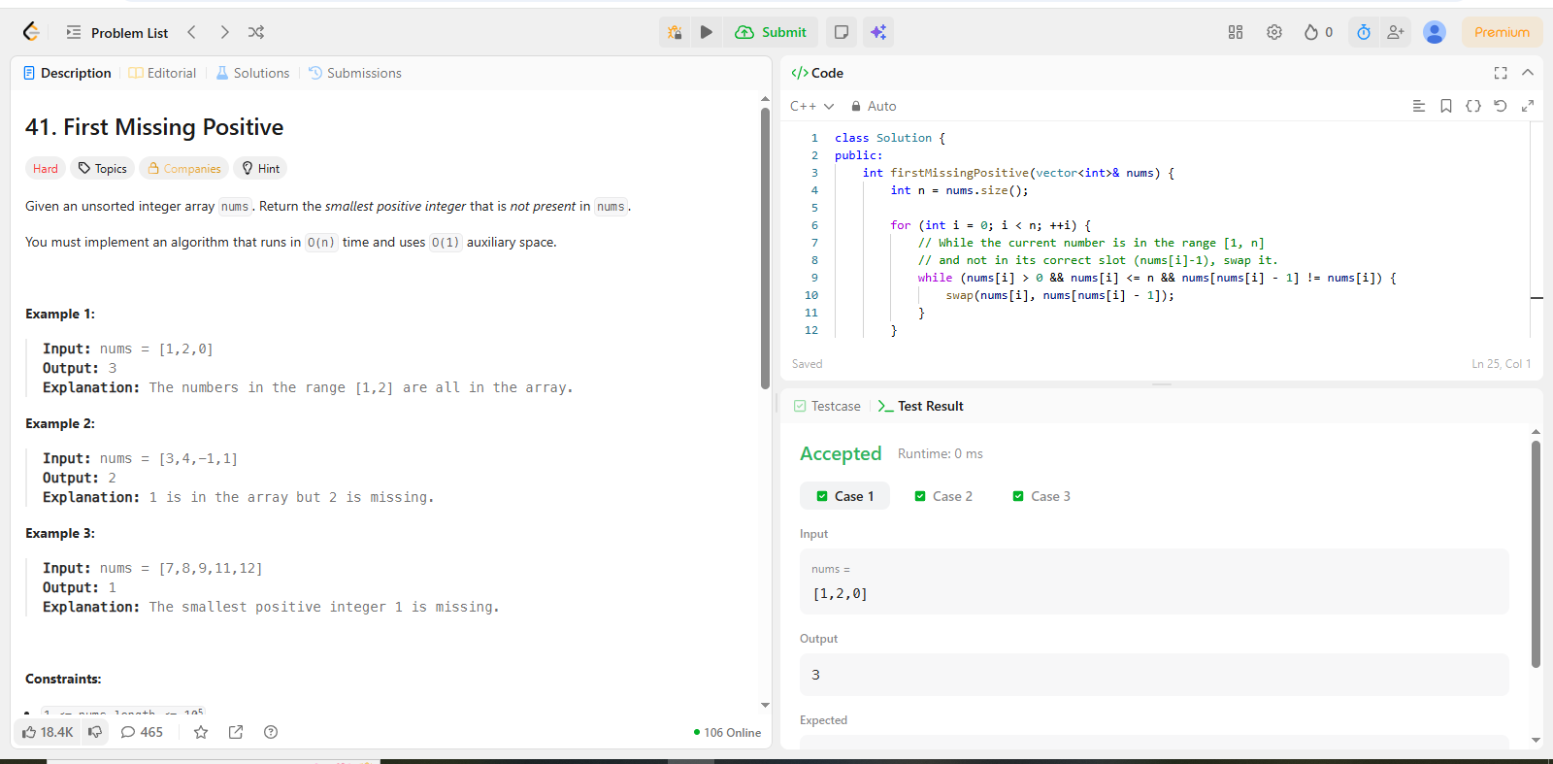
CODE:
class Solution {
public:
int firstMissingPositive(vector<int>& nums) {
int n = nums.size();

for (int i = 0; i < n; ++i) {
// While the current number is in the range [1, n]
// and not in its correct slot (nums[i]-1), swap it.
while (nums[i] > 0 && nums[i] <= n && nums[nums[i] - 1] != nums[i]) {
swap(nums[i], nums[nums[i] - 1]);
}
}

// Find the first index that doesn't match its value
for (int i = 0; i < n; ++i) {
if (nums[i] != i + 1) {
return i + 1;
}
}

// If all numbers 1 to n are present
return n + 1;
}
};

