PROGRAM:3
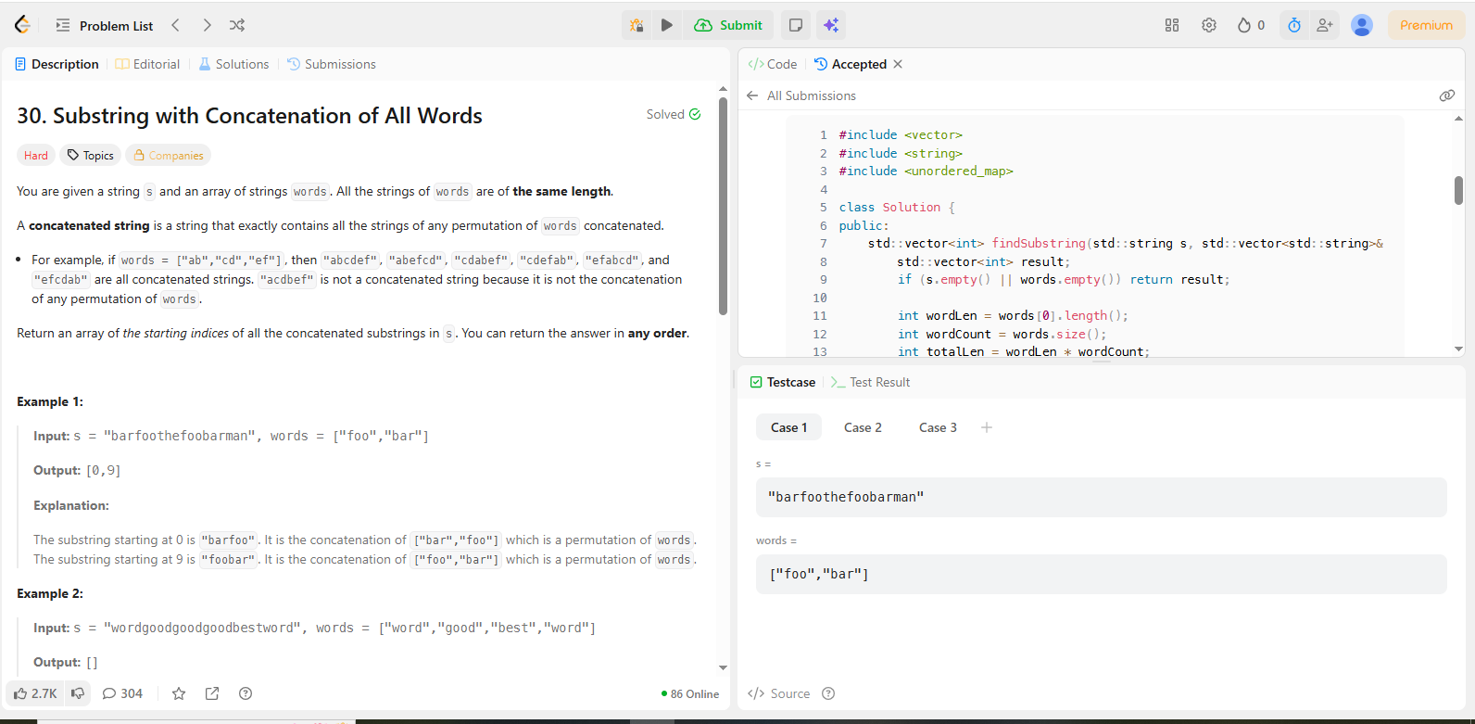
CODE:
#include <vector>
#include <string>
#include <unordered_map>

class Solution {
public:
std::vector<int> findSubstring(std::string s, std::vector<std::string>& words) {
std::vector<int> result;
if (s.empty() || words.empty()) return result;

int wordLen = words[0].length();
int wordCount = words.size();
int totalLen = wordLen * wordCount;
int sLen = s.length();

// 1. Store the frequency of each word in the input array
std::unordered_map<std::string, int> wordFreq;
for (const std::string& w : words) {
wordFreq[w]++;
}

// 2. Iterate through all possible starting offsets (0 to wordLen - 1)
for (int i = 0; i < wordLen; ++i) {
int left = i;
int right = i;
int count = 0;
std::unordered_map<std::string, int> currentFreq;

// 3. Sliding window of size totalLen
while (right + wordLen <= sLen) {
// Extract the word at the right end of the window
std::string word = s.substr(right, wordLen);
right += wordLen;

if (wordFreq.count(word)) {
currentFreq[word]++;
count++;

// If we have more instances of 'word' than needed, shrink from the left
while (currentFreq[word] > wordFreq[word]) {
std::string leftWord = s.substr(left, wordLen);
currentFreq[leftWord]--;
count--;
left += wordLen;
}

// If count matches total words, we found a valid starting index
if (count == wordCount) {
result.push_back(left);
}
} else {
// Not a valid word: reset the window
currentFreq.clear();
count = 0;
left = right;
}
}
}

return result;
}
};

