PROGRAM:4
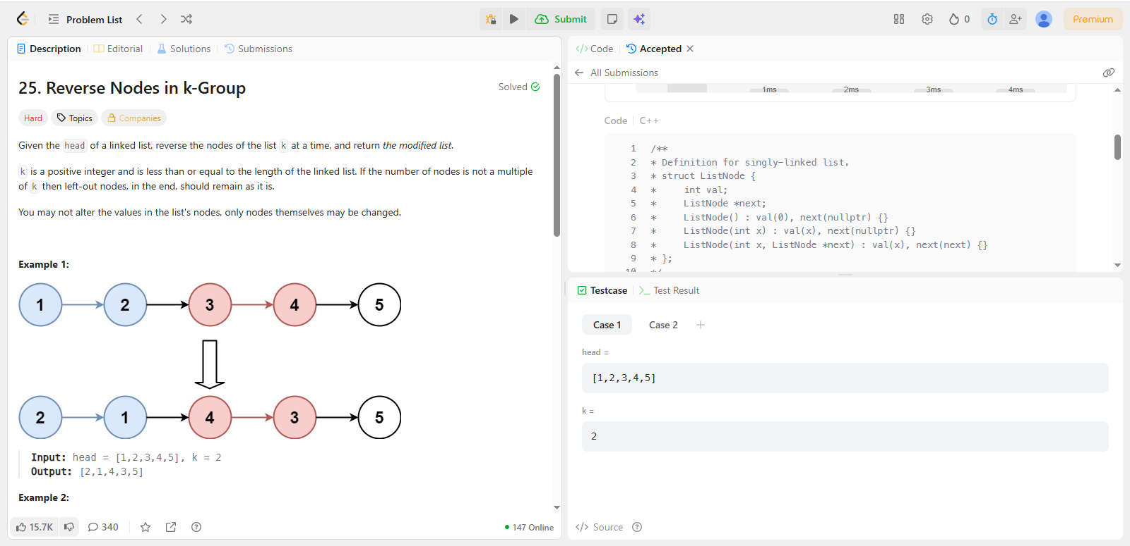
CODE:
/**
* Definition for singly-linked list.
* struct ListNode {
* int val;
* ListNode *next;
* ListNode() : val(0), next(nullptr) {}
* ListNode(int x) : val(x), next(nullptr) {}
* ListNode(int x, ListNode *next) : val(x), next(next) {}
* };
*/
class Solution {
public:
ListNode* reverseKGroup(ListNode* head, int k) {
if (!head || k == 1) return head;

// 1. Create a dummy node to handle head changes easily
ListNode dummy(0);
dummy.next = head;
ListNode *curr = &dummy, *next = &dummy, *prev = &dummy;

// 2. Count total number of nodes in the list
int count = 0;
while (curr->next) {
curr = curr->next;
count++;
}

// 3. Process each group of k
while (count >= k) {
curr = prev->next; // The first node of the current group
next = curr->next; // The node to be moved

// Reverse k-1 links within the group
for (int i = 1; i < k; ++i) {
curr->next = next->next;
next->next = prev->next;
prev->next = next;
next = curr->next;
}

// Move prev to the end of the reversed group
prev = curr;
count -= k;
}

return dummy.next;
}
};

