PROGRAM:2
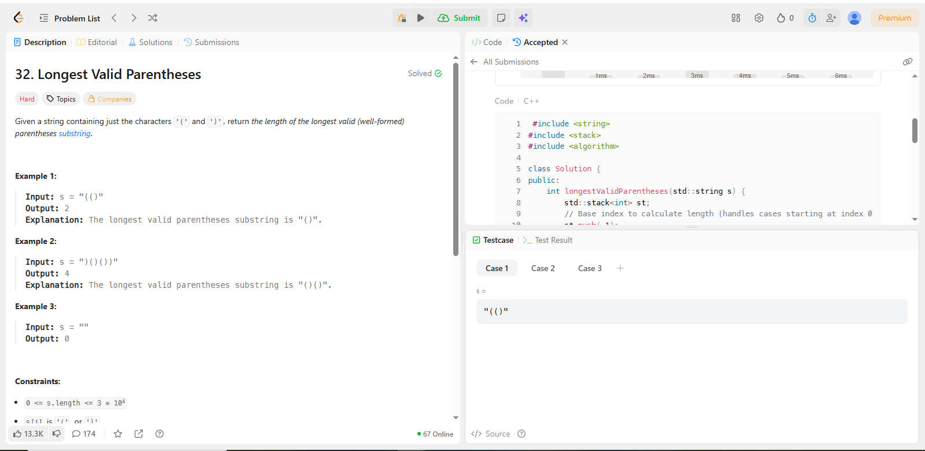
CODE:
#include <string>
#include <stack>
#include <algorithm>

class Solution {
public:
int longestValidParentheses(std::string s) {
std::stack<int> st;
// Base index to calculate length (handles cases starting at index 0)
st.push(-1);
int max_len = 0;

for (int i = 0; i < s.length(); i++) {
if (s[i] == '(') {
// Store the index of the opening bracket
st.push(i);
} else {
// Found a ')', pop the matching '(' or the base index
st.pop();

if (st.empty()) {
// Current ')' is a mismatch, push it as the new base
st.push(i);
} else {
// Valid pair! Length = current index - last unmatched index
max_len = std::max(max_len, i - st.top());
}
}
}

return max_len;
}
};

