PROGRAM:10
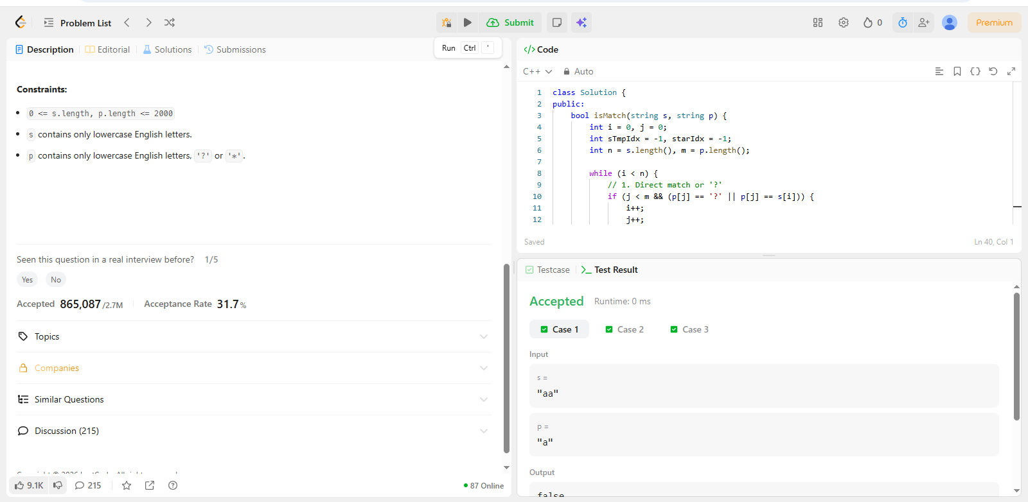
CODE:
class Solution {
public:
bool isMatch(string s, string p) {
int i = 0, j = 0;
int sTmpIdx = -1, starIdx = -1;
int n = s.length(), m = p.length();

while (i < n) {
// 1. Direct match or '?'
if (j < m && (p[j] == '?' || p[j] == s[i])) {
i++;
j++;
}
// 2. '*' found, save positions and try matching 0 characters
else if (j < m && p[j] == '*') {
starIdx = j;
sTmpIdx = i;
j++;
}
// 3. Last pattern was '*', but current chars don't match.
// Backtrack: make '*' consume one more character from s.
else if (starIdx != -1) {
j = starIdx + 1;
i = ++sTmpIdx;
}
// 4. No match and no '*' to rescue
else {
return false;
}
}

// Check for remaining characters in pattern; only '*' can remain.
while (j < m && p[j] == '*') {
j++;
}

return j == m;
}
};

