PROGRAM:9
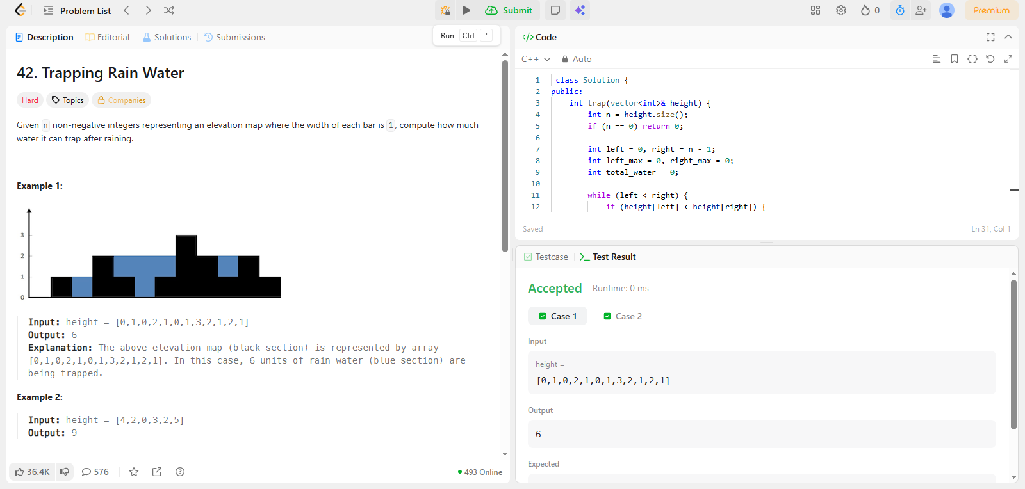
CODE:
class Solution {
public:
int trap(vector<int>& height) {
int n = height.size();
if (n == 0) return 0;

int left = 0, right = n - 1;
int left_max = 0, right_max = 0;
int total_water = 0;

while (left < right) {
if (height[left] < height[right]) {
if (height[left] >= left_max) {
left_max = height[left];
} else {
total_water += left_max - height[left];
}
left++;
} else {
if (height[right] >= right_max) {
right_max = height[right];
} else {
total_water += right_max - height[right];
}
right--;
}
}
return total_water;
}
};

