Data Cleaning & Preparation
Project 1 – Data Analytics

1. Project Objective
The objective of this project is to clean and prepare a raw e-commerce order dataset by identifying missing values, duplicate records, and data-format inconsistencies, and validating the dataset to ensure it is accurate and ready for further analysis.

2. Dataset Description
The dataset is an e-commerce order dataset containing information about customer orders, including Order ID, Date, Customer ID, Product, Quantity, Unit Price, Shipping Address, Payment Method, Order Status, Tracking Number, Items in Cart, Coupon Code, Referral Source, and Total Price.

3. Data Quality Issues Identified

3.1 Missing Values
Missing values were identified in the CouponCode column. These blank values were handled by replacing them with “No Coupon”, indicating that no coupon code was associated with the order.

3.2 Duplicate Records
The OrderID column was checked for duplicate values using Excel conditional formatting. No duplicate OrderIDs were identified.

3.3 Date Format
The Date column was inspected using Excel date filters. The dates were recognized as valid dates and were consistently represented in the DD-MM-YYYY format.

3.4 Numerical Data
The Quantity and UnitPrice columns were checked and found to contain valid numerical values.

3.5 Total Price Validation
The TotalPrice column was validated by calculating Quantity × UnitPrice for each record. All records returned an “OK” result, indicating that the TotalPrice values were consistent with Quantity and UnitPrice.

4. Data Cleaning Process
The dataset was inspected column by column before making any modifications. Missing values, duplicate OrderIDs, date formats, numerical fields, and categorical/text fields were checked. Blank values in the CouponCode column were replaced with “No Coupon”. No duplicate OrderIDs were found, so no records were deleted. The date, numerical, and categorical columns were checked for inconsistencies, and no additional issues requiring modification were identified.

5. Validation
After cleaning, the dataset was validated to ensure that the changes did not introduce new issues. The CouponCode column was checked again and contained no blank values. The OrderID column was checked for duplicates and no duplicate IDs were found. The Date column was verified as a valid date field. Finally, TotalPrice was recalculated using Quantity × UnitPrice and all records returned “OK”.

6. Before vs After
Data Quality Check | Before Cleaning | After Cleaning
CouponCode blanks | Present | 0 blanks; No Coupon used
Duplicate OrderIDs | 0 found | 0 found
Date format | Checked | Consistent DD-MM-YYYY
Quantity | Numeric | Numeric
UnitPrice | Numeric | Numeric
TotalPrice | Required validation | All records OK
Other text fields | Inspected | No changes required

7. Tools Used
Tool Used: Microsoft Excel
Excel features used: Filters, Conditional Formatting, Date Filters, Basic formulas, Data inspection, Data validation, and column formatting.

8. Final Outcome
The raw e-commerce dataset was successfully cleaned and validated using Microsoft Excel. Missing CouponCode values were handled by replacing blanks with “No Coupon”, duplicate OrderIDs were checked and none were found, date and numerical formats were validated, and TotalPrice calculations were verified across the dataset. The resulting dataset is structured and ready for further data analysis or visualization.

9. Evidence / Screenshots
- Figure 1: Raw dataset before data cleaning
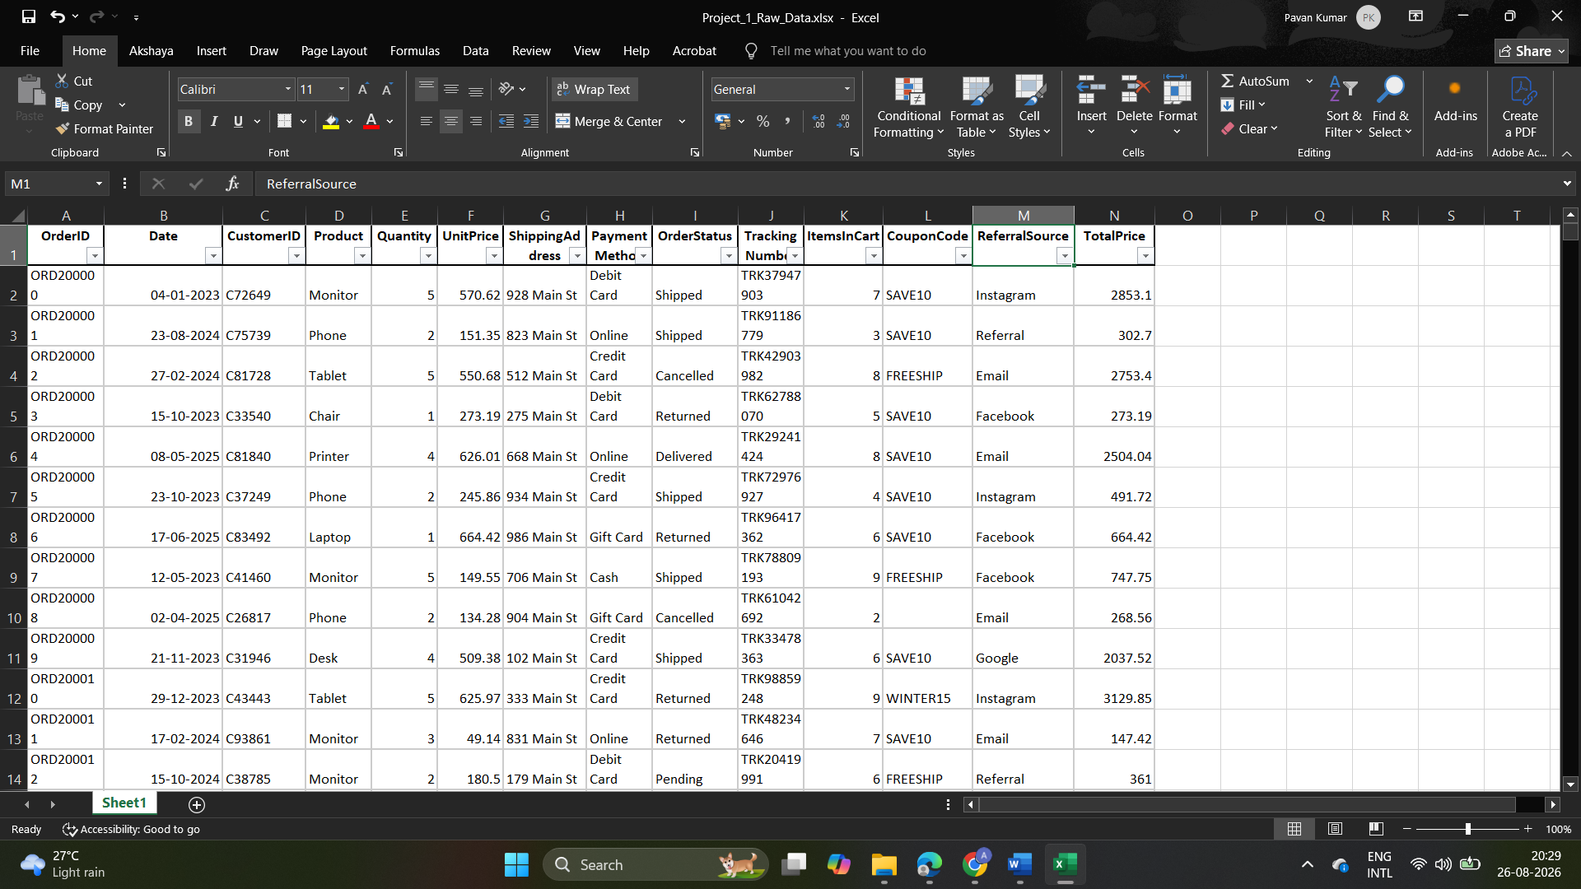

- Figure 2: Identification of missing CouponCode values

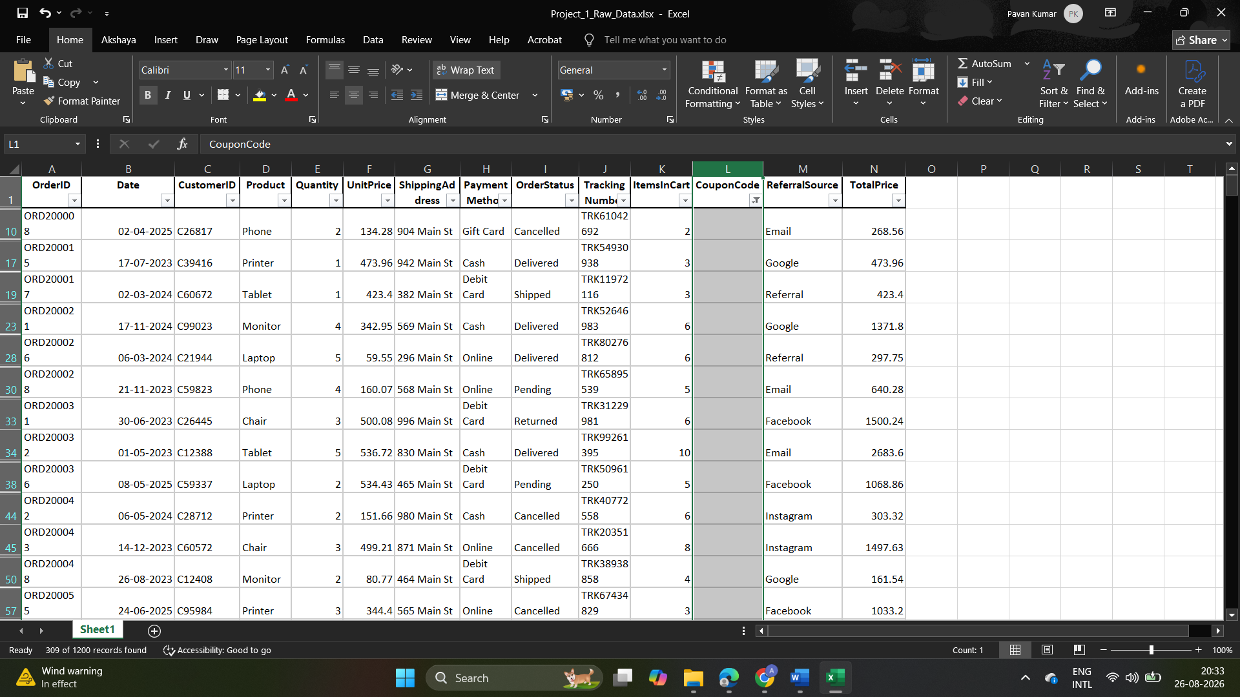

- Figure 3: Missing CouponCode values handled
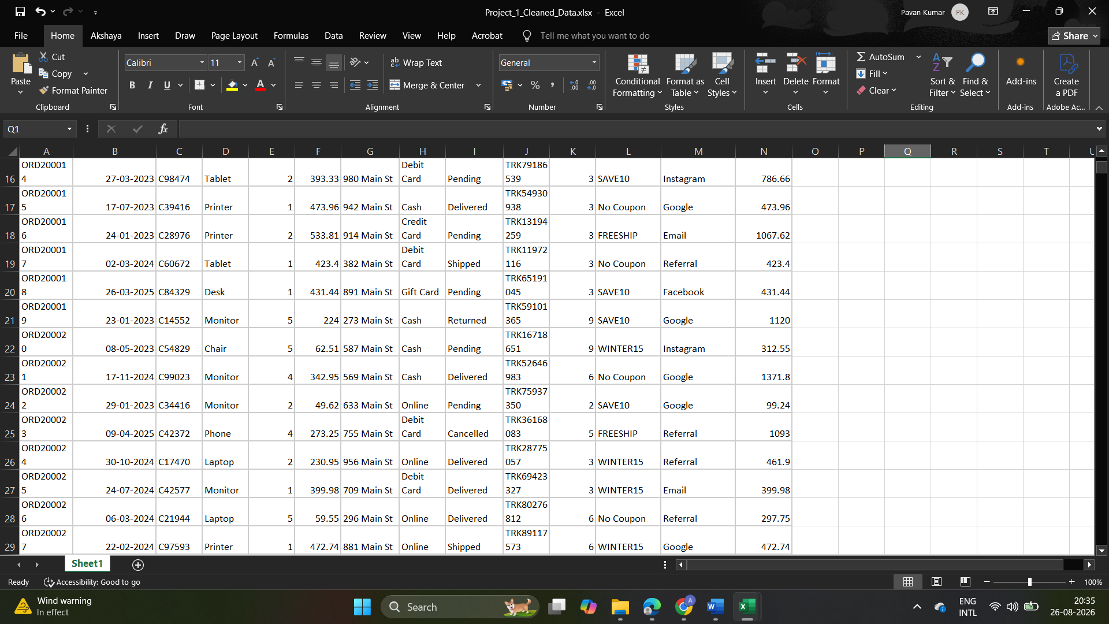

- Figure 4: Duplicate OrderID validation

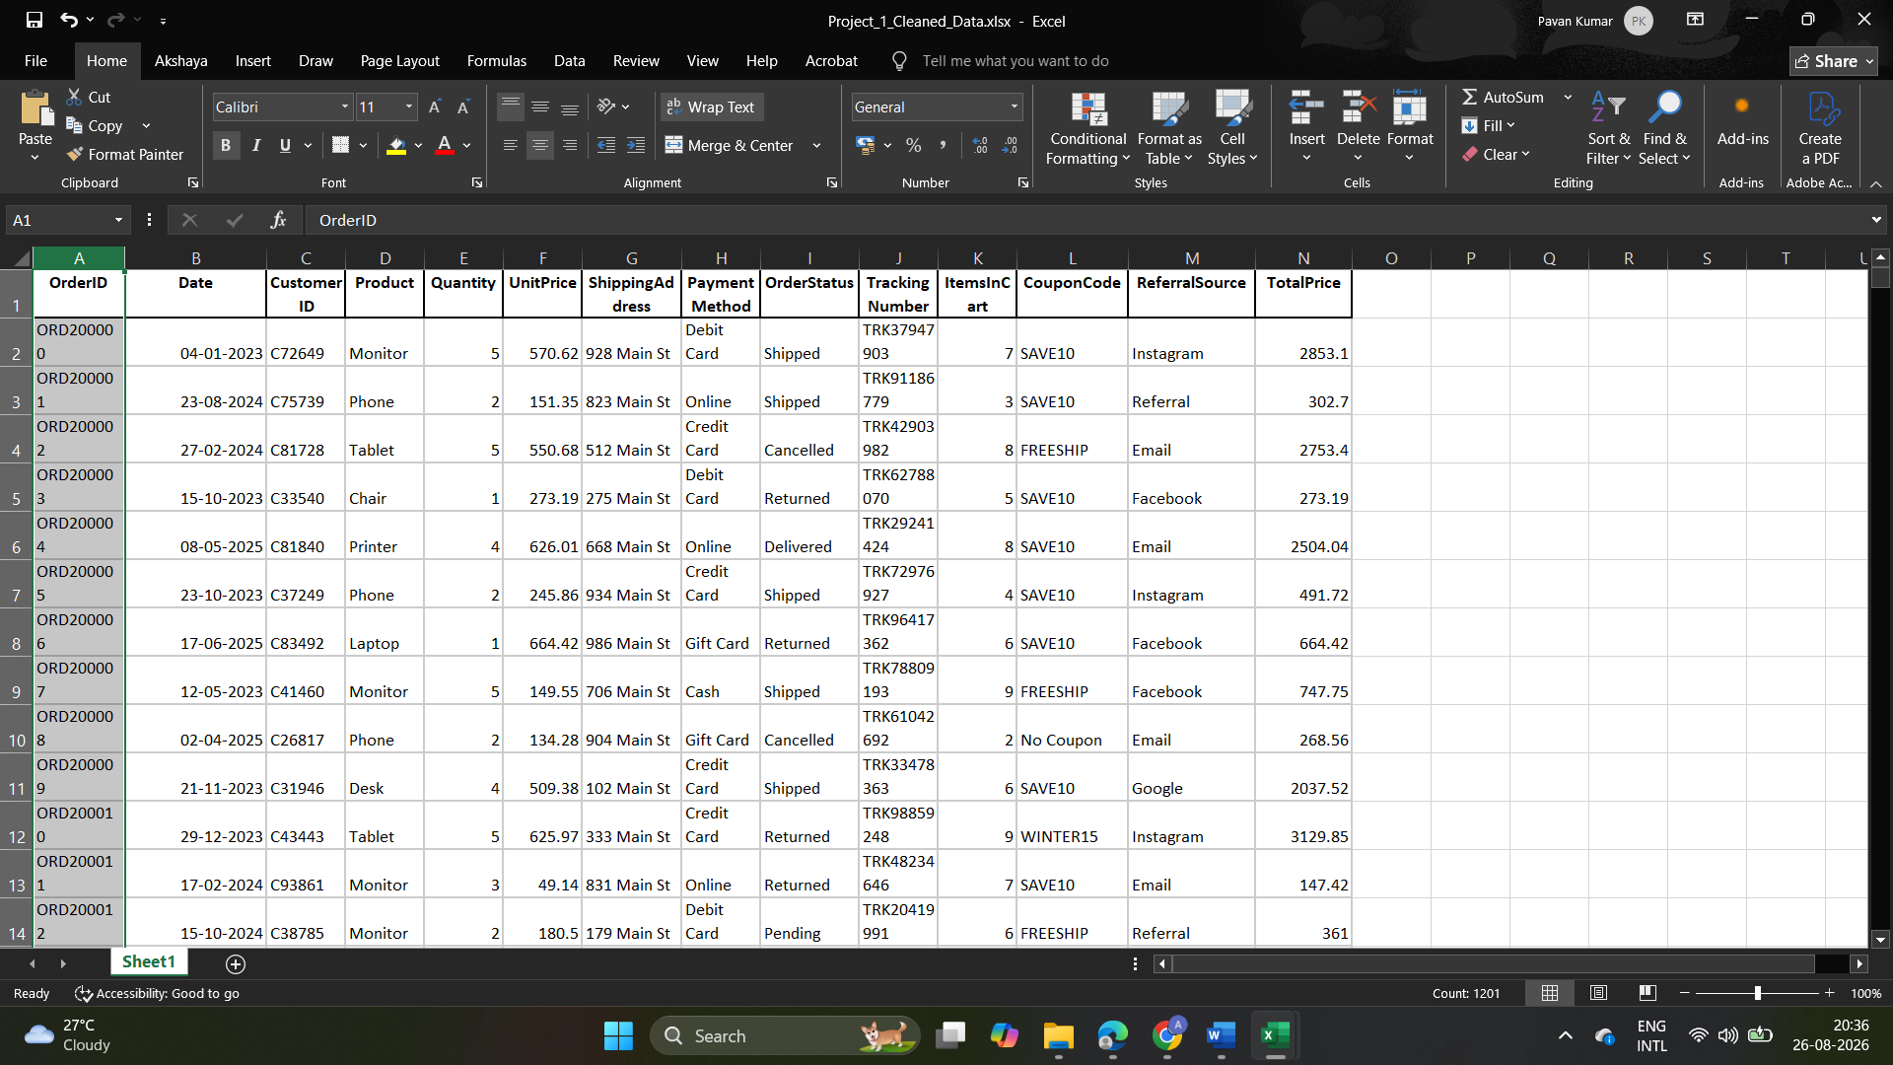

- Figure 5: TotalPrice validation
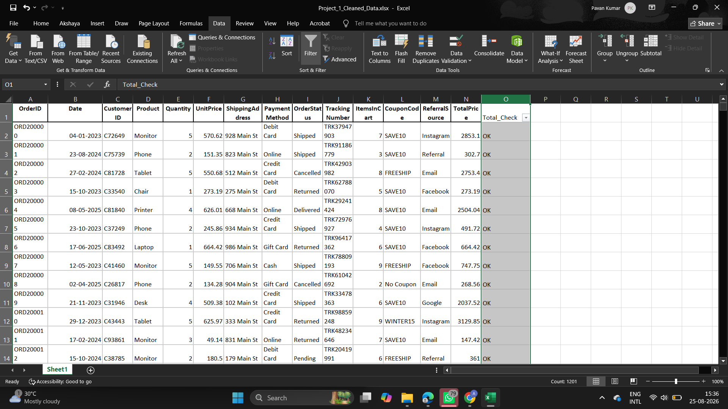

10. Project Files
- Project_1_Raw_Data.xlsx – Original company-provided dataset copy
- Project_1_Cleaned_Data.xlsx – Cleaned and validated dataset
- Project_1_Data_Cleaning_Report.docx – Project report

