COMET COLLABORATE

Radhika Kalaiselvan | Akshaya Udayakumar

DESCRIPTION

It is an Android application which is designed in specific for the comets!! It allows a user to search for a specific professor from a specific school and send him a request for appointment or to inform him about a leave. The main feature of the application is that it requires minimal typing by the user. The application contains built-in messages appropriate for the type of request to be sent and customizes the mail according to each user, by adding his/her details. The content is sent as an email to the professor’s mail-box directly. The future scope of the project is to include directions to the Professor’s office, to obtain TA details, raise doubts and also view the test schedule. In the future, accounts for professors may also be created, where the particular professor can update his TA details, his availability, and the tests scheduled for a particular course.

Attendance of a student can also be maintained through this app. When a class session begins, the Professor will generate a unique code and give it to the students present in the class. When the student enters this unique code into the application his attendance for that day will be marked. The database maintains only a list of dates on which a specific student was absent, along with the specific classid.

MODULES

1. User Login

The user can login into the application using his/her UTD email id and password. The session will be available to the user until they logout.

1. Selecting Details

This screen allows the user to select his school from the all the Schools in UTD. Once the school is selected, corresponding Professors’ name will be populated in the next field. The user may select the Professor whom he wants to contact.

1. Details of Professor

Once the professor’s name is selected, the next screen displays the contact information, office timing, office location of that particular professor. A user may just view the details and exit the application or continue by selecting Inform absence or Schedule appointment button.

1. Schedule Appointment

If the user selects the schedule appointment in the previous screen he will be directed to this screen. The user will have to enter the basic details like his name, class code, date that he wants to meet the professor, and additional reasons if he wishes to specify. These details will be integrated with the built-in message for “Schedule appointment” option and sent to the professor’s email id. Once the user presses the Request button, the mail will be sent.

1. Informing Absence from class

If the user selects the inform absence option in the screen 3, then he will be redirected here. Here, the user will have to enter his reason for absence and the day on which he will be absent. This, will in turn be attached with the built in message and sent to professor’s email id.

1. Success Page/Failure Page

Once the details are entered, if the mail was sent successfully then there will be a message on the screen that the mail was sent successfully. But there are chances of failure of sending the mail. Then the appropriate information will be displayed.

DATABASES

* Users

|  |  |  |
| --- | --- | --- |
| _id | email | password |
|  |  |  |

This table is used to check if the details entered while login are correct. The id is the primary key. Below is the list of columns and their data types.

_id – varchar(n)

Email – varchar (n)

Password – password.

* School

|  |  |
| --- | --- |
| _sid | School_name |
|  |  |

This table captures the School details. Every school is assigned an unique id which is used to identify the name.

sid – varchar(n)

School_name – varchar(n)

* Professor

|  |  |  |  |  |
| --- | --- | --- | --- | --- |
| _pid | _sid | pName | location | timings |
|  |  |  |  |  |

This table used the professor id as the primary key, and the school id as the foreign key and thus identifies a professor and retrieves his data.

Pid – varchar(n)

Name – varchar(n)

Location – varchar(n)

Timings – varchar(n)

* TA_details

|  |  |  |  |  |
| --- | --- | --- | --- | --- |
| _ta-id | taname | pid | talocation | tatiming |
|  |  |  |  |  |

This table captures the details of the TA of a specific professor using the id of the professor.

Ta-id – varchar(n)

taName – varchar(n)

taLocation – varchar(n)

taTimings – varchar(n)

* Professor_class_mapping

|  |  |  |  |
| --- | --- | --- | --- |
| _classid | code | section | Pid |
|  |  |  |  |

This table is used to map a professor to a specific class. The class has a unique id.

Classid – varchar(n)

Code – integer

Section - integer

* Absence (to maintain attendance)

|  |  |  |
| --- | --- | --- |
| id | classid | date |
|  |  |  |

The attendance can be maintained by mapping the student id to the specific classid and the date on which he was absent.

Date - date

SCREEN-SHOTS

* LOGIN

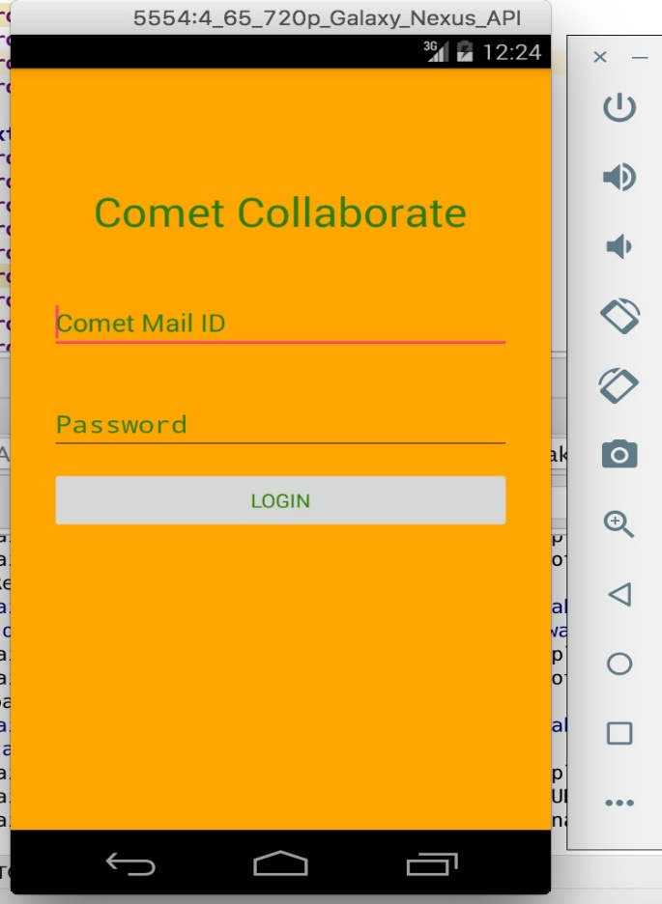

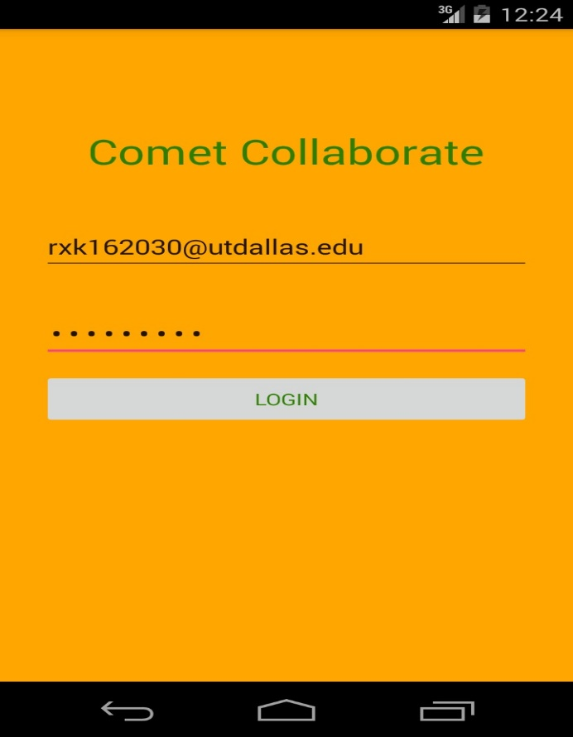

* SELECT PROFESSOR

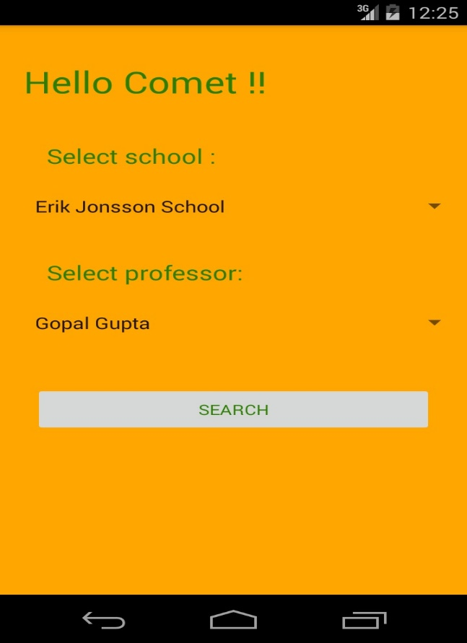

* SELECT OPTION

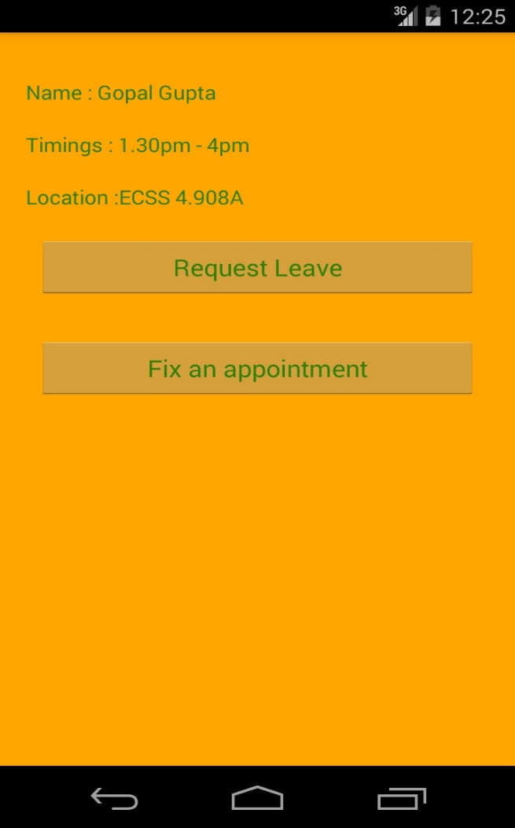

* LEAVE REQUEST

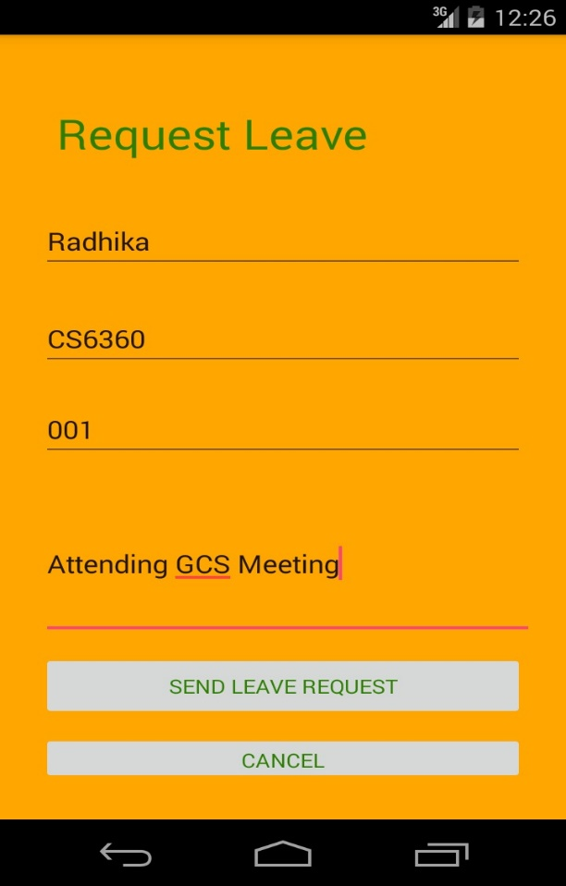

* APPOINTMENT REQUEST

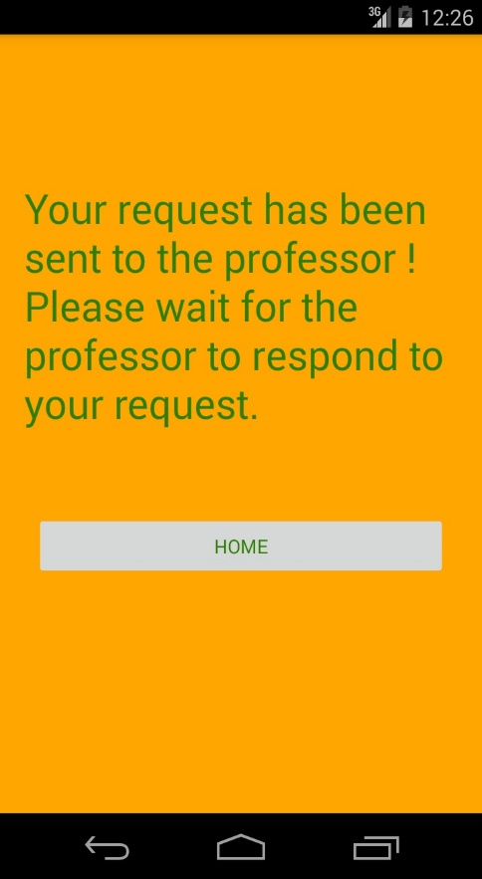

* SUCCESS SCREEN

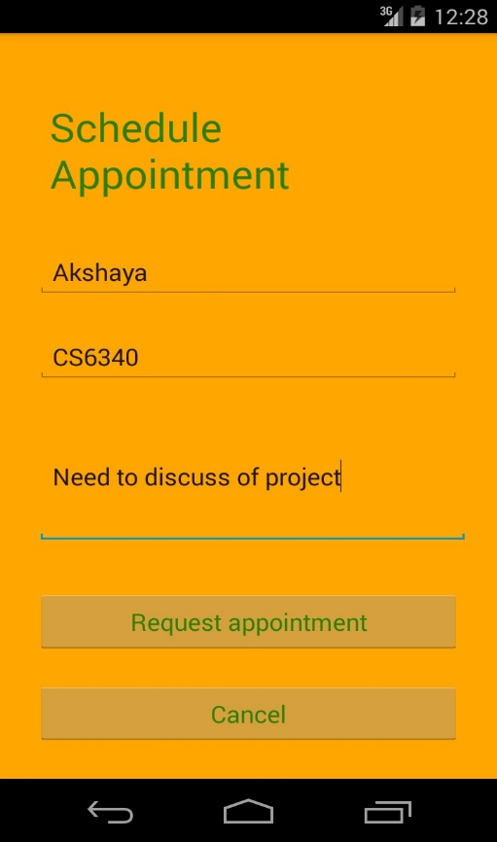

* ATTENDANCE

