CO2-AT3-Debugging and Optimization Task

NAME : AKSHAYA A
REG .NO : 192421222

Debugging String Matching Code (Pattern Index Leaks After Mismatch)
The given brute force string matching program uses the variable matched to determine whether a pattern is found. However, relying on the final value of the inner loop after a mismatch may incorrectly identify a partial comparison as a complete match. The program should record a match only after all characters of the pattern are successfully compared.
Error Code
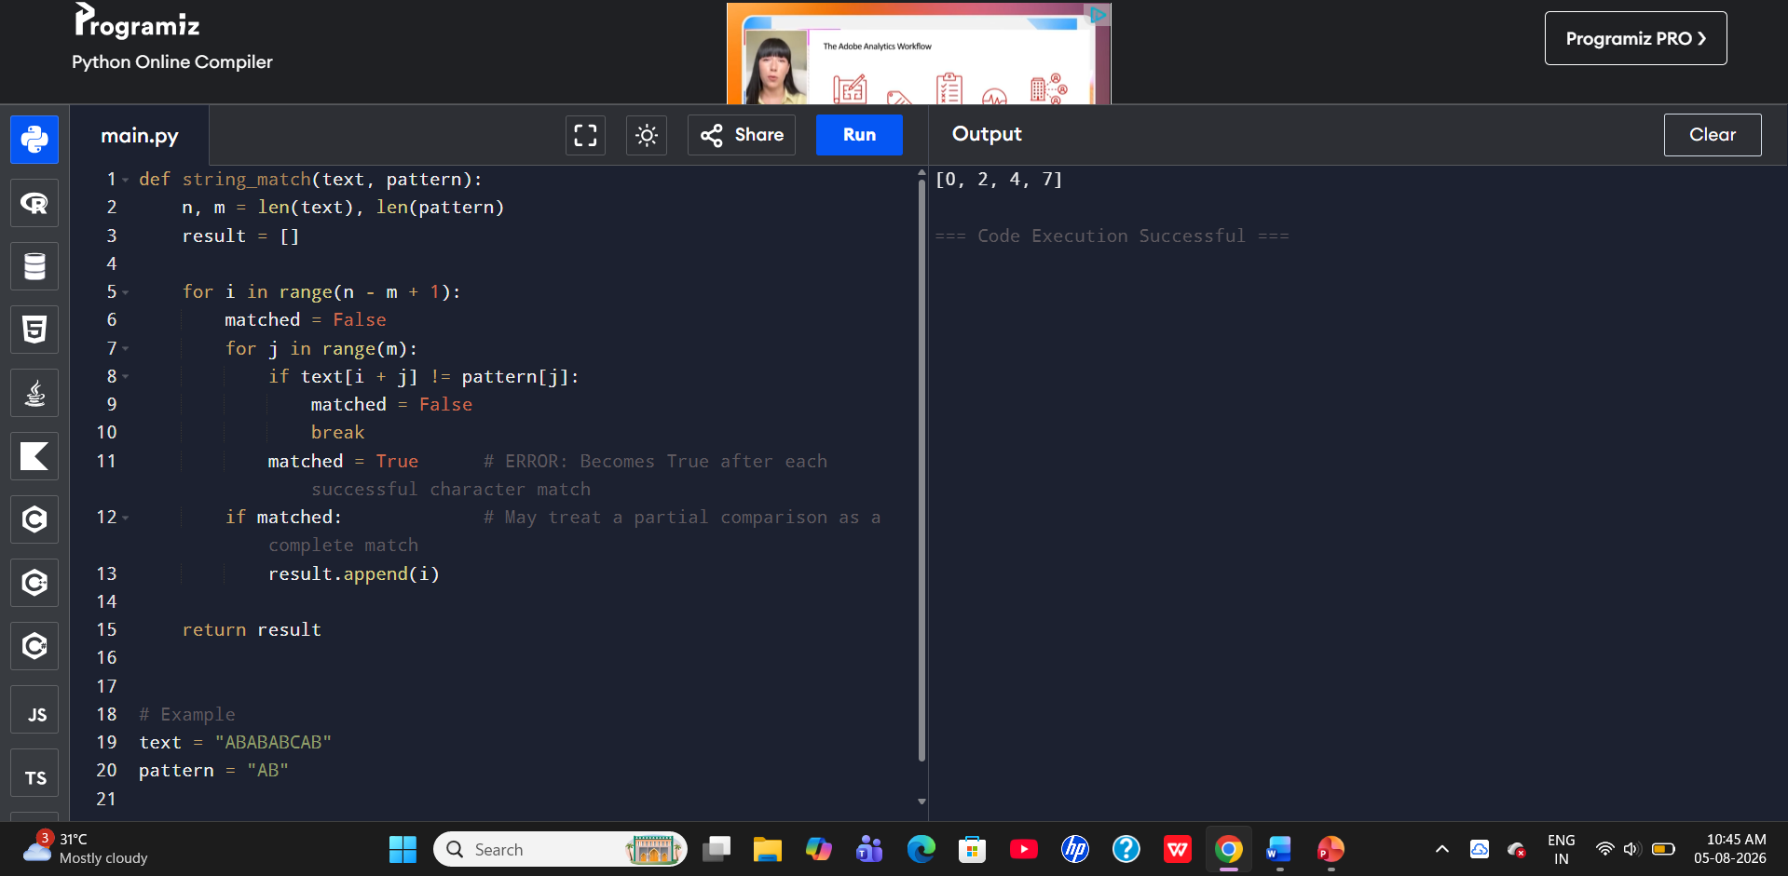
Program Error
- The program uses the matched variable inside the inner loop.
- During comparison, matched becomes True whenever a character matches.
- If a mismatch occurs, the loop breaks immediately.
- A match should be recorded only after verifying every character of the pattern.
- The logic should clearly indicate that the entire pattern has matched before adding the index.

Why the Pattern May Be Incorrectly Identified
- A partial match does not mean the complete pattern is matched.
- The final value of the inner loop or matched flag should not alone determine success.
- The program must ensure that all m characters are compared successfully.
- Only then should the starting index be stored in the result list.
Debugging
- Initialize matched = True before comparing characters.
- If any character does not match, set matched = False and break the loop.
- Append the index only when matched remains True after the inner loop completes.
- This ensures that only complete matches are recorded.
Optimization
- Initialize the match flag before the inner loop for better readability.
- Break immediately when a mismatch is found to avoid unnecessary comparisons.
- Record the index only after confirming the complete pattern match.
- The corrected code is simple, readable, and produces consistent results.

Corrected Code:
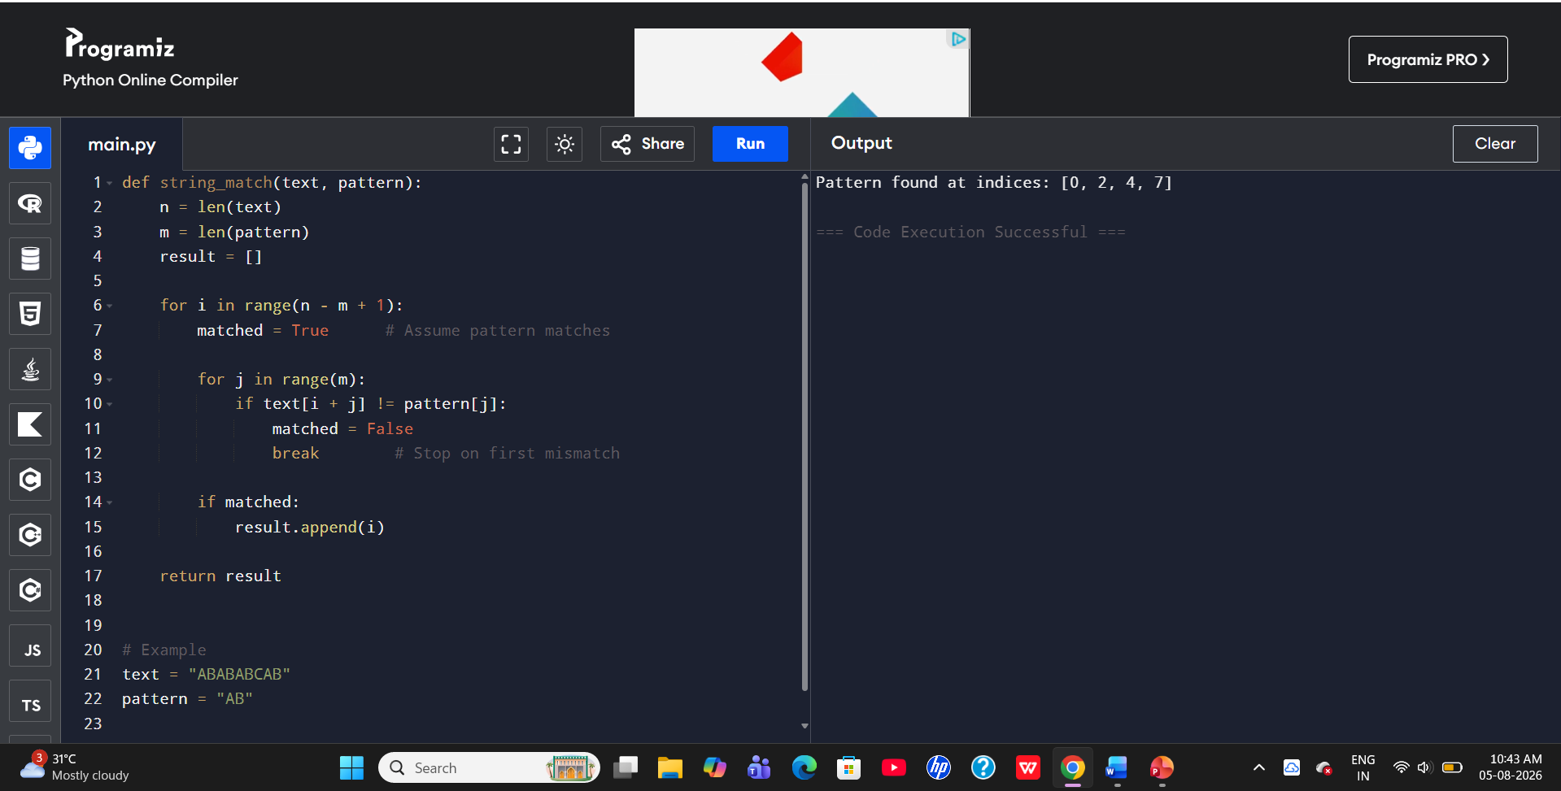
Time Complexity
- Best Case: If a mismatch occurs at the first character of each position, only one comparison is required. Hence, the Best Case Time Complexity is O(n).
- Average Case: Some characters are compared before a mismatch occurs. Hence, the Average Case Time Complexity is O(n × m).
- Worst Case: Every character of the pattern is compared at every possible position. Hence, the Worst Case Time Complexity is O(n × m).
- The algorithm uses only a few variables and no extra data structures. Hence, the Space Complexity is O(1).
Output Screen Explanation
- The program executes successfully without any errors.
- It compares the pattern with every possible position in the text.
- If all characters match, the starting index is stored.
- If a mismatch occurs, comparison stops immediately and moves to the next position.
- Finally, the program returns a list containing all matching indices.
- If no match is found, an empty list [] is returned.

Algorithm: Brute Force String Matching
Step 1: Start.
Step 2: Read the text and pattern.
Step 3: For each possible starting position in the text, assume the pattern matches.
Step 4: Compare each character of the pattern with the corresponding text character.
Step 5: If a mismatch occurs, stop comparing and move to the next position.
Step 6: If all characters match, store the starting index.
Step 7: Repeat until all positions are checked.
Step 8: Return the list of matching indices.
Step 9: Stop.

