NAME: AKSHAYA A
REG NO: 192421222
COURSE: CSA1402 COMPILER DESIGN
CO3_AT1_EXPERIMENTS

Q1 – Syntax-Directed Definition for Expression
Evaluation
Aim:
To implement a C program that evaluates an arithmetic expression using syntax-directed definition and synthesized attributes while maintaining operator precedence.
Algorithm:
- Read the arithmetic expression from the user.
- Scan the expression character by character.
- Evaluate numbers using the factor rule.
- Handle * and / before + and -.
- Handle expressions inside parentheses recursively.
- Apply the corresponding semantic rule for each operator.
- Display the final calculated value.

C CODE:
#include <stdio.h>
#include <ctype.h>

char str[100];
int i = 0;

int expression();
int term();
int factor();

int factor()
{
int n = 0;

if (str[i] == '(')
{
i++;
n = expression();
i++;
}
else
{
while (isdigit(str[i]))
{
n = n * 10 + (str[i] - '0');
i++;
}
}

return n;
}

int term()
{
int n = factor();

while (str[i] == '*' || str[i] == '/')
{
char op = str[i++];
int x = factor();

if (op == '*')
n = n * x;
else
n = n / x;
}

return n;
}

int expression()
{
int n = term();

while (str[i] == '+' || str[i] == '-')
{
char op = str[i++];
int x = term();

if (op == '+')
n = n + x;
else
n = n - x;
}

return n;
}

int main()
{
printf("Enter expression: ");
scanf("%s", str);

printf("Result = %d\n", expression());

return 0;
}

OUTPUT:
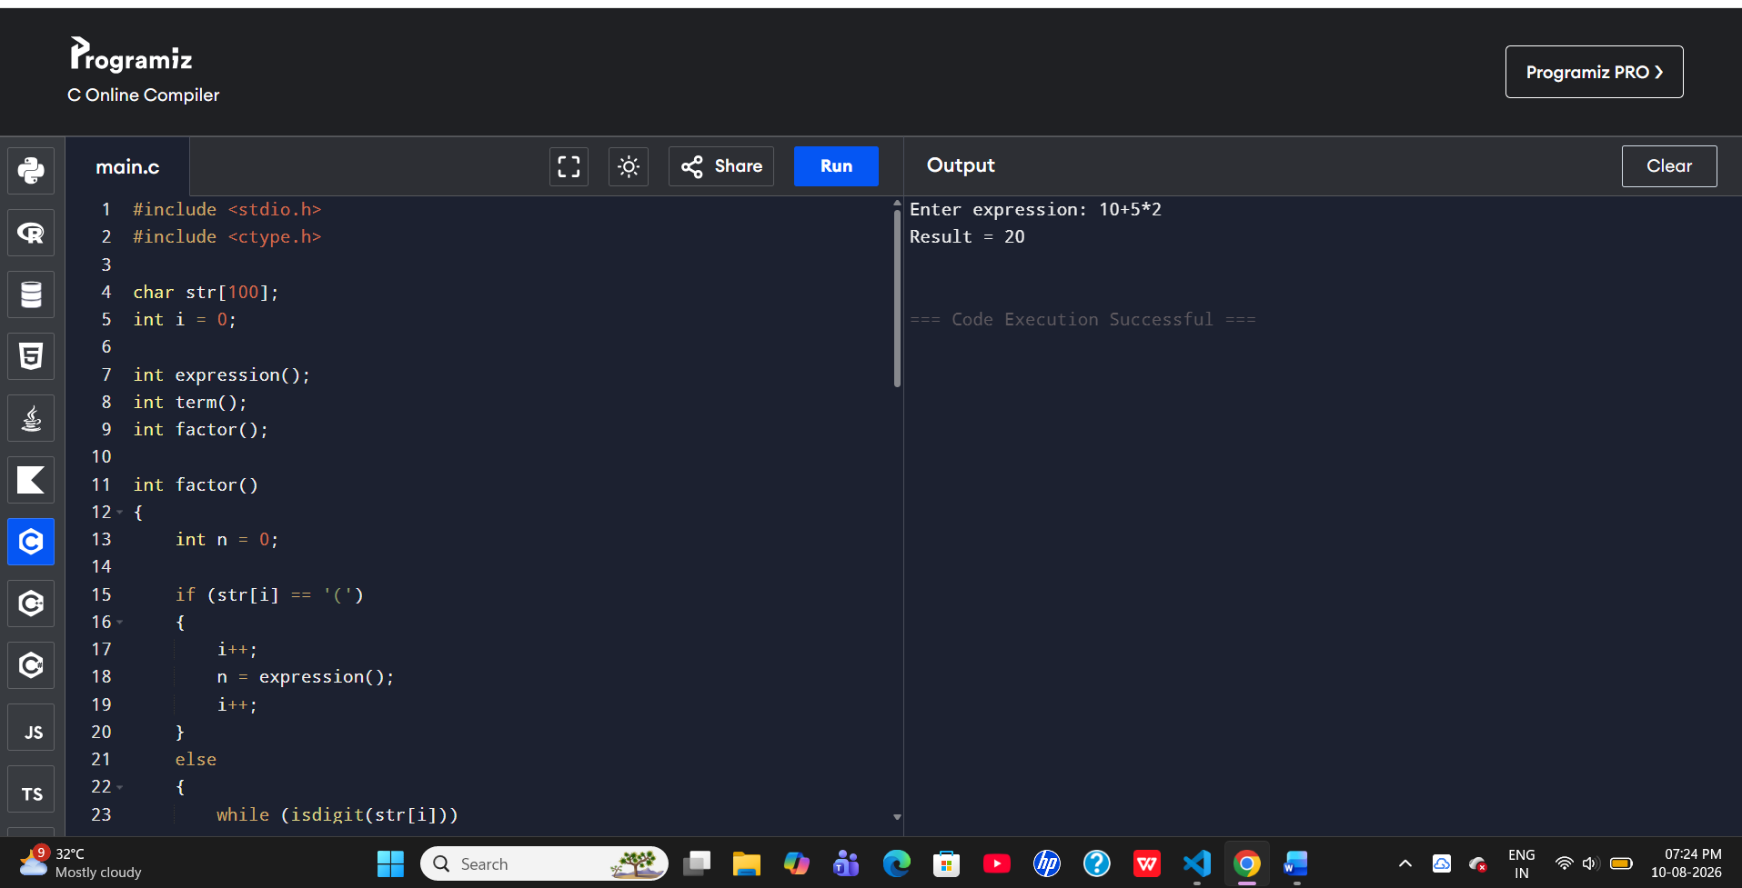

Q2 – Postfix Expression Evaluation
Aim:
To evaluate a postfix expression using stack-based bottom-up evaluation and demonstrate S-attributed definition evaluation.
Algorithm:
- Read the postfix expression.
- Create an empty stack.
- Scan the expression from left to right.
- If the symbol is an operand, push it onto the stack.
- If the symbol is an operator, pop two operands.
- Perform the operation and push the result.
- The final stack value is the result.
C Code:
#include <stdio.h>
#include <ctype.h>

int main() {
char exp[100];
int stack[100], top = -1;
int i, a, b;

printf("Enter postfix expression: ");
scanf("%s", exp);

for (i = 0; exp[i] != '\0'; i++) {
if (isdigit(exp[i])) {
stack[++top] = exp[i] - '0';
} else {
b = stack[top--];
a = stack[top--];

switch (exp[i]) {
case '+': stack[++top] = a + b; break;
case '-': stack[++top] = a - b; break;
case '*': stack[++top] = a * b; break;
case '/': stack[++top] = a / b; break;
}
}
}

printf("Result = %d\n", stack[top]);
return 0;
}

OUTPUT:
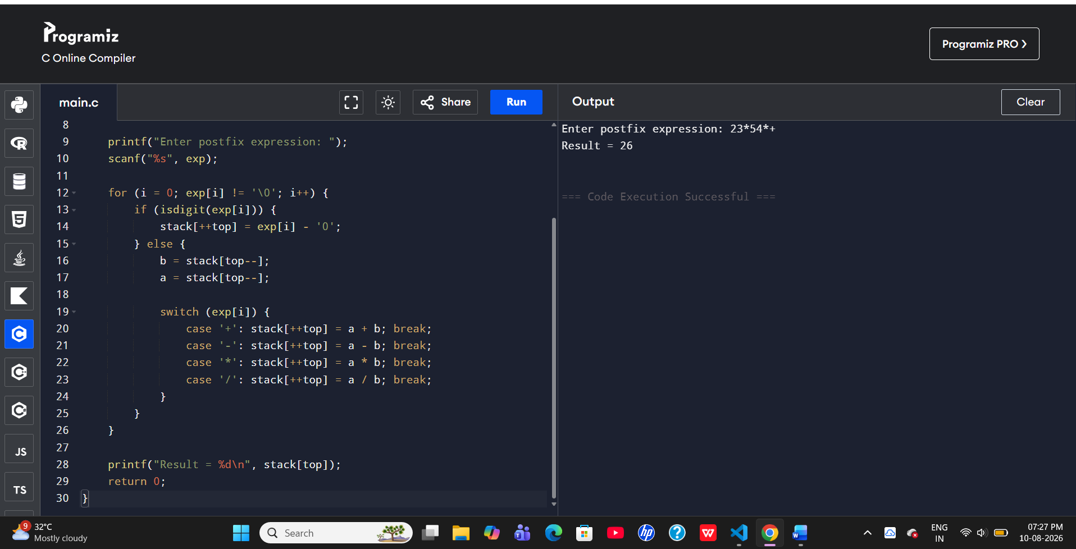

Q3 – L-Attributed Definition
Aim:
To evaluate a simple expression using function parameters to simulate inherited attributes and maintain correct operator precedence.
Algorithm:
- Read the values of a, b, and c.
- Pass values as function parameters.
- Evaluate multiplication first.
- Pass the intermediate result to the addition operation.
- Compute a + (b * c).
- Display the result.

C Code:
#include <stdio.h>

int multiply(int b, int c) {
return b * c;
}

int add(int a, int value) {
return a + value;
}

int main() {
int a, b, c, result;

printf("Enter a, b and c: ");
scanf("%d %d %d", &a, &b, &c);

result = add(a, multiply(b, c));

printf("Result = %d\n", result);
return 0;
}

OUPUT:
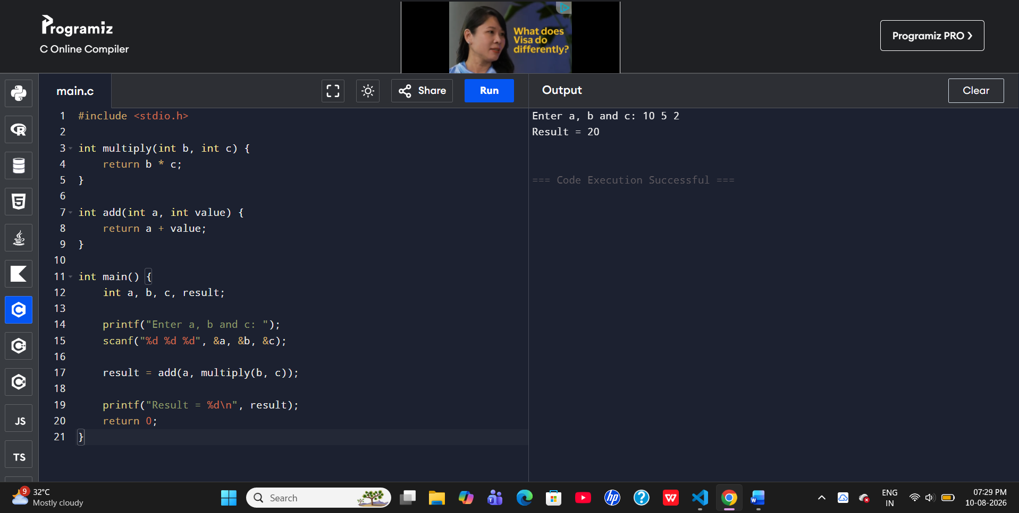

Q4 – Type Expression Equivalence
Aim:
To compare two type expressions and determine whether they are equivalent, including pointer types.
Algorithm:
- Read the first type expression.
- Read the second type expression.
- Compare both type expressions.
- If both strings are equal, declare them equivalent.
- Otherwise, declare them not equivalent.
- Display the result.

C Code:
#include <stdio.h>
#include <string.h>

int main() {
char type1[20], type2[20];

printf("Enter first type: ");
scanf("%s", type1);

printf("Enter second type: ");
scanf("%s", type2);

if (strcmp(type1, type2) == 0)
printf("Equivalent Types\n");
else
printf("Not Equivalent Types\n");

return 0;
}

OUTPUT:
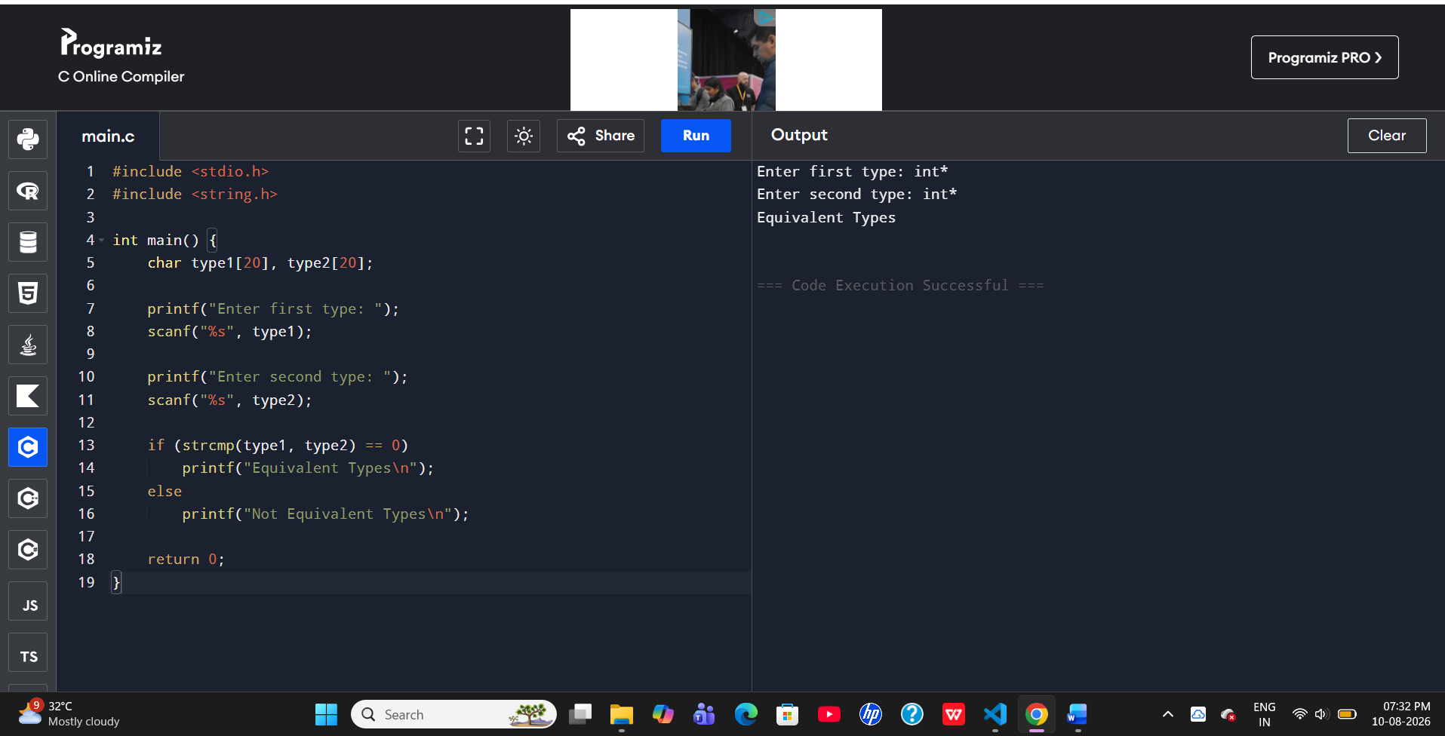

Q5 – Type Checking
Aim:
To implement a semantic analyzer that checks whether arithmetic operations between two operands are valid according to their types.
Algorithm:
- Read the first operand and its type.
- Read the second operand and its type.
- Read the arithmetic operator.
- Check whether the operand types are valid for the operation.
- If valid, display Valid Expression.
- Otherwise, display Type Error.
C Code:
#include <stdio.h>
#include <string.h>

int main() {
char type1[20], type2[20], op;

printf("Enter first type: ");
scanf("%s", type1);

printf("Enter operator (+ or *): ");
scanf(" %c", &op);

printf("Enter second type: ");
scanf("%s", type2);

if ((strcmp(type1, "int") == 0 || strcmp(type1, "float") == 0) &&
(strcmp(type2, "int") == 0 || strcmp(type2, "float") == 0))
printf("Valid Expression\n");
else
printf("Type Error\n");
return 0;}
OUTPUT:
