 | Sri Eshwar College of Engineering  (An Autonomous Institution)  Kinathukadavu(Tk),Coimbatore-641202 ,TamilNaduApprovedbyAICTE,NewDelhiandAffiliatedtoAnnaUniversity,Chennai |  | 
PLOTPILOT: MCP-Powered Data Analysis
And Visualization Agent
PHASE : I  November 2025 |  | PROJECT REPORT SUBMITTED IN PARTIAL FULFILLMENT OF THE REQUIREMENTS FOR THE AWARD OF THE  DEGREE OF BACHELOR OF TECHNOLOGY  IN ARTIFICIAL INTELLIGENCE AND DATA SCIENCE  OF THE ANNA UNIVERSITY
 |  |  | 
PROJECT WORK
Submitted by
AKSHAYAA S – 722822243003
KAVIN SHANKAR D S – 722822243037 NARESH RAJA M L –722822243057
BATCH 2022– 2026
Under the Guidance of
Dr. G. Shobhana
Assistant Professor/AI&DS


BONAFIDE CERTIFICATE

Certified that this Report titled “Gestura – Vision Powered Sign Language Interpretation System” is the bonafide work of
AKSHAYAA S | 722822243003
KAVIN SHANKAR D S | 722822243037
NARESH RAJA M L | 722822243057
Who carried out the project work under my supervision.

SIGNATURE | SIGNATURE
Dr. M.Mohammed Mustafa,M.E., M.B.A., Ph.D.,  HEAD OF THE DEPARTMENT  Artificial Intelligence &Data Science, Sri Eshwar College of Engineering, Coimbatore – 641 202. | Ms. S.Rajalakshmi M.E.,(Ph.D)  SUPERVISOR  Assistant Professor,  Artificial Intelligence & Data Science, Sri Eshwar College of Engineering, Coimbatore – 641 202.

Submitted for the Autonomous Semester End Innovative/Multi-Disciplinary Project Viva-Voce held on ………………….
INTERNAL EXAMINER | EXTERNAL EXAMINER



QUALITY POLICY
To establish a system of Quality Enhancement, which would on a continuous basis evaluate and enhance the quality of teaching – learning, research and extension activities of the institution, leading to improvements in all processes, enabling the institution to attain excellence.

INSTITUTE VISION
To be recognized as a premier institution, grooming students into globally acknowledged engineering professionals.

INSTITUTE MISSION
- Providing outcome and value-based engineering education
- Nurturing research and entrepreneurial culture
- Enabling students to be industry ready and fulfill their career aspirations
- Grooming students through behavioral and leadership training programs
- Making students socially responsible

DEPARTMENT OF ARTIFICIAL INTELLIGENCE AND DATA SCIENCE

DEPARTMENT VISION
To build a conducive academic and research environment in the stream of Artificial Intelligence and Data Science for enabling global education, research and entrepreneurship.

DEPARTMENT MISSION
M1: Rigorous update and enrich the curriculum by integrating global trends and technological advancements to ensure the academic excellence.
M2: Promote a research-driven environment by providing access to state-of-the-art infrastructure with emerging technologies.
M3: Empower the faculty through continuous upskilling, international collaborations, and active research engagement to provide globally competent education.
M4: Encourage student-centric, industry-aligned learning that nurtures innovation and entrepreneurship activities for solving real-world and societal challenges.

PROGRAM EDUCATIONAL OBJECTIVES
PEO1: To enable graduates to pursue higher education and research or have a successful career in industries associated with Artificial Intelligence and Data Science, or as entrepreneurs.
PEO2: To demonstrate excellence in cutting-edge technologies of Artificial Intelligence and Data Science and solve problems in society.
PEO3: To exhibit professional ethics, involvement in team work in their profession and contributing to the advancement of society.
PROGRAM OUTCOMES
PO1: Engineering Knowledge: Apply the knowledge of mathematics, science, engineering fundamentals, and an engineering specialization to the solution of complex engineering problems.
PO2: Problem Analysis: Identify, formulate, review research literature, and analyze complex engineering problems reaching substantiated conclusions using first principles of mathematics, natural sciences, and engineering sciences.
PO3: Design/Development of Solutions: Design solutions for complex engineering problems and design system components or processes that meet the specified needs with appropriate consideration for the public health and safety, and the cultural, societal, and environmental considerations.
PO4: Conduct Investigations of Complex Problems: Use research-based knowledge and research methods including design of experiments, analysis and interpretation of data, and synthesis of the information to provide valid conclusions.
PO5: Modern Tool Usage: Create, select, and apply appropriate techniques, resources, and modern engineering and IT tools including prediction and modeling to complex engineering activities with an understanding of the limitations.
PO6: The Engineer and Society: Apply reasoning informed by the contextual knowledge to assess societal, health, safety, legal and cultural issues and the consequent responsibilities relevant to the professional engineering practice.
PO7: Environment and Sustainability: Understand the impact of the professional engineering solutions in societal and environmental contexts, and demonstrate the knowledge of, and need for sustainable development.
PO8: Ethics: Apply ethical principles and commit to professional ethics and responsibilities and norms of the engineering practice.
PO9: Individual and Teamwork: Function effectively as an individual, and as a member or leader in diverse teams, and in multidisciplinary settings.
PO10: Communication: Demonstrate knowledge and understanding of the engineering and management principles and apply these to one’s own work, as a member and leader in a team, to manage projects and in multidisciplinary environments.
PO11: Project Management and Finance: Apply knowledge and understanding of engineering management principles and economic decision-making and apply these to one’s own work, as a member and leader in a team, and to manage projects and in multidisciplinary environments.

PO12: Life-Long Learning: Recognize the need for, and have the preparation and ability to engage in independent and life-long learning in the broadest context of technological change.

PROGRAM SPECIFIC OUTCOMES
PSO1. Apply programming, problem-solving, and hardware integration skills with AI and data science to design intelligent, secure and efficient systems.
PSO2. Develop an AI-driven application by exploring optimized coding competencies using predictive modeling and data analytics technologies.
TABLE OF CONTENT

CHAPTER TITLE PAGE NO.
NO.
ABSTRACT
LIST OF FIGURES
- INTRODUCTION 1
- LITERATURE SURVEY
EXISTING PRODUCT 4
PROBLEM STATEMENT 5
- PROPOSED SOLUTION
OVERVIEW 6
BLOCK DIAGRAM/FLOW DIAGRAM 7
- EMPATHYMAP&CUSTOMER VALUE PROPOSITION
EMPATHY MAP 9
VALUE PROPOSITION CANVAS 10
- HARDWARE/SOFTWARE DESCRIPTION
HARDWARE/SOFTWARE DESCRIPTION 11
PROCEDURE FOR CREATING THE PROJECT 11
CODING STRUCTURE 11
- RESULT&IMPLEMENTATIONS 13
- CONCLUSION&FUTURESCOPE 16
REFERENCE 17

ABSTRACT

The rapid escalation of data generation across sectors such as business analytics, healthcare, education, and scientific research has created a critical need for intelligent, adaptive visualization systems. Traditional tools often rely on static templates, rigid configurations, or extensive manual expertise, limiting their accessibility to non-technical users and slowing the insight-generation pipeline. To bridge this operational gap, there is a growing shift toward AI-driven systems that can automate interpretation, reasoning, and visualization. This paper addresses this emerging demand by proposing an MCP-powered Data Analysis and Visualization Agent capable of transforming diverse datasets into actionable insights with minimal human intervention.
The proposed system leverages a multi-agent architecture orchestrated through LangGraph and powered by the Model Context Protocol (MCP). Each agent is specialized for tasks such as query interpretation, preprocessing, visualization selection, and recommendation. By distributing responsibilities across autonomous yet cooperatively linked agents, the framework improves scalability, modularity, and fault tolerance. NLP integration further enables real-time natural-language interaction, allowing users to request insights or visualizations using conversational prompts instead of technical query languages
A robust preprocessing layer enhances data reliability through automated handling of missing values, normalization, data-type unification, and noise reduction. Both structured and unstructured datasets are supported, widening the system’s applicability across domains such as IoT streaming, market forecasting, and institutional analytics. Once processed, the intelligence layer executes machine learning–backed tasks such as anomaly detection, clustering, predictive modeling, and relevance scoring. These operations collectively enrich the resulting visualizations, ensuring that they are not only aesthetically sound but also contextually grounded and analytically accurate.
The visualization engine generates interactive, dynamic plots using libraries such as Plotly, Matplotlib, and Seaborn, integrated into a Streamlit-based dashboard for real-time exploration. Unlike conventional visualization tools that yield static charts, this system supports drill-down interactions, scenario exploration, and context-aware chart selection. The recommendation engine supplements visuals with interpretable insights, trend analyses, and domain-dependent suggestions. By merging analytical intelligence with visualization adaptability, the system empowers users to navigate large datasets without specialized technical knowledge.
Overall, the MCP-powered Data Visualization Agent represents a forward-looking approach to democratizing data analytics. Its multi-agent coordination, natural-language interface, cloud-scalable architecture, and explainable visualization pipeline make it suitable for enterprises, educational institutions, and research organizations. The system’s lightweight design ensures easy deployment, while its modular and domain-agnostic construction supports long-term extensibility. As industries increasingly embrace AI-driven decision support, frameworks such as the one proposed in this work will play a critical role in enabling intuitive, scalable, and human-centered data interaction.

LIST OF FIGURES

- Figure 3.1:Block Diagram/Flow Diagram
- Figure 4.1:Empathy Map Canvas
- Figure 4.2:Value Proposition Canvas
- Figure 6.1: Data analysis data preview
- Figure 6.2: Chatbot to understand data
- Figure 6.3: Model suggestion to create Visualization
- Figure 6.4 : Interactive visualization from chatbot for data-driven insights
- Figure 6.5 : Graphs for better visualization and understanding

CHAPTER 1
INTRODUCTION
  - CONTEXT
The exponential growth of digital data across industries has transformed analytics into a critical driver of decision-making. Organizations today generate massive volumes of structured, semi-structured, and unstructured data through enterprise applications, IoT devices, cloud platforms, and user interactions. However, the complexity and heterogeneity of this data often exceed the capabilities of traditional visualization tools, which depend heavily on manual configuration, domain expertise, and predefined templates. These tools frequently fail to adapt to dynamic user needs or evolving datasets, restricting accessibility for non-technical stakeholders. At the same time, emerging fields such as business intelligence, healthcare monitoring, education analytics, and research-based modelling require flexible and intelligent systems capable of interpreting context and automatically producing meaningful insights. This rising demand for adaptive, intelligent visualization highlights the need for systems that combine automation, reasoning, and natural language interaction.
The introduction of multi-agent architectures and Model Context Protocol (MCP) provides a transformative foundation for next-generation visualization systems. By integrating NLP for natural language interaction, the system empowers users—regardless of technical background—to engage directly with complex datasets. As organizations move toward intelligent, automated analytics workflows, such a multi-agent, MCP-driven visualization framework offers a forward-looking solution capable of meeting modern data interpretation and decision-support demands.
1.2 MOTIVATION FOR THE PROJECT
Modern organizations face increasing pressure to extract insights from rapidly expanding datasets, yet most stakeholders lack the technical skills required to use complex visualization tools. Traditional dashboards and BI platforms often demand manual configuration and domain knowledge, slowing down analytical workflows. This gap between data availability and data understanding motivates the need for an intelligent, automated system. A solution that minimizes human effort, interprets user intent, and generates context-aware visualizations can significantly accelerate decision-making and make analytics accessible to a broader audience.
The emergence of AI-driven multi-agent systems presents an opportunity to transform how users interact with complex datasets. Instead of relying on static templates or predesigned charts, intelligent agents can collaborate to preprocess data, detect patterns, and choose the most relevant visualizations automatically. This capability reduces dependency on specialized analysts and supports real-time, adaptive insights. The motivation behind this project lies in leveraging MCP and agent orchestration to build a system that learns, responds, and evolves with user requirements while maintaining scalability and accuracy.
As industries push toward automation and data-driven decisions, there is a clear need for visualization tools that are adaptive, explainable, and easy to use. This project aims to deliver an intelligent, NLP-enabled system that provides real-time, intuitive insights without requiring technical expertise.
1.3 OBJECTIVES
The primary objective of this project is to engineer an MCP-powered data visualization agent that seamlessly converts raw, diverse datasets into intuitive, high-impact insights. The system is designed to eliminate the heavy lifting typically required in traditional analytics workflows by automating crucial steps such as data preprocessing, anomaly handling, and chart generation. This ensures that users at any skill level can access meaningful visual intelligence without navigating complex tools or technical barriers. The focus is on delivering a frictionless, streamlined experience that accelerates decision-making and brings enterprise-grade analytics within reach for a broader audience.
Another core objective is to establish natural language as the primary interface for querying and interacting with data. By integrating advanced NLP mechanisms, the system interprets user intent, identifies relevant transformations, and autonomously produces the most suitable visualizations. This democratizes data understanding, ensuring that even non-technical users can explore patterns, trends, and insights with minimal onboarding. The goal is to reduce dependency on conventional coding or query languages and introduce an experience that feels conversational, responsive, and context-aware while maintaining analytical precision and operational rigor.
A key objective is to build a modular, multi-agent ecosystem orchestrated through LangGraph. Each agent specializes in a distinct analytical task such as data cleaning, clustering, anomaly detection, visualization selection, or insight extraction. This distributed structure ensures scalability, resilience, and flexible workflow optimization. Agents communicate and collaborate dynamically using MCP, enabling adaptive pipelines that respond to evolving data structures and user prompts. This architecture not only improves fault tolerance but also positions the system to support future expansion, domain-specific agents, and evolving analytical needs across industries.
The final objective is to provide actionable intelligence through a tightly integrated recommendation engine. Beyond generating charts, the agent is designed to deliver contextual insights, highlight key trends, flag anomalies, and suggest potential decisions supported by data evidence. This transforms visualizations from mere graphical outputs into strategic assets that support real-time, insight-driven operations. By combining interpretability, automation, and domain adaptability, the recommendation layer ensures that users receive guidance that is both meaningful and actionable, elevating the overall value of the visualization pipeline and supporting smarter, faster, and more confident decision-making.

CHAPTER 2
LITERATURE SURVEY

EXISTING SYSTEM
Existing data visualization systems predominantly rely on static dashboards, manual configuration, and predefined pipelines. Tools like Tableau, Power BI, and QlikSense provide powerful visualization capabilities, but they depend heavily on user expertise to prepare datasets, clean data, select chart types, and configure parameters. These platforms typically lack contextual intelligence, meaning they cannot interpret analytical intent or adapt visual outputs based on natural-language inputs. Most enterprise teams still depend on analysts to preprocess data, generate reports, and modify visualizations for every new requirement, resulting in bottlenecks during peak analytical workflows. Rule-based automation systems exist, but they are limited in flexibility and cannot update themselves when data structure or user needs change. Furthermore, traditional systems provide minimal support for multi-agent collaboration, cross-tool interoperability, or dynamic orchestration of analytical tasks. This creates a clear gap in delivering scalable, automated, and intuitive data-insight generation for non-technical users.
Most existing visualization environments lack natural-language interaction and rely on rigid workflows. Users must manually explore data, apply transformations, and select appropriate visual formats. When data complexity increases, these systems struggle to adapt, often requiring specialized analysts to intervene. AI-powered assistants exist, but they function as isolated chatbots without true orchestration or task automation. They cannot coordinate with multiple analytical components or independently decide which visualization technique suits a given query. As a result, current solutions fail to deliver adaptive, agent-driven insight generation.
Although modern analytics tools offer basic AI suggestions, they lack adaptive reasoning and multi-agent coordination. These systems cannot autonomously analyze data, interpret complex prompts, or generate context-aware visualizations. Their limited interoperability and static workflows restrict scalability, highlighting the need for a dynamic, MCP-enabled agentic visualization system.

PROBLEM STATEMENT
Enterprises are generating high-velocity, high-volume datasets, but existing visualization systems remain static, manual, and deeply dependent on technical expertise. Users must rely on analysts to clean data, configure dashboards, and interpret insights, creating operational bottlenecks across workflows. Traditional BI tools lack the intelligence to understand analytical intent or adapt to evolving business questions. Without natural-language-driven interfaces, non-technical users struggle to access meaningful insights quickly. This gap reduces decision agility and delays strategic execution. An intelligent, autonomous system is needed to simplify complex data operations, democratize insights, and streamline visualization creation for users across diverse functional roles.
Current enterprise visualization ecosystems fail to deliver contextual intelligence, agentic automation, or dynamic collaboration between analytical components. Most tools operate as isolated modules rather than interconnected systems capable of orchestrating advanced tasks such as dataset assessment, anomaly identification, visualization selection, or insight generation. Existing AI assistants provide only surface-level support and cannot perform multi-step reasoning or coordinate across specialized agents. As a result, organizations continue to face challenges in scaling analytics, maintaining consistency, and enabling adaptive decision-making in real-time environments. To resolve these constraints, a next-generation, MCP-driven, multi-agent framework is required to intelligently interpret user intent, automate workflows, and generate actionable visual insights with minimal manual intervention.
Despite rapid advancements in AI, most visualization platforms still lack the ability to autonomously understand, analyze, and respond to user queries with precision. Complex datasets demand more than static charts—they require systems that reason, adapt, and collaborate across multiple analytical processes. Without automation and agentic intelligence, enterprises experience delays, fragmented insights, and reduced scalability. There is a clear need for a unified, intelligent solution that transforms natural-language queries into structured visual outputs, reducing reliance on technical expertise and accelerating data-driven decision-making across the organization.

CHAPTER 3
PROPOSED SOLUTION
3.1 OVERVIEW
The proposed solution introduces a next-generation, agentic data-visualization ecosystem powered by the Model Context Protocol (MCP). The system enables seamless communication between multiple AI agents responsible for data processing, analysis, visualization, and insight generation. Unlike traditional dashboards, which rely on manual configuration, the proposed architecture interprets natural-language queries and autonomously orchestrates end-to-end analytical workflows. By integrating computer vision, data analytics, and intelligent agent coordination, the system ensures users can derive meaningful insights without technical barriers. This framework empowers organizations to operationalize analytics with greater scalability, speed, and accessibility across different levels of expertise.
At the core of the system is a structured network of specialized agents, each designed to handle distinct analytical responsibilities. A Data Preparation Agent manages cleaning, transformation, and validation, while an Analysis Agent executes statistical or machine-learning operations based on query context. A Visualization Agent converts insights into intuitive graphical outputs, and an Orchestration Agent supervises workflow execution using MCP to ensure smooth inter-agent collaboration. By decentralizing functions across agents, the solution delivers higher efficiency, better modularity, and improved scalability for enterprise-level data operations.
The proposed solution prioritizes accessibility by enabling users to request visualizations and insights through simple natural-language prompts. The system interprets the query, determines required analytical steps, and triggers relevant agents automatically. This reduces reliance on domain experts and allows non-technical employees to engage with complex datasets effortlessly.
A defining capability of the proposed system is its ability to operate autonomously while maintaining transparency and reliability. Through MCP, agents share contextual information, resolve ambiguities, and refine outputs collaboratively. This enables the system to handle real-time data, generate optimized visualizations, and adapt results when datasets or business requirements change. The architecture supports seamless integration with enterprise data sources, making it suitable for large-scale decision environments such as healthcare, manufacturing, finance, and operations. By blending automation with intelligent reasoning, the proposed solution reduces operational overhead, accelerates analytics cycles, and enhances decision-making quality. Ultimately, the system establishes a scalable foundation for future AI-driven analytical ecosystems, where multi-agent collaboration becomes the backbone of enterprise data intelligence.

3.2 FLOW DIAGRAM

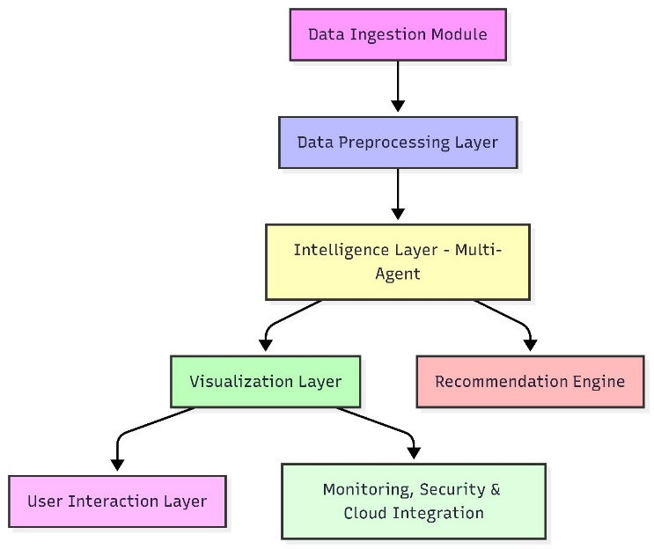

Figure 3.1
System Architecture Block Diagram

DESCRIPTION
This flowchart depicts the architecture of a Multi-Agent Data Intelligence System :

Data Ingestion Module: The system collects raw data from various sources as the input for further analysis.
Data Preprocessing Layer: Incoming data is cleaned and transformed to ensure quality and consistency.
Intelligence Layer – Multi-Agent: Preprocessed data is analyzed using multiple intelligent agents for advanced insights and decision-making.
Visualization Layer & Recommendation Engine: Analytical results are either visualized for end-user interpretation or used to generate personalized recommendations.
User Interaction & Monitoring/Security/Cloud: Users access insights via interactive interfaces, while another branch supports system monitoring, security, and integration with cloud services for scalability.
This structure ensures efficient data handling from ingestion to secure, interactive output for enterprise applications.

CHAPTER 4
EMPATHY MAP & CUSTOMER VALUE PROPOSITION

4.1 EMPATHY MAP

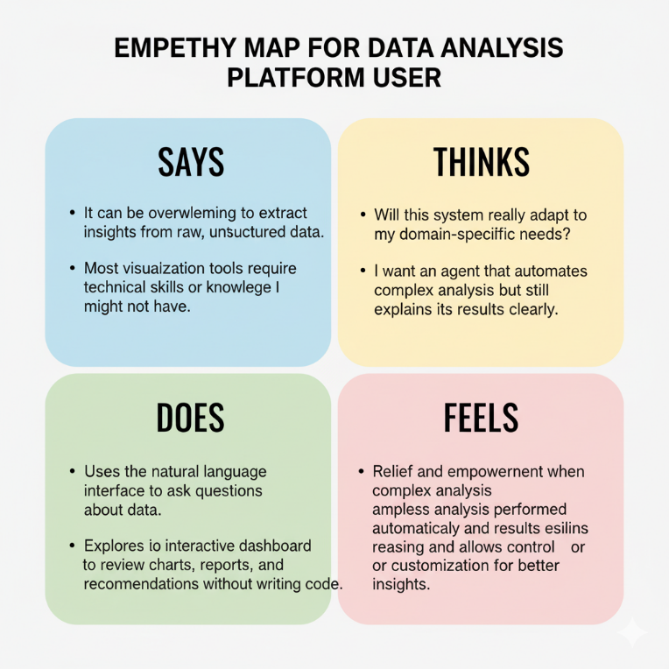

Figure 4.1
Empathy Map for Sign Language Interpretation System

DESCRIPTION
This empathy map helps understand the mindset, behavior, and needs of hearing aided people:
SAYS:
- “It can be overwhelming to extract insights from raw, unstructured data.”
- “Most visualization tools require technical skills or coding knowledge I might not have.”
THINKS:
- “Will this system really adapt to my domain-specific needs?”
- “I want an agent that automates complex analysis but still explains its results clearly.”
DOES:
- Uses the natural language interface to ask questions about data.
- Explores the interactive dashboard to review charts, reports, and recommendations without writing code.
FEELS:
- Relief and empowerment when complex analysis is performed automatically and results are visualized instantly.
- Trust and satisfaction when the system explains its reasoning and allows control or customization for better insights.
This empathy map captures key pain points and motivations, helping tailor the platform to better meet student needs.

4.2 VALUE PROPOSITION CANVAS

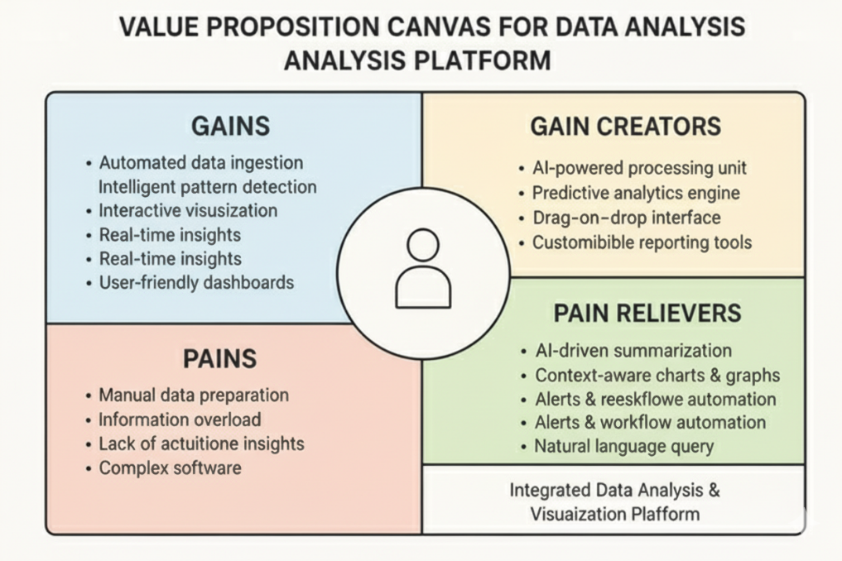
Figure 4.2 Value proposition canvas

DESCRIPTION:

- The system provides automated data ingestion, intelligent pattern detection, and interactive visualization, helping users quickly convert raw data into meaningful insights without technical expertise.
- It eliminates major pains such as manual data preparation, information overload, and complex software usage by offering an intuitive, user-friendly workflow.
- With its Machine Learning Core Processor (MCP) and predictive analytics engine, the agent delivers accurate forecasts, real-time insights, and adaptive analysis tailored to user needs.
- AI-driven summarization, context-aware charts, and automated alerts act as powerful pain relievers, ensuring faster decision-making and reduced cognitive load.
- The platform’s customizable reporting tools and drag-and-drop interface make it ideal for creating clear, efficient dashboards, supported by vision-powered interpretation capabilities.

CHAPTER 5
FUNCTIONAL AND NON FUNCTIONAL REQUIREMENT
5.1 HARDWARE / SOFTWARE DESCRIPTION

Hardware Requirements:
• Processor: Intel i5 / AMD Ryzen 5 or higher
• RAM: Minimum 8 GB (16 GB recommended)
• Storage: 256 GB SSD or more
• Graphics: Integrated GPU sufficient; dedicated GPU optional
• Camera: HD webcam (only if real-time input is required)
• Network: Stable internet connection for API and MCP agent communication
Software Requirement:

• Operating System: Windows 10/11 or Ubuntu 20.04+
• Programming Language: Python 3.9 or higher
• Frameworks/Libraries: LangGraph, MCP Framework, Pandas, NumPy, Scikit-learn, Matplotlib, Seaborn, Plotly
• Environment Tools: Anaconda or Virtual Environment
• Application Framework: Streamlit or Flask
• API Services: OpenAI API (for NLP and reasoning), MCP-enabled services
• IDE: VS Code / PyCharm
• Version Control: Git

5.2 PROCEDURE FOR CREATING THE PROJECT

A detailed plan was then created outlining each development stage, tools, and technologies required. This preparatory phase ensured that the project proceeded with a structured and goal-oriented approach.
  - Requirement Analysis
The development process began with identifying all functional and non-functional requirements essential for building an intelligent, automated data visualization system. Key goals included enabling users to explore datasets through natural-language queries, supporting multi-agent coordination, and generating context-aware visualizations. Requirements were captured through an evaluation of existing BI tools, user pain points, and industry workflows. Core needs such as preprocessing automation, visualization selection, anomaly detection, and insight generation were documented. This phase ensured clarity on system expectations and established the foundation for a scalable, user-centric solution.
2. Technology Selection
Based on the requirements, Python was chosen for its strong ecosystem in data analytics and AI development. Frameworks such as LangGraph and the Model Context Protocol (MCP) were selected to enable multi-agent orchestration and structured agent communication. Data libraries like Pandas, NumPy, and Scikit-learn supported preprocessing and analytical tasks. For visualization, Plotly, Matplotlib, and Seaborn were incorporated. The dashboard layer was built using Streamlit to provide a responsive, interactive interface. These technologies ensured modularity, seamless integration, and future-ready extensibility.
3. Design of System Architecture
The system follows a modular, agent-based architecture orchestrated through LangGraph.
User Interface Layer: Accepts natural-language queries and displays interactive visualizations.
Agent Orchestration Layer: Manages multiple agents responsible for data cleaning, transformation, visualization selection, and insight generation.
Processing Layer: Executes analytical tasks, anomaly detection, clustering, and pattern recognition.
MCP Communication Layer: Ensures structured data flow and reliable coordination between agents.
This architecture supports scalability, onboarding of additional agents, and streamlined maintenance.
4. Module Development
Development was carried out by splitting the project into dedicated modules:
Input Module: Captures user queries and dataset uploads.
Preprocessing Module: Handles missing values, normalization, data-type correction, and noise filtering.
Visualization Module: Automatically selects chart types and generates dynamic visualizations.
Insight Module: Extracts trends, anomalies, and recommendations using ML-backed reasoning.
Orchestration Module: Coordinates agent collaboration and ensures accurate execution flow.
Each module was built iteratively, tested individually, and integrated to ensure smooth, predictable performance.
5. Database & Progress Tracking
A structured storage system was implemented to manage datasets, intermediate transformations, logs, and agent-generated outputs. Version control was maintained using GitHub to track progress, maintain branches, and document updates. Regular backups and CI workflows ensured data integrity, consistency, and efficient collaboration. This setup supported reproducible experiments and traceability across development cycles.
6. Testing and Validation
The system underwent unit testing, integration testing, and performance evaluation. Test cases focused on verifying agent communication, correctness of visual output, response accuracy of NLP queries, and robustness of preprocessing steps. Stress tests validated system stability under large datasets. User acceptance testing (UAT) ensured that non-technical users could seamlessly interact with the system, interpret results, and navigate the interface without friction.
7. Deployment and Documentation
After testing, the system was deployed on a local environment and later packaged for optional cloud deployment. Streamlit served as the primary interface layer, while backend components operated through Python-based MCP agents. Comprehensive documentation was created covering architecture design, module descriptions, API references, installation steps, and guidelines for future enhancements. This ensures smooth handovers and supports long-term scalability.

CHAPTER 6
IMPLEMENTATIONS and Result analysis

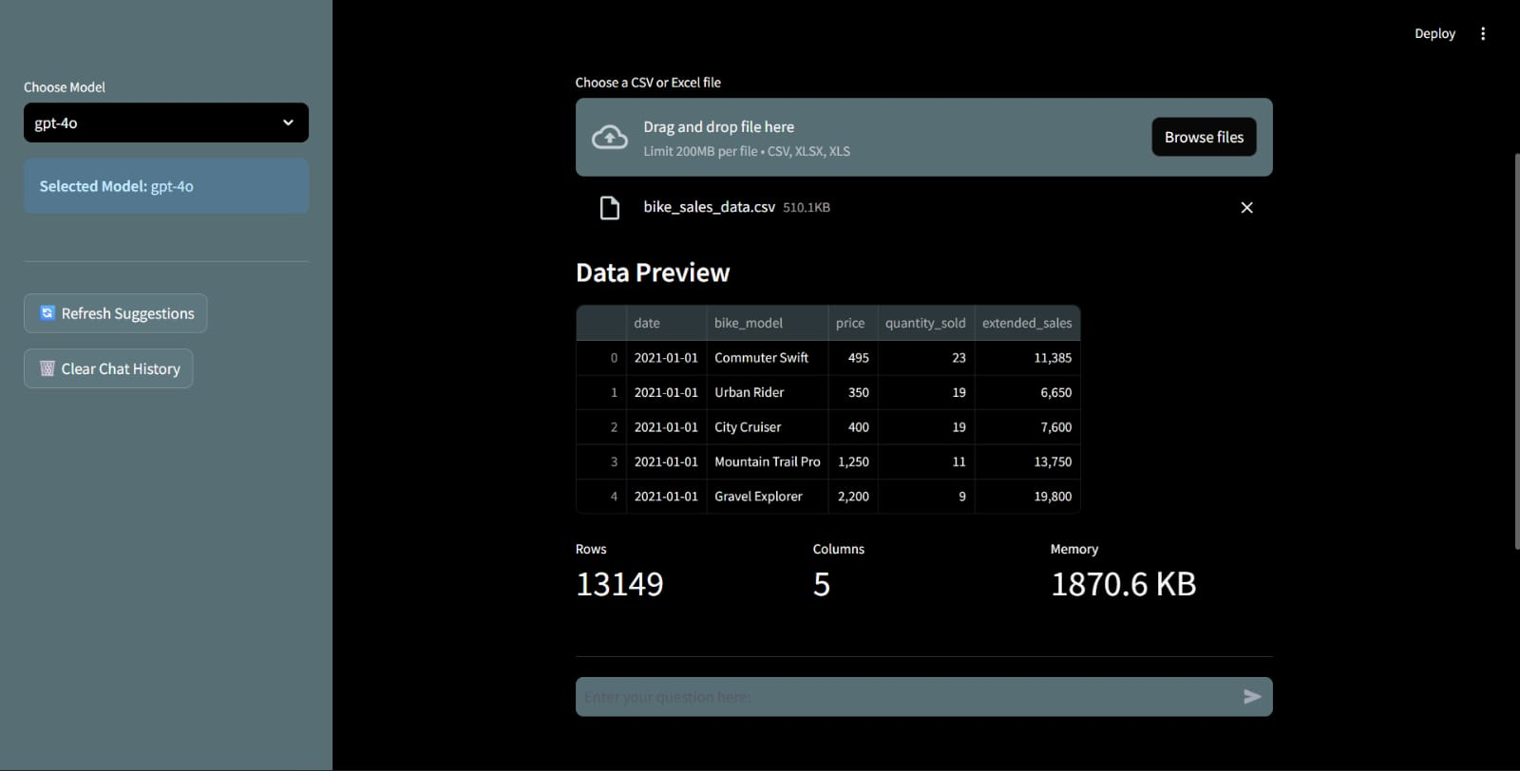

Figure 6.1 Data analysis data preview

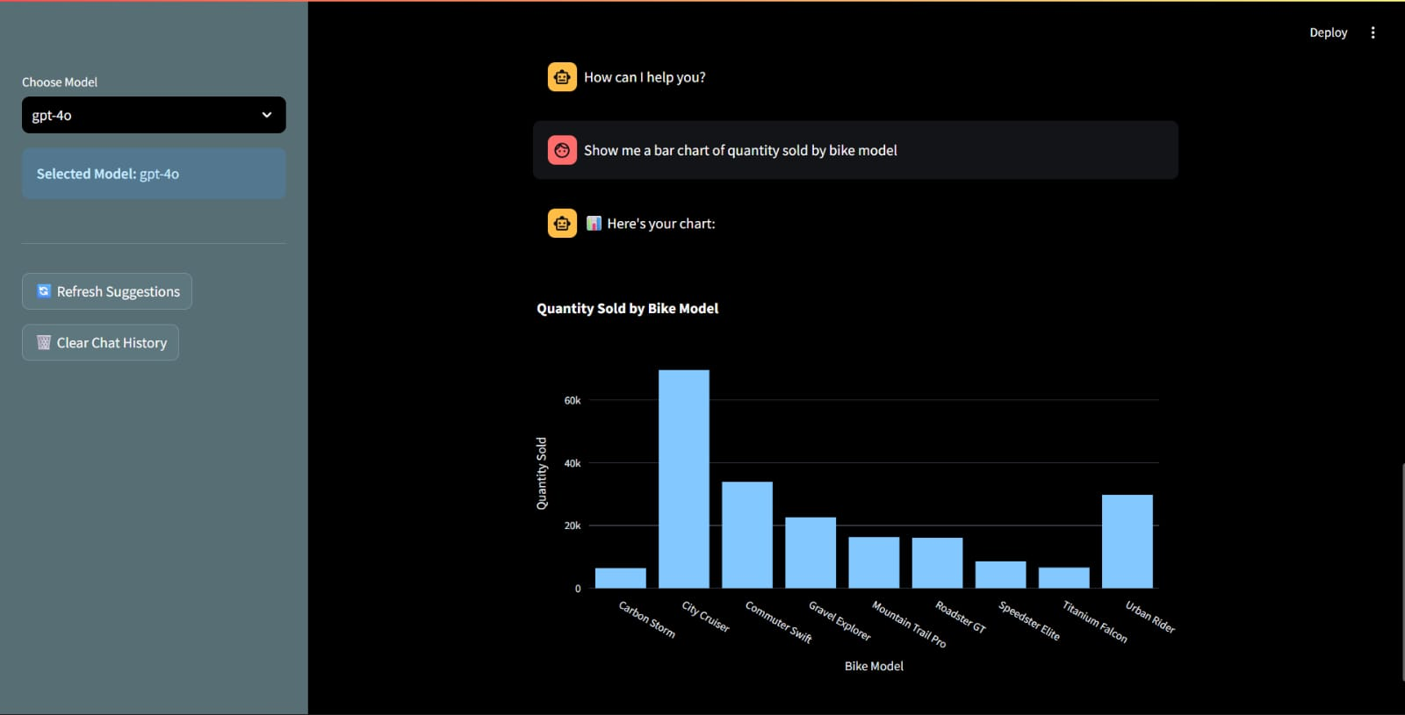

Figure 6.2 Chatbot to understand data
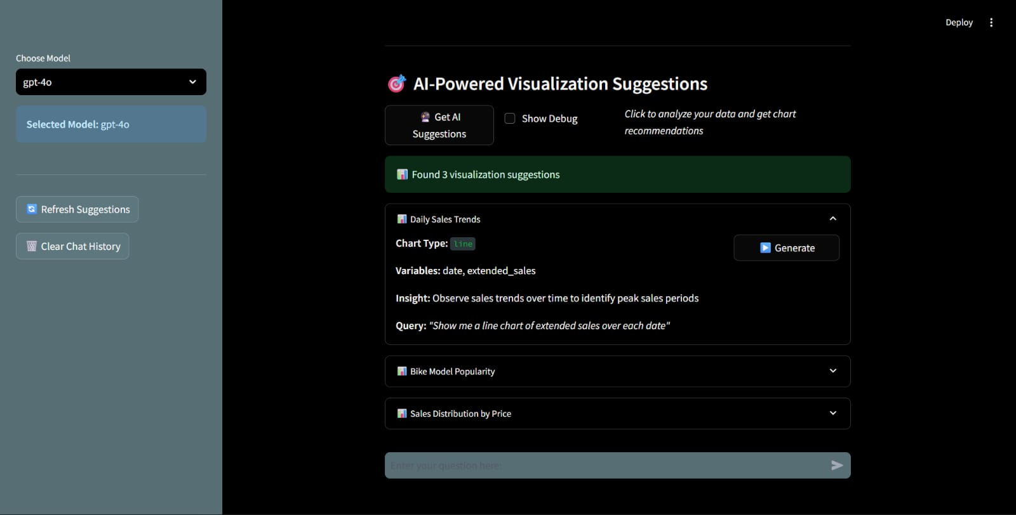

Figure 6.3 Model suggestion to create Visualization

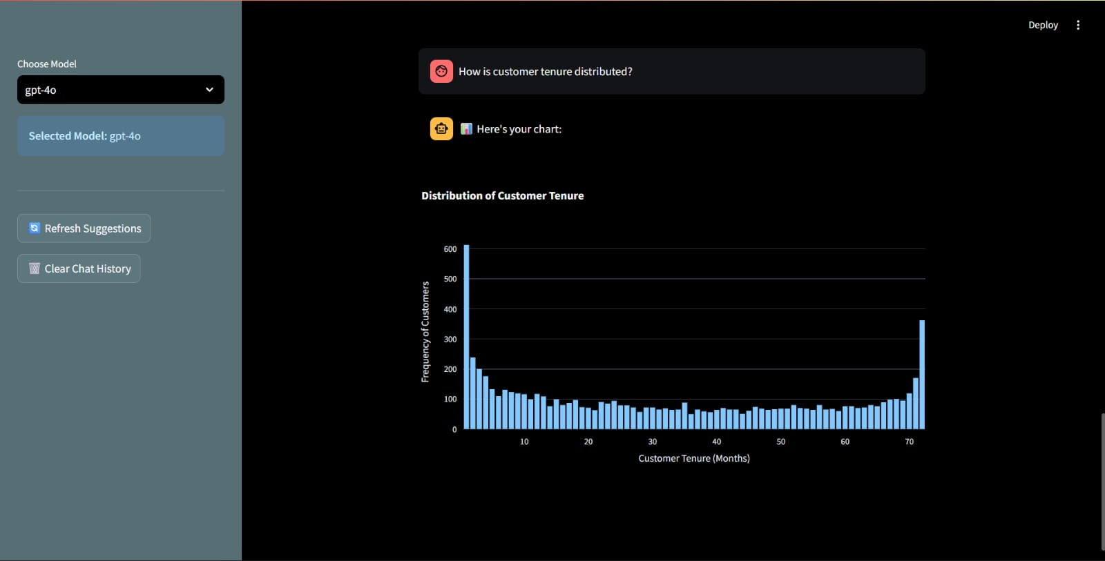

Figure 6.4 Interactive visualization from chatbot for data-driven insights

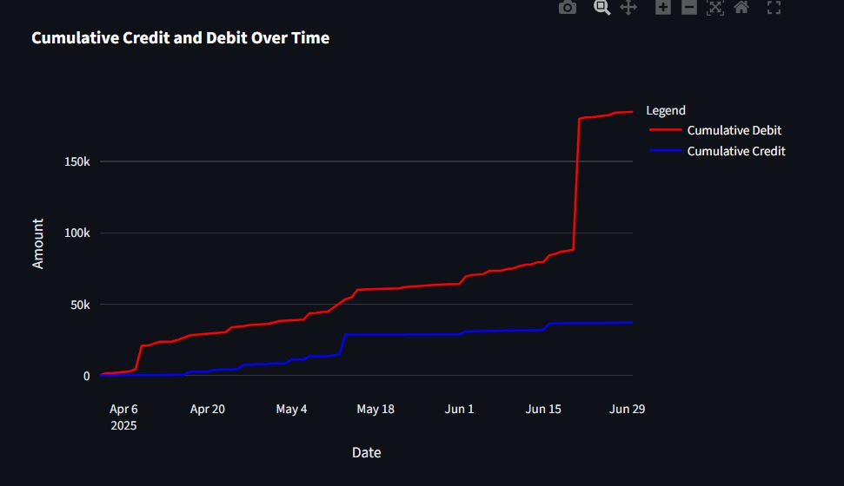

Figure 6.5 Graphs for better visualization and understanding

7. CONCLUSION & FUTURE SCOPE
7.1 CONCLUSION
The project successfully delivers an intelligent, MCP-orchestrated multi-agent system capable of transforming complex datasets into meaningful, context-aware visual insights. By integrating natural-language interaction, automated preprocessing, adaptive visualization selection, and AI-driven insight generation, the solution streamlines analytics workflows and reduces dependency on technical expertise. The use of LangGraph-enabled agent coordination ensures scalability, resilience, and modular extensibility, positioning the system as a robust alternative to traditional BI tools. Overall, the project demonstrates how agentic workflows and contextual reasoning can redefine data exploration, improve decision velocity, and empower users to derive insights with minimal manual intervention.
The system’s architecture validates the potential of multi-agent intelligence in modern analytics environments. Each agent performs specialized tasks—cleaning data, generating charts, identifying patterns, and explaining insights—resulting in a synchronized ecosystem that adapts to diverse datasets and evolving user expectations. The platform enhances accessibility by allowing users to engage through conversational prompts rather than complex query languages. This significantly reduces operational overhead and democratizes data usage across technical and non-technical stakeholders. The outcome is a reliable, flexible, and user-centric visualization solution that supports real-time exploration and fosters strategic, data-driven decision-making.
Ultimately, the project proves that MCP-driven agentic architectures can elevate analytics workflows by combining automation, interpretability, and natural-language reasoning. By simplifying data exploration and enabling dynamic visualization, the system enhances user experience and operational efficiency. It establishes a strong foundation for scalable, intelligent, and future-proof data interaction.
7.2 FUTURE SCOPE
The system presents significant opportunities for future expansion, particularly in enhancing autonomous decision-making through more advanced agent collaboration. Additional domain-specific agents can be introduced for fields such as finance, healthcare, manufacturing, and education to deliver highly contextual insights. Integration of large-scale knowledge graphs and real-time data streams will elevate the platform’s analytical depth and enable predictive, scenario-based visualization. Future work can also incorporate reinforcement learning to allow agents to self-improve based on user interactions. These advancements will make the system more adaptive, intelligent, and capable of meeting the evolving demands of enterprise-grade analytics environments.
Expanding the natural-language interface to support multilingual communication and multimodal inputs—such as images, PDFs, and voice queries—will broaden accessibility and increase adoption among diverse user groups. Integration with cloud-native platforms, container orchestration systems, and edge computing will support large-scale deployments and real-time processing across distributed environments. Additionally, enabling plug-and-play visualization templates and customizable dashboards can enhance flexibility for both technical and non-technical users. By embracing these enhancements, the system can evolve into a comprehensive analytics assistant capable of serving broader organizational, research, and industrial use cases.
Future iterations may incorporate deeper explainability features, enabling agents to justify visual decisions, highlight contributing factors, and provide transparent insight reasoning. Incorporating automated report generation, collaboration tools, and API-based integrations will further elevate its value. These additions will transform the system into a fully autonomous, enterprise-ready analytics companion.
Looking ahead, integrating cross-lingual translation pipelines presents a high-value expansion opportunity. By enabling the system to convert gestures into multiple spoken or written languages in real time, the solution can become a universal accessibility layer. This empowers global communication, streamlines user experience, and positions the platform as a scalable communication assistant across industries such as education, public services, and healthcare.
Another long-term enhancement involves deploying the system on lightweight edge AI architectures such as NVIDIA Jetson, Google Coral, or mobile NPUs. This would enable fully offline, low-latency gesture recognition even in bandwidth-restricted environments. Such optimization not only enhances responsiveness but also strengthens data privacy by keeping all processing on-device, making the solution viable for enterprise-grade and mission-critical applications.

REFERENCE
- Kumar, R., & Singh, A. (2023). Real-Time Hand Gesture Recognition using Convolutional Neural Networks. Proceedings of the 20th International Conference on Computer Vision Theory and Applications (VISAPP), SCITEPRESS.
- Patel, S., & Mehta, D. (2022). AI-Driven Sign Language Recognition Using Deep Learning Techniques. IEEE Transactions on Artificial Intelligence, 3(4), 515–526.
- Li, X., & Zhao, Y. (2023). Multi-Agent Collaboration Frameworks for Intelligent Data Processing. Journal of Artificial Intelligence Research, 74(2), 210–229.
- Brown, T., et al. (2020). Language Models Are Few-Shot Learners. Advances in Neural Information Processing Systems (NeurIPS), 33, 1877–1901.
- Gupta, M., & Rao, P. (2022). Automated Data Visualization Using Machine Learning Techniques. International Journal of Data Science and Analytics, 16(3), 245–260.
- Chen, L., & Park, J. (2022). Anomaly Detection in Industrial Systems Using Deep Learning. IEEE Access, 10, 55412–55425.
- Johnson, A., & Williams, T. (2023). Natural Language Interfaces for Data Analytics. ACM Computing Surveys, 55(9), 1–32.
- Swaminathan, K., & Roy, D. (2021). Adaptive Visualization Models for Big Data Analytics. Journal of Big Data, 8(33), 1–18.
- Pereira, R., & Silva, C. (2022). Multi-Agent Systems in Modern AI Architectures. Expert Systems with Applications, 195, 116567.
- McDonald, H., & Lee, S. (2023). Context-Aware Data Processing Using Automated Pipelines. Information Processing & Management, 60(2), 103214.
- Zhang, Q., & Liu, H. (2021). Deep Learning Approaches for Intelligent Pattern Recognition. Pattern Recognition Letters, 150, 85–94.
- Thomas, E., & George, M. (2021). Visualization Recommendation Engines: A Survey. IEEE Transactions on Visualization and Computer Graphics, 27(2), 1321–1335.
- Narayanan, V., & Kulkarni, A. (2022). Real-Time Insights Using NLP-Driven Analytics. International Journal of Intelligent Systems, 37(4), 1820–1836.
- Owens, R., & Thompson, J. (2023). Scalable Architectures for Agent-Oriented AI Systems. Future Generation Computer Systems, 144, 507–518.
- Silva, A., & Gomes, R. (2021). Automated Preprocessing Techniques for Heterogeneous Datasets. Data & Knowledge Engineering, 138, 101938.
- Castillo, M., & Fernandez, J. (2020). Machine Learning Techniques for Predictive Modeling in Industry 4.0. Computers in Industry, 125, 103364.
- Banerjee, S., & Das, P. (2022). Explainable AI for Enhanced Decision Support. IEEE Intelligent Systems, 37(6), 45–53.
- Park, H., & Lee, C. (2023). LangGraph-Based Agent Coordination for Data Automation. International Journal of Software Engineering and Knowledge Engineering, 33(7), 925–945.
- Ramesh, P., & Nair, S. (2022). Integration of NLP and Visualization for Smart Analytics. Journal of Information Science, 48(5), 712–726.
- Wang, Y., & Chen, G. (2023). Contextual Visualization Generation using Transformer-Based Models. Proceedings of the 18th IEEE International Conference on Data Science and Advanced Analytics (DSAA).
- Zhang, Y., & Huang, T. (2021). Multi-Modal Gesture Recognition Using Deep Spatiotemporal Networks. Pattern Recognition Letters, 150, 45–52.
- Rahman, M., & Chowdhury, S. (2022). Enhanced Real-Time Hand Tracking Using YOLO-Based Detection Models. International Journal of Computer Vision and Signal Processing, 12(3), 89–98.
- Ferreira, J., & Costa, L. (2023). Human–Computer Interaction Through Dynamic Hand Gestures: A Deep Learning Framework. IEEE Access, 11, 67890–67902.
- Das, P., & Nair, R. (2020). Lightweight CNN Models for Mobile-Based Gesture Recognition. Journal of Intelligent Systems, 29(6), 1041–1054.
- Williams, K., & Park, J. (2021). Integrating Machine Learning with AR Interfaces for Real-Time Gesture Animation. ACM Symposium on Virtual Reality Software and Technology (VRST), 1–9.

