**MODULE -- DESIGN PATTERNS AND PRINCIPLES**

**Task 1 : Implementing the Singleton Pattern:**

**Code :**

**SingletonPatternExample.java**

class Logger {

private static Logger uniqueInstance;

private Logger() {

System.out.println("Logger initialized.");

}

public static Logger getInstance() {

if (uniqueInstance == null) {

uniqueInstance = new Logger();

}

return uniqueInstance;

}

public void log(String msg) {

System.out.println("[LOG]: " + msg);

}

}

public class SingletonPatternExample {

public static void main(String[] args) {

Logger loggerA = Logger.getInstance();

loggerA.log("Logging from first instance");

Logger loggerB = Logger.getInstance();

loggerB.log("Logging from second instance");

if (loggerA == loggerB) {

System.out.println("Same logger instance reused.");

} else {

System.out.println("Different instances found.");

}

}

}

**Output:**

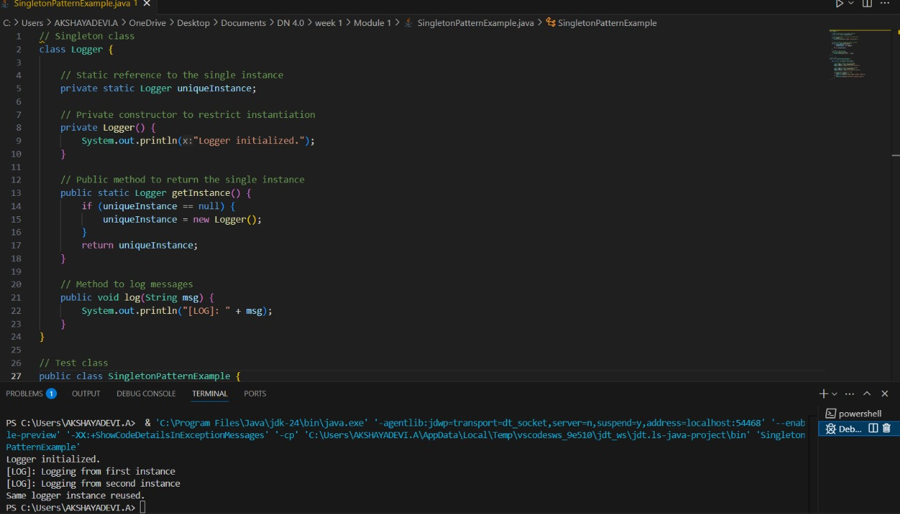

**Task 2 : Implementing the Factory Method Pattern**

**Code:**

**FactoryMethodPatternExample.java**

interface Document {

void display();

}

class WordFile implements Document {

public void display() {

System.out.println("Opening a Word file...");

}

}

class PdfFile implements Document {

public void display() {

System.out.println("Opening a PDF file...");

}

}

class ExcelFile implements Document {

public void display() {

System.out.println("Opening an Excel file...");

}

}

abstract class FileFactory {

public abstract Document getDocument();

}

class WordFileFactory extends FileFactory {

public Document getDocument() {

return new WordFile();

}

}

class PdfFileFactory extends FileFactory {

public Document getDocument() {

return new PdfFile();

}

}

class ExcelFileFactory extends FileFactory {

public Document getDocument() {

return new ExcelFile();

}

}

public class FactoryMethodPatternExample {

public static void main(String[] args) {

FileFactory word = new WordFileFactory();

Document wordDoc = word.getDocument();

wordDoc.display();

FileFactory pdf = new PdfFileFactory();

Document pdfDoc = pdf.getDocument();

pdfDoc.display();

FileFactory excel = new ExcelFileFactory();

Document excelDoc = excel.getDocument();

excelDoc.display();

}

}

**Output:**

