ONLINE RETAIL SALES ANALYSIS USING EXCEL AND POWER BI
1. Project Overview and Objective:
Project Overview:
This project involves cleaning, transforming, and analysing the Online Retail dataset using Microsoft Excel (Power Query) and developing an interactive dashboard using Power BI to derive meaningful business insights. The analysis focuses on sales performance, customer purchasing behaviour, product demand, and geographical sales distribution.
Objective:
The main objective of this project is to demonstrate data pre-processing techniques using Excel Power Query and to develop an interactive Power BI dashboard for analysing retail sales data and supporting business decision-making.

2. Data Sources:
Source Description and Timeline:
- Dataset Source: https://archive.ics.uci.edu/dataset/352/online+retail
- Timeline: December 2010 to December 2011
- Dataset Type: Transactional E-Commerce Sales Data
Domain:
Retail / Commerce / Sales Analytics

3. Problem Statement:
The objective of this project is to analyse online retail transaction data to identify business trends and customer purchasing patterns.
The project aims to:
- Analyse sales performance across different countries and products.
- Identify top-selling products based on revenue and quantity sold.
- Understand customer purchasing behaviour and buying patterns.
- Determine high-value customers contributing to overall sales.
- Analyse monthly and quarterly sales trends to support better business decisions.

4. Attribute (Column / Features) Details:
Attribute Name | Data Type | Description
Invoice No | String (Text) | Unique transaction invoice number
Stock Code | String (Text) | Unique product code
Description | String (Text) | Product description
Quantity | Numeric (Integer) | Number of units purchased
Invoice Date | Date/Time | Date and time of transaction
Unit Price | Numeric (Decimal) | Price per unit of the product
Customer ID | Numeric (Integer) | Unique identifier for each customer
Country | Categorical | Country where the customer belongs
Sales Amount | Numeric (Decimal) | Calculated field (Quantity × Unit Price)
Year | Numeric (Integer) | Year extracted from Invoice Date
Month | String (Text) | Month extracted from Invoice Date
Quarter | Categorical | Quarter extracted from Invoice Date (Q1-Q4)

5. Tools & Technologies:
Microsoft Excel (Power Query)
- Data Import
- Data Cleaning
- Data Transformation
- Handling Missing Values
- Removing Duplicate Records
- Standardizing Data Formats
- Creating Calculated Columns
- Filtering and Sorting
- Pivot Table Generation

Microsoft Power BI
- Data Modeling
- Fact and Dimension Table Creation
- DAX Calculations
- Interactive Dashboard Development
- KPI Cards
- Charts and Visualizations
- Slicers and Filters
- Drill-down Analysis

6. Data Pre-Processing (Excel / Power Query):
Tasks Performed:
Data Cleaning & Transformation:
- Imported the Online Retail dataset into Excel Power Query.
- Verified and assigned appropriate data types for all columns.
- Removed duplicate records to maintain data integrity.
- Handled missing values by removing records with blank Customer IDs and Product Descriptions.
- Removed cancelled transactions identified by Invoice Numbers beginning with the letter "C".
- Removed records containing zero or negative Quantity values.
- Removed records containing zero or negative Unit Price values.
- Standardized the InvoiceDate column by converting Date-Time values into Date format.
- Applied Trim and Clean transformations to text fields to remove unwanted spaces and non-printable characters.
- Created a calculated field named SalesAmount by multiplying Quantity and UnitPrice.
- Created additional calculated columns (Year, Month, and Quarter) from the InvoiceDate field to support time-based analysis.
Filtering & Sorting:
- Applied filters to retain only valid sales transactions.
- Sorted the dataset based on InvoiceDate (Oldest to Newest) to facilitate chronological analysis.

Pivot Tables:
The following Pivot Tables were generated for data summarisation and initial business insights:
- Country-wise Sales Analysis
- Monthly Sales Trend Analysis
- Top 10 Products by Revenue
- Top 10 Customers by Revenue
These Pivot Tables were used to validate the cleaned dataset and perform preliminary analysis before importing the data into Power BI.
Convert the Data into Fact and Dimension Tables (Star Schema)
The cleaned Online Retail dataset was transformed into a Star Schema model to improve data organization and analytical performance. The transaction-level data was maintained in the Fact_Sales table, while Customer, Product, Country, and Date information were separated into individual Dimension tables.
Fact Table
- Fact_Sales
Dimension Tables
- Dim_Customer
- Dim_Product
- Dim_Country
- Dim_Date

7. Data Modelling and DAX (Power BI):
Data Modelling:
A Star Schema data model was created to improve reporting performance and maintain data consistency.
The Fact_Sales table was used as the central transaction table, while Dim_Customer, Dim_Product, Dim_Country, and Dim_Date were used as lookup tables. One-to-Many (*:1) relationships were established between the Fact table and Dimension tables using Single Cross Filter Direction. This structure supports efficient filtering, aggregation, and interactive dashboard analysis.

Relationships Established:
Fact Table | Dimension Table | Relationship
Fact_Sales[CustomerID] | Dim_Customer[CustomerID] | Many-to-One
Fact_Sales[StockCode] | Dim_Product[StockCode] | Many-to-One
Fact_Sales[Country] | Dim_Country[Country] | Many-to-One
Fact_Sales[InvoiceDate] | Dim_Date[InvoiceDate] | Many-to-One

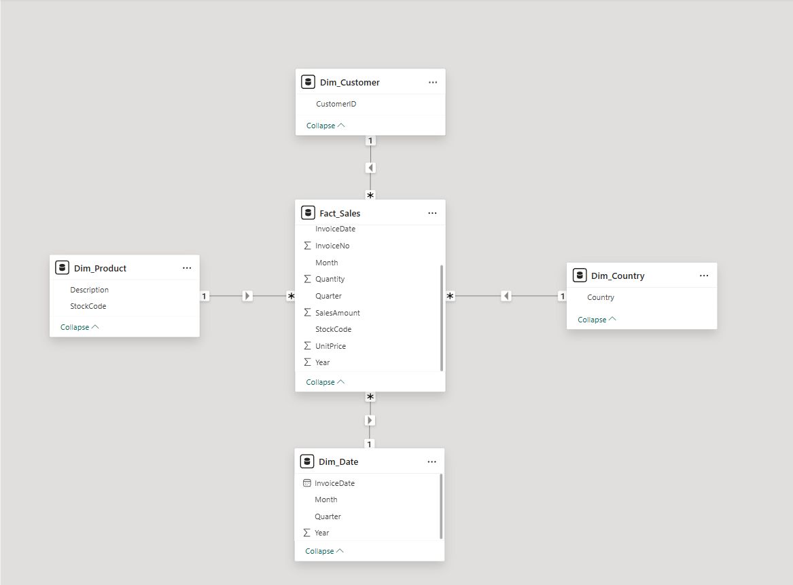
Calculated Columns & DAX Measures:
Calculated columns were created to support revenue calculations and time-based analysis. The Sales Amount column was derived by multiplying Quantity and Unit Price, while Year, Month, and Quarter were extracted from Invoice Date to facilitate trend and seasonal analysis.
DAX measures were implemented to calculate key business performance indicators and support dashboard reporting. These measures enabled the analysis of sales performance, customer contribution, order activity, and cumulative revenue trends.

Calculated Columns:
Column Name | Description
SalesAmount | Calculated as Quantity × UnitPrice
Year | Extracted from InvoiceDate
Month | Extracted from InvoiceDate
Quarter | Extracted from InvoiceDate

DAX Measures:
Measure Name | Purpose
Total Sales | Calculates total revenue generated from all transactions
Total Orders | Counts the number of unique orders
Total Customers | Counts the number of unique customers
Total Quantity Sold | Calculates the total quantity of products sold
Average Order Value | Calculates the average revenue per order
Average Unit Price | Calculates the average selling price of products
Sales per Customer | Calculates the average revenue generated per customer
Cumulative Sales | Tracks the running total of sales over time

These measures were utilized to create KPI cards, sales trend visualizations, customer insights, and interactive dashboard reports within Power BI.
8. Analysis and Visualizations (Power BI):
Dashboard Features:
The Power BI dashboard was designed to provide interactive insights into online retail sales performance. Multiple visualizations were created to analyze sales trends, customer behaviour, product performance, and geographical sales distribution.

Visualizations Included:
- KPI Cards: Total Sales, Total Orders, Total Customers, Total Quantity Sold, Average Order Value, and Sales per Customer.
- Monthly Sales Trend (Line Chart)
- Top 10 Countries by Sales (Bar Chart)
- Sales Contribution by Top 10 Countries (Donut Chart)
- Top 10 Products by Revenue (Bar Chart)
- Top 10 Customers by Revenue (Bar Chart)
- Quarterly Sales Analysis (Column Chart)
Interactive Features:
- Year Slicer
- Quarter Slicer
- Country Slicer
- Cross-filtering between visuals
- Dynamic aggregation using DAX measures
Dashboard Summary:
A consolidated interactive dashboard was developed to monitor key business metrics and sales performance. The dashboard enables users to analyze revenue trends, identify top-performing countries, products, and customers, and evaluate quarterly sales performance through dynamic filtering and interactive visualizations.

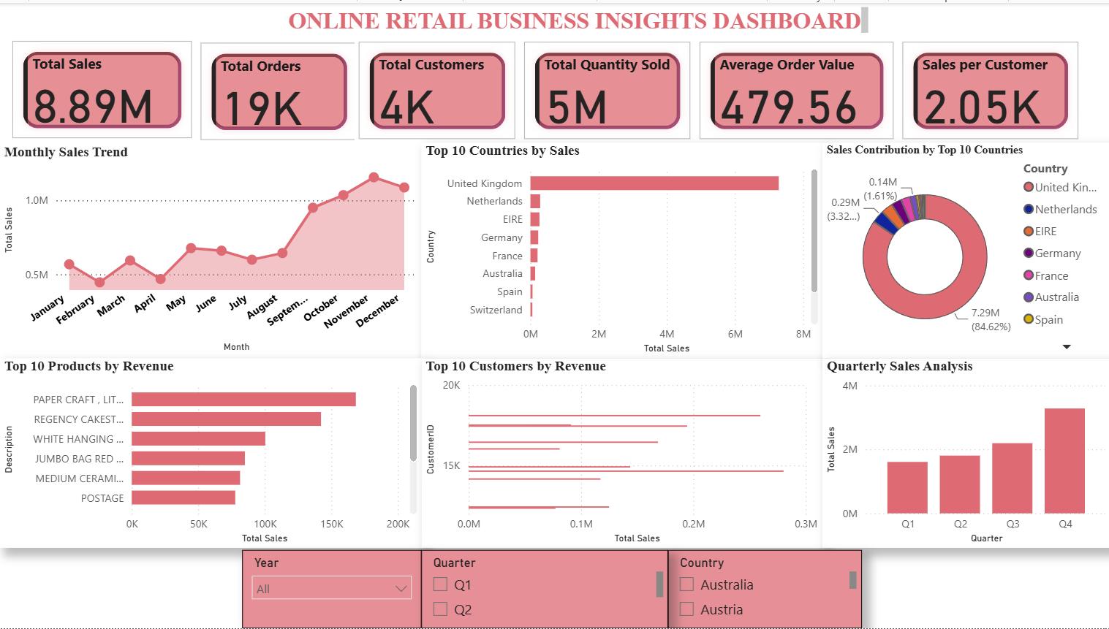
9. Insights & Conclusions:
Key Findings:
The analysis of the Online Retail dataset revealed several important business insights regarding sales performance, customer purchasing behaviour, product demand, and geographical distribution of revenue.
Key Trends and Patterns Identified:
- Total revenue generated during the analysis period was approximately 8.89 Million.
- A total of 19K orders were processed from approximately 4K customers.
- The United Kingdom contributed the majority of total sales revenue, accounting for more than 80% of overall sales.
- Sales performance showed a steady upward trend throughout the year, with the highest sales recorded during October, November, and December.
- Quarter 4 (Q4) generated the highest sales compared to other quarters, indicating strong seasonal demand during the year-end period.
- A small group of products contributed a significant portion of total revenue, highlighting the presence of high-performing products.
- Certain customers generated substantially higher revenue than others, demonstrating the importance of customer retention and loyalty.

Analysis Insights:
1. Descriptive Analysis (What Happened?)
- Total Sales: 8.89 Million
- Total Orders: 19K
- Total Customers: 4K
- Total Quantity Sold: 5 Million Units
- Average Order Value: 479.56
- Sales Per Customer: 2.05K
The business experienced consistent sales activity throughout the year, with significant revenue contributions from the United Kingdom and strong sales performance during the fourth quarter.
2. Diagnostic Analysis (Why Did It Happen?)
- The United Kingdom dominated sales because the majority of customers and transactions originated from that region.
- Higher sales during Q4 were likely influenced by seasonal shopping patterns, festive periods, and promotional activities.
- Revenue concentration among a limited number of products indicates that customer demand is focused on specific product categories.
- A relatively small number of customers contributed a large share of revenue, suggesting the presence of repeat and high-value customers.
3. Predictive Analysis (What Is Likely to Happen?)
- Based on the observed trend, sales are expected to continue increasing during the final quarter of future years.
- High-performing products are likely to remain strong revenue contributors if inventory levels and marketing efforts are maintained.
- Existing high-value customers are expected to continue generating significant revenue through repeat purchases.
- Countries with growing sales trends may provide opportunities for future market expansion.

4. Prescriptive Analysis (What Should Be Done?)
- Focus marketing and promotional campaigns during Q4 to maximize revenue opportunities.
- Maintain adequate inventory levels for top-performing products to prevent stock shortages.
- Implement customer loyalty programs to retain high-value customers.
- Explore strategies to increase sales in countries outside the United Kingdom to reduce geographical revenue dependency.
- Use customer segmentation and targeted promotions to improve customer engagement and increase average order value.
10. Conclusion
The integration of Excel and Power BI proved highly effective for performing end-to-end data analysis, from data cleaning and transformation to visualization and reporting. Excel was used for data preprocessing, calculated columns, pivot table analysis, and initial data validation, while Power BI enabled advanced data modeling, DAX calculations, and interactive dashboard development.
The project successfully transformed raw transactional data into meaningful business insights through the implementation of a Star Schema data model, DAX measures, and interactive visualizations. The dashboard provided valuable insights into sales performance, customer behaviour, product demand, and geographical sales distribution.
Overall, the analysis demonstrated how business intelligence tools can support data-driven decision-making, improve reporting efficiency, and help organizations identify growth opportunities and optimize business performance.

