SMARTBRIDGE | SKILLWALLET
Performance Testing
Date | 15 March 2026
Team ID | SWTID-2026-9624
Project Name | AI FAQ Assistant
Maximum Marks | 5 Marks
Performance Testing
Performance testing evaluates how your system behaves under expected and peak load conditions. Complete the sections below to document your testing approach, tools used, and results obtained.
Step 1: Testing Overview
Field | Details
Testing Tool Used | Thunder Client (VS Code extension, Postman-like REST client)
Type of Testing | Baseline (single-user) response-time test of the API
Target Module / API | AI Answer API – POST /api/ai/answer (Gemini-powered FAQ answer generation, JWT-protected); user registration POST /api/auth/register
Test Environment | Local (Node.js/Express server on localhost:5000, MongoDB on 127.0.0.1, Gemini model gemini-2.5-flash)
Test Date | 28 September 2026
Step 2: Test Scenarios
S.No | Test Scenario / Description | No. of Virtual Users | Duration (sec) | Expected Outcome
1 | Send a question ("what is mongodb") to POST /api/ai/answer with a valid Bearer token | 1 | ~7 (single request) | 200 OK with success: true and a generated answer; response time < 2 s
2 | Register a new user via POST /api/auth/register (JSON body: name, email, password) | 1 | Single request | User created and JWT token issued for use in protected routes
3 | Planned: concurrent questions to POST /api/ai/answer (not yet executed) | 10 (planned) | 60 (planned) | Avg response < 2 s, error rate < 1%
4 | Planned: peak load on POST /api/ai/answer (not yet executed) | 50 (planned) | 60 (planned) | Max response < 5 s, CPU and memory < 80%

Step 3: Performance Test Results
S.No | Metric | Target Value | Actual Value | Status (Pass / Fail) | Remarks
1 | Response Time (Avg) | < 2 seconds | 6.87 seconds | Fail | Single request to /api/ai/answer; time is dominated by the external Gemini API call
2 | Response Time (Max) | < 5 seconds | 6.87 seconds | Fail | Only one request measured, so max = avg
3 | Throughput (Req/sec) | — | ≈ 0.15 req/sec | N/A | 1 request in 6.87 s, sent sequentially; no target was defined
4 | Error Rate | < 1% | 0% | Pass | 1 of 1 request returned 200 OK (330 bytes)
5 | CPU Utilization | < 80% | Not measured | — | To be recorded from Task Manager during the test
6 | Memory Utilization | < 80% | Not measured | — | To be recorded from Task Manager during the test
Step 4: Observations & Analysis
Key Findings:
- The AI Answer API works correctly under a single-user test: it returned 200 OK with "success": true and a relevant answer about MongoDB (330 bytes).
- Error rate was 0% for the requests tested, and the JWT-protected route accepted the Bearer token.
- The response time of 6.87 s is above both the average target (< 2 s) and the maximum target (< 5 s).
- CPU and memory usage and multi-user load behaviour have not yet been measured.
Bottlenecks Identified:
- The main delay is the call to the external Gemini API (gemini-2.5-flash) for every question, which depends on network latency and model generation time.
- Every request triggers a fresh AI call, even for repeated or common questions.
Optimization Steps Taken:
- Used the faster gemini-2.5-flash model for answer and FAQ generation.
- Requested structured JSON output with a response schema in generateFAQ, so no extra parsing or retry is needed.
- Added error handling that throws a clear error when Gemini returns no text, and trims the response text before returning it.
Further improvements planned: cache answers to repeated questions in MongoDB, limit the maximum output length, and re-test with 10 and 50 concurrent users.
Step 5: Screenshots / Evidence
Screenshots of the performance testing tool results (Thunder Client):
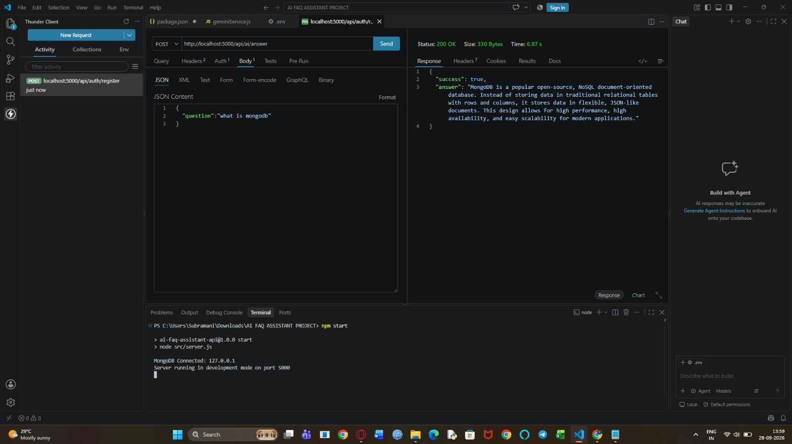
Screenshot 1: POST /api/ai/answer – Status 200 OK, 330 Bytes, 6.87 s; server running on port 5000 with MongoDB connected
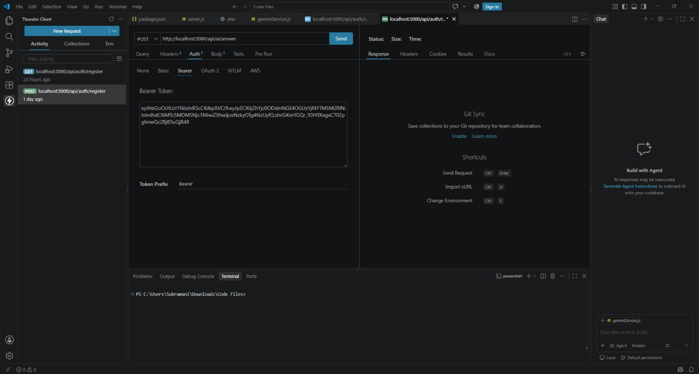
Screenshot 2: Thunder Client request setup for /api/ai/answer with Bearer token authentication
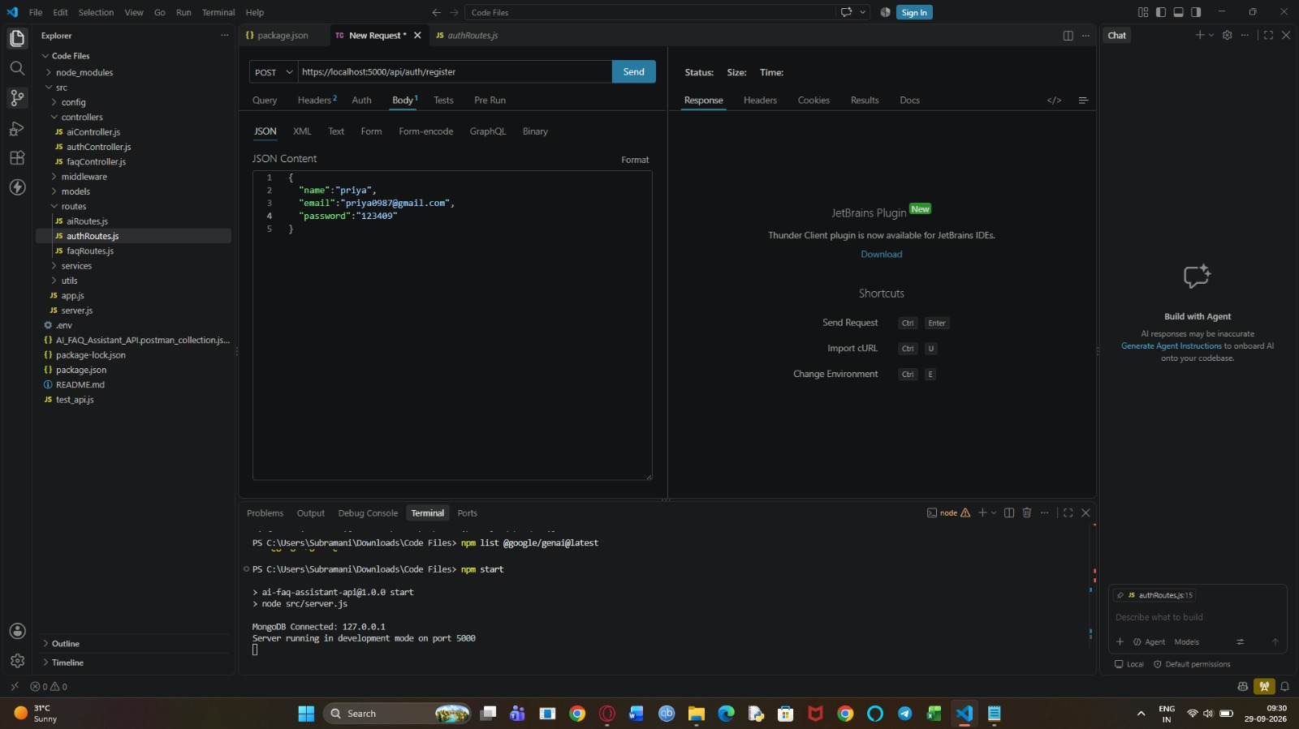
Screenshot 3: POST /api/auth/register request body and server started (MongoDB connected, port 5000)
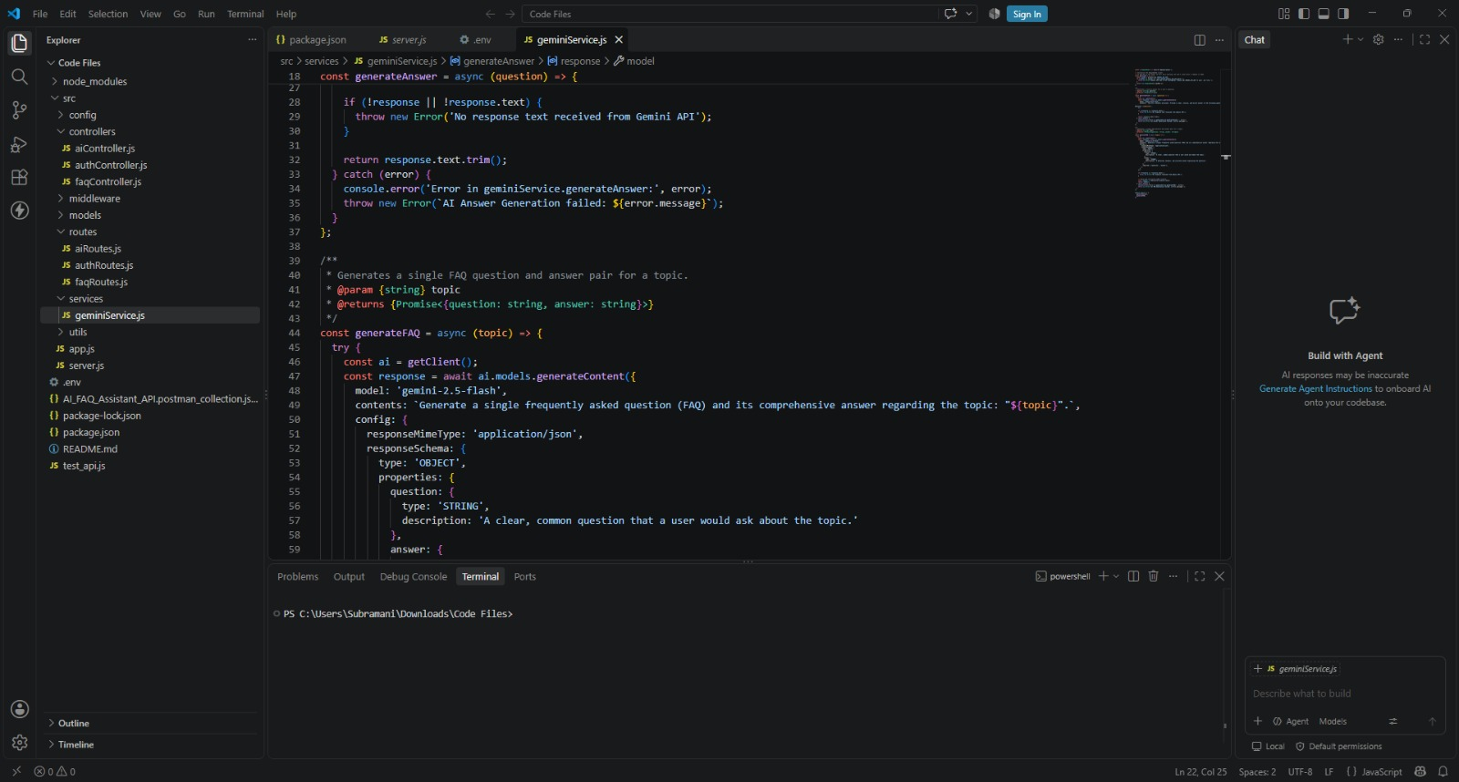
Screenshot 4: geminiService.js – Gemini model configuration (gemini-2.5-flash) with JSON response schema

