**Project**

**Employee Payroll Management System**

**Name:** Akshaya Ganesh

**Name of Project:** Employee Payroll Management System

**Summary:**

1. Employee Information

Employee data is very essential in order to maintain a proper record of the employees and there personal information for various purposes like contacting them for inviting for certain summit, feedback of the company from the employee data

1. Maintaining Salary

Very important to keep this data which will help not only the managers and the HR to keep a track of the employee salaries but also help the company or its board to analyze what amount they are spending on a particular employee of a particular company

1. Work Location

It is very much important for an organization small or big to have a record of all the work locations they operate from to see how they can develop in that particular region and also increase the hiring in that region so that the organization can increase there Market Outreach that area.

1. Projects

In order to be successful company should be involved in various projects, so they also need to maintain the record of the salaries each employee is being paid for a particular type of project he/she is working on

**PL/SQL features used in the project:**

1. Created Explicit Cursors which shows the hourly pay of the employees associated with there Accounts and Ref cursor showing the employees who are a part of a particular department
2. Create a CDB and a PDB with users to manage the data according to the area of interest
3. Implement pre-defined exception cursor_already_open to demonstrate the understanding of the exceptional handling concept which shows what error will populate when we try to open a cursor which is already open
4. Also, created Relational, Inline and Materialized Views satisfying various business requirements
5. Created Index on AccountDetails table
6. Built an E-R Diagram to know how the entities are related in the payroll management system for any company

**List of Entities:**

**Employee**

Employee table will include all the personal details of the employee and would be very much cover overall information of that particular employee

**Salary**

Salary Table will cover all the current and previous salaries an employee had or currently has. This table will help a manager/ an HR to analyze which employee has been given promotion on which date or when did his salary grade changed

**Department**

Department Table maintains the data of the all the possible departments an employee can belong to

**Account Details**

Account Details Table will maintain the data regarding the accounts which the employee has connected with the company for his/her salary to be credited

**Attendance**

This table includes all the data of the employees attendance which includes the number of hours an employee has worked in a week

**Project**

This table includes the data of all the projects a particular company is working on or the projects on which the company is going to work in the future

**Education**

The Education Table keeps the track of the education of the employee including his degrees achieved until now

Work Location

The name of the table tells you most of the things. This table includes the location of the office, which city is it located, which state it is in and also tracks the number of employees in a particular location

**Leave**

Leave table keeps the record of the number of leaves an employee takes or has taken over the course of any month or an year

E-R Diagram

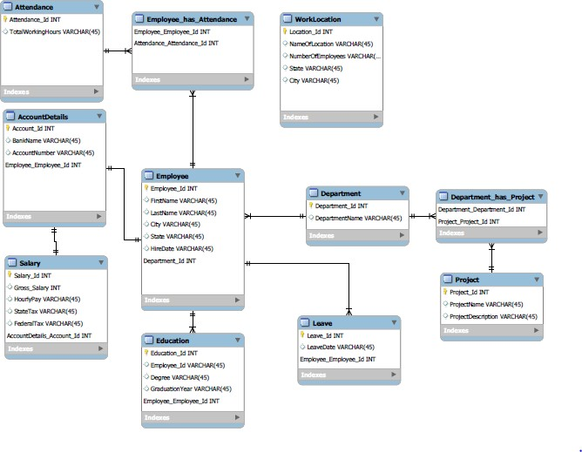

1. Created Common User on sysdba

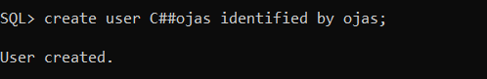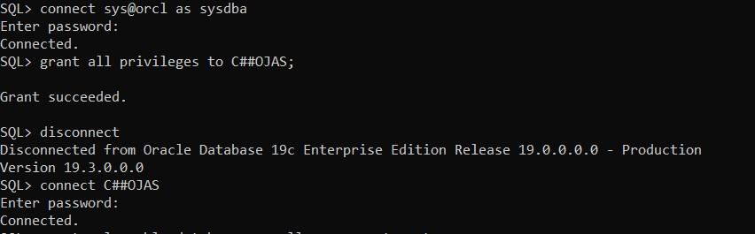

1. Create Pluggable Database

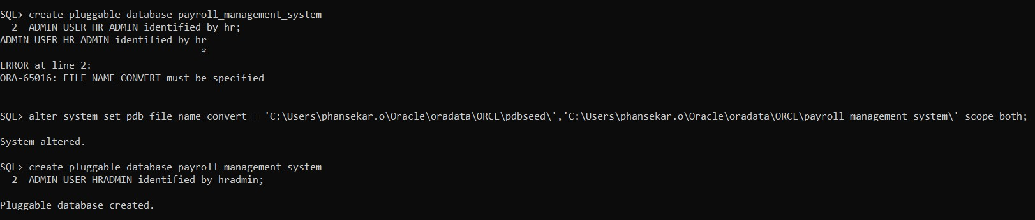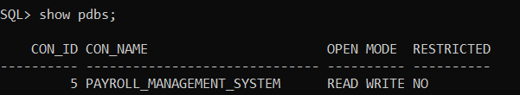

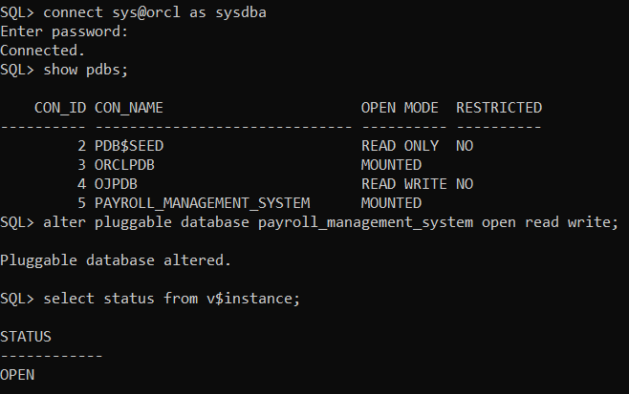

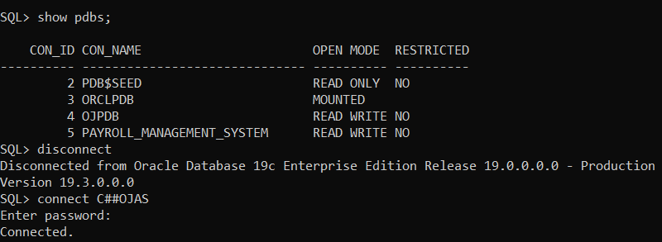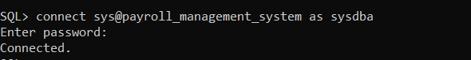

1. Inline View

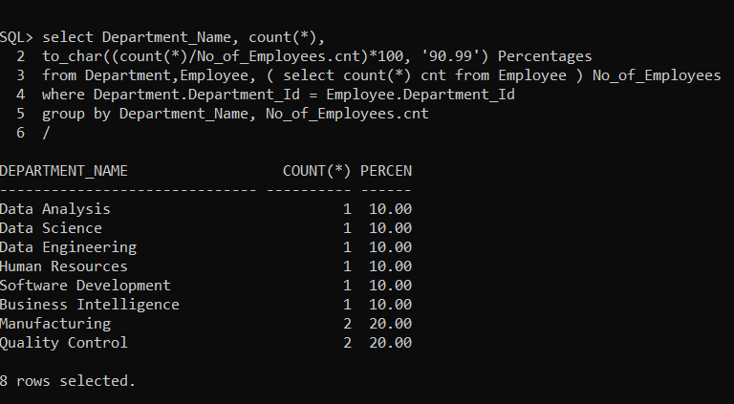

1. Materialized Views

-- Number of Employees with different degrees

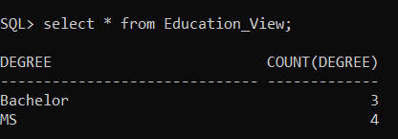

1. Explicit Cursor

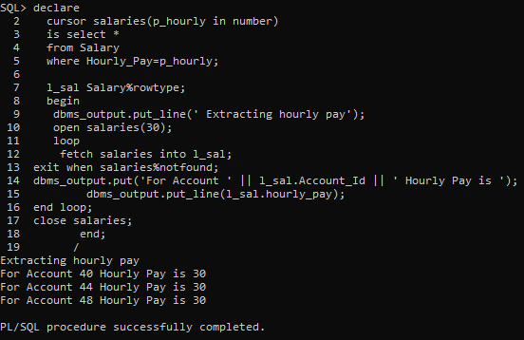

1. Index

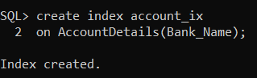

1. Relational Views

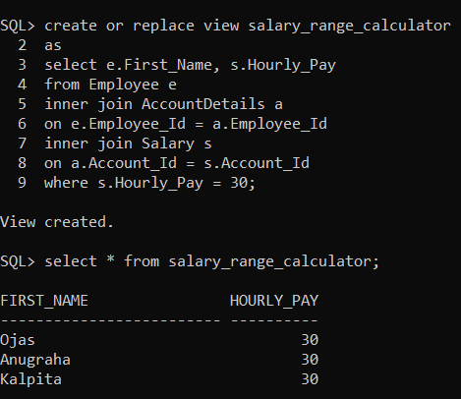

1. Transaction

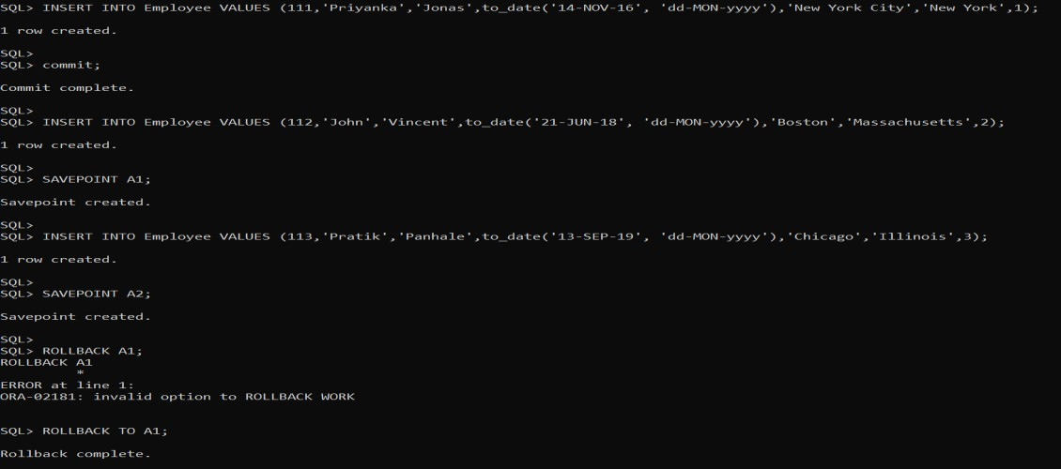

1. External Table

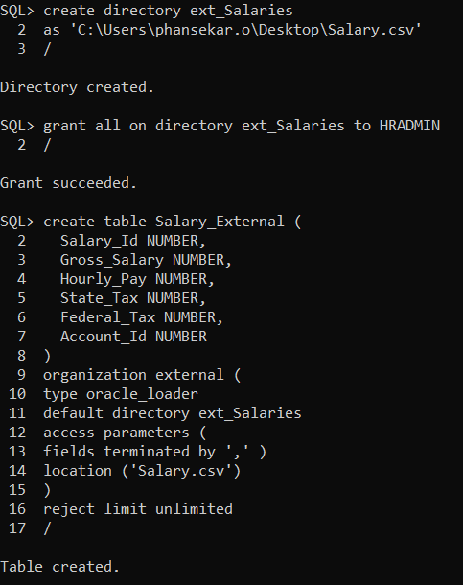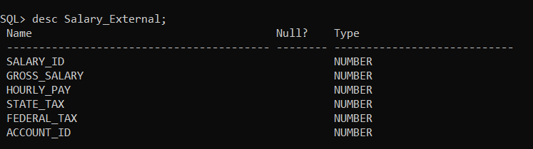

1. Ref cursor

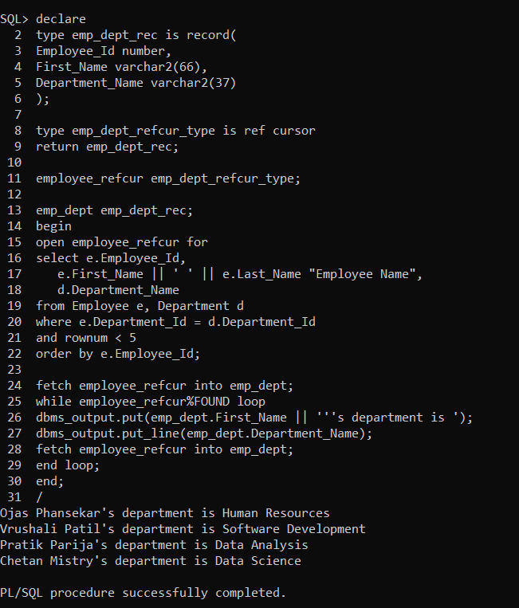

1. Pre-defined Exception

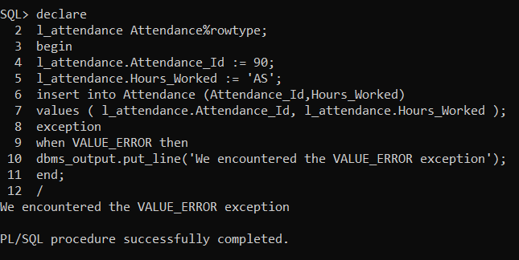

1. 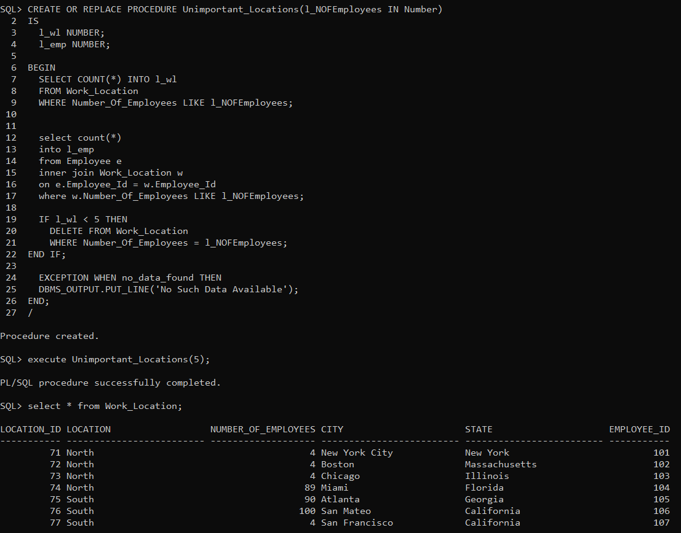Procedure
2. Predefined Exception and Explicit Cursor

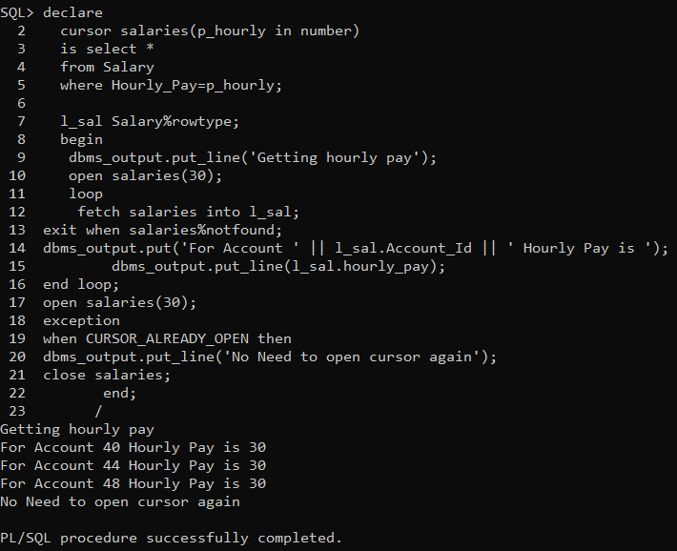

**Appendix:**

# Create Table Statements

Employee

---------------------------------------------------

CREATE TABLE Employee( Employee_Id NUMBER(6), First_Name VARCHAR2(25), Last_Name VARCHAR2(25), Hire_Date DATE,

City VARCHAR2(25), State VARCHAR2(25),

CONSTRAINT EMPLOYEE_PK PRIMARY KEY (Employee_Id));

---------------------------------------------------

Department

---------------------------------------------------

CREATE TABLE Department( Department_Id NUMBER, Department_Name VARCHAR2(30),

CONSTRAINT DEPARTMENT_PK PRIMARY KEY (Department_Id)

);

-------------------------------------------------

Salary

-------------------------------------------------

CREATE TABLE Salary(

Salary_Id NUMBER,

Gross_Salary NUMBER, Hourly_Pay NUMBER, State_Tax NUMBER, Federal_Tax NUMBER, Account_Id NUMBER,

CONSTRAINT SALARY_PK PRIMARY KEY (Salary_Id),

FOREIGN KEY (Account_Id)

REFERENCES ACCOUNTDETAILS(Account_Id)

);

-------------------------------------------------

DepartmentProject Bridge

-------------------------------------------------

CREATE TABLE DepartmentProject( Department_Id NUMBER, Project_Id NUMBER,

CONSTRAINT DEPTPROJECT_PK PRIMARY KEY (Department_Id,Project_Id), FOREIGN KEY (Department_Id)

REFERENCES Department(Department_Id), FOREIGN KEY (Project_Id)

REFERENCES Project(Project_Id)

);

--------------------------------------------------

Project

--------------------------------------------------

CREATE TABLE Project( Project_Id NUMBER, Project_Name VARCHAR2(50),

Project_Description VARCHAR2(50),

CONSTRAINT Project_PK PRIMARY KEY (Project_Id)

);

---------------------------------------------------

AccountDetails

----------------- -

- - - -

- - -

CREATE TABLE AccountDetails( Account_Id NUMBER, Bank_Name VARCHAR2(50), Account_Number VARCHAR2(50), Employee_Id NUMBER,

CONSTRAINT Account_PK PRIMARY KEY (Account_Id), FOREIGN KEY (Employee_Id)

REFERENCES Employee(Employee_Id)

);

---------------------------------------------------

Education

---------------------------------------------------

CREATE TABLE Education( Education_Id NUMBER, Employee_Id NUMBER, Degree VARCHAR(30),

Graduation_Year NUMBER(4),

CONSTRAINT Location_PK PRIMARY KEY (Education_Id), FOREIGN KEY (Employee_Id)

REFERENCES Employee(Employee_Id)

);

---------------------------------------------------

Leave

---------------------------------------------------

CREATE TABLE Leave(

Leave_Id NUMBER, Employee_Id NUMBER, Leave_date DATE,

CONSTRAINT Leave_PK PRIMARY KEY (Leave_Id),

FOREIGN KEY (Employee_Id) REFERENCES Employee(Employee_Id)

);

----------------------------------------------------

EmployeeAttendance Bridge

----------------------------------------------------

CREATE TABLE Employee_Attendance( Employee_Id NUMBER, Attendance_Id NUMBER,

CONSTRAINT DEPARTMENTPROJECT_PK PRIMARY KEY (Employee_Id,Attendance_Id), FOREIGN KEY (Employee_Id)

REFERENCES Employee(Employee_Id), FOREIGN KEY (Attendance_Id)

REFERENCES Attendance(Attendance_Id)

);

----------------------------------------------------

Attendance

----------------------------------------------------

CREATE TABLE Attendance( Attendance_Id NUMBER, Hours_Worked NUMBER,

CONSTRAINT Attendance_PK PRIMARY KEY (Attendance_Id)

);

----------------------------------------------------

WorkLocation

----------------------------------------------------

CREATE TABLE Work_Location( Location_Id NUMBER, Location VARCHAR2(25),

Number_Of_Employees NUMBER, City VARCHAR2(25),

State VARCHAR2(25),

CONSTRAINT Loc_PK PRIMARY KEY (Location_Id)

);

# Insert Statements

INSERT INTO Employee VALUES (101,'Ojas','Phansekar',to_date('14-APR-16', 'dd-MON-yyyy'),'New York City','New York',1);

INSERT INTO Employee VALUES (102,'Vrushali','Patil',to_date('21-JUN-18', 'dd-MON- yyyy'),'Boston','Massachusetts',2);

INSERT INTO Employee VALUES (103,'Pratik','Parija',to_date('13-SEP-19', 'dd-MON- yyyy'),'Chicago','Illinois',3);

INSERT INTO Employee VALUES (104,'Chetan','Mistry',to_date('12-APR-11', 'dd-MON- yyyy'),'Miami','Florida',4);

INSERT INTO Employee VALUES (105,'Anugraha','Varkey',to_date('16-AUG-17', 'dd-MON- yyyy'),'Atlanta','Georgia',5);

INSERT INTO Employee VALUES (106,'Rasagnya','Reddy',to_date('25-JUL-18', 'dd-MON-yyyy'),'San Mateo','California',6);

INSERT INTO Employee VALUES (107,'Aishwarya','Boralkar',to_date('18-DEC-10', 'dd-MON-yyyy'),'San Francisco','California',7);

INSERT INTO Employee VALUES (108,'Shantanu','Savant',to_date('27-NOV-15', 'dd-MON- yyyy'),'Seattle','Washington',8);

INSERT INTO Employee VALUES (109,'Kalpita','Malvankar',to_date('24-APR-16', 'dd-MON- yyyy'),'Boston','Massachusetts',8);

INSERT INTO Employee VALUES (110,'Saylee','Bhagat',to_date('21-MAY-14', 'dd-MON-yyyy'),'San Francisco','California',7);

INSERT INTO Department VALUES (1,'Human Resources'); INSERT INTO Department VALUES (2,'Software Development'); INSERT INTO Department VALUES (3,'Data Analysis');

INSERT INTO Department VALUES (4,'Data Science');

INSERT INTO Department VALUES (5,'Business Intelligence'); INSERT INTO Department VALUES (6,'Data Engineering'); INSERT INTO Department VALUES (7,'Manufacturing'); INSERT INTO Department VALUES (8,'Quality Control');

INSERT INTO Project VALUES (21,'Dev','Whatever'); INSERT INTO Project VALUES (22,'Prod','do something'); INSERT INTO Project VALUES (23,'Test','focus');

INSERT INTO Project VALUES (24,'Nothing','do nothing');

INSERT INTO Project VALUES (25,'Research','focus on everything'); INSERT INTO Project VALUES (26,'Next Steps','find some way out');

INSERT INTO AccountDetails VALUES (40,'Santander','S12344',101); INSERT INTO AccountDetails VALUES (41,'Santander','S12345',102);

INSERT INTO AccountDetails VALUES (42,'Santander','S12346',103); INSERT INTO AccountDetails VALUES (43,'Santander','S12347',104); INSERT INTO AccountDetails VALUES (44,'Chase','C12344',105); INSERT INTO AccountDetails VALUES (45,'Chase','C12345',106); INSERT INTO AccountDetails VALUES (46,'Chase','C12347',107); INSERT INTO AccountDetails VALUES (47,'Chase','C12334',108); INSERT INTO AccountDetails VALUES (48,'BOFA','C12378',109); INSERT INTO AccountDetails VALUES (49,'BOFA','C12390',110);

INSERT INTO Education VALUES (10,101,'MS',2017); INSERT INTO Education VALUES (11,102,'MS',2019); INSERT INTO Education VALUES (12,104,'MS',2011); INSERT INTO Education VALUES (13,108,'MS',2015); INSERT INTO Education VALUES (14,109,'Bachelor',2013); INSERT INTO Education VALUES (15,107,'Bachelor',2008); INSERT INTO Education VALUES (16,106,'Bachelor',2007);

INSERT INTO Leave VALUES (51,104,to_date('1-DEC-19', 'dd-MON-yyyy')); INSERT INTO Leave VALUES (52,108,to_date('2-DEC-19', 'dd-MON-yyyy')); INSERT INTO Leave VALUES (53,109,to_date('3-DEC-19', 'dd-MON-yyyy')); INSERT INTO Leave VALUES (54,107,to_date('4-DEC-19', 'dd-MON-yyyy')); INSERT INTO Leave VALUES (55,106,to_date('5-DEC-19', 'dd-MON-yyyy')); INSERT INTO Leave VALUES (56,104,to_date('6-DEC-19', 'dd-MON-yyyy')); INSERT INTO Leave VALUES (57,108,to_date('7-DEC-19', 'dd-MON-yyyy')); INSERT INTO Leave VALUES (58,109,to_date('7-DEC-19', 'dd-MON-yyyy')); INSERT INTO Leave VALUES (59,107,to_date('8-DEC-19', 'dd-MON-yyyy')); INSERT INTO Leave VALUES (60,106,to_date('9-DEC-19', 'dd-MON-yyyy'));

INSERT INTO Attendance VALUES (90,10); INSERT INTO Attendance VALUES (91,20); INSERT INTO Attendance VALUES (92,30); INSERT INTO Attendance VALUES (93,40); INSERT INTO Attendance VALUES (94,45); INSERT INTO Attendance VALUES (95,56); INSERT INTO Attendance VALUES (96,58);

INSERT INTO Work_Location VALUES (71,'North',4,'New York City','New York',101); INSERT INTO Work_Location VALUES (72,'North',4,'Boston','Massachusetts',102); INSERT INTO Work_Location VALUES (73,'North',4,'Chicago','Illinois',103);

INSERT INTO Work_Location VALUES (74,'North',89,'Miami','Florida',104); INSERT INTO Work_Location VALUES (75,'South',90,'Atlanta','Georgia',105);

INSERT INTO Work_Location VALUES (76,'South',100,'San Mateo','California',106); INSERT INTO Work_Location VALUES (77,'South',4,'San Francisco','California',107); INSERT INTO Work_Location VALUES (78,'South',2,'Seattle','Washington',108); INSERT INTO Work_Location VALUES (79,'South',25,'Alpharetta','Georgia',109); INSERT INTO Work_Location VALUES (80,'South',20,'Keene','New Hampshire',110);

INSERT INTO Work_Location VALUES (81,'South',22,'Hampton','New Hampshire',109);

INSERT INTO Employee_Attendance VALUES (101,90); INSERT INTO Employee_Attendance VALUES (102,91); INSERT INTO Employee_Attendance VALUES (103,92); INSERT INTO Employee_Attendance VALUES (104,93); INSERT INTO Employee_Attendance VALUES (105,94); INSERT INTO Employee_Attendance VALUES (106,95); INSERT INTO Employee_Attendance VALUES (107,96); INSERT INTO Employee_Attendance VALUES (108,91);

INSERT INTO Employee_Attendance VALUES (109,92); INSERT INTO Employee_Attendance VALUES (110,93);

INSERT INTO DepartmentProject VALUES (1,21); INSERT INTO DepartmentProject VALUES (2,22); INSERT INTO DepartmentProject VALUES (3,23); INSERT INTO DepartmentProject VALUES (4,24); INSERT INTO DepartmentProject VALUES (5,25); INSERT INTO DepartmentProject VALUES (6,26); INSERT INTO DepartmentProject VALUES (7,21); INSERT INTO DepartmentProject VALUES (8,24);

INSERT INTO Salary VALUES (1,57600,30,200,1000,40); INSERT INTO Salary VALUES (2,76800,40,300,1300,41); INSERT INTO Salary VALUES (3,96000,50,400,1500,42); INSERT INTO Salary VALUES (4,115200,60,500,1700,43); INSERT INTO Salary VALUES (5,57600,30,200,1000,44); INSERT INTO Salary VALUES (6,76800,40,300,1300,45); INSERT INTO Salary VALUES (7,96000,50,400,1500,46); INSERT INTO Salary VALUES (8,115200,60,500,1700,47); INSERT INTO Salary VALUES (9,57600,30,200,1000,48); INSERT INTO Salary VALUES (10,76800,40,300,1300,49);

# Inline View

select Department_Name, count(*), to_char((count(*)/No_of_Employees.cnt)*100, '90.99') Percentages

from Department,Employee, ( select count(*) cnt from Employee ) No_of_Employees where Department.Department_Id = Employee.Department_Id

group by Department_Name, No_of_Employees.cnt

/

# Materialized View

*Number of Employees with different degrees*

---------------------------------------------

create materialized view Education_View build immediate

refresh on commit as

select Degree, count(Degree) from Education

group by Degree;

# Procedure

*Locations with less number of employees*

CREATE OR REPLACE PROCEDURE Unimportant_Locations(l_NOFEmployees IN Number) IS

l_wl NUMBER; l_emp NUMBER;

BEGIN

SELECT COUNT(*) INTO l_wl

FROM Work_Location

WHERE Number_Of_Employees LIKE l_NOFEmployees;

select count(*) into l_emp

from Employee e

inner join Work_Location w

on e.Employee_Id = w.Employee_Id

where w.Number_Of_Employees LIKE l_NOFEmployees;

IF l_wl < 5 THEN

DELETE FROM Work_Location

WHERE Number_Of_Employees = l_NOFEmployees; END IF;

EXCEPTION WHEN no_data_found THEN DBMS_OUTPUT.PUT_LINE('No Such Data Available'); END;

# Explicit Cursor

declare

cursor salaries(p_hourly in number) is select *

from Salary

where Hourly_Pay=p_hourly;

l_sal Salary%rowtype; begin

dbms_output.put_line(' Extracting hourly pay'); open salaries(30);

loop

fetch salaries into l_sal;

exit when salaries%notfound;

dbms_output.put('For Account ' || l_sal.Account_Id || ' Hourly Pay is '); dbms_output.put_line(l_sal.hourly_pay);

end loop; close salaries;

end;

/

# Pre-Defined Exception

declare

l_attendance Attendance%rowtype; New_Exception exception;

begin

l_attendance.Attendance_Id := 90; l_attendance.Hours_Worked := 'AS';

insert into Attendance (Attendance_Id,Hours_Worked)

values ( l_attendance.Attendance_Id, l_attendance.Hours_Worked ); exception

when VALUE_ERROR then

dbms_output.put_line('We encountered the VALUE_ERROR exception');

end;

/

# Explicit Cursor and Pre-Defined Cursor Together

declare

cursor salaries(p_hourly in number) is select *

from Salary

where Hourly_Pay=p_hourly;

l_sal Salary%rowtype; begin

dbms_output.put_line('Getting hourly pay'); open salaries(30);

loop

fetch salaries into l_sal;

exit when salaries%notfound;

dbms_output.put('For Account ' || l_sal.Account_Id || ' Hourly Pay is '); dbms_output.put_line(l_sal.hourly_pay);

end loop;

open salaries(30); exception

when CURSOR_ALREADY_OPEN then dbms_output.put_line('No Need to open cursor again'); close salaries;

end;

/

# External Table

create table Salary_External ( Salary_Id NUMBER, Gross_Salary NUMBER, Hourly_Pay NUMBER, State_Tax NUMBER, Federal_Tax NUMBER, Account_Id NUMBER

)

organization external (

type oracle_loader

default directory ext_Salaries access parameters (

fields terminated by ',' ) location ('Salary.csv')

)

reject limit unlimited

/

# Ref Cursor

declare

type emp_dept_rec is record( Employee_Id number, First_Name varchar2(66), Department_Name varchar2(37)

);

type emp_dept_refcur_type is ref cursor return emp_dept_rec;

employee_refcur emp_dept_refcur_type;

emp_dept emp_dept_rec;

begin

open employee_refcur for

select e.Employee_Id,

e.First_Name || ' ' || e.Last_Name "Employee Name", d.Department_Name

from Employee e, Department d

where e.Department_Id = d.Department_Id and rownum < 5

order by e.Employee_Id;

fetch employee_refcur into emp_dept; while employee_refcur%FOUND loop

dbms_output.put(emp_dept.First_Name || '''s department is '); dbms_output.put_line(emp_dept.Department_Name);

fetch employee_refcur into emp_dept; end loop;

end;

/

# Transaction

INSERT INTO Employee VALUES (111,'Priyanka','Jonas',to_date('14-NOV-16', 'dd-MON-yyyy'),'New York City','New York',1);

commit;

INSERT INTO Employee VALUES (112,'John','Vincent',to_date('21-JUN-18', 'dd-MON- yyyy'),'Boston','Massachusetts',2);

SAVEPOINT A1;

INSERT INTO Employee VALUES (113,'Pratik','Panhale',to_date('13-SEP-19', 'dd-MON- yyyy'),'Chicago','Illinois',3);

SAVEPOINT A2;

ROLLBACK A1;

# Relational View

create or replace view salary_range_calculator as

select e.First_Name, s.Hourly_Pay from Employee e

inner join AccountDetails a

on e.Employee_Id = a.Employee_Id inner join Salary s

on a.Account_Id = s.Account_Id where s.Hourly_Pay = 30;