Visualising and forecasting stocks using Dash

INTRODUCTION
Stock price forecasting has become a vital tool for investors and financial experts in the age of data-driven decision-making. Reliable predictive models are extremely valuable because accurate forecasts can have major financial benefits. However, conventional linear regression models face a major obstacle due to the intrinsically volatile and non- linear structure of stock market data. Support Vector Regression (SVR) is one of the machine learning algorithms that have been used more and more to handle these challenges.

METHODOLOGY
- Collect Historical Stock Data: Gather stock price data from a reliable source.
- Preprocess Data: Normalize the data and split it into training and testing datasets.
- Train SVR Model: Fit the Support Vector Regression model to the training data.
- Create Dash Application: Set up a Dash app for visualization.
- Build Interactive Layout: Design the layout of the app, including charts and controls.

PROPOSED SYSTEM
The proposed system is a comprehensive web- based platform designed to visualize, analyze, and forecast stock market data using advanced machine learning techniques. This platform utilizes Support Vector Regression (SVR), a powerful predictive modeling method, to forecast stock prices and trends based on historical market data. Through this system, users can access real-time stock data and utilize various statistical analysis tools to gain insights into market behavior.

RESULTS

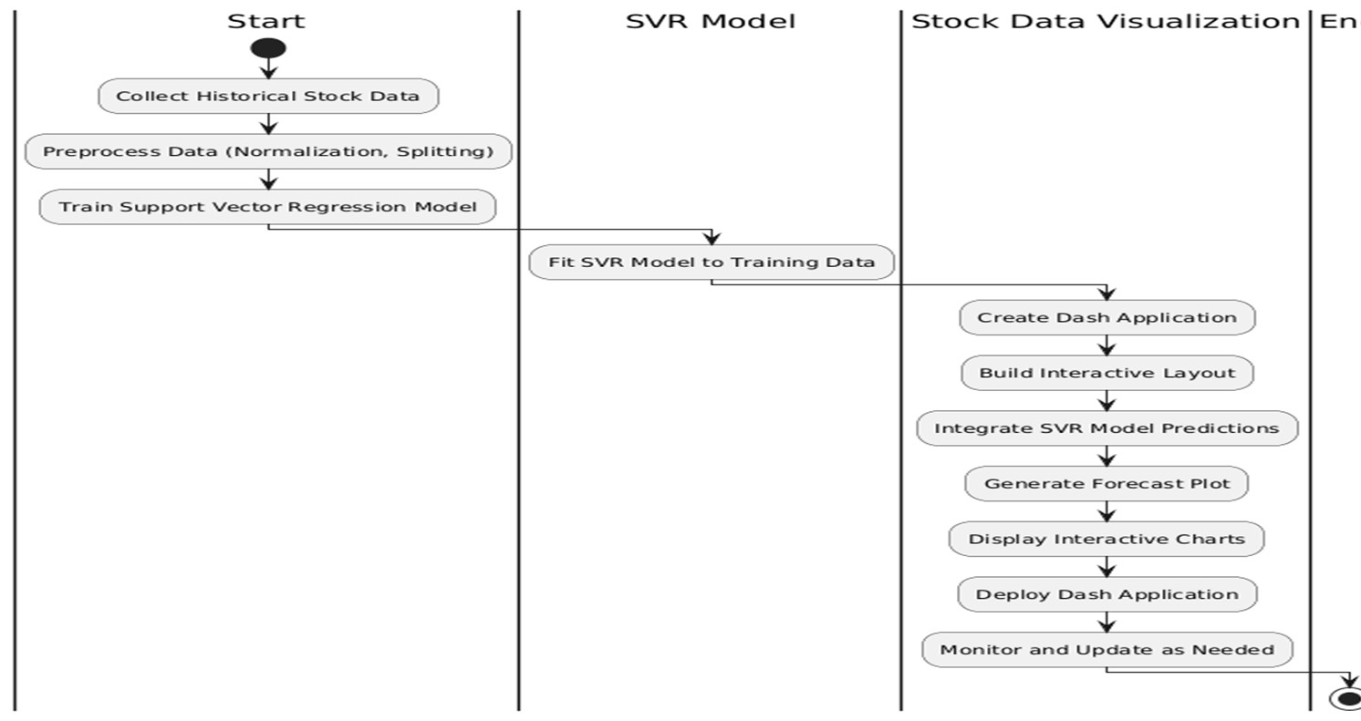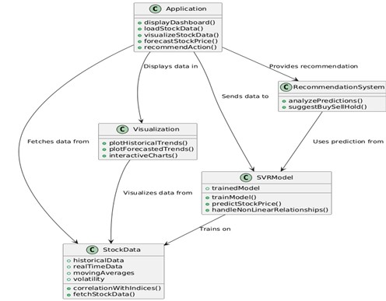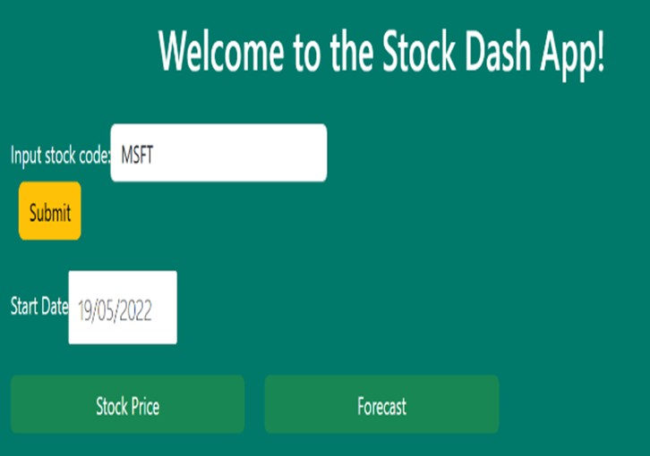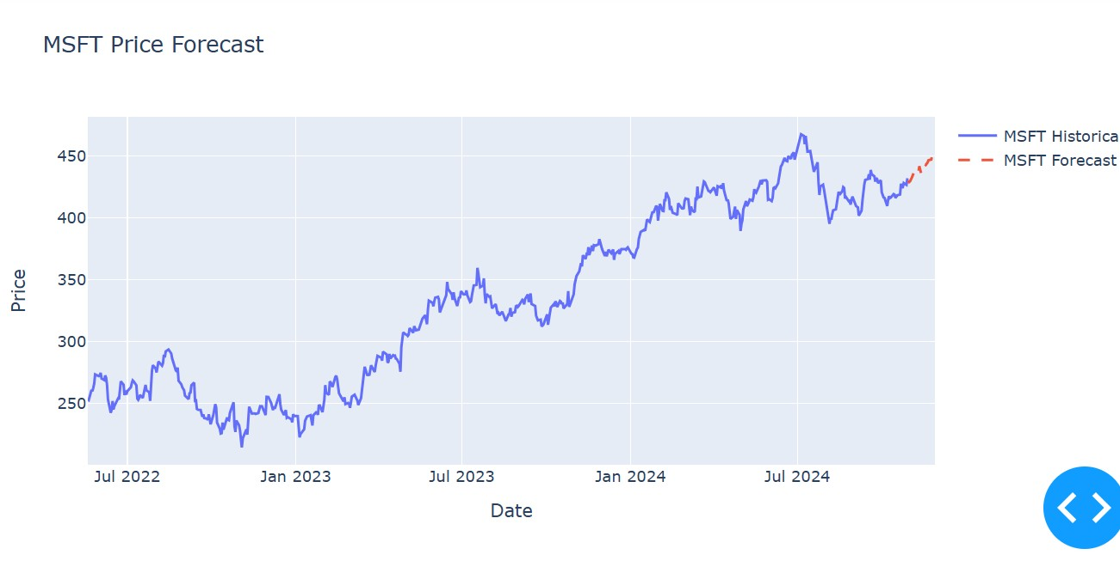SYSTEM ARCHITECTURE
Application: This is the main component, which orchestrates everything. It calls methods to load stock data, forecast prices, visualize trends, and provide recommendations. Stock Data: Responsible for fetching both historical and real-time stock data, and calculating metrics such as moving averages and volatility.
SVR Model: The Support Vector Regression model that is trained on the stock data and used to predict future stock prices.
Visualization: Handles the graphical representation of stock data, both historical and forecasted, using interactive charts.

P.B.Akshaya 2211cs050086

Your paragraph text

CONCLUSION
In conclusion, the proposed application for visualizing and forecasting stock prices using Dash and Support Vector Regression (SVR) significantly enhances the capabilities available to investors and financial analysts. By harnessing the power of machine learning, specifically the SVR model, the application adeptly handles the complexities of stock market data

Guide:
Mrs.B.Swetha
Assistant professor

