Ex no:
Date:
Title
State Diagram for Library Management System.
Aim
The aim of the Library Management System is to design a system that manages library operations such as validating student details, requesting books, checking availability, issuing books, and updating book status using State Diagram.
Problem description:
The Library Management System's state chart diagram illustrates the workflow of user interactions, from login to book issuance and return. It ensures efficient management of book records and timely updates. The system is technically, economically, and operationally feasible, with a feasible schedule for development and implementation
Diagram:
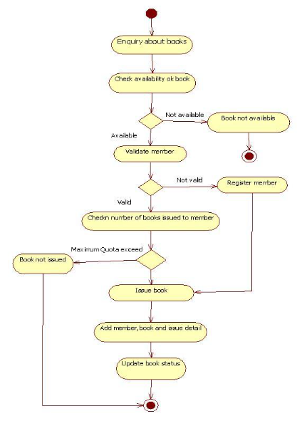

Diagram explanation:
- The diagram starts with the Initial State, representing the beginning of the process.
- The system moves to the Enter Student Details state, where the student enters ID and name.
- The system performs validation to check whether the details are correct.
- If the details are invalid, the process ends.
- If the details are valid, the system displays the student details.
- The student then requests a book.
- The system checks the availability of the requested book.
- If the book is not available, the system displays a “Book Not Available” message.
- If the book is available, the system issues the book to the student.
- The system then displays the issued book details.
- Finally, the book status is updated, and the process reaches the Final State.
State transition:
- Initial State – Starting point of the process.
- Validation State – System checks the entered student details.
- Display Student Details State – Verified student information is displayed.
- Request Book State – Student requests a book.
- Check Book Availability State – System checks whether the requested book is available.
- Issue Book State – Book is issued to the student.
- Display Book Details State – Issued book details are displayed.
- Update Book Status State – System updates the book status in the database.
- Final State – End of the process.
Methodology:
1.Identify States: Determine the different states an object or system can be in (e.g., User Interface, Profile Dashboard, Issue Book)
2.Define Transitions: Specify the events or actions that trigger transitions between states (e.g., Login Successful, Book Issued).
3.Determine Events: Identify the events that cause state changes (e.g., user login, book return).
4.Draw the Diagram: Use a diagramming tool to create the state chart, representing states as rectangles and transitions as arrows.
Feasibility Analysis:
- Technical Feasibility: The system uses existing technology and infrastructure, making it technically feasible
- .Economic Feasibility: The system reduces manual labor and increases efficiency, making it economically feasible.
- Operational Feasibility: The system is designed to be user-friendly and accessible, making it operationally feasible.
- Schedule Feasibility: The system can be developed and implemented within a reasonable timeframe, making it schedule feasible.
Result:
A complete State chart diagram was developed successfully. The itinerary, cost structure, and feasibility justification collectively demonstrate that the proposed solution satisfies all constraints
Conclusion
The State Diagram clearly represents the different states and transitions involved in the book issuing process. It helps visualize how the system behaves under different conditions such as successful validation, invalid student details, or book unavailability.
By using a state diagram, the system behavior becomes easier to understand, analyze, and design, ensuring a clear representation of how the process flows from the initial state to the final state.

