Experiment No: 6
Date:
USE CASE DIAGRAM FOR WITHDRAWING AMOUNT FROM ATM
Aim:
To apply software engineering principles by implementing use case diagram for withdrawal of amount from ATM machine.
Use case diagram:
A Use Case Diagram is a type of Unified Modeling Language (UML) diagram that represents the interaction between actors (users or external systems) and a system under consideration to accomplish specific goals. It provides a high-level view of the system's functionality by illustrating the various ways users can interact with it.
Software Used:
• Rational Rose (or any UML modeling tool)
• Windows Operating System
Actors Identified:
• User
• ATM Machine
Server Use Cases Identified:
• Insert Card
• Validation
• Enter PIN
• Display Options
• Choose Withdrawal
• Enter Amount
• Display Balance
• Take Card
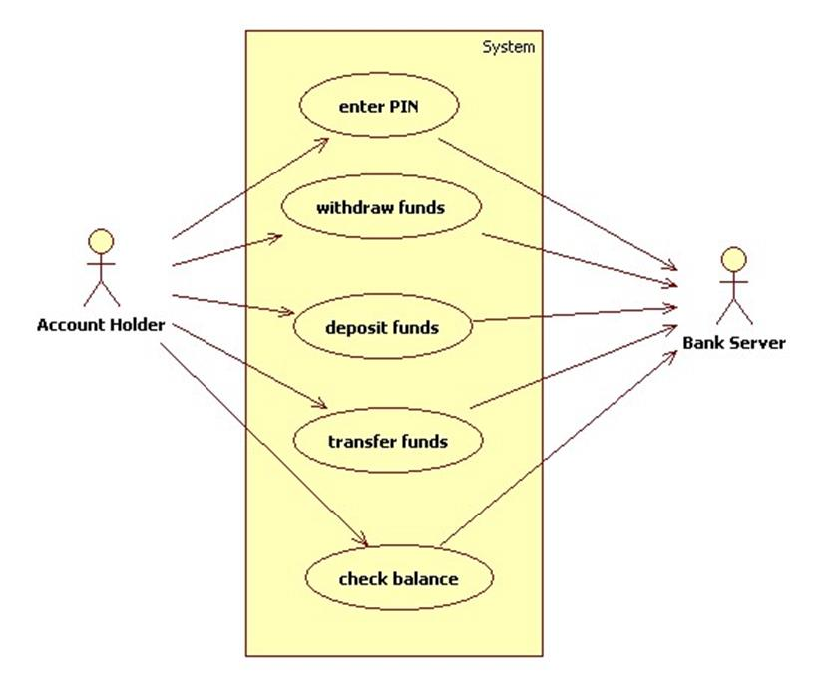
This use case diagram represents a banking system that allows an Account Holder to perform various financial transactions. The account holder is the primary actor who interacts with the system to access different services. Before performing any transaction, the user must enter a valid PIN, which ensures authentication and security.
The system provides several core functionalities such as withdrawing funds, depositing funds, transferring money to another account, and checking the account balance. Each of these actions is shown as a separate use case inside the system boundary, indicating that they are services offered by the banking system.
All the operations are connected to the Bank Server, which plays a crucial role in verifying user credentials, processing transactions, updating account information, and maintaining records. The server ensures that each request is securely handled and accurately executed.
Relationship occurred:
The use case diagram shows relationships such as association between the Account Holder and the banking functions, include relationship where PIN authentication is required for other transactions, and dependency on the Bank Server for processing and verification. These relationships illustrate how the user interacts with the system and how all operations rely on the central server for secure transaction management.
Conclusion:
In conclusion, the use case diagram clearly illustrates how an Account Holder interacts with the banking system to perform various transactions such as withdrawing, depositing, transferring funds, and checking balance after PIN authentication. It highlights the system boundary and shows that all user actions are processed through the Bank Server.

