 | Pimpri Chinchwad Education Trust’s Pimpri Chinchwad University Sate Maval, Pune | Record No.: ACAD/R/18
 |  | Revision:
 |  | Date:
Examination Question Paper

Department: {{DEPARTMENT}}  Semester: {{SEMESTER}} | Academic Year: {{ACADEMIC_YEAR}}  Year and Div.: {{YEAR_DIV}} |  | Maximum Marks: {{MAX_MARKS}}
Course Name: {{COURSE_NAME}} |  | Subject Teacher: {{SUBJECT_TEACHER}}  Duration: {{DURATION}}
Course Code: {{COURSE_CODE}} | Date: {{DATE}} |  | Date of Examination: {{EXAMINATION _DATE}}

Question No. | Question Statement | Level of mapping and Number |  | Bloom’s Level | Marks
 |  | CO | PO

SECTION A – Unit 1
(2 Marks Each) [Solve Any Two]
{{SECTION_A_Q1}}
{{SECTION_A_Q2}}
{{SECTION_A_Q3}}
SECTION B – Unit 2
(2 Marks Each) [Solve Any Two]
{{SECTION_B_Q1}}
{{SECTION_B_Q2}}
{{SECTION_B_Q3}}
SECTION C – Unit 3
(5 Marks Each) [Solve Any Two]
{{SECTION_C_Q1}}
{{SECTION_C_Q2}}
{{SECTION_C_Q3}}
SECTION D – Unit 4
(5 Marks Each) [Solve Any Two]
{{SECTION_D_Q1}}
{{SECTION_D_Q2}}
{{SECTION_D_Q3}}
SECTION E – Unit 5
(10 Marks Each) [Solve Any One]
{{SECTION_E_Q1}}
{{SECTION_E_Q2}}

Bloom’s level no | Bloom’s Taxonomy terms
6 | 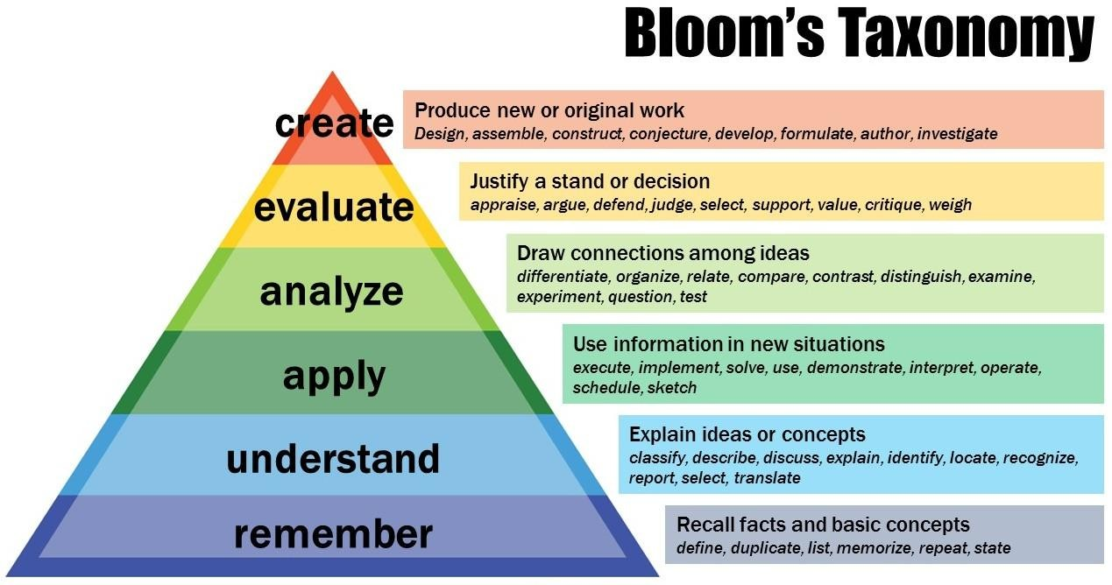
5
4
3
2
1

{{SUBJECT_INCHARGE}} | {{ACADEMIC_COORDINATOR}} | {{HOD_NAME}}
Subject In-charge | Academic Coordinator | HOD

 | Pimpri Chinchwad Education Trust’s Pimpri Chinchwad University Sate Maval, Pune | Record No.: ACAD/R/18A
 |  | Revision:
 |  | Date:
Assignment Submission Record

Roll  no. | Sign of  student | Roll  no. | Sign of  student | Roll  no. | Sign of  student | Roll  no. | Sign of  student
1 |  | 23 |  | 45 |  | 67
2 |  | 24 |  | 46 |  | 68
3 |  | 25 |  | 47 |  | 69
4 |  | 26 |  | 48 |  | 70
5 |  | 27 |  | 49
6 |  | 28 |  | 50
7 |  | 29 |  | 51
8 |  | 30 |  | 52
9 |  | 31 |  | 53
10 |  | 32 |  | 54
11 |  | 33 |  | 55
12 |  | 34 |  | 56
13 |  | 35 |  | 57
14 |  | 36 |  | 58
15 |  | 37 |  | 59
16 |  | 38 |  | 60
17 |  | 39 |  | 61
18 |  | 40 |  | 62
19 |  | 41 |  | 63
20 |  | 42 |  | 64
21 |  | 43 |  | 65
22 |  | 44 |  | 66

