**NAME: T.SANGEETHA MARI**

**ROLL NO. : 19UITE033**

**EX NO. 1: Managing Set of Program using make utility**

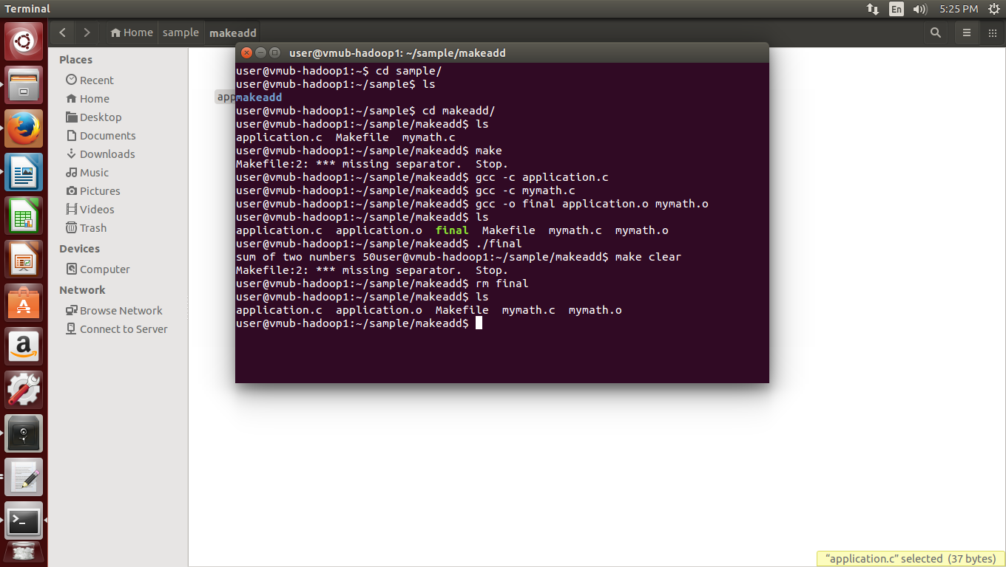**DATE: 02/09/2022**

