Assignment 6

NAME – Akshay Amin
BRANCH – Computer Science & Engineering
ROLL NO.- A-67
ADMISSION NO. - U22CS067
SUBJECT – BlockChain

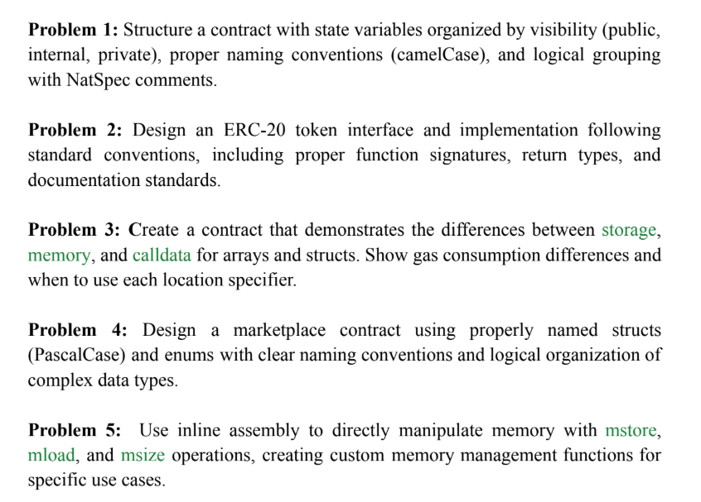

Question 1

// SPDX-License-Identifier: MIT
pragma solidity ^0.8.20;

/// @title SimpleContract
/// @notice Demonstrates visibility and naming conventions in Solidity
contract SimpleContract {
// Public variable
/// @notice Stores the name of the contract owner
address public owner;

// Internal variable
/// @dev Used internally to count actions
uint internal actionCount;

// Private variable
/// @dev Secret value used only within the contract
uint private secretCode;

/// @notice Constructor sets the initial owner and secret code
constructor() {
owner = msg.sender;
secretCode = 1234;
actionCount = 0;
}

/// @notice Increments the action count
function performAction() public {
actionCount++;
}

function getActionCount() public view returns (uint) {
return actionCount;
}

/// @notice Get the secret code (for testing only)
function getSecretCode() public view returns (uint) {
return secretCode;
}
}

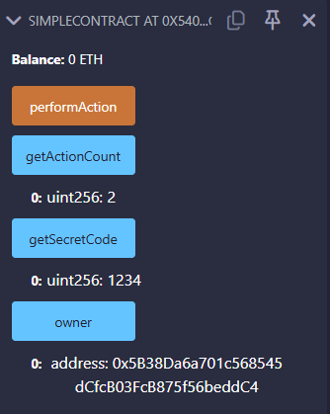

Question 2

// SPDX-License-Identifier: MIT
pragma solidity ^0.8.20;

contract SimpleToken {
mapping(address => uint) public balanceOf;
uint public totalSupply;

constructor(uint _initialSupply) {
totalSupply = _initialSupply;
balanceOf[msg.sender] = _initialSupply;
}

function transfer(address to, uint amount) public returns (bool) {
require(balanceOf[msg.sender] >= amount, "Not enough tokens");
balanceOf[msg.sender] -= amount;
balanceOf[to] += amount;
return true;
}
}

Initial supply = 1000
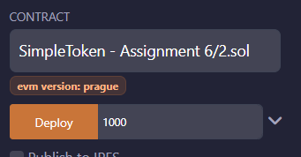

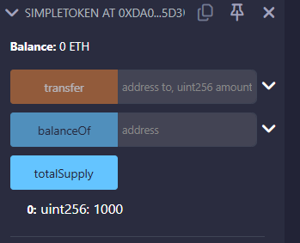

Checking my balance = 1000
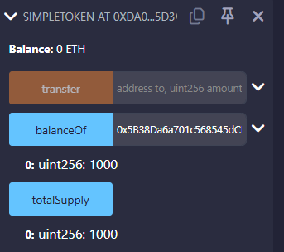

40 coin transferred to another address
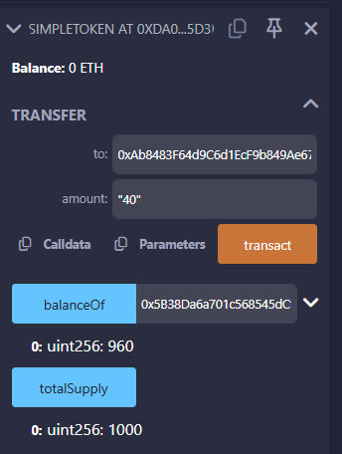

Question 3

// SPDX-License-Identifier: MIT
pragma solidity ^0.8.20;

/// @title Data Location Demo
contract DataLocationDemo {
struct User {
string name;
uint256 age;
}

User[] public users;

/// @notice Adds a new user (stored in storage)
function addUser(string memory name, uint256 age) public {
users.push(User(name, age));
}

/// @notice View user from storage (modifies in storage)
function updateUserName(uint index, string memory newName) public {
User storage user = users[index];
user.name = newName;
}

/// @notice Get user info using memory (read-only copy)
function getUserMemory(uint index) public view returns (string memory, uint256) {
User memory user = users[index];
return (user.name, user.age);
}

/// @notice Accepts calldata input for gas efficiency
function validateNames(string[] calldata inputNames) external pure returns (bool) {
return inputNames.length > 0;
}
}

Storage -> Adding user -> high gas cost
Permanent storage

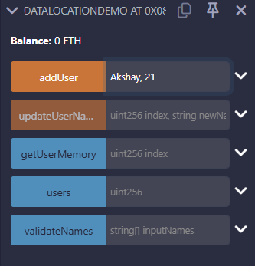

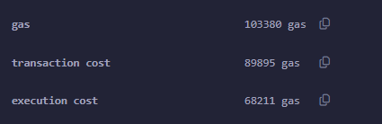

storage-> update user -> medium gas cost

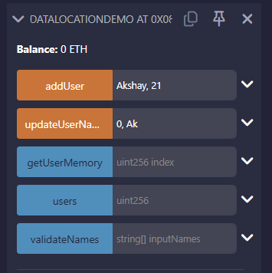

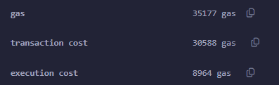

Memory -> Read -> lower gas cost
Temporary inside Variable

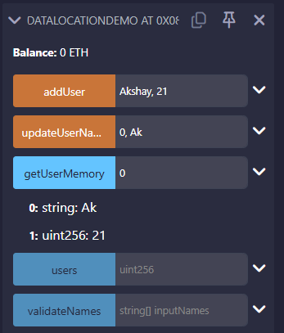
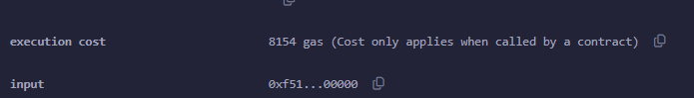

Calldata -> validation -> lowest gas cost
Use calldata for external function inputs (especially for arrays or structs) for efficiency.

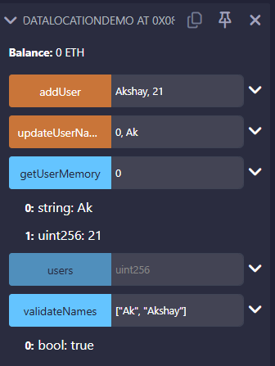

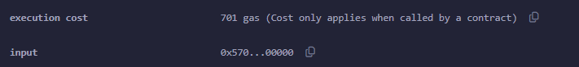

Question 4
// SPDX-License-Identifier: MIT
pragma solidity ^0.8.20;

/// @title Marketplace Contract
contract Marketplace {
enum OrderStatus { Pending, Shipped, Completed, Cancelled }

struct Product {
uint256 productId;
string productName;
uint256 price;
address seller;
}

struct Order {
uint256 orderId;
uint256 productId;
address buyer;
OrderStatus status;
}

uint256 public nextProductId = 1;
uint256 public nextOrderId = 1;

mapping(uint256 => Product) public products;
mapping(uint256 => Order) public orders;

function addProduct(string memory name, uint256 price) public {
products[nextProductId] = Product(nextProductId, name, price, msg.sender);
nextProductId++;
}

function createOrder(uint256 productId) public {
require(products[productId].productId != 0, "Invalid product");
orders[nextOrderId] = Order(nextOrderId, productId, msg.sender, OrderStatus.Pending);
nextOrderId++;
}

function updateOrderStatus(uint256 orderId, OrderStatus newStatus) public {
require(orders[orderId].orderId != 0, "Order not found");
orders[orderId].status = newStatus;
}
}

enum OrderStatus { Pending, Shipped, Completed, Cancelled }

One product and one order is created
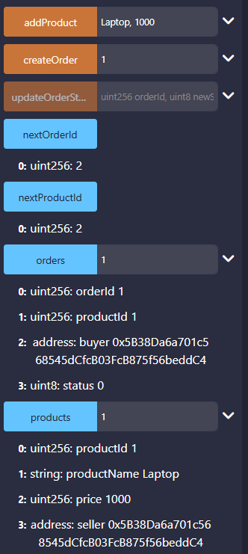

Status of order is changed

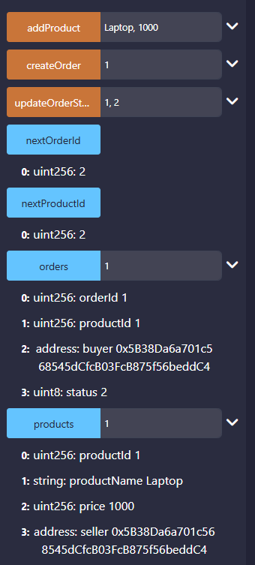

Question 5

// SPDX-License-Identifier: MIT
pragma solidity ^0.8.20;

/// @title Memory Operations with Inline Assembly
contract MemoryManager {
/// @notice Store and retrieve a number using mstore and mload
function storeAndLoad(uint256 input) external pure returns (uint256 result) {
assembly {
let memPtr := mload(0x40) // get free memory pointer
mstore(memPtr, input) // store input at memPtr
result := mload(memPtr) // load the value back
}
}

/// @notice Get current memory size
function getMemorySize() external pure returns (uint256 size) {
assembly {
size := msize()
}
}
}

