SUPERSTORE SALES ANALYTICSPrepared by: Akshaya R

Power BI Dashboard Project Report
Sales • Profitability • Orders • Category & Regional Analysis

2.33M  TOTAL SALES | 292.30K  TOTAL PROFIT | 39K  TOTAL QUANTITY | 5,111  TOTAL ORDERS

1. Executive Summary
A management-ready view of the Superstore dataset
This report documents a Power BI sales analytics dashboard built from the Superstore dataset. The dashboard consolidates commercial performance into a small set of decision-focused visuals, including KPI cards, category and sub-category analysis, a year-wise sales trend, regional filtering, and a country/region profit comparison.
- The dashboard reports approximately 2.33M in total sales and 292.30K in total profit.
- Total quantity is approximately 39K units, while the dashboard shows 5,111 total orders.
- Sales are presented across the available years, with a visible upward movement in the later years shown in the dashboard.
- Category and sub-category visuals allow users to identify where sales concentration occurs and compare product groups.
- Region and category slicers provide interactive filtering so the same dashboard can be used for different business views.
Dashboard snapshot
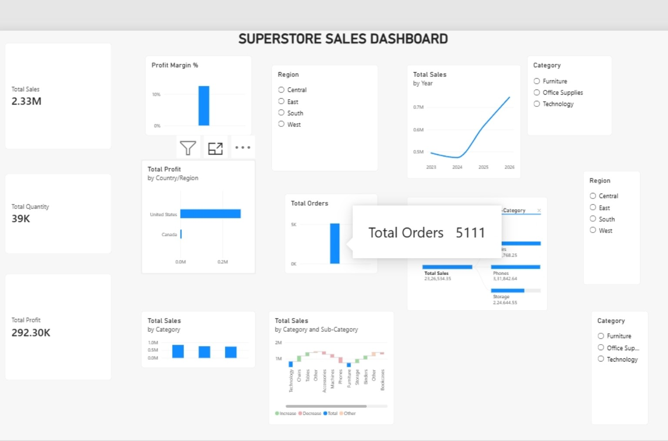
Figure 1. Superstore Sales Dashboard — final analytical view.

2. Data Preparation & Power BI Build
Prepared by: Akshaya R
From raw Superstore data to an analysis-ready model
The Power Query stage was used to prepare the source data before dashboard construction. The visible query workflow includes type conversion for date fields and validation of column quality. The objective was to make the dataset reliable for aggregation, filtering and time-based analysis.
Preparation area | Implementation in the project
Data quality | Checked validity, errors and empty values in Power Query before analysis.
Date handling | Order Date and Ship Date were converted to date data types for consistent time analysis.
Column structure | Fields such as Category, Region/Country, Customer, Product, Sales, Profit and Quantity were retained for analysis.
Measures | Dedicated measures were used for Total Sales, Total Profit, Total Quantity, Total Orders and Profit Margin %.
Interactivity | Category and Region slicers were added so users can dynamically filter the dashboard.

3. Data Model & Measure Layer
The report uses the Superstore table as the main analytical source and a separate _Measures area for reusable calculations. Keeping measures separate improves report organization and makes the dashboard easier to maintain.
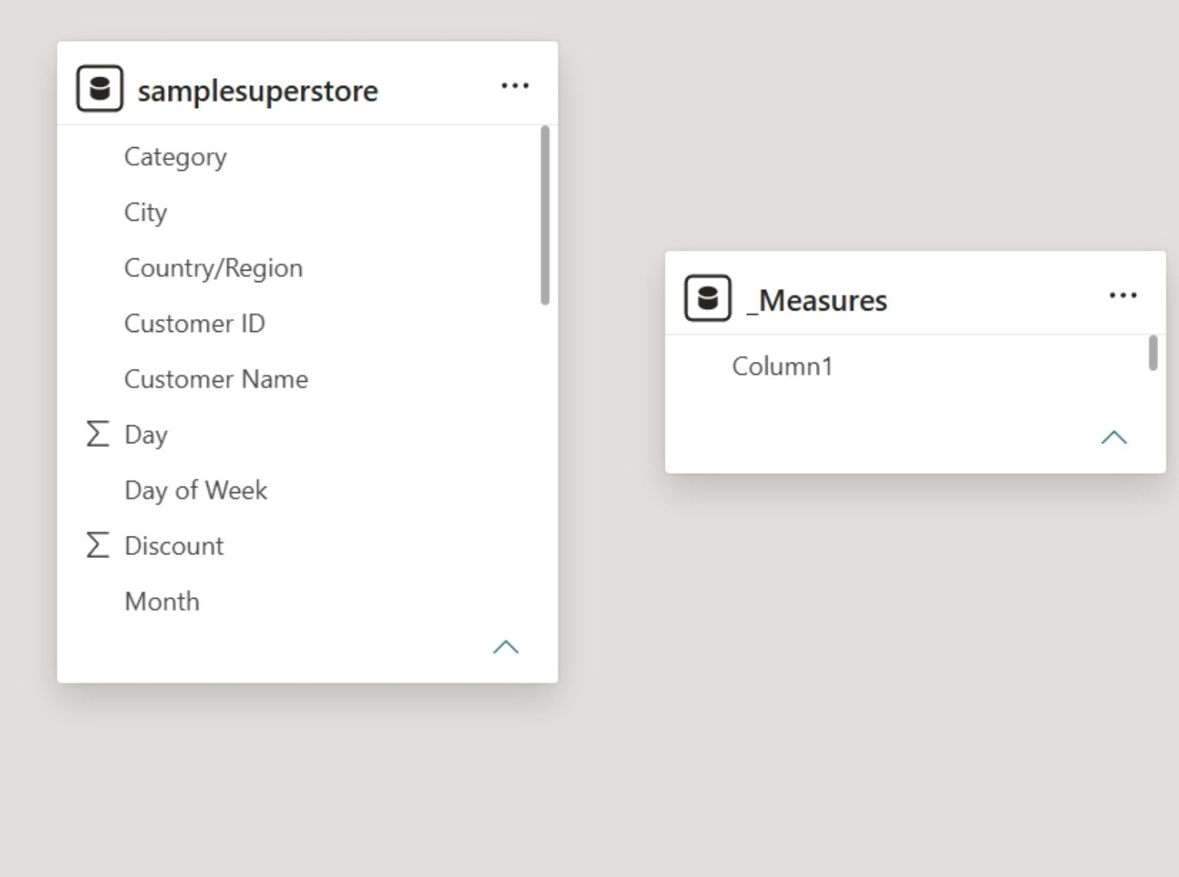
Figure 2. Power BI data/model view used during the project.
Core analytical measures
- Total Sales — sum of Sales.
- Total Profit — sum of Profit.
- Total Quantity — sum of Quantity.
- Total Orders — distinct order count.
- Profit Margin % — profit divided by sales, expressed as a percentage.

4. Dashboard Analysis
Prepared by: Akshaya R
What the visuals communicate
KPI PERFORMANCE  - Total Sales: 2.33M  - Total Profit: 292.30K  - Total Quantity: 39K  - Total Orders: 5,111 | PROFITABILITY  - The Profit Margin visual is around the low-teens percentage range in the displayed dashboard.  - The dashboard separates profit from sales, allowing profitability to be considered alongside revenue.
TIME TREND  - Total Sales by Year shows a dip/flat period before stronger growth in the later years displayed.  - The year trend provides a quick view of changes in sales performance over time. | PRODUCT MIX  - Category-level sales can be compared across Furniture, Office Supplies and Technology.  - The Category/Sub-Category visual provides a deeper product-mix view.

5. Key Findings from the Dashboard
Scale of business: The dashboard summarizes a business with 2.33M in sales, 292.30K in profit and approximately 39K units sold.
Order activity: 5,111 total orders are shown, providing a useful volume metric alongside revenue and quantity.
Geographic concentration: The country/region profit visual is dominated by the United States, with Canada contributing a much smaller amount in the displayed comparison.
Category comparison: The category chart supports side-by-side comparison of Furniture, Office Supplies and Technology rather than relying on a single overall sales number.
Interactive analysis: Region and Category slicers allow the same visuals to be re-used for focused questions without creating separate reports.

Metric | Displayed value | Use in decision-making
Sales | 2.33M | Measures revenue scale
Profit | 292.30K | Measures absolute profitability
Quantity | 39K | Measures unit volume
Orders | 5,111 | Measures transaction activity

6. Business Recommendations
Prepared by: Akshaya R
Action-oriented use of the dashboard
Monitor revenue growth by year
Use the year-wise sales chart as a recurring management view. Investigate periods where sales flatten or decline and compare those periods with category and region filters.
Review profitability, not only sales
Pair Total Sales with Total Profit and Profit Margin %. High revenue does not automatically indicate strong profitability, so product and regional decisions should consider both measures.
Focus category and sub-category reviews
Use the Category slicer and sub-category visual to isolate product groups. This can support assortment, promotion and inventory discussions.
Use regional filtering for local actions
Apply the Region slicer to compare Central, East, South and West views. Regional performance can then be reviewed without changing the underlying report structure.
Standardize monthly/quarterly reporting
The current dashboard structure can be reused as a management template, with the same KPI definitions and interactive filters applied to future refreshed data.

7. Project Outcome
The completed Power BI dashboard converts the Superstore transaction data into an interactive analytical report. It combines headline KPIs with trend, category, sub-category and geographic views, while slicers allow users to move from an overall business view to a focused segment view. The result is a compact management dashboard that can support routine sales and profitability monitoring.

8. Conclusion
The project demonstrates the end-to-end Power BI workflow: preparing data in Power Query, establishing a clean measure layer, creating interactive visuals and presenting the results in a dashboard format. The dashboard's strength is its combination of simple KPIs and drill-down analysis, enabling users to move from 'how much?' to 'where?' and 'which product groups?' within the same report.
Submission checklist
✓ Power BI dashboard completed and formatted.
✓ KPI cards and core measures displayed.
✓ Category and Region slicers configured.
✓ Year-wise sales trend included.
✓ Category/Sub-Category analysis included.
✓ Report documentation prepared in four pages.
— End of Report —

