Synopsis

on
Gesture Based Communication Using Hidden Markov Model
of

Bachelor of Technology
in
Computer Science & Engineering
By:
Akshay Kumar
(Roll No. 1002810009)
4th Year (B)



DEPARTMENT OF COMPUTER SCIENCE AND ENGINEERING
Ideal Institute of Technology Ghaziabad [U.P.]
(Approved by AICTE and affiliated to Mahamaya Technical University, Noida, U.P.)

Abstract

A gesture based communication system using hidden markov model has been proposed in which we are considering the indian sign languages gestures. Sign language imparts an absolute way of communication especially among the deaf communities all over the world with keeping their own grammatical structures. It emphasis the movement of hands,arms,head and body in a conceptual predetermined way so that a gesture language would be constructed significantly.
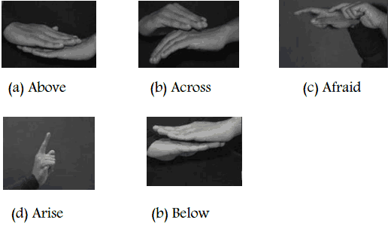

Motivation

The idea behind this concept is that the A gesture based communication system using hidden markov model has been proposed in which we are considering the indian sign languages gestures. Sign language imparts an absolute way of communication especially among the deaf communities all over the world with keeping their own grammatical structures. It emphasis the movement of hands,arms,head and body in a conceptual predetermined way so that a gesture language would be constructed significantly.

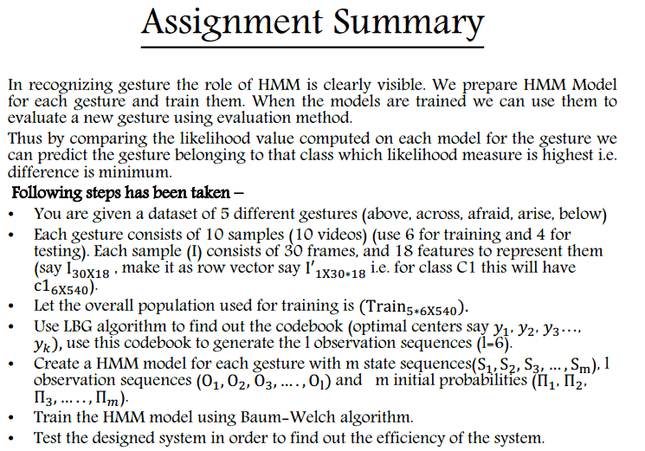

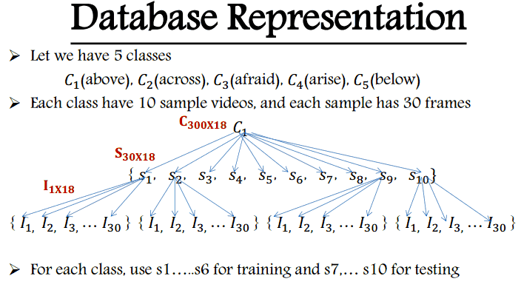

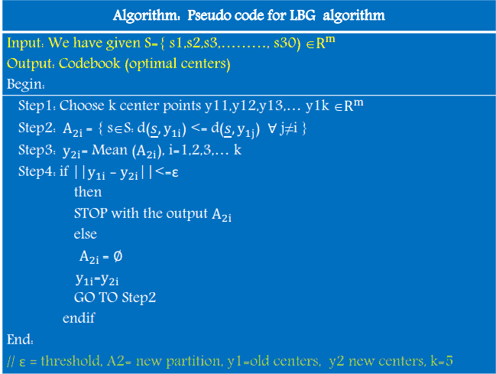

Tools To Be Used :
Mat lab software
Expected Duration of the project:
2 Months
Expected Outcome of the project:
verifying the indian sign gestures of the deaf communities through the mat lab software.
Milestones to be achieved:
it can be best applied in the cloud robotics ,artificial intelligence.

