ADVANCED OBJECT ORIENTED PROGRAMMING
(25CS2205E)
Practical Exercise 1: Bank Account and Money Transfers

Name : T.Sai Akshaya Roll No: 2520030143 Sec : 4

1. Aim
To analyse the Bank Account and Money Transfers case study, identify the design problems and
business invariants, and develop a Java banking application in which objects protect their own rules
(encapsulation, validation, immutability), so that overdraft limits, account states, transaction amounts,
transfers and the ledger always remain valid and consistent.

2. Software Used
Software/ Tool Details
Java JDK 21 (compile and run the application)
IDE / Editor VS Code / IntelliJ IDEA (edit to match what you used)
Operating System macOS
Version Control Git and GitHub (code and PDF submission)

3. Case Study Summary
A retail bank wants a Java application that lets customers maintain accounts, deposit, withdraw and
transfer funds. The development team's first version used public fields, primitive data types.
Other design problems found:
• Public fields let any class change balance or status directly, bypassing all rules.
• double/primitives for money cause rounding errors and carry no currency; Money stores paise as
long plus currency.
• Rules are scattered across service methods, so every new method must remember every rule.
• No state model: nothing says which operations are legal in ACTIVE, FROZEN or CLOSED.
• History can be edited or deleted, so there is no reliable audit trail.
• Concurrent transfers can interleave and corrupt data; transfer() is synchronized

3.1 Design problems identified (Message 1 of the task)
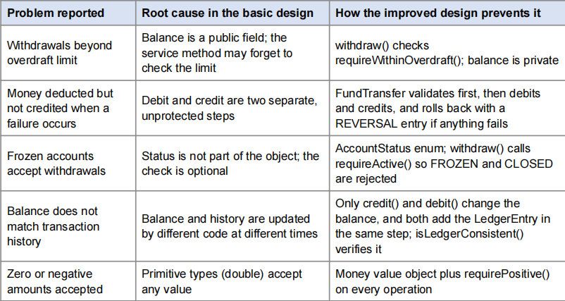

4. Activity 1: Analyse the Banking Problem (Modelling)
4.1 Q1. Domain invariants
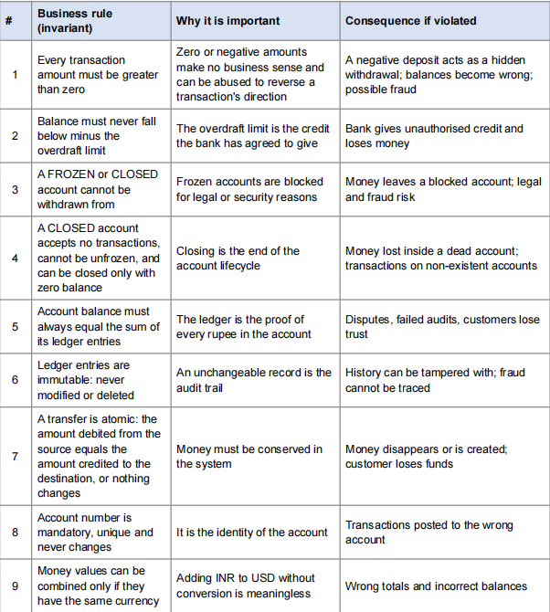
4.3 Account attributes, behaviours and valid states
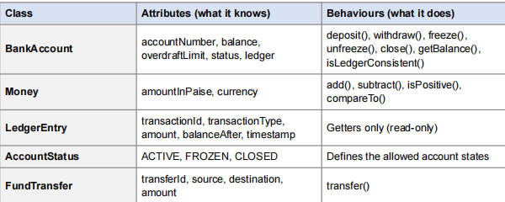

4.2 Q2. Entities and Value Objects
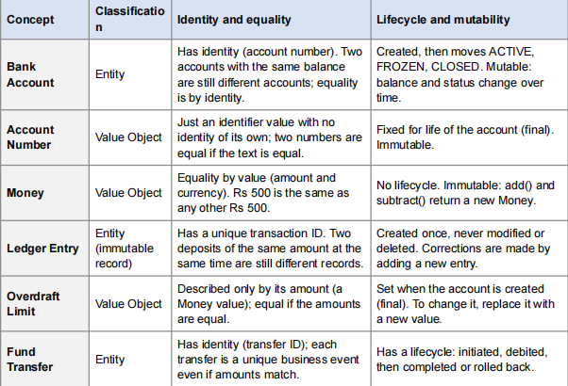

Valid and invalid operations by account state:
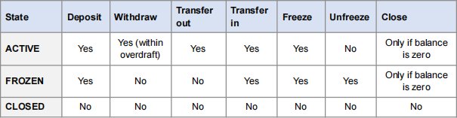
5. Activity 2: Design Self-Enforcing Objects
5.1 Class design (Project Structure)
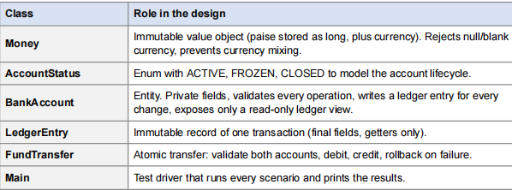

5.2 Q3. How the design enforces the rules
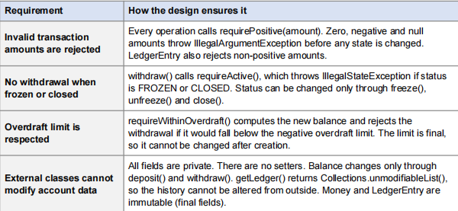

Screenshot of the project folder showing all six files in the IDE:
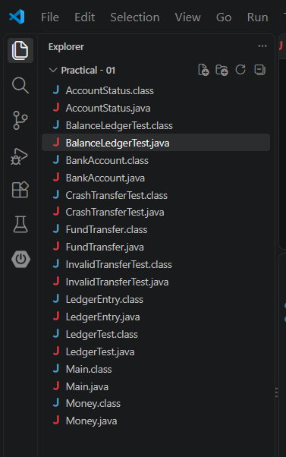

5.3 Java source code
Money.java
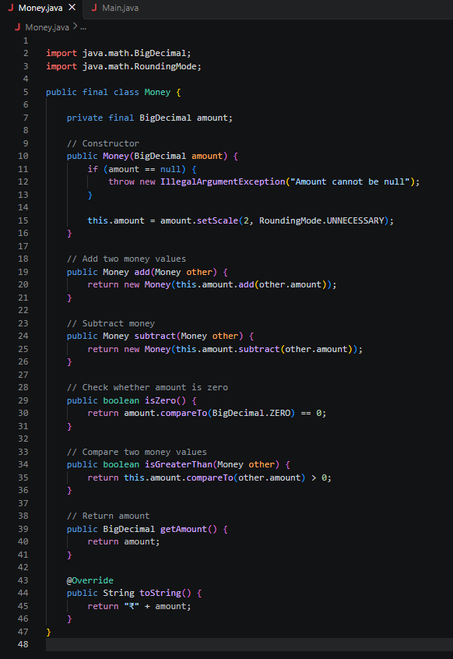

AccountStatus.java
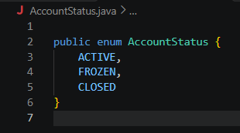
LedgerEntry.java
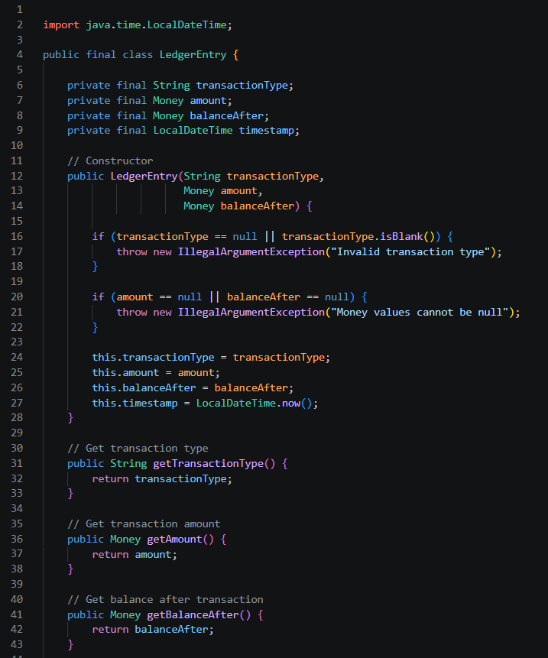
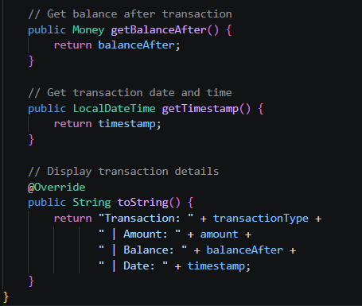
FundTransfer.java
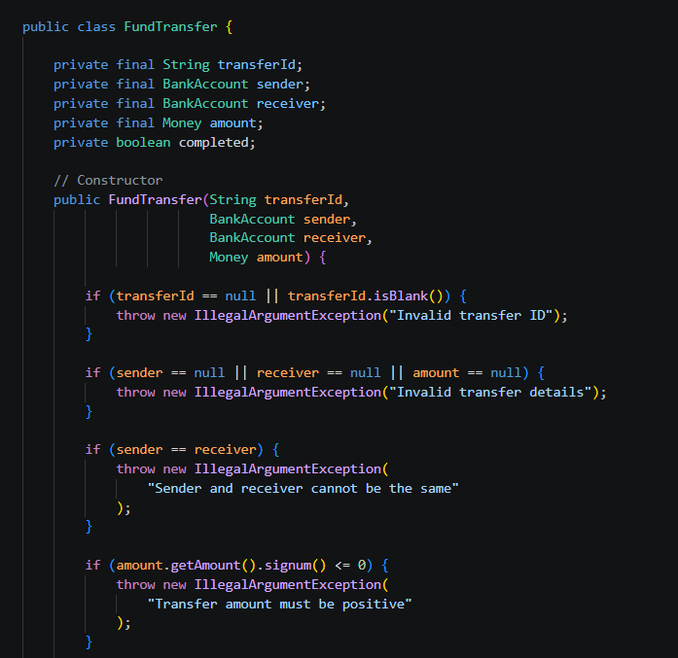
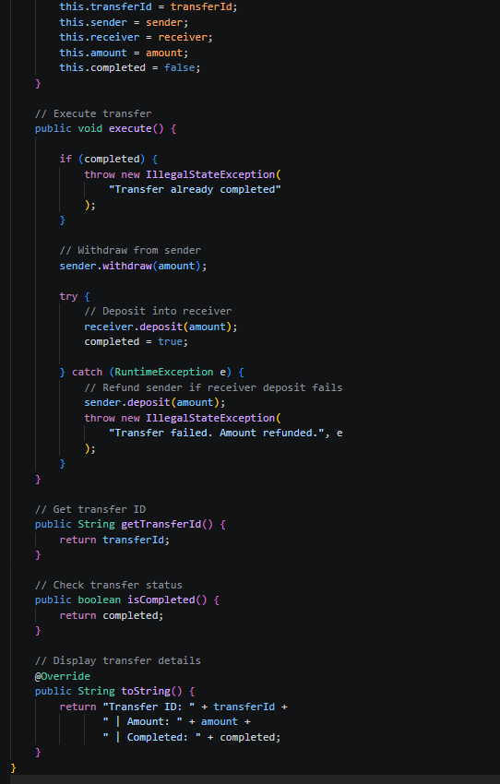

BankAccount.java
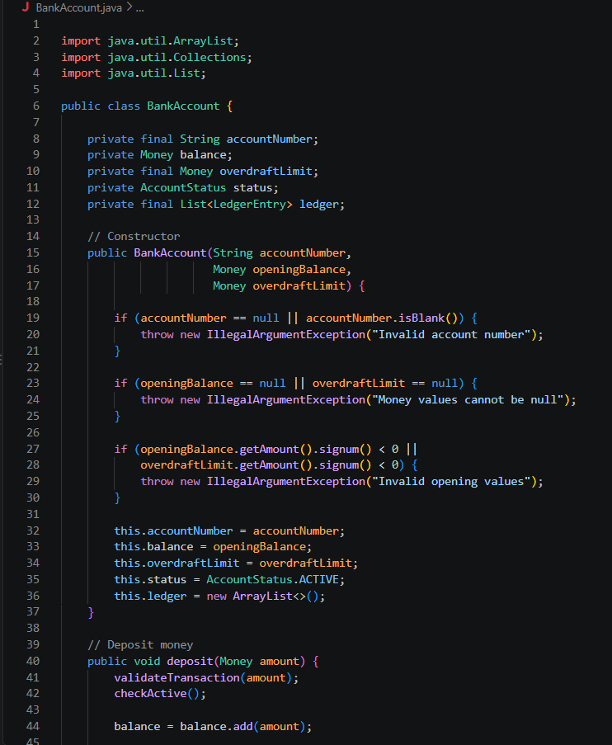
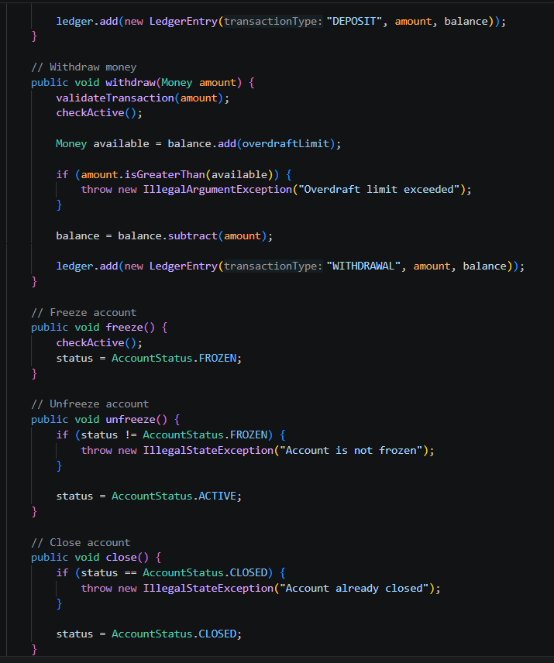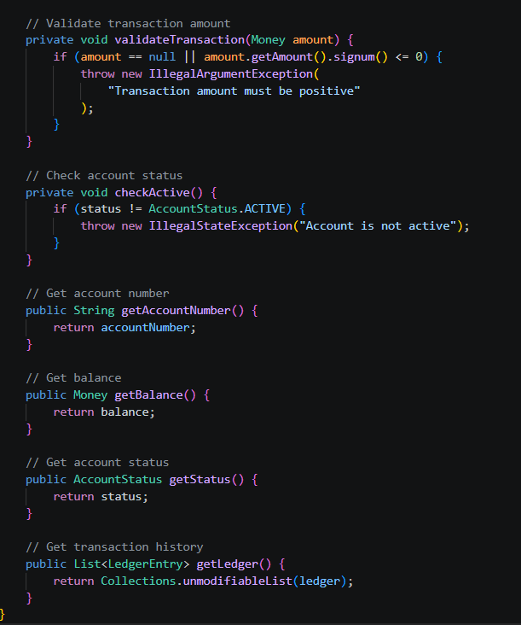

Main.java
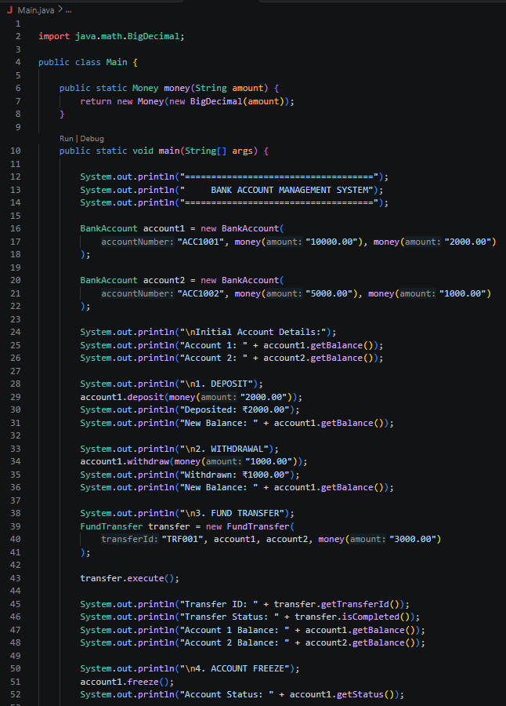
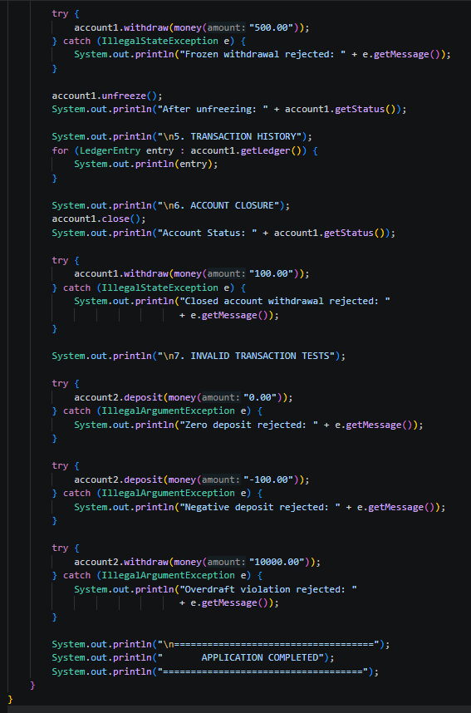

6. Activity 3: Handle Failures and Maintain Consistency
6.1 Q4. Money transfer and aggregate consistency
Scenario: Rs 5,000 is transferred from Account A to Account B. The system deducts it from A and
crashes before crediting B.
(a) Problems that can arise
• Customer A loses Rs 5,000 and B never receives it, so money has vanished from the system.
• A's ledger shows a debit with no matching credit anywhere, so the books do not balance.
• Retrying the transfer may deduct Rs 5,000 a second time.
• Customer disputes, loss of trust and audit failure.
(b) Invariants violated
• Invariant 7: the transfer is not atomic, and money is not conserved.
• Invariant 5: the books are inconsistent because a debit exists without its matching credit.
(c) Design that prevents money loss
• Validate both accounts first (amount, status, overdraft, different accounts) so that a bad transfer
fails before anything changes.
• Treat debit and credit as one unit of work inside FundTransfer.transfer(), which is synchronized.
• Give every transfer a unique transferId so it can be traced and not applied twice.
• In a real system, wrap both updates in one database transaction (BEGIN, COMMIT, ROLLBACK).
(d) How failures during the transfer are handled
• If the credit fails, the catch block calls reverseTransferDebit(), which puts the money back with a
REVERSAL ledger entry.
• The failed attempt stays visible in the history (TRANSFER_OUT followed by REVERSAL);
nothing is deleted.
• The caller receives an exception saying the transfer failed and was rolled back.
• If the whole program crashes, a database transaction rolls back automatically, or a recovery job
reads the stored transfer status (INITIATED, DEBITED) and completes or reverses it.
(e) If the accounts belong to different banking systems
• One database transaction cannot span two banks, so atomicity is not available directly.
• Use a saga with compensating transactions or two-phase commit: debit and hold the money,
request the credit from the other bank, then confirm or reverse the hold.
• Use idempotency keys (the transferId) so retries never double-debit, and send status queries on
timeout.
• Run reconciliation against the other bank's records; the system is eventually consistent. This is
how real systems like NEFT, IMPS and UPI work through a clearing network.

6.2 Transfer workflow diagram
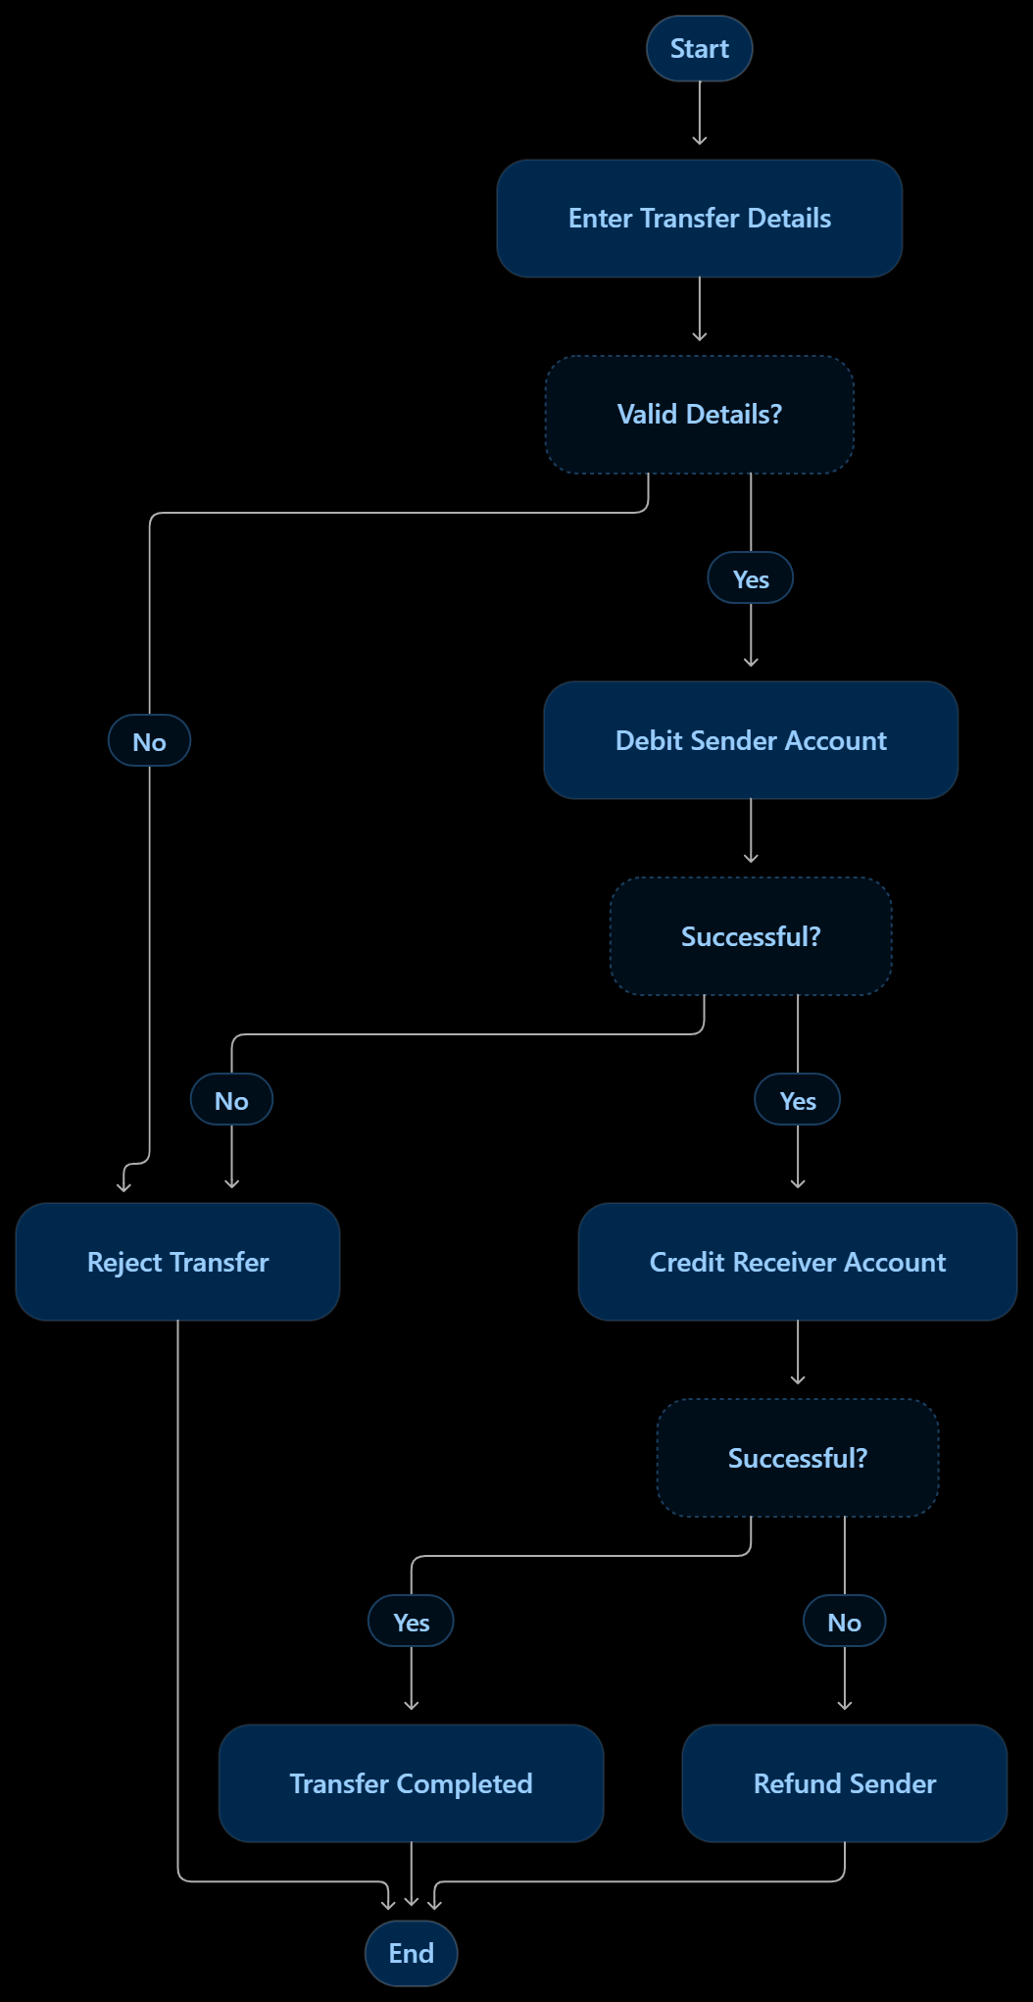
6.3 Q5. Ledger management and design evaluation
(a) Information in a ledger entry
• Transaction ID (unique), transaction type (DEPOSIT, WITHDRAWAL, TRANSFER_IN,
TRANSFER_OUT, REVERSAL), amount, balance after the transaction, and timestamp
(implemented).
• In a production system: account number, transfer or reference ID, description, and the user or
channel that initiated it.
(b) Should a completed entry be modified or deleted?
• No. The ledger is an append-only audit trail; editing or deleting entries would allow tampering and
break the link between history and balance.
• Mistakes are corrected by adding a new compensating entry (such as REVERSAL). In the code,
LedgerEntry has only final fields and getters, and BankAccount exposes only an unmodifiable list.
(c) Keeping balance consistent with history
• Only the private credit() and debit() methods change the balance, and each one adds the ledger
entry in the same step, so the two cannot drift apart.
• is LedgerConsistent() recomputes the balance from all entries and compares it with the stored
balance (see Test 11).
• In a database, the balance update and ledger insert happen in one transaction, with periodic
reconciliation.
(d) Challenges when history becomes very large
• Memory and speed: loading a huge list is slow, so use pagination and database indexes on account and date.
• Recomputing the balance from every entry is expensive, so use running balances and periodic
snapshots (checkpoints).
• Storage growth: archive old entries to cheaper storage and partition by date.
• Write contention: many concurrent updates on a busy account need careful locking or queuing
7. Observation and Results
7.1 Test cases and observations
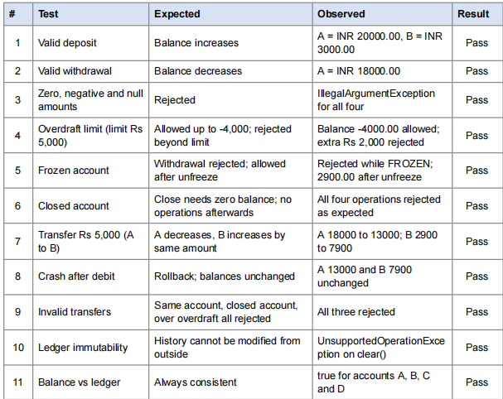

7.2 Output screenshots (java Main)
Each test below shows the console output produced by running java Main
OUTPUT --> TEST 1: Valid deposit
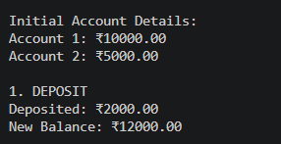
OUTPUT --> TEST 2: Valid withdrawal
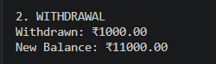
OUTPUT --> TEST 3: Invalid amounts (zero / negative / null)
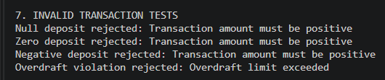
OUTPUT --> TEST 4: Overdraft limit
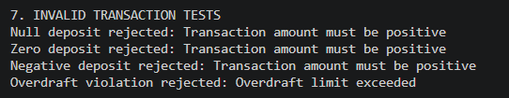
OUTPUT --> TEST 5: Frozen account
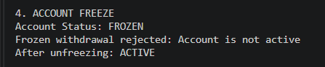
OUTPUT --> TEST 6: Closed account
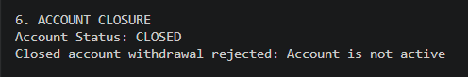
OUTPUT --> TEST 7: Successful transfer of Rs 5000 (A to B)
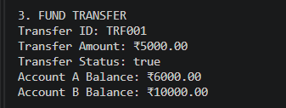

OUTPUT --> TEST 8: Crash during transfer and rollback
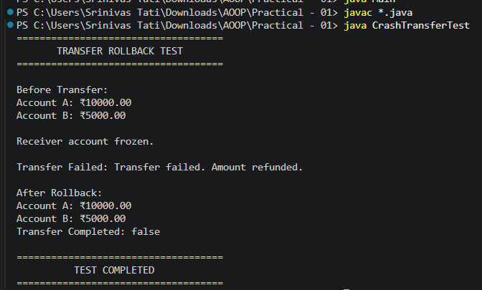

OUTPUT --> TEST 9: Invalid transfers
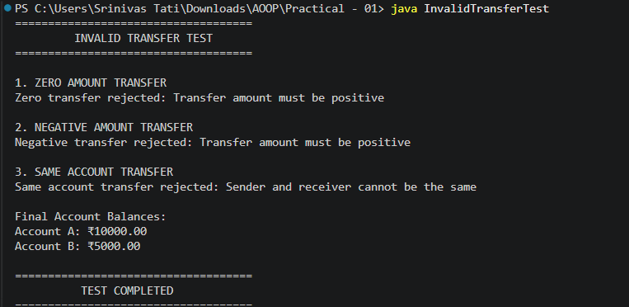

OUTPUT --> TEST 10: Ledger of Account A (immutable history)
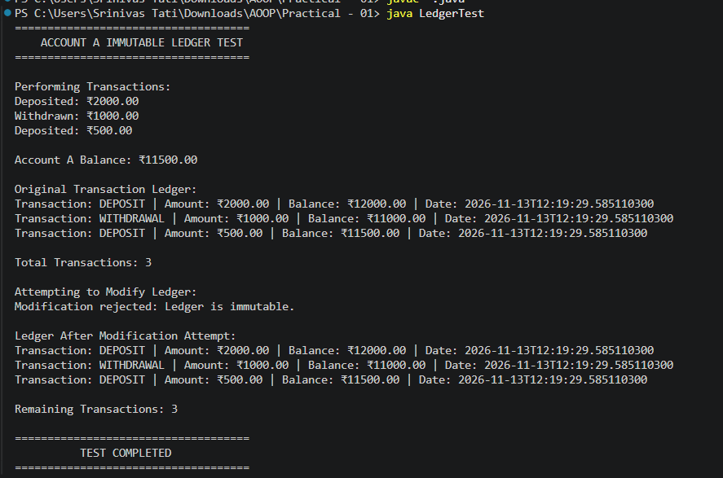
OUTPUT --> TEST 11: Balance vs ledger consistency
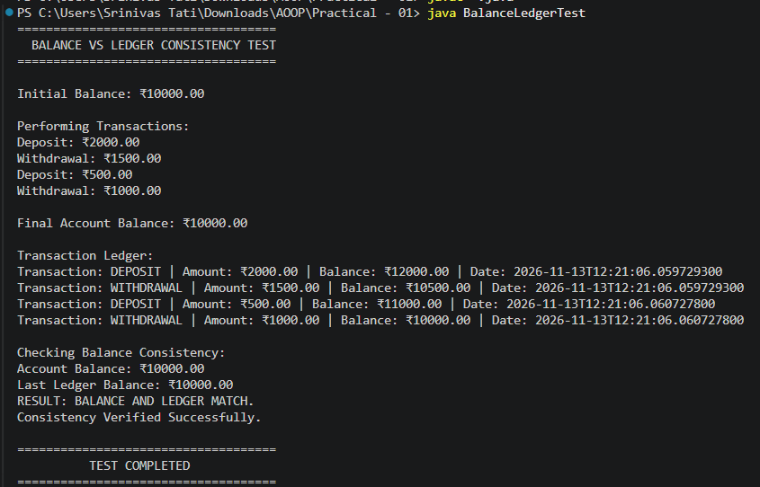

8. Result
The banking application was designed and implemented in Java using self-enforcing objects. All five
reported problems are prevented: invalid amounts, overdraft violations, withdrawals from frozen or
closed accounts, lost money during failed transfers, and mismatch between balance and history. All
eleven test cases passed.
9. Conclusion
A well-designed object protects its own invariants instead of relying on callers to follow the rules.
Private fields, constructor validation, immutable value objects (Money), state control (AccountStatus),
an append-only ledger and an atomic FundTransfer with rollback together ensure that account data
stays valid, consistent and auditable. This forms the basis for the later modules on SOLID principles,
failure handling and transactions.

